**TigerSpike assignment**

Goal –

1. To search for top 5 brands in laptops category, add the highest ranked item from the search to the shopping cart and proceed to the payment page.
2. To validate the navigation of pages during checkout process

|  |  |  |
| --- | --- | --- |
| **Pre-requisites** | | |
| Item | Version | |
| Eclipse IDE | Oxygen 2. Release (4.7.2) | |
| Python | 3.6.4 | |
| External Python Modules used | Chromedriver 2.24.1  Py 1.5.2  Pytest 3.4.2  Selenium 3.8.1 | |
| Browsers | Chrome: Version 65.0.3325.162 (Official Build) (64-bit) **(Recommended)**  Firefox : 59.0  IE: 11.309.16299.0 | |
| **Assumptions** | |
| The environment required to run this python project is fully setup | |
| The following are considered out of scope of this assignment –   1. Validation of input read from input_data file 2. login page and credentials validation 3. validation of contents of “Shop by Department” page 4. validation of contents of any intermediate pages | |
| This test always starts with an empty cart. | |
| Delivery address and credit card details are stored in amazon users page | |

**Package Structure:**

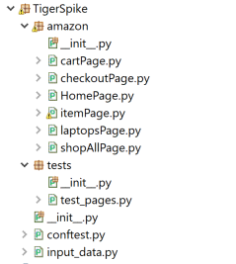

**Description of contents of TigerSpike package**

1. Different element locators (id, name, css and xpath ) are used throughout the project.
2. The package **TigerSpike** consists of two packages namely **“amazon”** and **“tests”**. It also contains helper files - **conftest** and **input_data**
3. The package **amazon** contains helper classes to drive the UI. Page Object Model design pattern is used in its implementation.
4. Pytest module is used in the implementation of the tests
5. The package ***tests*** contains test_pages which uses amazon module to search for top 5 brands in laptops category, add the highest ranked item from the search to the shopping cart and proceed to the payment page.
6. Additionally, the test also validates the navigation of pages during checkout process
7. The **input_data** contains all the user inputs like login credentials, url, etc.…
8. The **conftest** is a special file recognized by pytest. It contains **amazonTest** pytest fixtures to handle all the initial configuration that every test performs
9. Each test accepts the object returned by amazonTest fixture as a parameter.

**Steps to run the test**

1. Ensure that pytest module is installed
2. Test can be run from either console or eclipse.
3. To run it from console –
   1. Cd to the location containing the TigerSpike package
   2. Run the test as - **pytest TigerSpike\tests\test_1_add_laptop_to_cart.py**
   3. Following is the console output of test run - 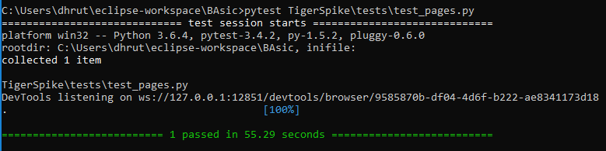
4. To run it from eclipse –
   1. Right click on test_pages.py
   2. Select Run as > Python Run
   3. Following is the sample output –

