Simulation Report

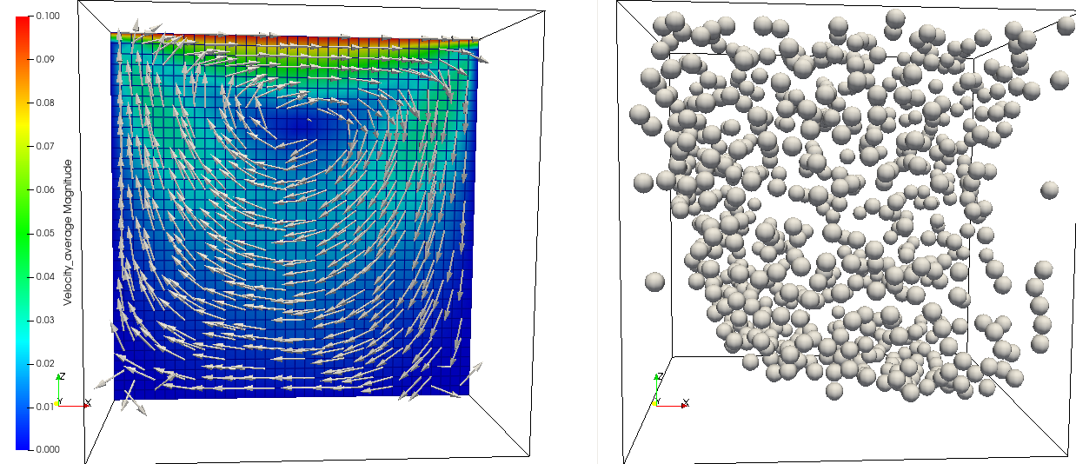
Simulation Parameters
Simulation Id: | 1675001940
Viscosity μ [g/cm∙s] | 0.1
Density ρ [g/cm³] | 1.0
Volume Fraction [%] | 5.0
Particle Radius [cm] | 0.2
Reynolds Number | 9
Domain [cm, cm, cm] | [0, 0, 0] ˟ [9, 9, 9]

Archive: samplePackA_1675001940.tar.gz

Archive Contents:
- Folder stepData1: velocity, pressure timesteps 0-10000
- Folder stepData2: velocity, pressure timesteps 10001-20000
- u_eff1.dat: effective viscosity timesteps 0-10000
- u_eff2.dat: effective viscosity timesteps 10001-20000
- gamma_dot.dat: gamma_dot like in EffViscosityForm.pdf

u_eff1.dat format:
00000 0.100394213882303 effective viscosity for step_00000.res in stepData1
00010 0.1003930823553709 effective viscosity for step_00010.res in stepData1
00020 0.10038707823407886 effective viscosity for step_00020.res in stepData1
…

analogous for u_eff2.dat

