ASSIGNMENT-4

rama krishna

11/7/2021

setwd("C:/Users/krish/OneDrive/Desktop/R_MLCODES/rmullapu_64060")  
library(factoextra)

## Loading required package: ggplot2

## Welcome! Want to learn more? See two factoextra-related books at https://goo.gl/ve3WBa

library(ggplot2)  
Pharmaanalyst<-read.csv("Pharmaceuticals.csv")  
summary(Pharmaanalyst)

## Symbol Name Market_Cap Beta   
## Length:21 Length:21 Min. : 0.41 Min. :0.1800   
## Class :character Class :character 1st Qu.: 6.30 1st Qu.:0.3500   
## Mode :character Mode :character Median : 48.19 Median :0.4600   
## Mean : 57.65 Mean :0.5257   
## 3rd Qu.: 73.84 3rd Qu.:0.6500   
## Max. :199.47 Max. :1.1100   
## PE_Ratio ROE ROA Asset_Turnover Leverage   
## Min. : 3.60 Min. : 3.9 Min. : 1.40 Min. :0.3 Min. :0.0000   
## 1st Qu.:18.90 1st Qu.:14.9 1st Qu.: 5.70 1st Qu.:0.6 1st Qu.:0.1600   
## Median :21.50 Median :22.6 Median :11.20 Median :0.6 Median :0.3400   
## Mean :25.46 Mean :25.8 Mean :10.51 Mean :0.7 Mean :0.5857   
## 3rd Qu.:27.90 3rd Qu.:31.0 3rd Qu.:15.00 3rd Qu.:0.9 3rd Qu.:0.6000   
## Max. :82.50 Max. :62.9 Max. :20.30 Max. :1.1 Max. :3.5100   
## Rev_Growth Net_Profit_Margin Median_Recommendation Location   
## Min. :-3.17 Min. : 2.6 Length:21 Length:21   
## 1st Qu.: 6.38 1st Qu.:11.2 Class :character Class :character   
## Median : 9.37 Median :16.1 Mode :character Mode :character   
## Mean :13.37 Mean :15.7   
## 3rd Qu.:21.87 3rd Qu.:21.1   
## Max. :34.21 Max. :25.5   
## Exchange   
## Length:21   
## Class :character   
## Mode :character   
##   
##   
##

#a)Use only the numerical variables (1 to 9) to cluster the 21 firms. Justify the various choices made in conducting the cluster analysis, such as weights for different variables, the specific clustering algorithm(s) used, the number of clusters formed, and so on. Prior to clustering data, remove the missing data and rescale variables for comparability.

x <- na.omit(Pharmaanalyst) #gives the data after removing the incomplete cases.  
x

## Symbol Name Market_Cap Beta PE_Ratio ROE ROA  
## 1 ABT Abbott Laboratories 68.44 0.32 24.7 26.4 11.8  
## 2 AGN Allergan, Inc. 7.58 0.41 82.5 12.9 5.5  
## 3 AHM Amersham plc 6.30 0.46 20.7 14.9 7.8  
## 4 AZN AstraZeneca PLC 67.63 0.52 21.5 27.4 15.4  
## 5 AVE Aventis 47.16 0.32 20.1 21.8 7.5  
## 6 BAY Bayer AG 16.90 1.11 27.9 3.9 1.4  
## 7 BMY Bristol-Myers Squibb Company 51.33 0.50 13.9 34.8 15.1  
## 8 CHTT Chattem, Inc 0.41 0.85 26.0 24.1 4.3  
## 9 ELN Elan Corporation, plc 0.78 1.08 3.6 15.1 5.1  
## 10 LLY Eli Lilly and Company 73.84 0.18 27.9 31.0 13.5  
## 11 GSK GlaxoSmithKline plc 122.11 0.35 18.0 62.9 20.3  
## 12 IVX IVAX Corporation 2.60 0.65 19.9 21.4 6.8  
## 13 JNJ Johnson & Johnson 173.93 0.46 28.4 28.6 16.3  
## 14 MRX Medicis Pharmaceutical Corporation 1.20 0.75 28.6 11.2 5.4  
## 15 MRK Merck & Co., Inc. 132.56 0.46 18.9 40.6 15.0  
## 16 NVS Novartis AG 96.65 0.19 21.6 17.9 11.2  
## 17 PFE Pfizer Inc 199.47 0.65 23.6 45.6 19.2  
## 18 PHA Pharmacia Corporation 56.24 0.40 56.5 13.5 5.7  
## 19 SGP Schering-Plough Corporation 34.10 0.51 18.9 22.6 13.3  
## 20 WPI Watson Pharmaceuticals, Inc. 3.26 0.24 18.4 10.2 6.8  
## 21 WYE Wyeth 48.19 0.63 13.1 54.9 13.4  
## Asset_Turnover Leverage Rev_Growth Net_Profit_Margin Median_Recommendation  
## 1 0.7 0.42 7.54 16.1 Moderate Buy  
## 2 0.9 0.60 9.16 5.5 Moderate Buy  
## 3 0.9 0.27 7.05 11.2 Strong Buy  
## 4 0.9 0.00 15.00 18.0 Moderate Sell  
## 5 0.6 0.34 26.81 12.9 Moderate Buy  
## 6 0.6 0.00 -3.17 2.6 Hold  
## 7 0.9 0.57 2.70 20.6 Moderate Sell  
## 8 0.6 3.51 6.38 7.5 Moderate Buy  
## 9 0.3 1.07 34.21 13.3 Moderate Sell  
## 10 0.6 0.53 6.21 23.4 Hold  
## 11 1.0 0.34 21.87 21.1 Hold  
## 12 0.6 1.45 13.99 11.0 Hold  
## 13 0.9 0.10 9.37 17.9 Moderate Buy  
## 14 0.3 0.93 30.37 21.3 Moderate Buy  
## 15 1.1 0.28 17.35 14.1 Hold  
## 16 0.5 0.06 -2.69 22.4 Hold  
## 17 0.8 0.16 25.54 25.2 Moderate Buy  
## 18 0.6 0.35 15.00 7.3 Hold  
## 19 0.8 0.00 8.56 17.6 Hold  
## 20 0.5 0.20 29.18 15.1 Moderate Sell  
## 21 0.6 1.12 0.36 25.5 Hold  
## Location Exchange  
## 1 US NYSE  
## 2 CANADA NYSE  
## 3 UK NYSE  
## 4 UK NYSE  
## 5 FRANCE NYSE  
## 6 GERMANY NYSE  
## 7 US NYSE  
## 8 US NASDAQ  
## 9 IRELAND NYSE  
## 10 US NYSE  
## 11 UK NYSE  
## 12 US AMEX  
## 13 US NYSE  
## 14 US NYSE  
## 15 US NYSE  
## 16 SWITZERLAND NYSE  
## 17 US NYSE  
## 18 US NYSE  
## 19 US NYSE  
## 20 US NYSE  
## 21 US NYSE

collect only the quantitative variables(1-9) to cluster the 21 firms

row.names(x)<- x[,1]  
Pharma1<- x[,3:11]  
head(Pharma1)

## Market_Cap Beta PE_Ratio ROE ROA Asset_Turnover Leverage Rev_Growth  
## ABT 68.44 0.32 24.7 26.4 11.8 0.7 0.42 7.54  
## AGN 7.58 0.41 82.5 12.9 5.5 0.9 0.60 9.16  
## AHM 6.30 0.46 20.7 14.9 7.8 0.9 0.27 7.05  
## AZN 67.63 0.52 21.5 27.4 15.4 0.9 0.00 15.00  
## AVE 47.16 0.32 20.1 21.8 7.5 0.6 0.34 26.81  
## BAY 16.90 1.11 27.9 3.9 1.4 0.6 0.00 -3.17  
## Net_Profit_Margin  
## ABT 16.1  
## AGN 5.5  
## AHM 11.2  
## AZN 18.0  
## AVE 12.9  
## BAY 2.6

Scale all the quantitative variables in the dataframe

Pharma2<-scale(Pharma1)  
head(Pharma2)

## Market_Cap Beta PE_Ratio ROE ROA Asset_Turnover  
## ABT 0.1840960 -0.80125356 -0.04671323 0.04009035 0.2416121 0.0000000  
## AGN -0.8544181 -0.45070513 3.49706911 -0.85483986 -0.9422871 0.9225312  
## AHM -0.8762600 -0.25595600 -0.29195768 -0.72225761 -0.5100700 0.9225312  
## AZN 0.1702742 -0.02225704 -0.24290879 0.10638147 0.9181259 0.9225312  
## AVE -0.1790256 -0.80125356 -0.32874435 -0.26484883 -0.5664461 -0.4612656  
## BAY -0.6953818 2.27578267 0.14948233 -1.45146000 -1.7127612 -0.4612656  
## Leverage Rev_Growth Net_Profit_Margin  
## ABT -0.2120979 -0.5277675 0.06168225  
## AGN 0.0182843 -0.3811391 -1.55366706  
## AHM -0.4040831 -0.5721181 -0.68503583  
## AZN -0.7496565 0.1474473 0.35122600  
## AVE -0.3144900 1.2163867 -0.42597037  
## BAY -0.7496565 -1.4971443 -1.99560225

To determine the no of clusters to do the cluster analysis using Elbow Method

fviz_nbclust(Pharma2, kmeans, method = "wss") + labs(subtitle = "Elbow Method")

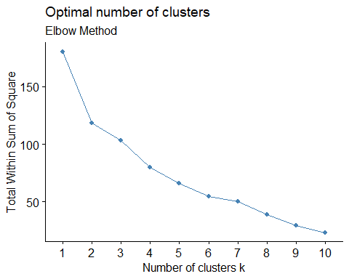 Silhouette method for determining no of clusters

fviz_nbclust(Pharma2, kmeans, method = "silhouette")+ labs(subtitle = "Silhouette Method")

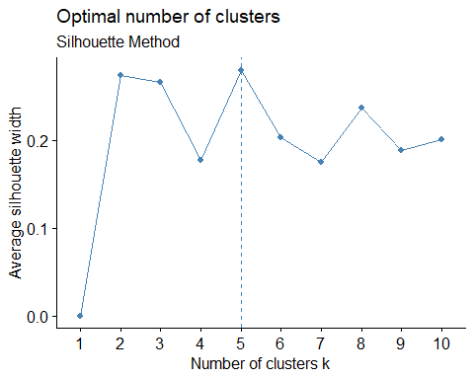 from the above plots, it is clear that the no of clusters are 5 and they are enough to show the variations that are present in the data

set.seed(120)  
k5<- kmeans(Pharma2,centers=5,nstart = 25)   
#Visualize the output  
k5$centers #centroids

## Market_Cap Beta PE_Ratio ROE ROA Asset_Turnover  
## 1 1.69558112 -0.1780563 -0.19845823 1.2349879 1.3503431 1.1531640  
## 2 -0.43925134 -0.4701800 2.70002464 -0.8349525 -0.9234951 0.2306328  
## 3 -0.03142211 -0.4360989 -0.31724852 0.1950459 0.4083915 0.1729746  
## 4 -0.87051511 1.3409869 -0.05284434 -0.6184015 -1.1928478 -0.4612656  
## 5 -0.76022489 0.2796041 -0.47742380 -0.7438022 -0.8107428 -1.2684804  
## Leverage Rev_Growth Net_Profit_Margin  
## 1 -0.46807818 0.4671788 0.591242521  
## 2 -0.14170336 -0.1168459 -1.416514761  
## 3 -0.27449312 -0.7041516 0.556954446  
## 4 1.36644699 -0.6912914 -1.320000179  
## 5 0.06308085 1.5180158 -0.006893899

fviz_cluster(k5,data = Pharma2) # to Visualize the clusters

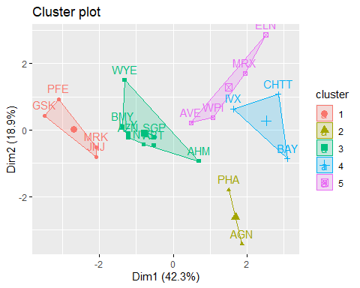

k5

## K-means clustering with 5 clusters of sizes 4, 2, 8, 3, 4  
##   
## Cluster means:  
## Market_Cap Beta PE_Ratio ROE ROA Asset_Turnover  
## 1 1.69558112 -0.1780563 -0.19845823 1.2349879 1.3503431 1.1531640  
## 2 -0.43925134 -0.4701800 2.70002464 -0.8349525 -0.9234951 0.2306328  
## 3 -0.03142211 -0.4360989 -0.31724852 0.1950459 0.4083915 0.1729746  
## 4 -0.87051511 1.3409869 -0.05284434 -0.6184015 -1.1928478 -0.4612656  
## 5 -0.76022489 0.2796041 -0.47742380 -0.7438022 -0.8107428 -1.2684804  
## Leverage Rev_Growth Net_Profit_Margin  
## 1 -0.46807818 0.4671788 0.591242521  
## 2 -0.14170336 -0.1168459 -1.416514761  
## 3 -0.27449312 -0.7041516 0.556954446  
## 4 1.36644699 -0.6912914 -1.320000179  
## 5 0.06308085 1.5180158 -0.006893899  
##   
## Clustering vector:  
## ABT AGN AHM AZN AVE BAY BMY CHTT ELN LLY GSK IVX JNJ MRX MRK NVS   
## 3 2 3 3 5 4 3 4 5 3 1 4 1 5 1 3   
## PFE PHA SGP WPI WYE   
## 1 2 3 5 3   
##   
## Within cluster sum of squares by cluster:  
## [1] 9.284424 2.803505 21.879320 15.595925 12.791257  
## (between_SS / total_SS = 65.4 %)  
##   
## Available components:  
##   
## [1] "cluster" "centers" "totss" "withinss" "tot.withinss"  
## [6] "betweenss" "size" "iter" "ifault"

distance<- dist(Pharma2, method = "euclidean")  
fviz_dist(distance)

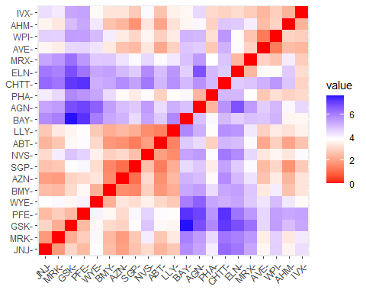 K-Means Cluster Analysis- Fit the data with 5 clusters

fit<-kmeans(Pharma2,5)

Finding the mean value of all quantitative variables for each cluster

aggregate(Pharma2,by=list(fit$cluster),FUN=mean)

## Group.1 Market_Cap Beta PE_Ratio ROE ROA  
## 1 1 -0.87051511 1.3409869 -0.05284434 -0.6184015 -1.1928478  
## 2 2 0.08926902 -0.4618336 -0.32086149 0.3260892 0.5396003  
## 3 3 -0.96686975 1.5162611 -0.57398880 -0.8382671 -0.9892673  
## 4 4 1.69558112 -0.1780563 -0.19845823 1.2349879 1.3503431  
## 5 5 -0.57238455 -0.6220844 0.86927480 -0.7381675 -0.7242993  
## Asset_Turnover Leverage Rev_Growth Net_Profit_Margin  
## 1 -4.612656e-01 1.3664470 -0.6912914 -1.3200002  
## 2 6.589509e-02 -0.2559803 -0.7230135 0.7343816  
## 3 -1.845062e+00 0.5302448 1.7123890 0.2445520  
## 4 1.153164e+00 -0.4680782 0.4671788 0.5912425  
## 5 1.776140e-16 -0.2991312 0.3682951 -0.8069490

Pharma3<-data.frame(Pharma2,fit$cluster)  
Pharma3

## Market_Cap Beta PE_Ratio ROE ROA Asset_Turnover  
## ABT 0.1840960 -0.80125356 -0.04671323 0.04009035 0.2416121 0.0000000  
## AGN -0.8544181 -0.45070513 3.49706911 -0.85483986 -0.9422871 0.9225312  
## AHM -0.8762600 -0.25595600 -0.29195768 -0.72225761 -0.5100700 0.9225312  
## AZN 0.1702742 -0.02225704 -0.24290879 0.10638147 0.9181259 0.9225312  
## AVE -0.1790256 -0.80125356 -0.32874435 -0.26484883 -0.5664461 -0.4612656  
## BAY -0.6953818 2.27578267 0.14948233 -1.45146000 -1.7127612 -0.4612656  
## BMY -0.1078688 -0.10015669 -0.70887325 0.59693581 0.8617498 0.9225312  
## CHTT -0.9767669 1.26308721 0.03299122 -0.11237924 -1.1677918 -0.4612656  
## ELN -0.9704532 2.15893320 -1.34037772 -0.70899938 -1.0174553 -1.8450624  
## LLY 0.2762415 -1.34655112 0.14948233 0.34502953 0.5610770 -0.4612656  
## GSK 1.0999201 -0.68440408 -0.45749769 2.45971647 1.8389364 1.3837968  
## IVX -0.9393967 0.48409069 -0.34100657 -0.29136529 -0.6979905 -0.4612656  
## JNJ 1.9841758 -0.25595600 0.18013789 0.18593083 1.0872544 0.9225312  
## MRX -0.9632863 0.87358895 0.19240011 -0.96753478 -0.9610792 -1.8450624  
## MRK 1.2782387 -0.25595600 -0.40231769 0.98142435 0.8429577 1.8450624  
## NVS 0.6654710 -1.30760129 -0.23677768 -0.52338423 0.1288598 -0.9225312  
## PFE 2.4199899 0.48409069 -0.11415545 1.31287998 1.6322239 0.4612656  
## PHA -0.0240846 -0.48965495 1.90298017 -0.81506519 -0.9047030 -0.4612656  
## SGP -0.4018812 -0.06120687 -0.40231769 -0.21181593 0.5234929 0.4612656  
## WPI -0.9281345 -1.11285216 -0.43297324 -1.03382590 -0.6979905 -0.9225312  
## WYE -0.1614497 0.40619104 -0.75792214 1.92938746 0.5422849 -0.4612656  
## Leverage Rev_Growth Net_Profit_Margin fit.cluster  
## ABT -0.21209793 -0.52776752 0.06168225 2  
## AGN 0.01828430 -0.38113909 -1.55366706 5  
## AHM -0.40408312 -0.57211809 -0.68503583 5  
## AZN -0.74965647 0.14744734 0.35122600 2  
## AVE -0.31449003 1.21638667 -0.42597037 5  
## BAY -0.74965647 -1.49714434 -1.99560225 1  
## BMY -0.02011273 -0.96584257 0.74744375 2  
## CHTT 3.74279705 -0.63276071 -1.24888417 1  
## ELN 0.61983791 1.88617085 -0.36501379 3  
## LLY -0.07130879 -0.64814764 1.17413980 2  
## GSK -0.31449003 0.76926048 0.82363947 4  
## IVX 1.10620040 0.05603085 -0.71551412 1  
## JNJ -0.62166634 -0.36213170 0.33598685 4  
## MRX 0.44065173 1.53860717 0.85411776 3  
## MRK -0.39128411 0.36014907 -0.24310064 4  
## NVS -0.67286239 -1.45369888 1.02174835 2  
## PFE -0.54487226 1.10143723 1.44844440 4  
## PHA -0.30169102 0.14744734 -1.27936246 5  
## SGP -0.74965647 -0.43544591 0.29026942 2  
## WPI -0.49367621 1.43089863 -0.09070919 5  
## WYE 0.68383297 -1.17763919 1.49416183 2

View(Pharma3)

To view the cluster plot

library(cluster)  
clusplot(Pharma2,fit$cluster,color = TRUE,shade = TRUE,labels = 2,lines = 0)

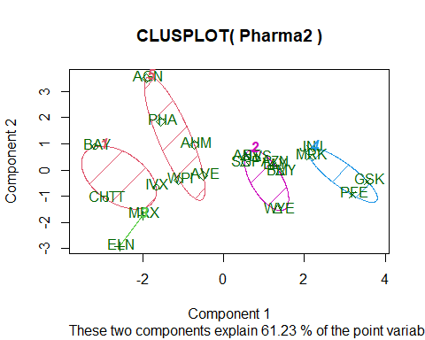

#b)Interpret the clusters with respect to the numerical variables used in forming the clusters.

By observing the mean values of all quantitative variables for each cluster

Cluster 1 - BAY, CHTT, IVX

Cluster 2 - ABT, AZN, BMY, LLY, NVS, SGP,WYE

Cluster 3 - ELN, MRX

Cluster 4 - JNJ, MRK, PFE, GSK

Cluster 5 - AGN, AHM, AVE, PHA, WPI

Cluster 1 has highest Beta , Leverage and lowest Market_Cap, ROE, ROA, Leverage, Rev_Growth, Net_Profit_Margin Cluster 2 has highest Net_Profit_Margin and lowest Beta. Cluster 3 has highest Rev_Growth and lowest PE_Ratio, Asset_Turnover. Cluster 4 has highest Market_Cap, ROE, ROA,Asset_Turnover Cluster 5 has highest PE_Ratio.

#c)Is there a pattern in the clusters with respect to the numerical variables (10 to 12)? (those not used in forming the clusters)

There is a pattern in the clusters with respect to Media recommendation variable.

Cluster 1 with highest Beta, highest Leverage has mostly Moderate Buy Recommendation.

Cluster 2 with highest Net_Profit_Margin has mostly Hold Recommendation

Cluster 3 with lowest PE_Ratio and lowest Asset_Turnover has Hold Recommendation

Cluster 4 with highest Market_Cap, highest ROE, highest ROA, highest Asset_Turnover has equal Hold and Moderate Buy Recommendation

Cluster 5 with highest PE_Ratio has the Strong Buy Recommendation, because high PE_Ratio indicates the company is growing fast.

Could see a pattern among the clusters with respect to variables(10 to 12)

Clusters 1,4 has mostly Moderate Buy Recommendation

Clusters 2,3,4 has Hold Recommendation

#d)Provide an appropriate name for each cluster using any or all of the variables in the dataset.

Cluster1 - high Beta, Leverage cluster (or) Buy Cluster.

Cluster2 - high Net_Profit_Margin cluster (or) high hold cluster.

Cluster3 - Low PE_Ratio, Asset_Turnover cluster (or) hold cluster.

Cluster4 - Moderate Buy cluster

Cluster5 - high PE_Ratio cluster (or) high Buy cluster.