**Lab2**

**Name:Trinadha Raji Muppala, ClassId : 6**

**PART III**

**User Case:** Coursera provides multiple courses online. Each course got many details and multiple users try learn from Coursera. Provide the courses user looking for by the topic or whether courses offered by universities or companies, how difficult is the course for the user to decide based on his current skill set if he/she can do the course

**Created Table with the coursera with the following fields, PRIMARY KEY for this table are (course_id, Created_By)**

Field Name Type Details

course_id int Unique number for each course

Course_Name text Name of the Course

About_Course text Description about the course

Created_By text Who created the course (Universities/Companies like IBM)

Thought_by text Who is teaching the course

Basic_Info text Short description of the course what do they cover

Level text Level of the course (Basic/Intermediate etc)

Language text What are the languages course is supported

How_to_pass text Details to pass the exam (how many tests or assignments)

Rate decimal Rate of the course

Creation of the Table:

CREATE TABLE coursera (

course_id int,

Course_Name text,

About_Course text,

Created_By text,

Thought_by text,

Basic_Info text,

Level text,

Language text,

How_to_pass text,

Rate decimal,

PRIMARY KEY(course_id, Created_By)

);

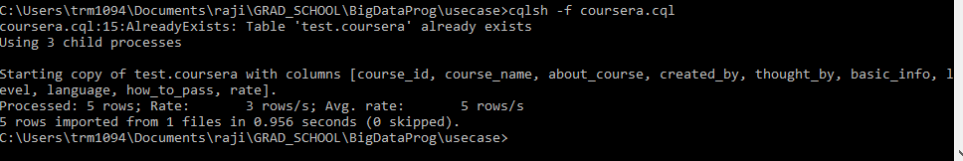

**Created data for courses related to Data Science and Java :**

Introduction to Data Science in Python

What is Data Science?

SQL for Data Science

HTML, CSS, and Javascript for Web Developers

Java Programming: Solving Problems with Software

**Import the data using:**

COPY coursera (course_id,Course_Name,About_Course,Created_By,Thought_by,Basic_Info,Level,Language,How_to_pass,Rate) FROM 'coursera.csv' WITH HEADER=True AND DELIMITER='|';

**Create Index for course_name and About_course :**

CREATE CUSTOM INDEX crname_index ON coursera(course_name)

USING 'org.apache.cassandra.index.sasi.SASIIndex'

WITH OPTIONS = {

'mode': 'CONTAINS',

'analyzer_class': 'org.apache.cassandra.index.sasi.analyzer.NonTokenizingAnalyzer',

'case_sensitive': 'false'};

CREATE CUSTOM INDEX abt_course_index ON coursera(About_Course)

USING 'org.apache.cassandra.index.sasi.SASIIndex'

WITH OPTIONS = {

'mode': 'CONTAINS',

'analyzer_class': 'org.apache.cassandra.index.sasi.analyzer.NonTokenizingAnalyzer',

'case_sensitive': 'false'};

**Queries:**

1. Find out the course by the topic:

select course_name, created_by, rate from coursera where course_name like '%Data Science%';

As Index added on course name can search course name like

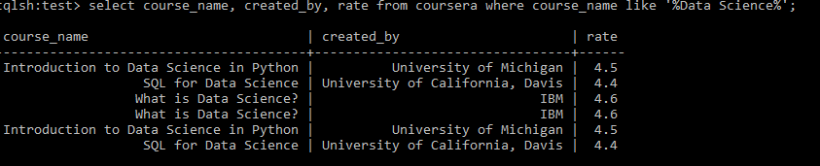

1. Find out if the course is offered by Johns Hopkins University

select course_name, created_by, thought_by , language from coursera where created_by = 'Johns Hopkins University’

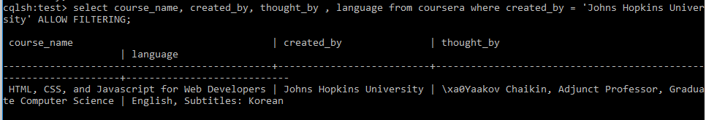

1. Find out level of difficulty for Java courses what is the criteria to pass that way user can decide which course to take

select course_name, basic_info, level ,how_to_pass from coursera where course_name like '%Java%' ALLOW FILTERING;

