Name: Trinadha Muppala

Class Id: 7

1. **Determine the domain and scope of the ontology.**

Domain of the ontology is What are the causes of the Parkinson’s Disease

Scope of this ontology will help in finding following like what are the treatments for PD, what helps to protect brain cells

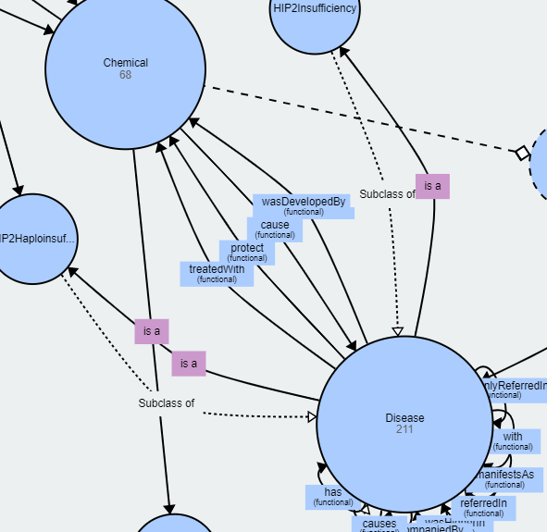

**What can protect Dopaminergic cells?**

Dopaminergic cell groups are collections of neurons in the central nervous system.

specific mitochondrial NCX inhibitors,protect,dopaminergic cells

NCX inhibitors,protect,dopaminergic cells

**How to PD patients treated ?**

PD patients,treated with,L-DOPA

1. **Consider reusing existing ontologies.**

Existing ontology <http://bioportal.bioontology.org/ontologies/PDON> used for reference

From the referenced ontology:

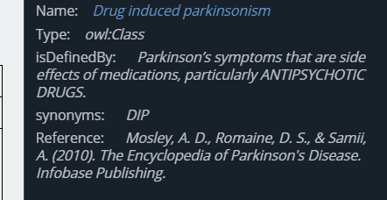

In the ontology I have built explains there are some experiments and some of the increased, removed, decreased chemicals, this information will help to identify more details of what kind of medicine got side effects

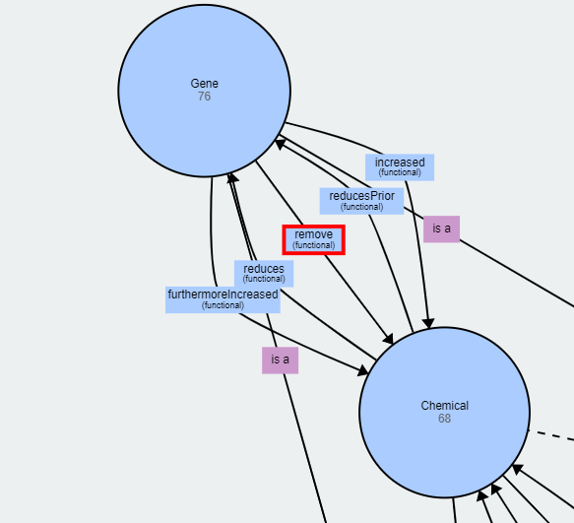

Details from the ontology:

enzyme GBA1,remove,terminal glucose

tributyltin,reduces,GluA2

1. **Enumerate important terms.**

My ontology is built based on medical terms . Identified important medical tems:

Disease,SpinalDeformity  
Chemical,Acetylcholine  
Disease,Thickness  
Disease,SpinalDeformity  
Chemical,Carbohydrate  
Disease,CholinergicSyndrome  
Disease,Neurotoxic  
Disease,ImpairmentAndDopaminergicNeuronalLoss  
Disease,NeurodegenerativeDisorder  
Disease,HIP2Insufficiency  
Gene,GBA1  
Chemical,FattyAcids  
Disease,AdhesiveCapsulitis  
Disease,Poisoning  
Disease,OrganotinParkinson'sDisease  
Disease,PainAndReductionOfMovement  
Chemical,Superoxide  
Disease,VisualHallucinations  
Disease,MentalDiseases

**4.Define the classes & class hierarchy**

Classes:

Disease  
Chemical  
Mutation  
Gene

All the medical words associated with the above class are subclasses:

Chemical,Superoxide  
Disease,VisualHallucinations  
Disease,MentalDiseases  
Chemical,Oxygen  
Chemical,Glucosylceramide  
Disease,HIP2Haploinsufficiency  
Disease,NeurologicDisorders  
Disease,CognitiveDecline  
Chemical,MDA  
Disease,ProdromalPD  
Disease,ImpingementSyndrome  
Chemical,Malondialdehyde  
Disease,LossOfDopaminergicNeurons  
Disease,PDSpinalDeformity  
Disease,IncreasedKyphosis  
Disease,Tremors  
Chemical,Calcium  
Chemical,Glucose  
Disease,Death  
Chemical,Glutathione  
Disease,Proteinopathy  
Disease,NeurodegenerativeDisease  
Gene,HIP2  
Disease,6-Bromo-N-prop-2-enylquinazolin-4-amineParkinson'sDisease  
Chemical,Tributyltin  
Chemical,Ceramide  
Mutation,Rs11343  
Disease,PisaSyndrome  
Disease,HumeroacromialImpingementSyndrome  
Disease,OrganoidsPD  
Disease,Dementias  
Mutation,Rs601999  
Chemical,Organophosphate  
Disease,AdhesiveCapsulitis  
Disease,SpinalDeformity  
Chemical,Apomorphine  
Disease,Cytotoxicity  
Disease,Small-vesselDisease  
Disease,NeuropsychiatricDisorder  
Disease,Parkinson'sProgression  
Disease,MultifactorialDisorder  
Disease,MobilityImpairments  
Gene,Alpha-synuclein  
Gene,HuntingtinInteractionProtein2  
Gene,SQSTM1  
Chemical,Glutamate  
Gene,GluA2  
Chemical,ThioflavinT  
Disease,NeuronalDeath  
Disease,PD

**5. Define the properties of classes.**

reducesPrior,Chemical,Gene,Func

remove,Gene,Chemical,Func

isIn,Disease,Disease,Func

wasHigherIn,Disease,Disease,Func

isAccompaniedBy,Disease,Disease,Func

remove,Gene,Chemical,Func

suddenlyReferredIn,Disease,Disease,Func

cause,Chemical,Disease,Func

protect,Disease,Chemical,Func

furthermoreIncreased,Gene,Chemical,Func

reduces,Chemical,Gene,Func

increased,Gene,Chemical,Func

remove,Gene,Chemical,Func

has,Disease,Disease,Func

with,Disease,Disease,Func

wasDevelopedBy,Disease,Chemical,Func

causes,Disease,Disease,Func

treatedWith,Disease,Chemical,Func

manifestsAs,Disease,Disease,Func

isIn,Disease,Disease,Func

causes,Disease,Disease,Func

referredIn,Disease,Disease,Func

manifestsAs,Disease,Disease,Func

**6. Define the facets of the slots.**

Not defined any data properties

**7. Create instances.**

Chemical,NigralDopamineNeurons  
Gene,Membrane-boundGBA2  
Gene,GBA2  
Disease,FeParkinson  
Gene,GlutamatergicSynapticFunction  
Chemical,GlutamatergicSynapticFunction  
Disease,DopaminergicCellDeath  
Chemical,DopaminergicCellDeath  
Disease,IncreasedCognitiveDecline  
Disease,20PDPatients  
Disease,NeurotoxicPollutants  
Gene,Cytosol-facingMembrane-boundGBA2  
Disease,NDementias  
Disease,CellDeath  
Disease,MostPDCases  
Disease,GaucherDiseaseInheritedDeficiency  
Gene,OligomericΑ-synuclein  
Disease,MediatedToxicity  
Disease,FamilialParkinson'sDisease  
Chemical,DopaminergicNeuronSusceptibility  
Disease,DopaminergicNeuronalCellDeath  
Chemical,DopaminergicNeuronalCellDeath  
Disease,PD-likeModels  
Chemical,DopaminergicNeurons  
Disease,Highly-correlatedPDInteractome  
Disease,IdiopathicPD  
Gene,IncreasedΑ-synuclein  
Disease,SpinalDeformityPatients  
Chemical,DopamineTransporterSinglePhotonEmission  
Disease,FivePD-relatedGenes  
Disease,PDRecoveryEfficiency  
Disease,UPDRSAxialScores  
Disease,KineticTremor  
Gene,SmallProteinΑ-synuclein  
Gene,Α-synucleinSeedsAggregation  
Disease,EarlyParkinsonianSymptomatology  
Gene,Syndromes  
Gene,Α-synuclein

**PART II :** **Characterize the triplets based on the following Rules**

1. **Inverse Of**

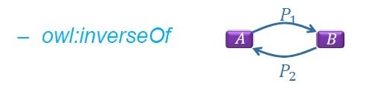

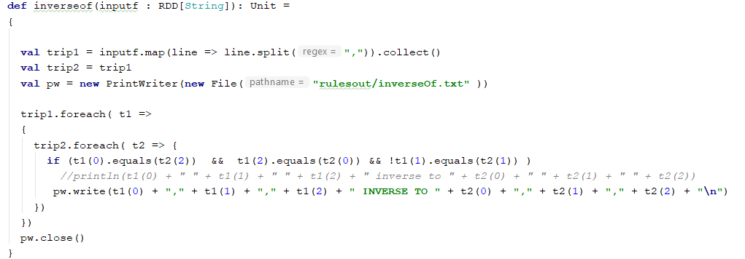

diseases,disease_'s,Parkinson **INVERSE TO** Parkinson,has,diseases  
patients,is_With,other disorders INVERSE TO other disorders,much_Smaller_Number_Of,patients  
patients,is_With,other disorders **INVERSE TO** other disorders,number_Of,patients  
patients,is_With,other disorders **INVERSE TO** other disorders,smaller_Number_Of,patients  
other disorders,much_Smaller_Number_Of,patients **INVERSE TO** patients,is_With,other disorders  
Parkinson,has,diseases **INVERSE TO** diseases,disease_'s,Parkinson  
other disorders,number_Of,patients INVERSE TO patients,is_With,other disorders  
other disorders,smaller_Number_Of,patients **INVERSE TO** patients,is_With,other disorders

1. **Symmetric Property**

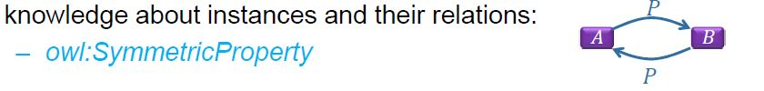

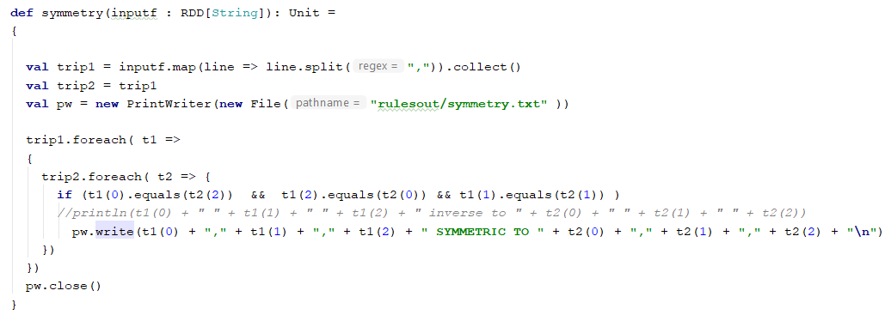

Parkinson 's disease,is,neurodegenerative disorder caused by dopamine production **SYMMETRIC TO** neurodegenerative disorder caused by dopamine production,is,Parkinson 's disease  
neurodegenerative disorder caused by dopamine production,is,Parkinson 's disease **SYMMETRIC TO** Parkinson 's disease,is,neurodegenerative disorder caused by dopamine production

1. **Transitive Property**

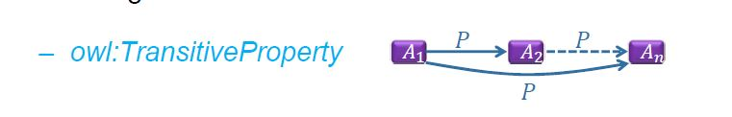

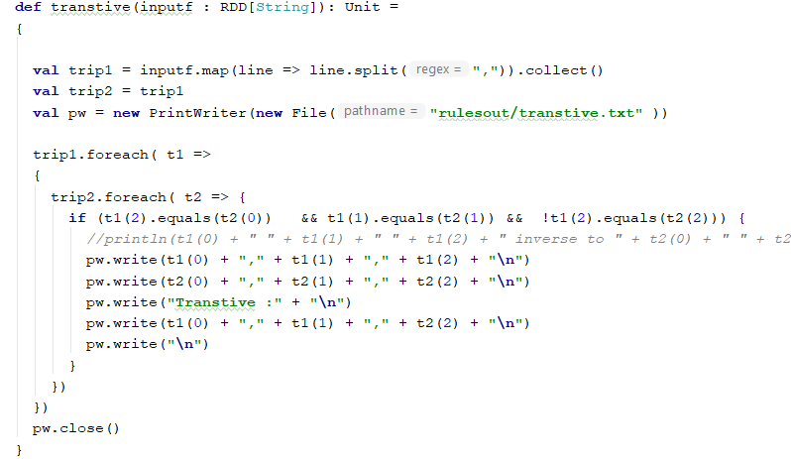

dopaminergic neurons,is_In,Parkinson 's disease  
Parkinson 's disease,is_In,man  
Transtive :  
dopaminergic neurons,is_In,man  
  
dopaminergic neurons,is_In,Parkinson 's disease  
Parkinson 's disease,is_In,diabetic patients  
Transtive :  
dopaminergic neurons,is_In,diabetic patients

neurodegenerative disorder caused by dopamine production,is,Parkinson 's disease  
Parkinson 's disease,is,disease characterized by degeneration of neurons  
Transtive :  
neurodegenerative disorder caused by dopamine production,is,disease characterized by degeneration of neurons

1. **Property Chain Axiom**

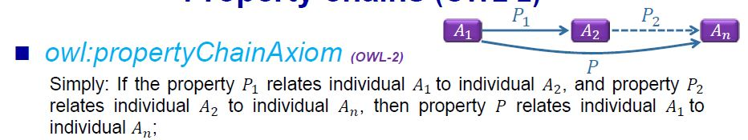

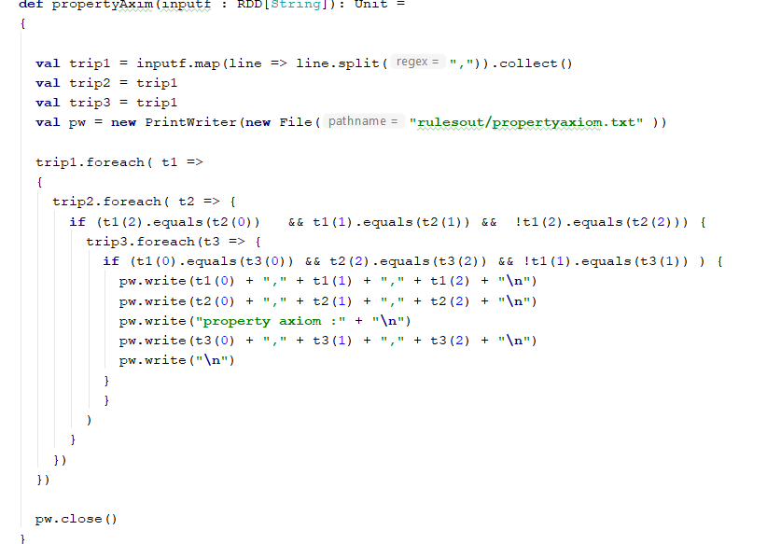

gait impairment,is_In,PD  
PD,is_In,Chinese population  
property axiom :  
gait impairment,observed in ,Chinese population

1. **Irreflexive Property**



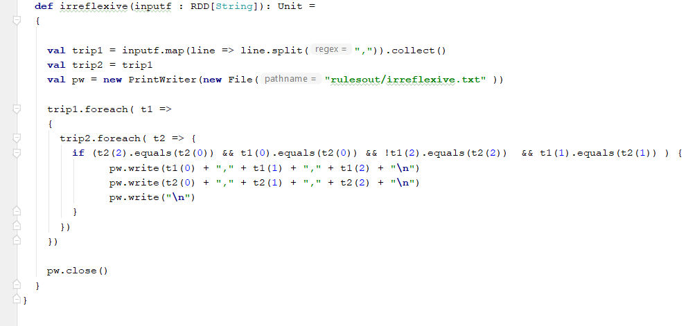

nicotine-induced tremor,is_In,mice  
nicotine-induced tremor,is_In,nicotine-induced tremor

**PART III :** **Record unique features noted from your ontology**

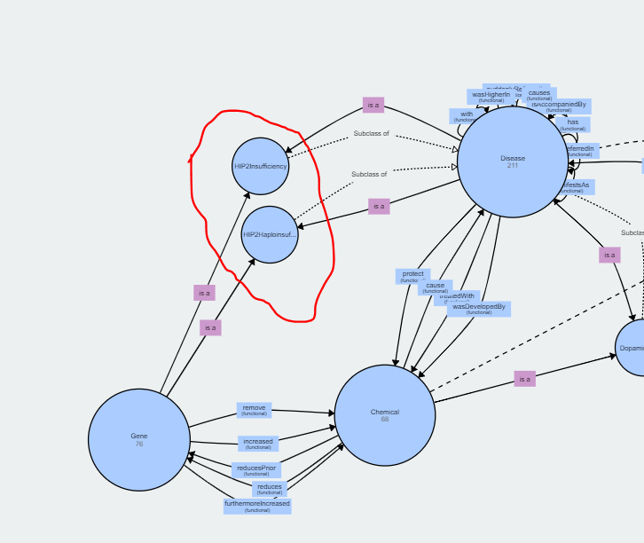

Observed HIP2 got some facts related to Parkinson’s Disease ,pulled all the triplets contains HIP2 as predicate.

Studies has been done on HIP2 for PD and observed HIP2 insufficiency factor for PD

our studies,therefore_Have_Indicated_HIP2_Insufficiency_As,factor for PD  
we,validated_HIP2_MRNA_In,PD patients  
we,finally_Observed_Blood_HIP2_MRNA_Levels_In,study  
our in studies,therefore_Have_Indicated_HIP2_Insufficiency_As,contributing factor for PD  
our in studies,have_Indicated_HIP2_Insufficiency_As,contributing factor for PD  
our studies,have_Indicated_HIP2_Insufficiency_As,factor  
we,observed_Blood_HIP2_MRNA_Levels_In,1-year 20-patient study  
we,validated_HIP2_MRNA_In,PD patients including de patients  
our studies,therefore_Have_Indicated_HIP2_Insufficiency_As,contributing factor for PD  
our studies,have_Indicated_HIP2_Insufficiency_As,contributing factor for PD  
we,finally_Observed_Blood_HIP2_MRNA_Levels_In,20-patient study  
we,observed_Blood_HIP2_MRNA_Levels_In,20-patient study  
our studies,have_Indicated_HIP2_Insufficiency_As,contributing factor  
our in studies,have_Indicated_HIP2_Insufficiency_As,factor for PD  
we,observed_Blood_HIP2_MRNA_Levels_In,1-year study  
our in studies,therefore_Have_Indicated_HIP2_Insufficiency_As,factor for PD  
we,observed_Blood_HIP2_MRNA_Levels_In,study  
we,finally_Observed_Blood_HIP2_MRNA_Levels_In,1-year 20-patient study  
our in studies,therefore_Have_Indicated_HIP2_Insufficiency_As,contributing factor  
we,finally_Observed_Blood_HIP2_MRNA_Levels_In,1-year study  
our studies,therefore_Have_Indicated_HIP2_Insufficiency_As,contributing factor  
we,validated_HIP2_MRNA_In,PD patients including patients