Name: Trinadha Raji Muppala

Class Id: 32

**Introductio**n: Multiclass text classification using CNN.

**Objectives:** Use Amazon baby products review data predict the overall rating using reviewText

**Approaches/Methods**:

1. Load data and label (reviewText, overall) from baby_review.zip

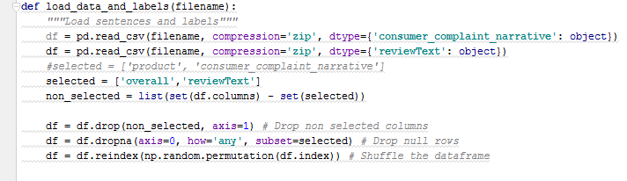

1. Define place holders, weight Bias

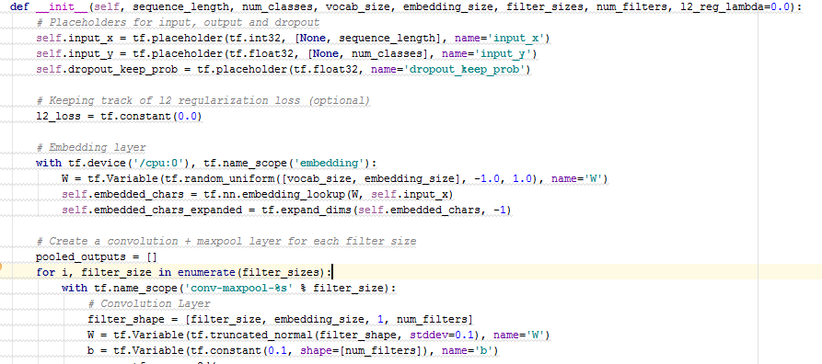

3.Define cnn with strides 1 , activation function ReLU , and maximum pool

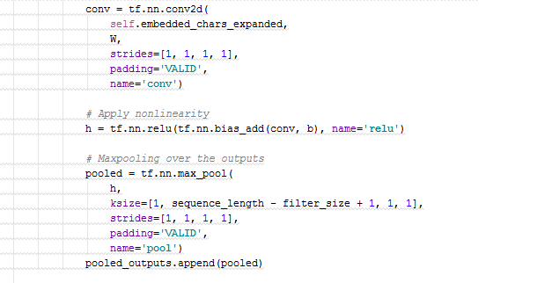

4.Define dropout

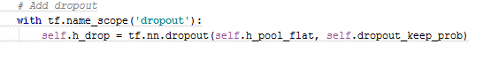

5. Define Gradient – reduce mean loss

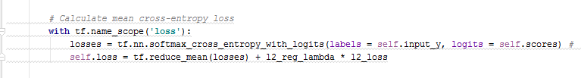

6. Train model

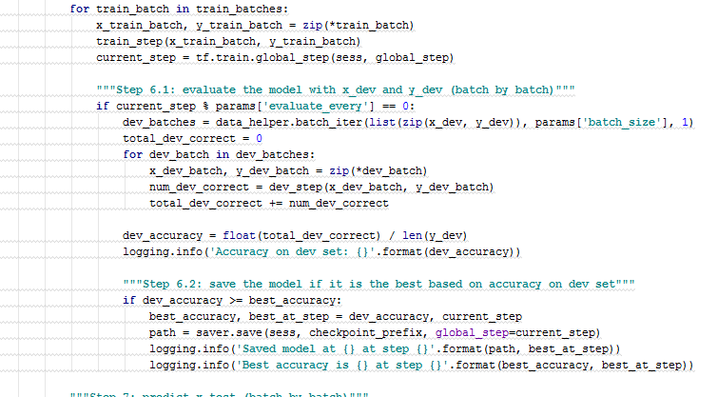

7. Test Mode

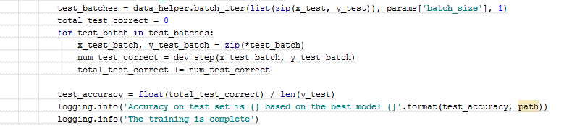

**WorkFlow:**

Define place holders, weight , strides, activation function, maxpooling

Divide data train test

Define Crossentorpy reduce loss

Read Data

Train CNN model for the epochs, with batch size and learning rate

Set hyper parameters (learning rate, batch size, epochs)

Find training and testing accuracy

**Data Sets: Amazon baby review data**

<https://www.kaggle.com/roopalik/amazon-baby-dataset/data>

**Parameters:**

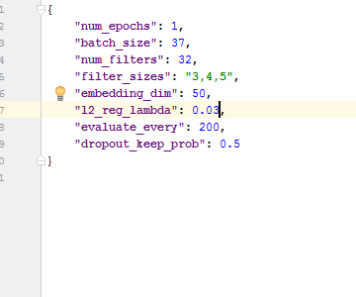

**Activation function** – ReLu , **Pooling** – Maximum pooling

**Evaluation and Discussion:**

Trained with learning rate with 0.01

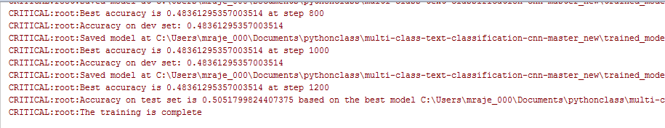

Learning rate 0.03

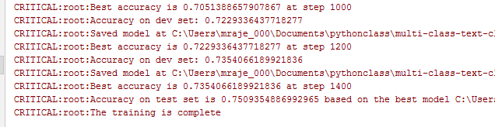

**Conclusion:**

Learning rate with 0.03 improved accuracy to 0.75

**TensorBoard:**

