**MECE 5397- Scientific Computing**

**Project A – Helmholtz Equation AHc2-5**

Rachel Murphy, 1351620

May 9th, 2018

Abstract

Math Model

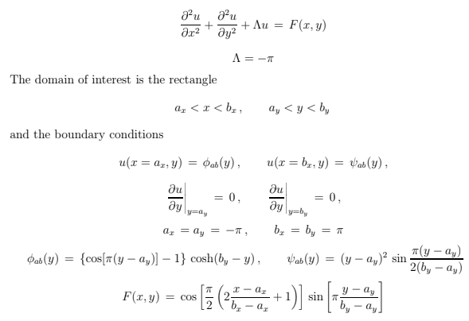

**Equation Discretization**

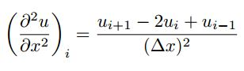

$$\frac{u_{i+1,j}-2u_{i,j}+u_{i-1,j}}{{∆x}^{2}}+\frac{u_{i,j+1}-2u_{i,j}+u_{i,j-1}}{{∆y}^{2}}+Λu_{i,j}=F_{i,j}$$

Assume: $∆x=∆y$

Rearrange and simplify this equation.

$$u_{i+1,j}+u_{i-1,j}+u_{i,j+1}+u_{i,j-1}-4*u_{i,j}+{∆x}^{2}Λu_{i,j}=F_{i,j}*{∆x}^{2}$$

$$u_{i,j}=\frac{u_{i+1,j}+u_{i-1,j}+u_{i,j+1}+u_{i,j-1}+{∆x}^{2}F_{i,j}}{4-{∆x}^{2}Λ}$$

For the Neumann Boundary condition, use the second order center difference approximation.

$\frac{u_{i,j}-u_{i-1,j}}{2∆x}=0$

to get $: u_{i,j}=u_{i-1,j}$

Description of Numerical Methods:

**Gauss-Seidel Method:**

The Gauss-Seidel method is a solution process for a given set of n linear equations. If given a set of 3x3 equations in the form of [A]{X}={B}, initial guesses for x can be made and then substituted back in after every iteration until….

In this project, all boundary conditions were defined, and then all internal nodes were initially set to 0 as an initial guess. After each iteration, an error formula is generated to compare the new value with the previous value. Once enough iterations are conducted, the error should be very small and the system has converged.

**Successive Over-Relaxation Method**

The SOR method is a modification of the Gauss Seidel method. This method uses the formula:



With lambda values between 1 and 2 in order to accelerate the convergence of the system.

**Technical Specifications of Computer Used**

The computer used is an Intel ® Xeon ® CPU E5620 @ 2.40GHz with 1 core/CPU and a current CPU clock frequency of 2394 MHz (max CPU clock frequency of 2660 MHz). The machine has 64 memory channels, a DRAM total width of 32 bits, and a total DRAM per CPU of 16384 MB.

* RAM - 8 GB
* Hard Drive - 500 GB
* Graphics Card - any with DisplayPort/HDMI or DVI support - desktop only
* Monitor – Dell OptiPlex widescreen LCD with DisplayPort/HDMI or DVI support

**Results:**

Gauss-Seidel

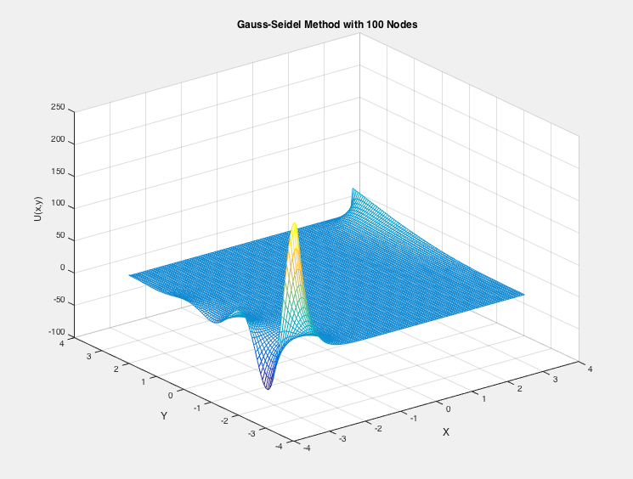

Figure -Surface Plot with Gauss-Seidel Method

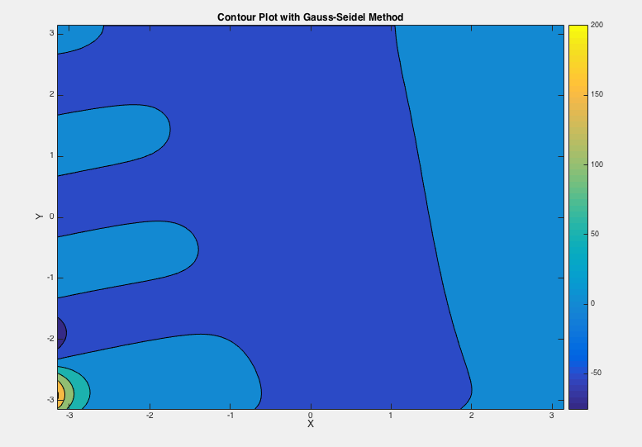

Figure -Contour Plot with Gauss-Seidel

Table 1: Performance results for Gauss-Seidel Method

|  |  |  |
| --- | --- | --- |
| Mesh size (N) | Number of Iterations | Run Time |
| 10 | 20 | 0.002211 |
| 50 | 100 | 0.082787 |
| 100 | 1000 | 0.315920 |
| 1000 | 10,000 | 2.568503 |

Successive Over Relaxation

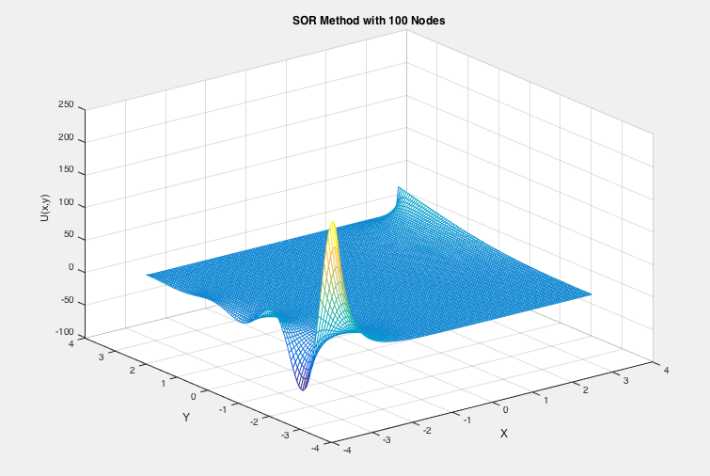

Figure -Surface Plot with SOR Method

Grid Convergence Study:

|  |  |  |  |
| --- | --- | --- | --- |
| Gauss-Seidel Method | | SOR Method | |
| Number of Nodes (N) | Result | Number of Nodes (N) | Result |
| 10 | 6.5396 | 10 | 6.5396 |
| 50 | 61.4732 | 50 | 61.4732 |
| 100 | 70.8272 | 100 |  |
| 1000 |  | 1000 |  |