Ryan Murphy

Homework 1

1. Fe_H:

Mean: -0.5419148936170213

Median: -0.55

Mode: -0.6

Standard Deviation: 0.11322617414930365

oRV:

Mean: -5.418421052631579

Median: -5.35

Mode: -5.2

Standard Deviation: 1.1253480574273982

PLX:

Mean: 0.08812499999999998

Median: 0.089

Mode: 0.089

Standard Deviation: 0.0055917669070569415

PM (RA):

Mean: -1097.0

Median: -1095.5

Mode: -1093.0

Standard Deviation: 8.342661445845684

Velocities:

Mean: -5.372790697674418

Median: -5.3

Mode: -5.2

Standard Deviation: 1.067237924964642

2. Fe_H is a measure of stellar metallicity relative to the Sun. It is defined by the logarithm of the ratio of a star's iron abundance minus that of the Sun. Iron content is used to define overall metallicity due to iron being relatively easy to measure with spectral data.

The radial velocity, or oRV, measures the rate of change of the distance between a star and an observer (Earth) measured in kilometers per second.

PLX is a measure of stellar parallax in arcseconds. Stellar parallax is the apparent shift in position of a star against a background of other distant objects, which can be used to calculate the distance of the star from Earth.

PM is a measure of stellar proper motion in milliarcseconds per year. Proper motion is the observed change in a star’s position as seen from the center of mass of the Solar System. This value, along with radial velocity and distance, allow for calculations of a star’s true motion with respect to the Sun.

Velocities is the radial velocity of a star calculated from the wavelength shift due to the Doppler Effect, measured in kilometers per second.

3. Fe_H Sample Variance: 0.012820166512488438

Fe_H Parent Variance: 0.012547397012222726

4.

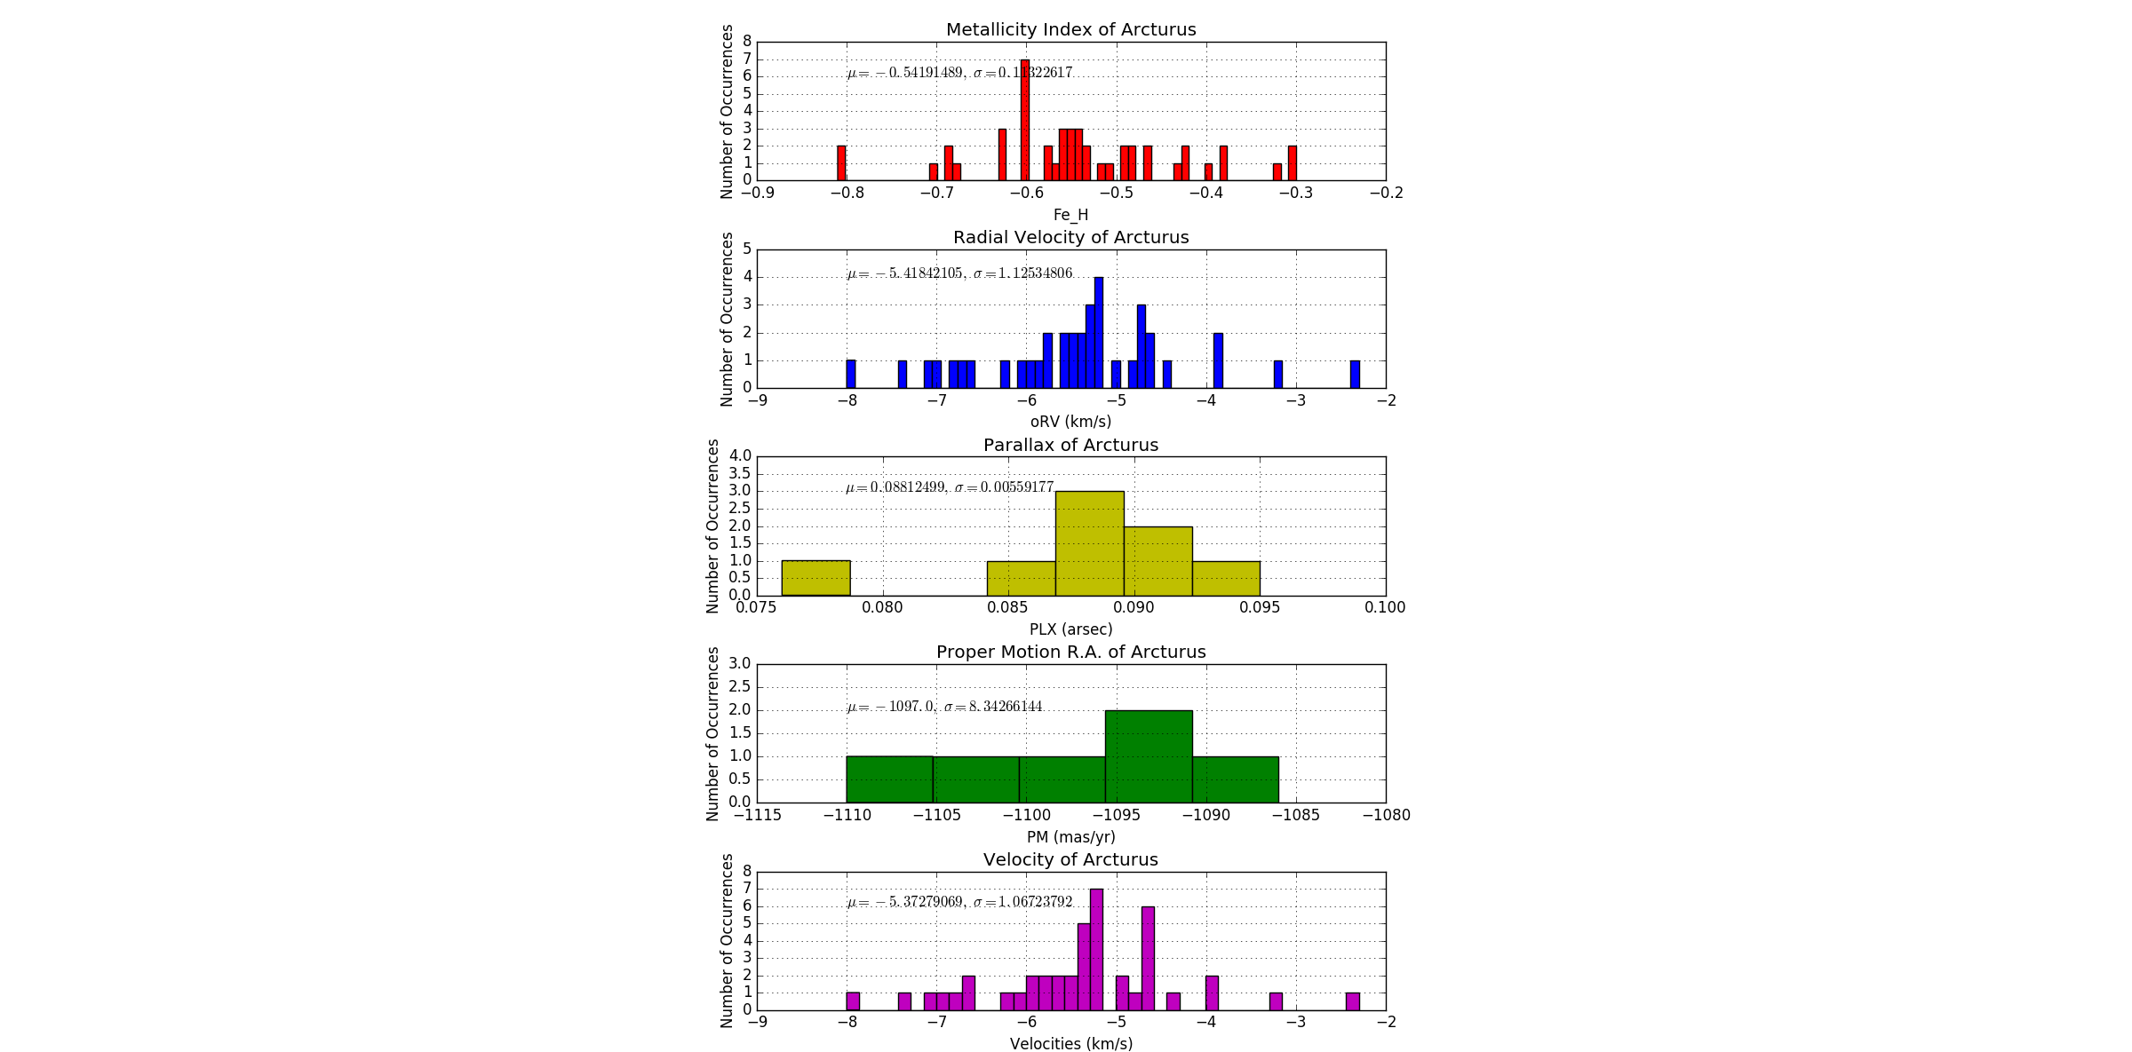

5.

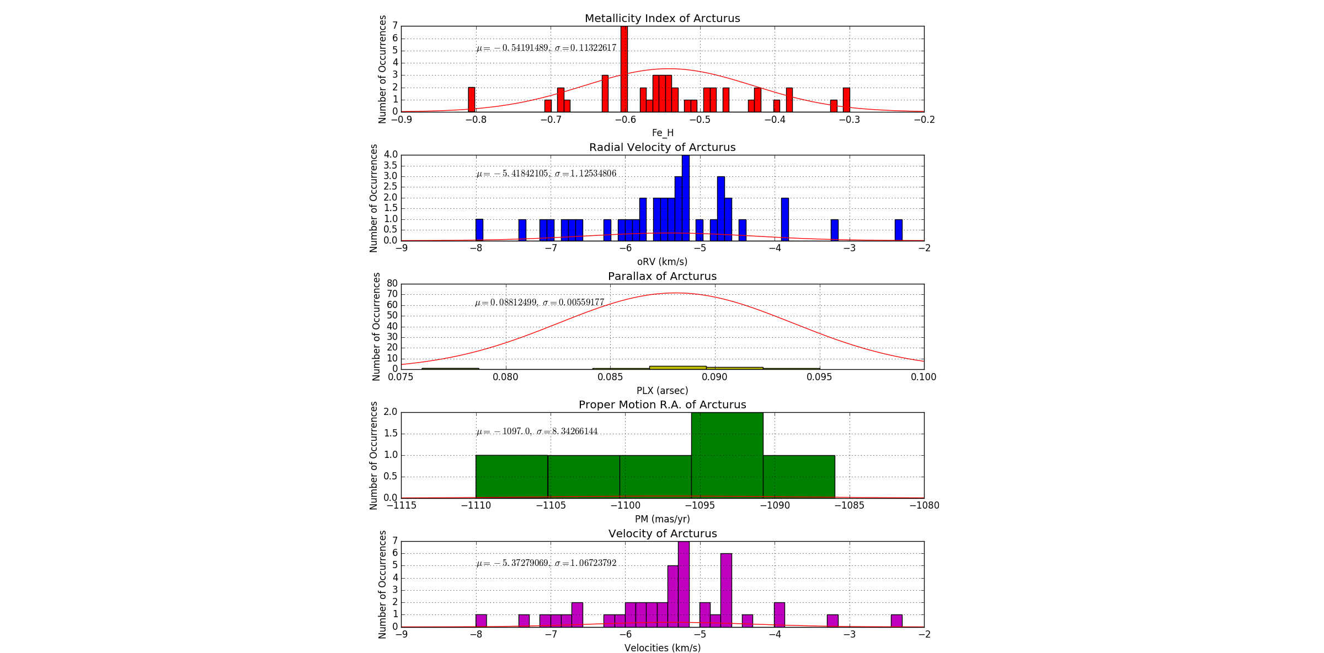

Each of the data sets seem to have a normal distribution, however the probability density function overlaid on some of the histograms are hard to see due to the large sigma values from the oRV, PM, and Velocities data. In the case of the PLX data, the small, but precise set of data gave an opposite effect to the generated Gaussian distribution function.

6. If it were the same person using the same equipment for each of the measurements, then systematic errors would be the main source of uncertainty. Inexperience and/or lack of awareness of proper instrumentation usage would potentially damage the accuracy of every single measured quantity. The opposite could also be true of an expert astronomer producing highly accurate results. Furthermore, due to propagation of errors, each quantity would be less and less accurate for every measured value used in its calculation.