|  |
| --- |
| *VENI App* |
| **Software Design Document** |
| **SE 6387 Advanced Software Engineering Project**  **R.Z. Wenkstern**    ***March 21, 2015*** |

|  |
| --- |
| **Group *X*** |
| **Brian MacKay** |
| **Anant Kambli** |
| **Raleigh Murráy** |
| **Shahed Shuman** |
| **Kathryn Whitmire** |

**Revision History**

|  |  |  |  |
| --- | --- | --- | --- |
| **Version** | **Date** | **Description** | **Authors** |
| 1.0 | 21-Mar-2015 | Create initial document | K.Whitmire |

Contents

Detailed Design Diagrams 4

White Box sequence diagram 4

Design Class Diagram 4

# Detailed Design Diagrams

## White Box sequence diagram

For primary use case CheckIn()

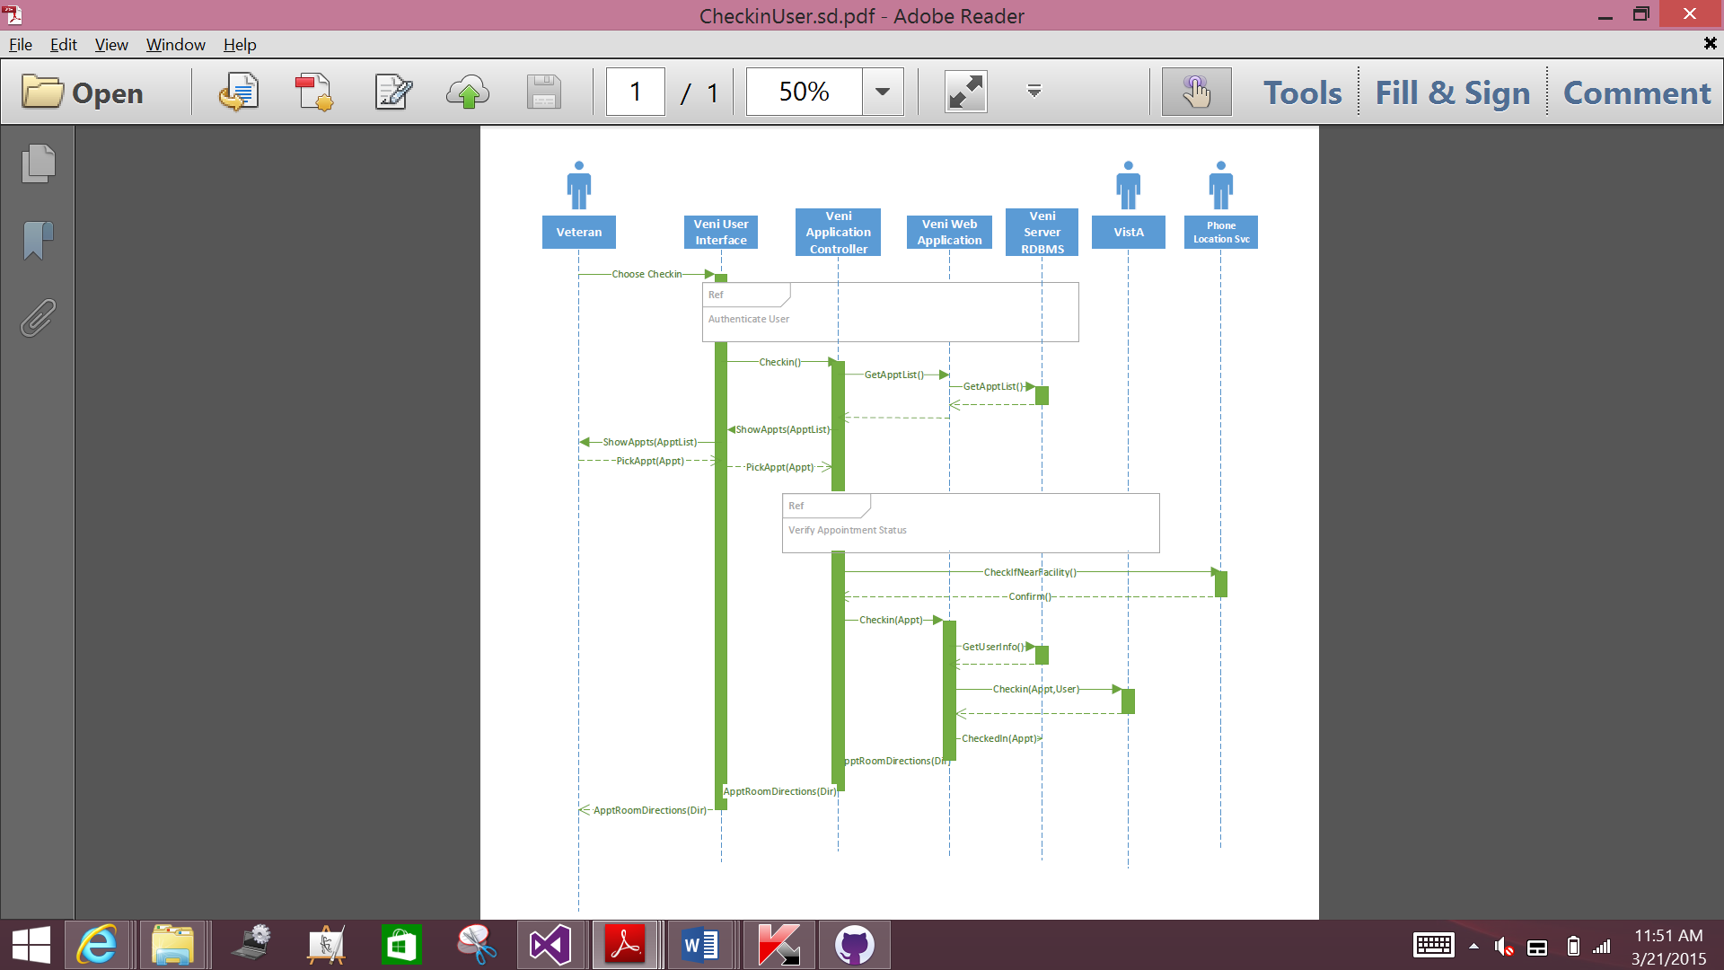

Figure 1

## Design Class Diagram

For primary use case CheckIn()

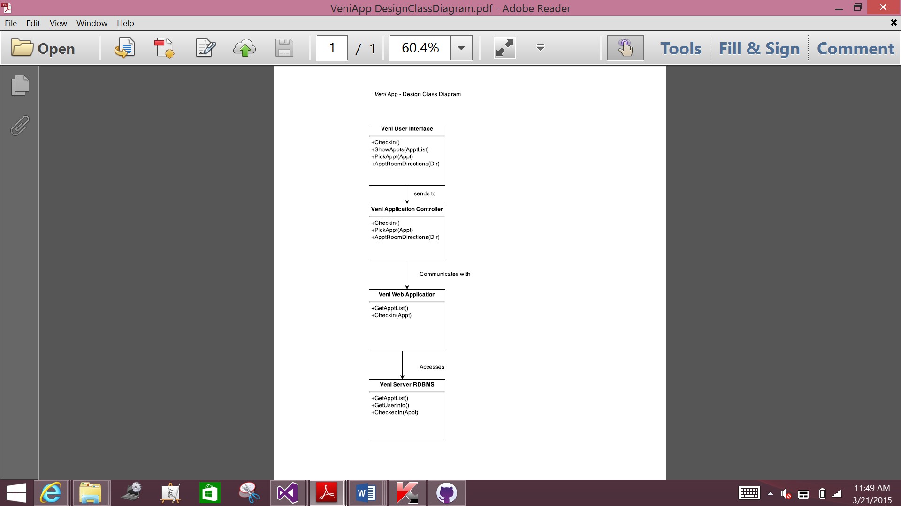

Figure 2