**Use Case Analysis Document**

**Version** 1.0

04 February 2015

***The Veni VA Checkin System***

Advanced Software Engineering Project

SE 6387.M01

*Anant Kambli*

*Brian MacKay*

*Raleigh Murráy*

*Shahed Shuman*

*Kathryn Whitmire*

# Change Log

|  |  |  |  |
| --- | --- | --- | --- |
| Date | Version | Changed By | Description |
| 4-Feb-2015 | 1.0 | BM | Initial Release |
| 21-Mar-2015 | 1.1 | KW | Addition of sequence diagrams |
|  |  |  |  |

Table of Use Cases

Contents

Change Log 2

Use Case Diagram 4

Use Case: Maintain Administrative Information 5

Use Case: First Run Experience 6

Use Case: Download Appointment 7

Use Case: Get Directions to Facility 8

Use Case: Verify Appointment Status 9

Use Case: Check-in at VA Facility 10

Use Case: Transfer to Phone Calendar 12

Use Case: Authenticate User 13

# Use Case Diagram

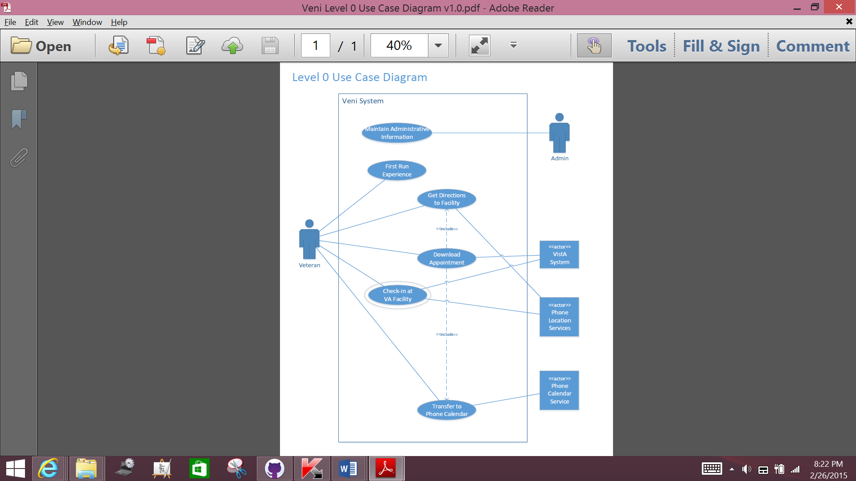

|  |
| --- |
| Use Case: Maintain Administrative Information |
| ID: 1 |
| Brief Description: This use case describes the administrative tasks in the Veni System |
| Primary Actors: Administrative users |
| Secondary Actors: None |
| Preconditions: The system is setup and connected to a VistA system or a system that emulates VistA |
| Main Flow: Administrators are responsible for setting up and maintaining:   1. The list of VistA systems available and the mechanisms for communicating with them 2. The list of VHA facilities available to Veni system users 3. The mapping of VHA facilities to VistA systems |
| Post Conditions:  1. With the lists of the VistA systems and VHA facilities all set up, and the mapping between them, the Veni System is capable of servicing veterans |
| Alternative Flows: |

|  |
| --- |
| Use Case: First Run Experience |
| ID: 2 |
| Brief Description: After the user has downloaded the Veni App to his phone, he/she will need to identify himself to the Veni system, enter personal and healthcare information and establish a Veni account |
| Primary Actors: A veteran |
| Secondary Actors: None |
| Preconditions: The veteran has downloaded the Veni App to his/her phone |
| Main Flow:  1. The veteran starts the Veni App on his/her phone the first time 2. The Veni App asks for personal information 3. The Veni App establishes the veteran’s credentials 4. The Veni App asks for information about which VA health care facilities the veteran frequents |
| Post Conditions:  1. The veteran has a Veni account 2. The Veni server has the information needed to contact the VistA system on the veteran’s behalf, associated with the veteran’s account |
| Alternative Flows: |

|  |
| --- |
| Use Case: Download Appointment |
| ID: 3 |
| Brief Description: After a veteran has made an appointment, he/she will be able to download the appointment into his/her Veni appointment list. This is a precondition to being able to check-in for the appointment at the VA facility |
| Notes:  * The creation of an appointment by the veteran with a VA facility is out of scope for this project. It may be included at some time in the future. * In addition, when the Veni app creates a calendar appointment, it is a “send and forget” operation. The calendar appointment cannot be edited or deleted from within the Veni app. |
| Primary Actors:  * Veteran |
| Secondary Actors: A VistA system |
| Preconditions:  1. The veteran has downloaded the Veni app to his phone and run the “First Run” experience (see “First Run Experience” (2)) 2. The veteran has made an appointment with one of his/her chosen VA facilities (out of scope) |
| Main Flow:  1. The veteran authenticates to the application    * INCLUDE [Authenticate User] (8) 2. The veteran chooses the “Download Appointment” in the Veni phone app 3. The phone app communicates with the Veni server system. 4. The Veni server system looks up which VistA system owns the appointment and downloads the appointment information from the appropriate VistA system 5. The Veni server system transfers the appointment information to the Veni phone application 6. The appointment information is shown to the veteran 7. The veteran if offered a chance to transfer the appointment to his/her phone’s calendar. If the veteran agrees, the appointment is handed off to the phone’s calendar.    * INCLUDE [Transfer to Phone Calendar] (7) 8. The veteran is offered an option to get directions to the appointment    * INCLUDE [Get Directions to Facility] (4) |
| Post Conditions:  1. The Veni system server and the Veni phone app both know about the upcoming appointment 2. The appointment appears in the Veni app’s “appointment list” |
| Alternative Flows: None |

|  |
| --- |
| Use Case: Get Directions to Facility |
| ID: 4 |
| Brief Description: The system will provide the ability for a veteran to obtain directions from his current position to the VA facility associated with any of his/her upcoming appointments or any facility he has set up. Once the veteran has set up an appointment, or any time in the future, the veteran can choose to “Get Directions”. The Veni phone app will pass the location to the phone’s mapping app so that directions to the appointment can be generated |
| Note: This Use Case is both a “stand-alone” case and a “included” case |
| Primary Actors: Veterans |
| Secondary Actors: The location/mapping services on the veteran’s phone |
| Preconditions:  1. The system has been setup (see “Maintain Administrative Information” (1)) 2. The veteran has downloaded the Veni App and run the initial setup (see “First Run Experience” (2)) 3. The veteran has configured a mapping/directions application on his phone (out of scope) |
| Main Flow:  1. If the veteran has not already authenticated (for example, if this is a stand-alone use case and not included in another case):    * INCLUDE [Authenticate User] (2) 2. The veteran chooses the “Get Directions to Appointment” option in the Veni phone app 3. If the user is getting directions for a previously created appointment, the system will verify the status of this appointment (and all other appointments in the Veni “appointment list”)    * INCLUDE [Verify Appointment Status] (5) 4. The veteran chooses one of his/her upcoming appointments, or one of his/her configured VA facilities from the list shown (or, if this is an included use case, this information will already be known by the app) 5. The veteran invokes the “Get Directions” command 6. The app fetches the location information from the Veni System Server 7. The app passes the information to the phone’s location services with a request to provide locations from the veteran’s location to the chosen VHA facility 8. The phone’s configured location and directions application provides the user with directions (out of scope for this project) |
| Post Conditions:  * The phone’s mapping app has started and control has shifted from the Veni app to the mapping app. |
| Alternative Flows: |

|  |
| --- |
| Use Case: Verify Appointment Status |
| ID: 5 |
| Brief Description: The Veni system relies on information in VistA systems. It will not be notified should the information upon which it relies changes in the VistA system from which the information originated. As a result, each time the Veni system looks at appointment information, it needs to check with the appropriate VistA system to make sure the information has not changed. If changes occur, the veteran will be notified. |
| Note: This use case is “include only”. |
| Primary Actors:  * Veteran * VistA system |
| Secondary Actors: None |
| Preconditions:  1. The veteran has downloaded the Veni app to his phone and run the “First Run” experience (see “First Run Experience” (2)) 2. The veteran has made at least one appointment with one of his/her chosen VA facilities (out of scope) |
| Main Flow:  1. When this is invoked, the Veni system will query the VistA system (or systems) for all appointments associated with the user 2. If new appointments exist, the user will be presented with the option to download the appointment    * INCLUDE [Download Appointment] (3) 3. If an appointment has been changed (for example its time or location) the Veni system will change the appointment and notify the veteran through the Veni phone application 4. If an appointment has been deleted, the Veni system will remove the appointment from the veteran’s Veni “appointment list” and notify him/her |
| Post Conditions: The Veni system and the VistA systems will be in sync for that particular veteran |
| Alternative Flows: None |

| Use Case: Check-in at VA Facility |
| --- |
| ID: 6 |
| Brief Description: When veteran arrives at a VA facility for an appointment setup within the Veni system, he/she will be able to check in for his appointment at the facility. The Veni app will use the phone’s location services to check that the veteran is at (or very near) the facility. |
| Note: This is the primary use case for this system |
| Primary Actors:  * Veteran |
| Secondary Actors:  * A VistA System * Location Services on Veteran’s phone |
| Preconditions:  1. The veteran has downloaded the Veni app to his phone and run the “First Run” experience (see “First Run Experience” (2)) 2. The veteran’s appointment exists 3. The veteran has downloaded the appointment to the Veni system |
| Main Flow:  1. The veteran starts the Veni phone app and authenticates to the application    * INCLUDE [Authenticate User] (8) 2. The veteran chooses the Check-in option within the Veni app. He/she is presented with a list of upcoming appointments previously downloaded to the Veni system 3. The veteran chooses the appointment he/she wishes to check in to. The system will verify the appointment exists    * INCLUDE [Verify Appointment Status] (5) 4. The Veni app contacts the phone’s location services to obtain the veteran’s location 5. The Veni app compares the veteran’s location with the location of the appointment 6. If the veteran is at or very near the location of his appointment,    * The Veni phone app notifies the Veni System Server    * The Veni System Server contacts the VistA system to check the Veteran in to his/her appointment    * The veteran is notified that he/she is checked in 7. If the Veni System is configured to include “within the facility” location information, a textual description of the directions the veteran should follow to get to the exact location of the appointment is displayed in the Veni app |
| Post Conditions:  * The veteran’s status within the VistA system is “checked in” * The veteran has a textual description of how to get to his/her appointment (within the facility) |
| Alternative Flows:  * If the veteran is not at or very near the location of his/her appointment, the application notifies the veteran that he/she must be present at the appointment’s location before check-in can happen * If the check-in operation fails, the veteran is notified and told to check-in manually |

|  |
| --- |
| Use Case: Transfer to Phone Calendar |
| ID: 7 |
| Brief Description: When a veteran downloads an appointment to the Veni app on the phone (see “Download Appointment” (3)), he/she is given the option to create a calendar entry on the phone. In addition, the veteran can create a calendar entry from any previously downloaded appointment within the Veni app at any time.  The veteran is also give a choice to create other calendar entries related to the appointment. For example he/she could create an entry the night before with a reminder to start fasting before the next day’s appointment |
| Notes:  * This is normally invoked as an “included” use case. It’s possible to run it alone * There is no link between the Veni app and calendar item it creates on the phone. Once the calendar item is created, it must be maintained within the calendar application |
| Primary Actors: Veteran |
| Secondary Actors: Calendar Services on the Veteran’s Phone |
| Preconditions:  1. The veteran has downloaded the Veni app to his phone and run the “First Run” experience (see “First Run Experience” (2)) 2. The veteran has made an appointment with one of his/her chosen VA facilities (out of scope) 3. The veteran has at least one downloaded appointment available within the Veni app |
| Main Flow:  1. If the Veni phone app is not already open, the veteran opens the application and authenticates to it    * INCLUDE [Authenticate User] (8)) 2. The veteran chooses the Create Calendar Entry command within the Veni app 3. The veteran chooses which previously appointment to associate with the calendar entry 4. The veteran confirms his/her choices 5. The Veni app contacts the phone’s calendar services and the appointment is created 6. The veteran is offered the choice to create other, related calendar appointments (for example to remind him/her about fasting requirements). These are created in a similar fashion |
| Post Conditions:  1. One or more calendar entries are created on the veteran’s phone |
| Alternative Flows: |

|  |
| --- |
| Use Case: Authenticate User |
| ID: 8 |
| Brief Description: The user presents his/her credentials to the Veni App, which are forwarded to the Veni System Server. Once verified, a user’s session can start. |
| Note: This is an “Included” –only use case. |
| Primary Actors: Veterans |
| Secondary Actors: None |
| Preconditions:  1. The system has been setup (see “Maintain Administrative Information” (1)) 2. The veteran has downloaded the Veni App and run the initial setup (see “First Run Experience” (2)) |
| Main Flow:  1. The Veni App will provide a standard UI to which the user will provide his credentials 2. The user will provide his credentials 3. The Veni App will transfer the credentials to the Veni Server 4. The server will validate the credentials, fetch the user’s information (including his/her identifying tokens to the VistA system), creating the user’s session 5. The server will send session initiation information to the Veni app. |
| Post Conditions: The veteran is authenticated, the Veni System Server has created a session for him that includes the information needed to communicate to the VistA system on his/her behalf |
| Alternative Flows:  1. If the veteran does not provide credentials within a reasonable time, the Veni App will transfer to a “Welcome” screen, requiring a new authentication effort from the user 2. The system does not include account lockout, but repeated authentication failures will result in longer wait times between authentication attempts – an “anti-hammer” rather than lock-out strategy |

# Black box diagrams

Figures

