|  |
| --- |
| *The Veni App A Checkin Tool for the VA* |
| **Vision Document** |
| **SE 6387 Advanced Software Engineering Project**  **Dr. R.Z. Wenkstern**    ***December 16, 2014*** |

|  |
| --- |
| **Group *X*** |
| **Brian MacKay** |
| **Anant Kambli** |
| **Raleigh Murráy** |
| **Shahed Shuman** |
| **Kathryn Whitmire** |

# 

# Revision History

|  |  |  |  |
| --- | --- | --- | --- |
| **Version** | **Date** | **Description** | **Authors** |
| 1.0 | 16-Dec-2014 | Completed initial draft | Group |

**Contents**

Revision History

1. Introduction

2. Positioning

2.1. Business Opportunity

2.2. Problem Statement

2.3. Product Position Statement

2.4. Alternatives and Competition

3. User Description

3.1 User/Market Demographics

3.2 User Profiles

3.3 Key User Needs

3.4 User Environment

4. Product Overview

4.1 Product Perspective

4.2 Summary of Capabilities and benefits

4.3 Assumptions and Dependencies

4.4 Cost and Pricing

4.5 Licensing and Installation

5. Other Requirements and Constraints

Appendix A: Glossary

Appendix B: References

# 1. Introduction

*Veni, Vidi, Affui. I came, I saw, I arrived.*

The Veterans Administration Health System -- colloquially, “The VA” -- has been in the news in the past year about the issues it has had in getting its customers, the nation’s veterans, properly set up for receiving the health care they deserve. This system, “*Veni*” seeks to address one aspect of that problem - the registration of patients when they arrive at a health care facility.

The system will combine a smartphone application and a cloud-hosted, server component that will allow veterans to easily check-in at VA medical facilities.

The purpose of this document is to collect, analyze, and define high-level needs and potential features of this mobile medical check-in application. This document focuses on the capabilities needed by the targeted users and other stakeholders. It will also describe the rationale for the creation of this application. The following details explore how the *Veni* application addresses these unique needs while using an open-source, cost effective development and deployment stack.

# 2. Positioning

Throughout the VA medical system, veterans and their families can spend hours waiting in line to check in for their appointments. Once checked-in at the reception, they can wait again after arriving at the appropriate doctor’s office or clinic. Mistakes as a result of mis-transcribed appointment information can compound the problem.

The *Veni* App is intended as a lightweight solution to help address the veteran checkin problem and to make the veteran experience simpler. For the veteran, not only will the app streamline the checkin experience, it will also provide a way to track appointments and get driving instructions to the facility.

For the VA, the system offers a simple lightweight solution that will free administrative staff from the checkin process. With a simplified, veteran-focused, checkin experience, the reception area can be rededicated to offer services other than simple registration.

With the country winding down from more than 10 years of war, the veteran population has become much younger and much more technically adept. Not every veteran will want to use a smartphone application to interact with VA medical facilities, but with a clientele that numbers in the millions, the number of potential users is very large.

## 2.1. Business Opportunity

The scale of the Veterans Health Administration is breath-taking. It provides health benefits to millions of veterans and their families, administers approximately 1300 health care facilities and operates on a budget measured in the tens of billions of dollars. Doing a small system for the VA results in a very large-scale system.

At the core of the VA’s IT systems is an electronic health record system called the VistA Computerized Health Record System (CPRS). VistA is built on decades old technology. The result is a distributed system without a central datastore. Instead, a constellation of 130 VistA separate systems, distributed geographically, provide CPRS services to VA facilities. Each VistA instance is tied to one, or a small number of hospitals in a region as well as their local satellite facilities. The records for a single patient may be spread across several VistaA systems.

The *Veni* app will be architected with this in mind, blurring this constellation of systems into single whole for its users.

The business opportunity for *Veni* is focused on providing the VA with a simple, veteran-focussed smartphone application that increases customer satisfaction and reduces the VA’s administrative costs. The VA encourages vendors to add value to VistA in a demonstration program. Successful vendors end up with government contracts.

## 2.2. Problem Statement

This is a simple, single-focus application. It is meant to streamline the checkin process for veterans who install the application on their smartphones. Doing so allows the veterans to skip the first step in the process of visiting a VA health facility, the registration and checkin process. Instead, veterans will do a “self-service” checkin using their smartphones.

The application will provide a few other minor services related to a VA health facility appointment:

* Appointment reminders
* Driving directions to the facility

## 2.3. Product Position Statement

This is a simple, light-weight, low-cost, veteran focused solution aimed at simplifying the veteran’s experience at VA health care facilities.

Veterans deserve the health care they’ve earned. They don’t need to be standing in lines from the moment they arrive at the VA.

## 2.4. Alternatives and Competition

The Veterans Health Administration is a large government bureaucracy. They maintain complex, large-scale IT systems. However, they also provide a way for private industry - government contractors - to add value to their systems. A system vendor can create an application that interacts with the VA’s systems and sell it to the VA.

One such system is a kiosk system currently used at some VA health facilities. It is sold to the facility as a turn-key add-on to the local VistA system. Based on a touch-screen, It resembles an airline checkin kiosk and allows veterans to checkin for their appointment by swiping their VA health identification card (<http://www.va.gov/healthbenefits/vhic/index.asp>). Currently, there are three forms of kiosk devices: free-standing, desktop, and wall-mounted. Even though this check-in facility is available, veterans still need to stand in a queue, and it will not help prevent long wait times. The *Veni* application unbolts the kiosk from the wall and puts it in the veteran’s pocket.

VetLink is another service offered by the Veterans Point of Service program. It is targeted at VA administrative staff. VetLink helps staff streamline patient flow and branch operations. It also allows system administrators to track usage, update content and software, and receive alerts about any technical issues. The *Veni* app will reduce the workload for the staff involved in the check-in process, thereby freeing them to work other tasks.

# 3. User Description

The users of the system will be veterans who want to walk in and check in without worrying about long wait times. The veteran population is becoming more tech-savvy, so we provide a more technological and convenient method than current set up

## 3.1 User/Market Demographics

The key people who will benefit from this app will be the VA patients who need to check in for appointments and the VA hospital staff who will be able to take care of other tasks besides checking in patients themselves or servicing kiosks.

## 3.2 User Profiles

The primary users of this app will be VA patients ages 18 and up and their dependents.

## 3.3 Key User Needs

This app addresses three key user needs:

* Reducing checkin time upon arrival at a VA health facility
* Providing appointment reminders on the user’s smartphone
* Getting driving directions to the VA facility

## 3.4 User Environment

*Veni* users will interact with the system much like any other smartphone app. It will be touchscreen based and require an internet connection to work.

The smartphone app will communicate with a back-end, cloud-hosted server component. This server application will interact with the VistA instance which maintains the veteran’s appointment. It will maintain a mapping of VA facilities to VistA instances, hiding these complexities from users.

Like any smartphone application, users will be able to interact with *Veni* at their convenience. In particular, the application will require users to download their appointment before the appointment, and then checkin with the application as they arrive at the VA facility. The application will use the phone’s location services to make sure that the user is at the VA site before allowing the user to checkin.

The system will be designed so that the amount of protected user data (protected health information (PHI) and personally identifiable information (PII)) kept on the phone and on the server host is minimized. All communication will be encrypted. The application will protected the PHI and PII stored in the system in a manner that complies with the applicable data protection standards.

# 4. Product Overview

The main component of this system will be a smartphone application. The application will be created in a way that makes it portable to multiple smartphone operating systems, but during the prototype development, this will likely be restricted to a single platform.

The smartphone application will connect to a *Gateway* server. The server will run a J2EE instance within a Linux virtual machine and will be hosted in a commercial cloud vendor’s infrastructure. The smartphone application will communicate with the gateway server using a simple JSON + REST interface. The gateway gets its name because it will act as a gateway to the various Veterans Administration VistA systems that will own the data the smartphone app interacts with.

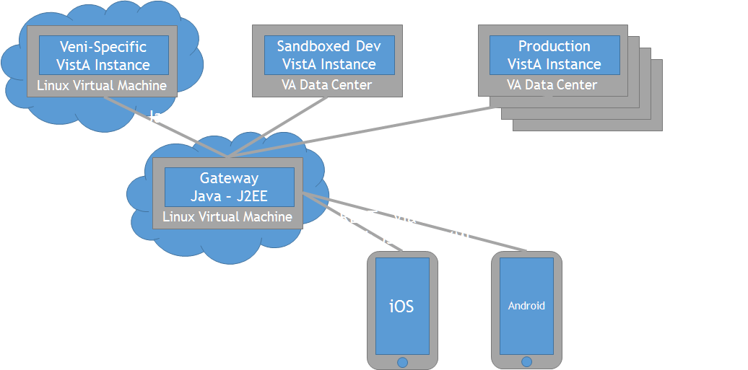

**4.1 Product Perspective**

The drawing above describes the interactions that the *Veni* application will have during its development lifecycle. In the lower right are the smartphone applications. Though the prototype will target one of either Android or iOS, the eventual system will work on both those platforms, and perhaps Windows Phone as well.

In the center is the *Gateway*. It acts as a data forwarder between the user operating the application on his smartphone and one or many VA VistA systems. It will run in the J2EE server, running on Linux within a cloud-hosted virtual machine. It will be designed to *scale-out*; to achieve scale by having multiple gateway instances running in parallel.

During development, the gateway system will interact with a cloud-hosted *Veni*-specific VistA instance. Once we are able to demonstrate the application’s capabilities, we expect to be able to interact with a Veterans Administration-hosted “sandbox” VistA system. The VA hosts these systems to allow its partners to test their software.

Should the VA agree to purchase the system, the gateway will communicate with the many VA VistA systems that make up the Veterans Health Administration's CPRS system. At this point, mulitple gateway systems will exist in a “scale-out” configuration.

## 4.2 Summary of Capabilities and benefits

|  |  |
| --- | --- |
| **Feature** | **User Benefit** |
| Check-in to VA hospital/clinic | *Veni* app allows veterans to check-in for an appointment directly without waiting in lines. |
| Download the VA appointment | *Veni* app provides appointment details to veterans. |
| VA Appointment Reminder | *Veni* app sends reminder to veteran when next appointment scheduled. |
| Directions to Doctor’s office | *Veni* app provides directions to veterans to Doctor’s office |

## 4.3 Assumptions and Dependencies

The primary assumption in this project will be determining if the VA firewall will permit app access to VA information. The project also assumes phone compatibility will not be a problem. The VA firewall issue is the most important issue because the app depends on being able to talk to the VistA system.

## 4.4 Cost and Pricing

We are using as many free tools as possible, so the end price will be based on the time and effort of the individuals involved.

Once the system is developed, an effort will be made to enroll it in the VA’s vendor demonstration program. If successful, the next step would be to sell it to the VA.

## 4.5 Licensing and Installation

The security of PHI and PII is extremely important, so it is intended that the app will be closed every time the phone is locked. Upon opening the app, it will require the user to login every time – it will not be left open.

# 5. Other Requirements and Constraints

Our goals with this app are:

* to reduce appointment wait time by 50%
* to finish by April 3rd 2015.

The constraints involved are:

* accomplishing this project with a 5 person team
* gaining the cooperation of the VA for data access.

# Appendix A: Glossary

|  |  |
| --- | --- |
| **Term** | **Definition** |
| PHI | Protected Health Information |
| PII | Personally identifiable information |
|  |  |
|  |  |
|  |  |
|  |  |
|  |  |
|  |  |
|  |  |

# Appendix B: References