|  |
| --- |
| *VENI App* |
| **Vision Document** |
| **SE 6387 Advanced Software Engineering Project**  **R.Z. Wenkstern**    ***February 5, 2015*** |

|  |
| --- |
| **Group *X*** |
| **Brian MacKay** |
| **Anant Kambli** |
| **Raleigh Murráy** |
| **Shahed Shuman** |
| **Kathryn Whitmire** |

# Revision History

|  |  |  |  |
| --- | --- | --- | --- |
| **Version** | **Date** | **Description** | **Authors** |
| 1.0 | 16-Dec-2014 | Completed initial draft | Group |
| 2.0 | 05-Feb-2015 | Updated BLAH | Group |

Contents

Revision History 2

1. Introduction 4

2. Positioning 4

2.1. Business Opportunity 5

2.2. Problem Statement 5

2.3. Product Position Statement 5

2.4. Alternatives and Competition 6

3. User Description 7

3.1 User/Market Demographics 7

3.2 User Profiles 7

3.3 Key User Needs 7

3.4 User Environment 7

4. Product Overview 8

4.2 Summary of Capabilities and benefits 9

4.3 Assumptions and Dependencies 9

4.4 Cost and Pricing 10

4.5 Licensing and Installation 10

5. Other Requirements and Constraints 10

Appendix A: Glossary 11

Appendix B: References 12

Veterans Health Identification Card 12

The new Veteran Health Identification Card (VHIC) provides: 12

Purpose of the VHIC 12

Getting the New Card is Easy! 12

How to Receive a VHIC 13

Increased Security - Two Forms of Identification is Now Needed to Receive a VHIC 13

What to do if you do not receive your VHIC 13

What to do with your old VIC 13

What to do if you’re VHIC is lost or stolen 13

Acceptable Identification Documents 14

# 1. Introduction

*Veni, Vidi, Affui. I came, I saw, I arrived.*

The Veterans Administration Health System -- colloquially, “The VA” -- has been in the news in the past year about the issues it has had in getting its customers, the nation’s veterans, properly set up for receiving the health care they deserve. This system, “*Veni*” seeks to address one aspect of that problem - the registration of patients when they arrive at a health care facility.

The system will combine a smartphone application and a cloud-hosted, server component that will allow veterans to easily check-in at VA medical facilities.

The purpose of this document is to collect, analyze, and define high-level needs and potential features of this mobile medical check-in application. This document focuses on the capabilities needed by the targeted users and other stakeholders. It will also describe the rationale for the creation of this application. The following details explore how the *Veni* application addresses these unique needs while using an open-source, cost effective development and deployment stack.

# 2. Positioning

Throughout the VA medical system, veterans and their families can spend hours waiting in line to check in for their appointments. Once checked-in at the reception, they can wait again after arriving at the appropriate doctor’s office or clinic. Mistakes as a result of incorrectly transcribed appointment information can compound the problem.

The *Veni* system is intended as a lightweight solution to help address the veteran check-in problem and make the veteran experience simpler. For the veteran, not only will the system streamline the check-in experience, it will also provide a way to track appointments and get driving instructions to the facility.

For the VA, the system offers a simple lightweight solution that will free administrative staff from the check-in process. With a simplified, veteran-focused, check-in experience, the reception area can be rededicated to offer services other than simple registration.

With the country winding down from more than 10 years of war, the veteran population has become much younger and much more technically adept. Not every veteran will want to use a smartphone application to interact with VA medical facilities, but with a clientele that numbers in the millions, the number of potential users is very large.

## 2.1. Business Opportunity

The scale of the Veterans Health Administration is breath-taking. It provides health benefits to millions of veterans and their families, administers approximately 1300 health care facilities and operates on a budget measured in the tens of billions of dollars. As a result, any system created for the VA results in a very large scale system no matter the intent.

At the core of the VA’s IT systems is an electronic health record system called the Veteran’s Integrated System Technology Architecture (VistA) Computerized Health Record System (CPRS). VistA is built on decades old technology. The result is a distributed system without a central datastore. Instead, a constellation of 130 VistA separate systems, distributed geographically, provide CPRS services to VA facilities. Each VistA instance is tied to either one or a small number of hospitals in a region, as well as their local satellite facilities. The records for a single patient may be spread across several VistA systems.

The *Veni* app will be architected with this in mind, blurring this constellation of systems into single whole for its users.

The business opportunity for *Veni* is focused on providing the VA with a simple, veteran-focused smartphone application that increases customer satisfaction and reduces the VA’s administrative costs. The VA encourages vendors to add value to VistA in a demonstration program. Successful vendors end up with government contracts.

## 2.2. Problem Statement

This is a simple, single-focus application. It is meant to streamline the check-in process for veterans who install the application on their smartphones. Doing so allows the veterans to skip the first step in the process of visiting a VA health facility, the registration and check-in process. Instead, veterans will do a “self-service” check-in using their smartphones.

The application will provide a few other minor services related to a VA health facility appointment:

* Appointment reminders
* Driving directions to the facility

## 2.3. Product Position Statement

This is a simple, light-weight, low cost, and veteran focused solution aimed at simplifying the veteran’s experience at VA health care facilities.

Veterans deserve the health care they have earned. They do not need to be standing in lines from the moment they arrive at the VA.

## 2.4. Alternatives and Competition

The Veterans Health Administration is a large government bureaucracy. They maintain complex, large-scale IT systems. However, they also provide a way for private industry - government contractors - to add value to their systems. A system vendor can create an application that interacts with the VA’s systems and sell it to the VA.

One such system is a kiosk system currently used at some VA health facilities (see figure below). It is sold to the facility as a turn-key add-on to the local VistA system. Based on a touch-screen, it resembles an airline check-in kiosk and allows veterans to check-in for their appointment by swiping their VA health identification card (see Appendix B for more information). Currently, there are three forms of kiosk devices: free-standing, desktop, and wall-mounted. Even though this check-in facility is available, veterans still need to stand in a queue, and it will not help prevent long wait times. The *Veni* application unbolts the kiosk from the wall and puts it in the veteran’s pocket.

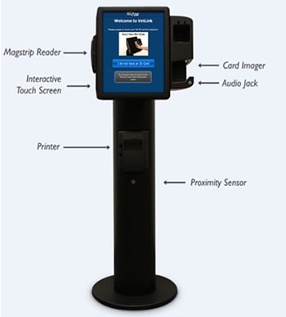

Figure 1: Kiosk in use at the VA

VetLink is another service offered by the Veterans Point of Service program. It is targeted at VA administrative staff. VetLink helps staff streamline patient flow and branch operations. It also allows system administrators to track usage, update content and software, and receive alerts about any technical issues. *Veni* will reduce the workload for the staff involved in the check-in process, thereby freeing them to work other tasks.

# 3. User Description

The users of the system will be veterans who want to walk in and check in without worrying about long wait times. The veteran population is becoming more tech-savvy, so we provide a more technological and convenient method than the current set up.

## 3.1 User/Market Demographics

The key people who will benefit from this app will be the VA patients who need to check in for appointments and the VA hospital staff who will be able to take care of other tasks besides checking in patients themselves or servicing kiosks.

## 3.2 User Profiles

The primary users of this app will be VA patients ages 18 and up and their dependents.

## 3.3 Key User Needs

This app addresses three key user needs:

* Reducing check-in time upon arrival at a VA health facility
* Providing appointment reminders on the user’s smartphone
* Getting driving directions to the VA facility

## 3.4 User Environment

*Veni* users will interact with the system through a GUI much like any other smartphone app. It will be touchscreen based and require an internet connection to work.

The *Veni* phone app will communicate with a back-end, cloud-hosted server component, henceforth called the *Veni* System Server. This server will interact with the VistA server instance which maintains the veterans’ appointments. It will maintain a mapping of VA facilities to VistA instances, hiding these complexities from users.

Like any smartphone application, users will be able to interact with *Veni* at their convenience. In particular, the application will require users to download their appointment before the appointment, and then check-in with the application as they arrive at the VA facility. The application will use the phone’s location services to make sure that the user is at the VA site before allowing the user to check-in.

The system will be designed so that the amount of protected user data (protected health information (PHI) and personally identifiable information (PII)) kept on the phone and on the server host is minimized. All communication will be encrypted. The application will protect the PHI and PII stored in the system in a manner that complies with the applicable data protection standards.

# 4. Product Overview

The main component of this system will be a smartphone application (*Veni* phone app). The application will be created in a way that makes it portable to multiple smartphone operating systems, but during the prototype development this will likely be restricted to a single platform.

The smartphone application will connect to the *Veni* system server. The server will run a J2EE instance within a Linux virtual machine and will be hosted in a commercial cloud vendor’s infrastructure. The *Veni* phone app will communicate with the gateway server using a simple JSON + REST interface. The *Veni* system server will act as a gateway to the various Veterans Administration VistA systems that will own the data the *Veni* phone app interacts with.

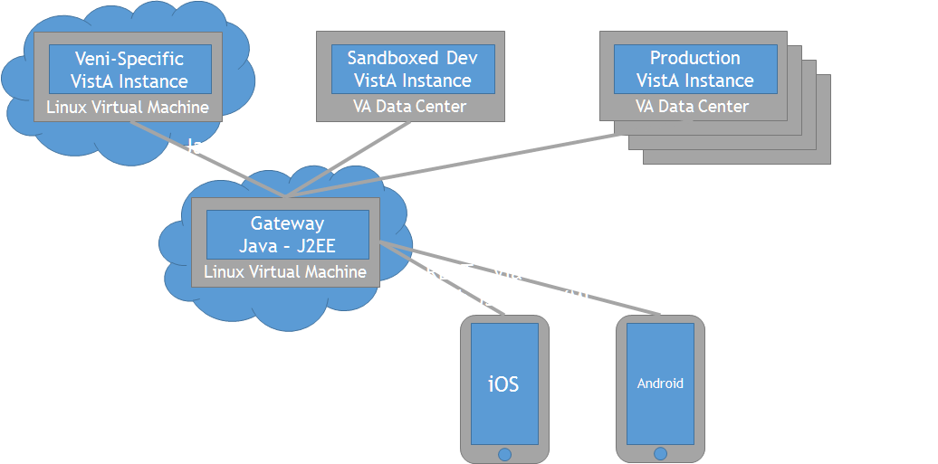

**4.1 Product Perspective**

The drawing above describes the interactions that *Veni* system will have during its development lifecycle. In the lower right are the smartphone applications. Though the prototype will target either the Android or iOS platforms, the eventual system will work on both of these and perhaps the Windows Phone as well.

In the center is the *Veni* System Server. It acts as a data forwarder between the user operating the application on his smartphone and one or many VA VistA systems. It will run in the J2EE server, running on Linux within a cloud-hosted virtual machine. It will be designed to *scale-out*; to achieve scale by having multiple gateway instances running in parallel.

During development, the *Veni* system server will interact with a cloud-hosted *Veni*-specific VistA instance, which is a team-created dummy server strictly for testing purposes. Once we are able to demonstrate the application’s capabilities, we expect to be able to interact with a Veterans Administration-hosted “sandbox” VistA system, which is a dummy system created and provided by the VA for evaluation purposes and stricter testing. The VA hosts these systems to allow its partners to test their software.

Should the VA agree to purchase the system, the gateway will communicate with the many VA VistA instances that make up the Veterans Health Administration's CPRS system. At this point, multiple gateway systems will exist in a “scale-out” configuration.

## 4.2 Summary of Capabilities and benefits

|  |  |
| --- | --- |
| **Feature** | **User Benefit** |
| Check-in to VA hospital/clinic | *Veni* app allows veterans to check-in for an appointment directly without waiting in lines. |
| Download the VA appointment | *Veni* app provides appointment details to veterans. |
| VA Appointment Reminder | *Veni* app sends reminder to veteran when next appointment scheduled. |
| Directions to Doctor’s office | *Veni* app provides directions to veterans to Doctor’s office |

## 4.3 Assumptions and Dependencies

The primary assumption in this project will be determining if the VA firewall will permit app access to VA information. The VA firewall issue is the most important because the system depends on being able to talk to the VistA server. The project also assumes phone compatibility will not be a problem even though the operating system differs depending on type.

The main dependency of *Veni* is meeting the security requirements for protecting the PHI and PPI of the user. Failure to keep this data safe will result in the immediate dismissal of the project.

## 4.4 Cost and Pricing

We are using as many free tools as possible, so the end price will be based on the time and effort of the individuals involved. The current projection is that it will take five people working 20 hours a week to complete the system by the end date of April 3rd, 2015 (10 week duration) for a total of 1000 hours of work.

Once the system is developed, an effort will be made to enroll it in the VA’s vendor demonstration program. If successful, the next step would be to sell it to the VA.

## 4.5 Licensing and Installation

The security of PHI and PII is extremely important, so it is intended that the app will be closed every time the phone is locked. Upon opening the app, it will require the user to login every time – it will not be left open.

# 5. Other Requirements and Constraints

Our goals with this app are:

* to reduce appointment wait time by 50%
* to finish by April 3rd 2015

The constraints involved are:

* accomplishing this project with a 5 person team
* gaining the cooperation of the VA for data access

# Appendix A: Glossary

|  |  |
| --- | --- |
| **Term** | **Definition** |
| PHI | Protected Health Information |
| PII | Personally identifiable information |
|  |  |
|  |  |
|  |  |
|  |  |
|  |  |
|  |  |
|  |  |

# Appendix B: References

(<http://www.va.gov/healthbenefits/vhic/index.asp>)

## Veterans Health Identification Card

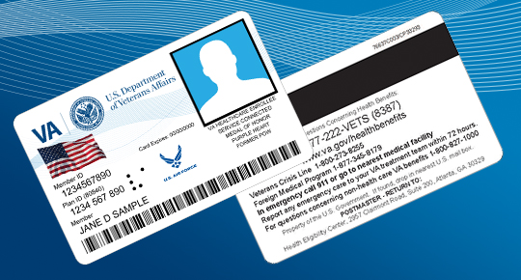

## The new Veteran Health Identification Card (VHIC) provides:

* Increased security for your personal information - no personally identifiable information is contained on the magnetic stripe or barcode.
* Unique Member Identifier -- Department of Defense assigns an electronic data interchange personal identifier (EDIPI) that allows VA to retrieve the Veteran’s health record.
* A salute to your military service – The emblem of your latest branch of service is displayed on your card. Several special awards will also be listed.
* Accessibility – Braille “VA” helps visually impaired Veterans to recognize and use the card
* Anti-Counterfeiting – Microtext helps thwart reproductions

The VHIC is issued only to Veterans who are enrolled in the VA health care system.

## Purpose of the VHIC

The VHIC is for identification and check-in at VA appointments. It cannot be used as a credit card or an insurance card, and it does not authorize or pay for care at non-VA facilities.

## Getting the New Card is Easy!

In February 2014, VA began issuing the VHIC to newly enrolled Veterans and enrolled Veterans who were not previously issued the old VIC but requested an identification card.  VA will automatically mail the new VHIC to enrolled Veterans who were previously issued the old VIC; there is no action required by these Veterans in order to receive the new VHIC.   Enrolled Veterans who were not issued the old VIC may contact their local VA medical center Enrollment Coordinator to arrange to have their picture taken for the new VHIC, or they may request a new VHIC at their next VA health care appointment.

VA expects to complete mailing of the replacement VHICs by Winter 2014. Because we will be reissuing more than 6 million VHICs, we ask for your patience during this time.

**Important!!** Veterans who are already enrolled should ensure the address VA has on file is correct so you can receive your VHIC in a timely manner. To update or to confirm your address with us, please call 1-877-222-VETS (8387). If the post office cannot deliver your VHIC, the card will be returned to the VA.

## How to Receive a VHIC

To receive a VHIC, you must be enrolled.  If you are not enrolled, you may apply for enrollment online at www.va.gov/healthbenefits/enroll or by calling 1-877-222-VETS (8387). You may also apply for enrollment in person at your local VA medical facility. Once your enrollment is verified (you will receive a Veteran Health Benefits Handbook welcoming you to the VA), you may have your picture taken at your local VA medical center, so that a VHIC can be mailed to you.

## Increased Security - Two Forms of Identification is Now Needed to Receive a VHIC

In addition to serving as identification for enrolled Veterans when they check in for their VA appointment, VHICs are also being used to access U.S. military bases and in some cases, allows access through U.S. airport security.  As a result, VA wants to assure that VHICs are issued appropriately and to the correct person.  To ensure your identity, VA has strengthened requirements to receive a VHIC. Veterans must provide one form of primary identification and one form of secondary identification when requesting a VHIC. Please see the **Acceptable Identification Documents** table below.

## What to do if you do not receive your VHIC

Once you have your picture taken, you should receive your VHIC within 7 to 10 days. If you have questions about the status of your VHIC, you may call your local VA medical facility where you receive your care or contact us at 1-877-222-VETS (8387).

## What to do with your old VIC

VA wants all enrolled Veterans to have the Veteran Health Identification Card, which is more secure and protects their personal information. If you have the previous version of the Veterans Identification Card (VIC), you should destroy your old VIC by cutting it up or shredding it.

## What to do if you’re VHIC is lost or stolen

If your VHIC is lost or stolen, you should contact the VA Medical Facility where your picture was taken to request a new card be re-issued, or call us at 1-877-222-VETS (8387). Identifying information will be asked to ensure proper identification of the caller.

## Acceptable Identification Documents

The old VICs and VHICs are acceptable forms of primary identification. Note that two forms of ID are now required, which means that the Veteran must have at least one primary and one secondary form of identification in order to receive a VHIC. The chart below lists the additional forms of identification which are acceptable primary and secondary identification.

|  |  |
| --- | --- |
| **Primary Identification** | **Secondary Identification** |
| Present ONE form of Primary Identification | Present ONE form of Secondary Identification |
| State-Issued Driver's License | Social Security Card |
| U.S. Passport or U.S. Passport Card (unexpired) | Original Social Security Card |
| Foreign passport with Form I-94 or Form I-94A (unexpired) | Certification of Birth Abroad Issued by the Department of State (Form FS-545) |
| U.S. Military card | Certification of Report of Birth issued by the Department of State (Form DS-1350) |
| Military dependent’s ID card | Voter’s Registration Card |
| U.S. Coast Guard Merchant Mariner Card | Native American Tribal Document |
| Foreign passport that contains a temporary I-551 stamp | U.S. Citizen ID Card (Form I-197) |
| Permanent Resident Card or Alien Registration Receipt Card (Form I- 551) | Identification Card for Use of Resident Citizen in the United States (Form I-179) |
| Employment Authorization Document that contains a photograph (Form I- 766) | Employment Authorization document issued by the Department of Homeland Security |
|  | Canadian Driver’s License |