Info App Build Instructions

Step 1: clone the repo & cd into it.
Step 2 (optional): update the version string in www/config.xml
Step 3: run cleanBuild
Step 4: edit platforms/ios/VA Info App/VA Info App-Info.plist
Find "UISupportedInterfaceOrientations" key…
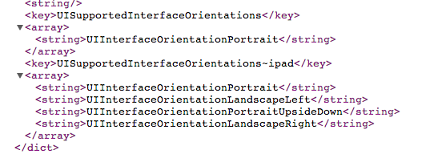
Copy the 3 additional orientations from the UISupportedInterfaceOrientations~ipad" array into it so they both are identical. Save the file.

Step 5 (optional): update the version string for iOS. With the project loaded in XCode, go to the menu, File | New | File…, under iOS find Resource and pick Settings Bundle. Next. Accept the defaults and click Create. Find the newly created Settings.bundle in XCode, drill down to Root.plist and edit it as in the following capture:
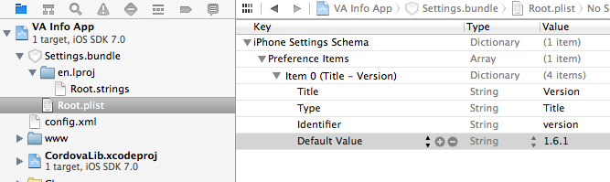

Step 6: Build or Archive in XCode.

