Evaluating K-Nearest Neighbors and Radius Neighbors Classifiers on the Wine Dataset

Ruchitha Musku
University of the Cumberlands
MSCS-634-M50: Advanced Big Data and Data Mining
Professor Satish Penmatsa
September 27, 2026

Evaluating K-Nearest Neighbors and Radius Neighbors Classifiers on the Wine Dataset
Instance-based learning methods classify a new observation by comparing it directly with stored training examples rather than by building an explicit model of the data (Han et al., 2023). The K-Nearest Neighbors (KNN) classifier, formalized by Cover and Hart (1967), assigns a test point to the majority class among its k closest training points. The Radius Neighbors classifier, referred to in this report as RNN, instead uses every training point that lies within a fixed distance r of the test point (scikit-learn developers, n.d.). Both methods rely on a single neighborhood hyperparameter, and a poor choice of that value can cause a model to overfit noise or to smooth away meaningful class structure.
The purpose of this lab was to examine how the choice of k and r affects classification accuracy on the Wine dataset (Aeberhard & Forina, 1991). KNN was evaluated with k = 1, 5, 11, 15, and 21, and RNN was evaluated with r = 350, 400, 450, 500, 550, and 600. Test-set accuracy was recorded for each setting, the accuracy trends were visualized, and the two models were compared to identify the conditions under which each approach is preferable. The Jupyter Notebook, figures, and README file for this work are available in the project repository (Musku, 2026).

Method

Dataset
The Wine dataset was loaded from the scikit-learn library (Pedregosa et al., 2011); it originates from the UCI Machine Learning Repository (Aeberhard & Forina, 1991). It contains 178 samples of wine grown in the same region of Italy and derived from three different cultivars. Each sample is described by 13 continuous features obtained through chemical analysis, including alcohol, malic acid, flavanoids, color intensity, hue, magnesium, and proline. Exploration showed that the dataset has no missing values and that the three classes are moderately balanced, with 59 samples in class_0, 71 in class_1, and 48 in class_2 (see Figure 1). Because no class is heavily under-represented, accuracy was considered a reasonable evaluation metric.
Figure 1
Class Distribution in the Wine Dataset
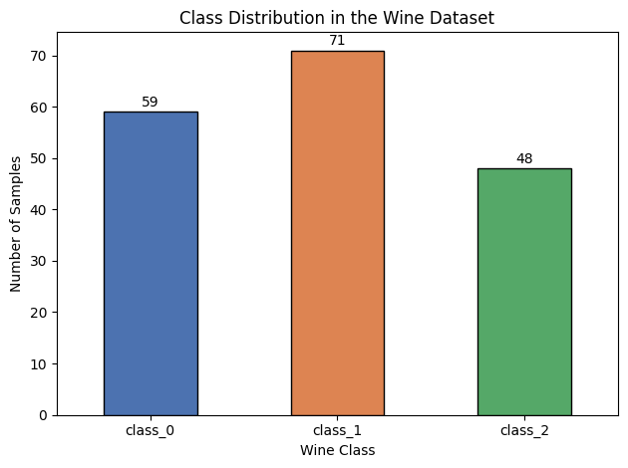
Note. Counts are for the full dataset (N = 178) before the train–test split.
Descriptive statistics revealed that the features are measured on very different scales. Proline ranges from 278 to 1,680 and magnesium ranges from 70 to 162, whereas hue ranges from 0.48 to 1.71 and nonflavanoid phenols range from 0.13 to 0.66. Because both classifiers rely on Euclidean distance, distances computed on the raw features are dominated by proline. This observation proved central to interpreting the results.

Data Preparation
The data were divided into a training set (80%, n = 142) and a test set (20%, n = 36) using a stratified split so that each class kept the same proportion in both sets. A fixed random seed (random_state = 42) was used so that the results can be reproduced. The features were not standardized for the main experiments. The radius values specified for the lab (350 to 600) correspond to the scale of distances between raw, unscaled observations; after standardization, every training point would fall inside a radius of 350, which would make the radius comparison meaningless. A supplementary KNN experiment on standardized features was conducted separately to show the effect of scaling.

Model Implementation and Evaluation
All analyses were performed in Python using scikit-learn (Pedregosa et al., 2011), pandas, NumPy, and Matplotlib (Hunter, 2007). The KNN models used the KNeighborsClassifier class with its default Euclidean distance and uniform neighbor weights. The RNN models used the RadiusNeighborsClassifier class. The parameter outlier_label = "most_frequent" was set as a safeguard, because the classifier otherwise raises an error when a test point has no training points inside the radius. For each RNN setting, the minimum, mean, and maximum number of training points falling inside the radius were also recorded to help explain the results. Each model was trained on the training set and evaluated on the test set, and accuracy was calculated as the proportion of test samples classified correctly.

Results

K-Nearest Neighbors
Table 1 and Figure 2 present the KNN results. Accuracy was lowest at k = 1 (.778; 28 of 36 test samples correct). It rose to .806 (29 of 36 correct) at k = 5 and remained at that level for k = 11, 15, and 21. Therefore, beyond a small value of k, KNN performance was stable and insensitive to the exact number of neighbors.
Table 1
KNN Test Accuracy by Number of Neighbors
k | Accuracy | Correct predictions (of 36)
1 | .778 | 28
5 | .806 | 29
11 | .806 | 29
15 | .806 | 29
21 | .806 | 29
Note. Features were unscaled. Accuracy is the proportion of the 36 test samples classified correctly.
Figure 2
KNN Test Accuracy Across Values of k
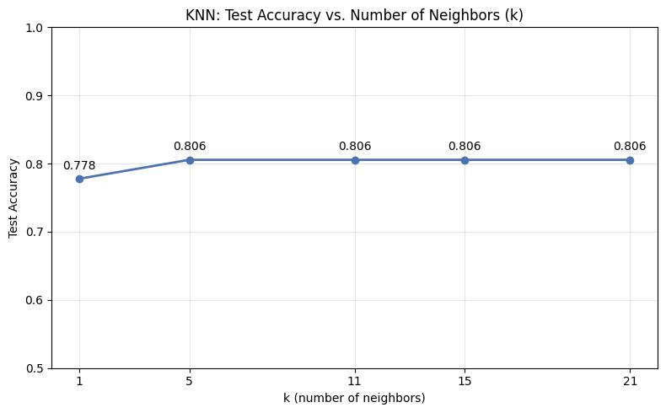

Radius Neighbors
Table 2 and Figure 3 present the RNN results. The highest accuracy (.722; 26 of 36 correct) occurred at the smallest radius, r = 350. Accuracy declined to .694 for r = 400 through 500 and to .667 for r = 550 and 600. The neighbor counts show why this occurred. Even at r = 350, a test point had on average 80.5 of the 142 training points (57%) inside its radius; at r = 600, the average rose to 111.0 (78%). Every test point had at least four neighbors at every radius, so the outlier fallback was never used.
Table 2
Radius Neighbors Test Accuracy and Neighborhood Size by Radius
r | Accuracy | M neighbors | Min. neighbors | Max. neighbors
350 | .722 | 80.5 | 4 | 111
400 | .694 | 87.9 | 9 | 121
450 | .694 | 94.8 | 14 | 126
500 | .694 | 100.1 | 17 | 136
550 | .667 | 106.0 | 19 | 138
600 | .667 | 111.0 | 23 | 140
Note. Neighbor counts refer to the number of the 142 training samples located within radius r of each test sample.
Figure 3
Radius Neighbors Test Accuracy Across Values of r
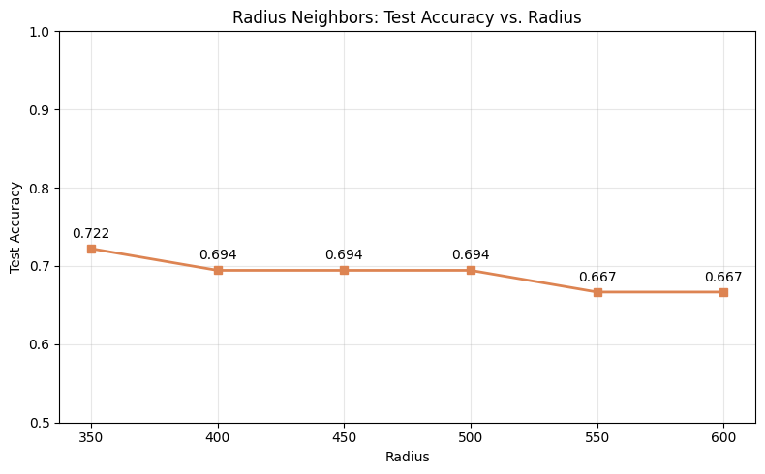

Supplementary Analysis: Effect of Feature Scaling
To examine the influence of feature scale, KNN was repeated after the features were standardized to a mean of 0 and a standard deviation of 1 (the scaler was fitted on the training data only). As Table 3 shows, accuracy increased from .778–.806 on the raw features to .972–1.000 on the standardized features.
Table 3
KNN Test Accuracy on Unscaled Versus Standardized Features
k | Unscaled | Standardized
1 | .778 | .972
5 | .806 | .972
11 | .806 | 1.000
15 | .806 | 1.000
21 | .806 | 1.000
Note. Standardization used scikit-learn’s StandardScaler inside a pipeline.

Discussion

Comparison of the Two Models
KNN outperformed RNN at every setting tested. The best KNN accuracy (.806) exceeded the best RNN accuracy (.722) by about 8 percentage points, and the mean accuracy across the parameter grid was .800 for KNN compared with .690 for RNN. KNN was also more stable: once k reached 5, further changes had no effect on accuracy. RNN, by contrast, lost accuracy steadily as the radius increased.
These trends reflect the bias–variance trade-off that governs neighbor-based methods (Han et al., 2023). With k = 1, a single atypical training sample can determine a prediction, which produces high variance and slightly lower accuracy. Averaging the votes of five or more neighbors reduced that sensitivity. The RNN models sat at the opposite extreme. Because the tested radii were large relative to the spread of the data, each neighborhood contained most of the training set. As the radius grew, the vote increasingly reflected the overall class proportions rather than the local structure around the test point, so the model underfit.
The supplementary analysis showed that feature scale limited both models. On the raw data, proline alone largely determined which points were considered close, so the other 12 chemical features contributed little to the distance calculation. Standardizing the features raised KNN accuracy to between .972 and 1.000. This result suggests that scaling is a more important first step than tuning k or r when features are measured in different units.

When Each Model Is Preferable
KNN is generally preferable when data density varies across the feature space, because it always uses exactly k neighbors and therefore adapts to both dense and sparse regions. Its parameter is also easier to tune, since a moderate value of k tends to work across many datasets, whereas a useful radius depends entirely on the distance scale of a particular dataset. In addition, KNN guarantees that every test point is classified from its own neighborhood. The Wine dataset, which is small and has features on very different scales, fits this profile, and this is consistent with KNN’s stronger results.
RNN is preferable when distance has a meaningful, interpretable unit and the data are fairly uniform in density, for example, when points within a known physical distance should be treated as related in geographic or sensor data. RNN is also useful when unusual observations should be identified rather than forced into a class, because a test point with no neighbors inside the radius can be labeled as an outlier. However, the present results show that the radius must be chosen carefully; with radii that are too large, RNN approaches a majority-class classifier.

Challenges and Decisions
The main decision in this lab concerned feature scaling. The specified radius range is only meaningful on unscaled data, so the main experiments used the raw features to follow the lab design, and a separate standardized experiment was added to show how scaling affects performance. A second decision was to set a fallback outlier label for RNN so that the classifier would not fail if a test point had no neighbors within the radius. A stratified split and a fixed random seed were used to preserve class proportions and make the results reproducible.

Limitations
The test set contained only 36 samples, so a single misclassification changes accuracy by about 2.8 percentage points, and small differences between settings should be interpreted cautiously. The results are also based on one train–test split. Repeated k-fold cross-validation would provide more reliable estimates and would allow the choice of k and r to be tuned without relying on the test set. Finally, accuracy was the only metric reported; precision, recall, and a confusion matrix could show whether errors were concentrated in a particular class.

Conclusion
This lab compared KNN and Radius Neighbors classifiers on the Wine dataset across a range of parameter values. KNN performed better and more consistently, reaching an accuracy of .806 for all values of k from 5 to 21. RNN reached its highest accuracy of .722 at the smallest radius and declined as the radius increased because its neighborhoods grew to include most of the training data. A supplementary experiment showed that standardizing the features raised KNN accuracy to as high as 1.000. Overall, the results show that neighbor-based classifiers depend strongly on how the neighborhood is defined and on the scale of the features used to measure distance.

References
Aeberhard, S., & Forina, M. (1991). Wine [Data set]. UCI Machine Learning Repository. https://doi.org/10.24432/C5PC7J
Cover, T., & Hart, P. (1967). Nearest neighbor pattern classification. IEEE Transactions on Information Theory, 13(1), 21–27. https://doi.org/10.1109/TIT.1967.1053964
Han, J., Pei, J., & Tong, H. (2023). Data mining: Concepts and techniques (4th ed.). Morgan Kaufmann.
Hunter, J. D. (2007). Matplotlib: A 2D graphics environment. Computing in Science & Engineering, 9(3), 90–95. https://doi.org/10.1109/MCSE.2007.55
Musku, R. (2026). MSCS_634_Lab_2 [Computer software]. GitHub. https://github.com/rmusku61699/MSCS_634_Lab_2
Pedregosa, F., Varoquaux, G., Gramfort, A., Michel, V., Thirion, B., Grisel, O., Blondel, M., Prettenhofer, P., Weiss, R., Dubourg, V., Vanderplas, J., Passos, A., Cournapeau, D., Brucher, M., Perrot, M., & Duchesnay, É. (2011). Scikit-learn: Machine learning in Python. Journal of Machine Learning Research, 12, 2825–2830. https://jmlr.org/papers/v12/pedregosa11a.html
scikit-learn developers. (n.d.). Nearest neighbors. scikit-learn. Retrieved September 27, 2026, from https://scikit-learn.org/stable/modules/neighbors.html

Appendix
Notebook Output Screenshots
The screenshots below were taken from the executed Jupyter Notebook in the project repository. The complete notebook, README file, and all images are available at
https://github.com/rmusku61699/MSCS_634_Lab_2
Figure A1
Stratified 80/20 Train–Test Split
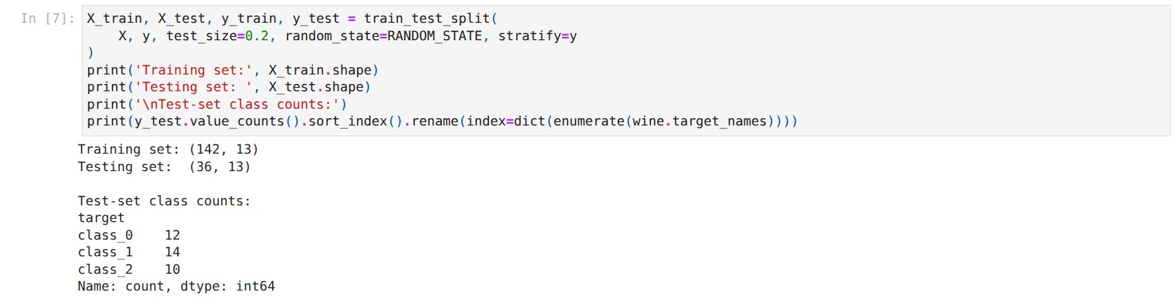

Figure A2
KNN Training, Evaluation, and Recorded Accuracy
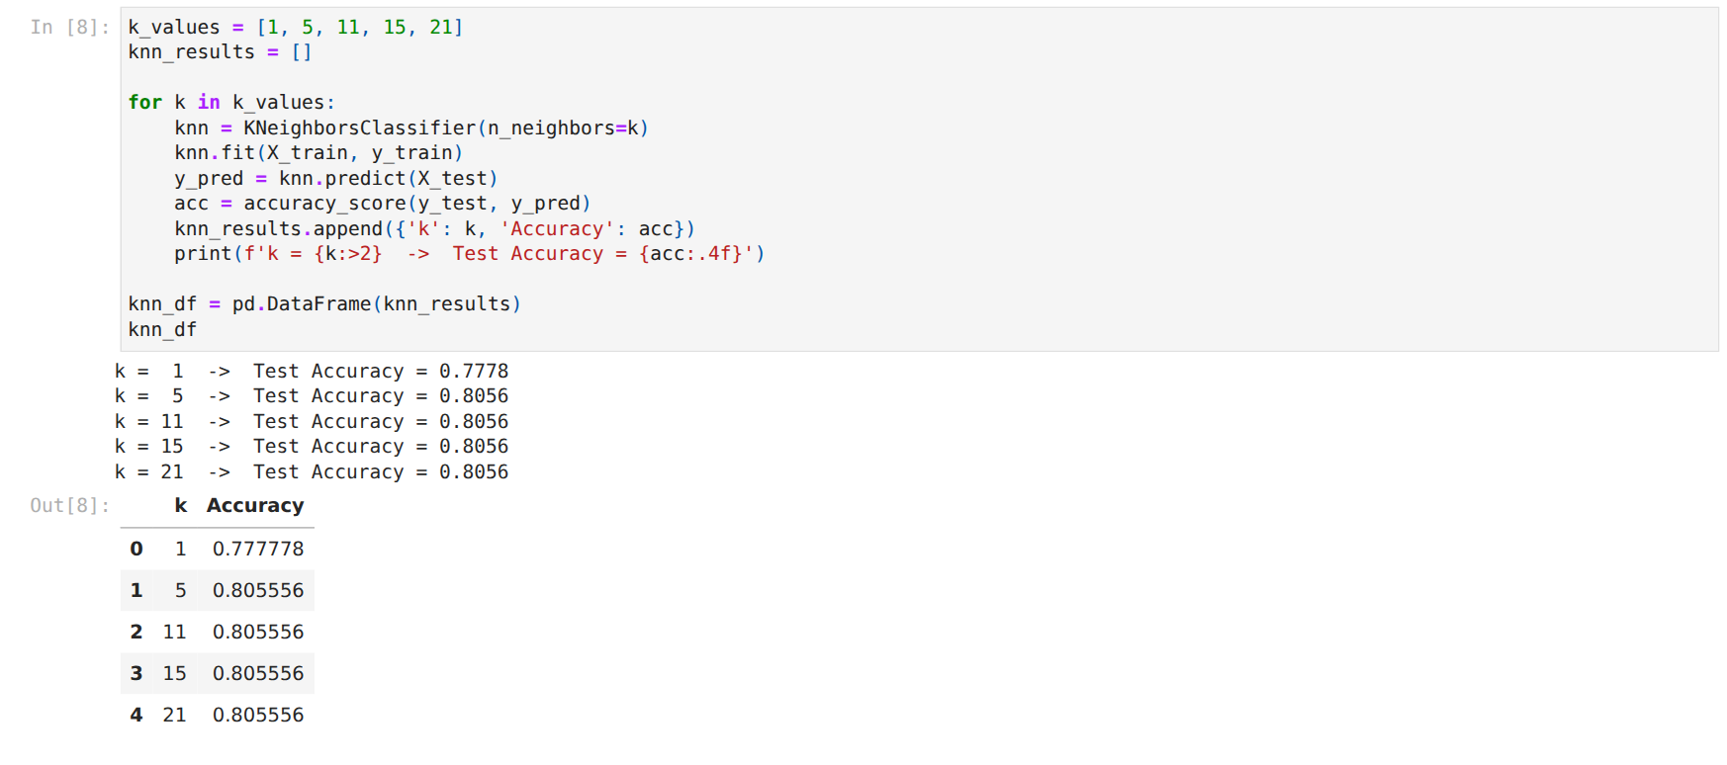

Figure A3
Radius Neighbors Training, Evaluation, and Recorded Accuracy
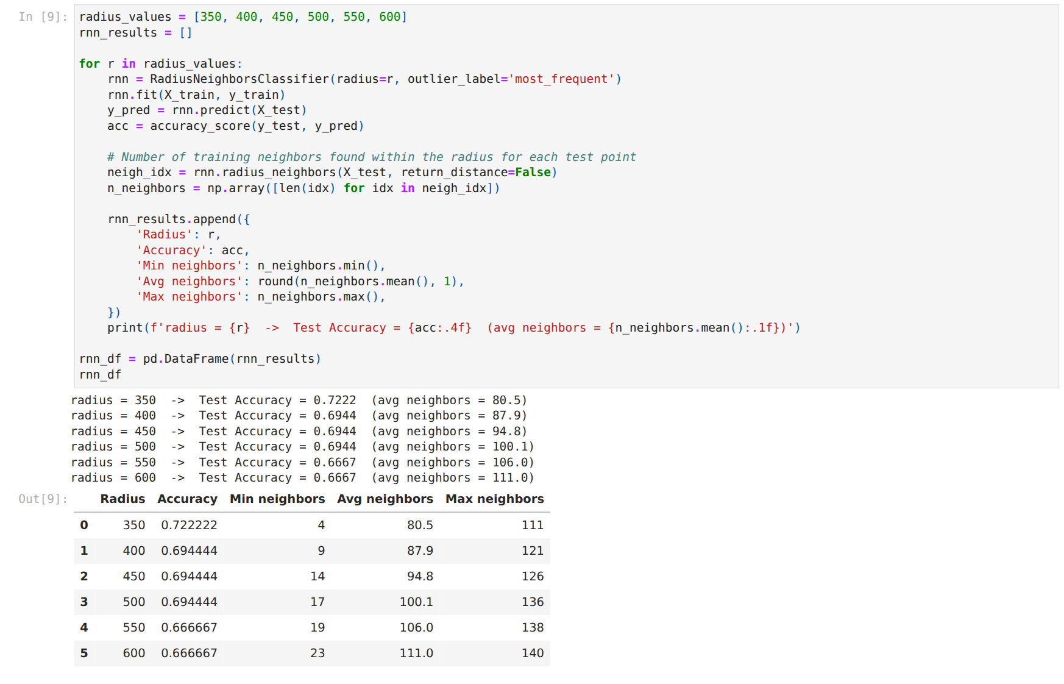

Figure A4
Side-by-Side Accuracy Trends and Summary Table
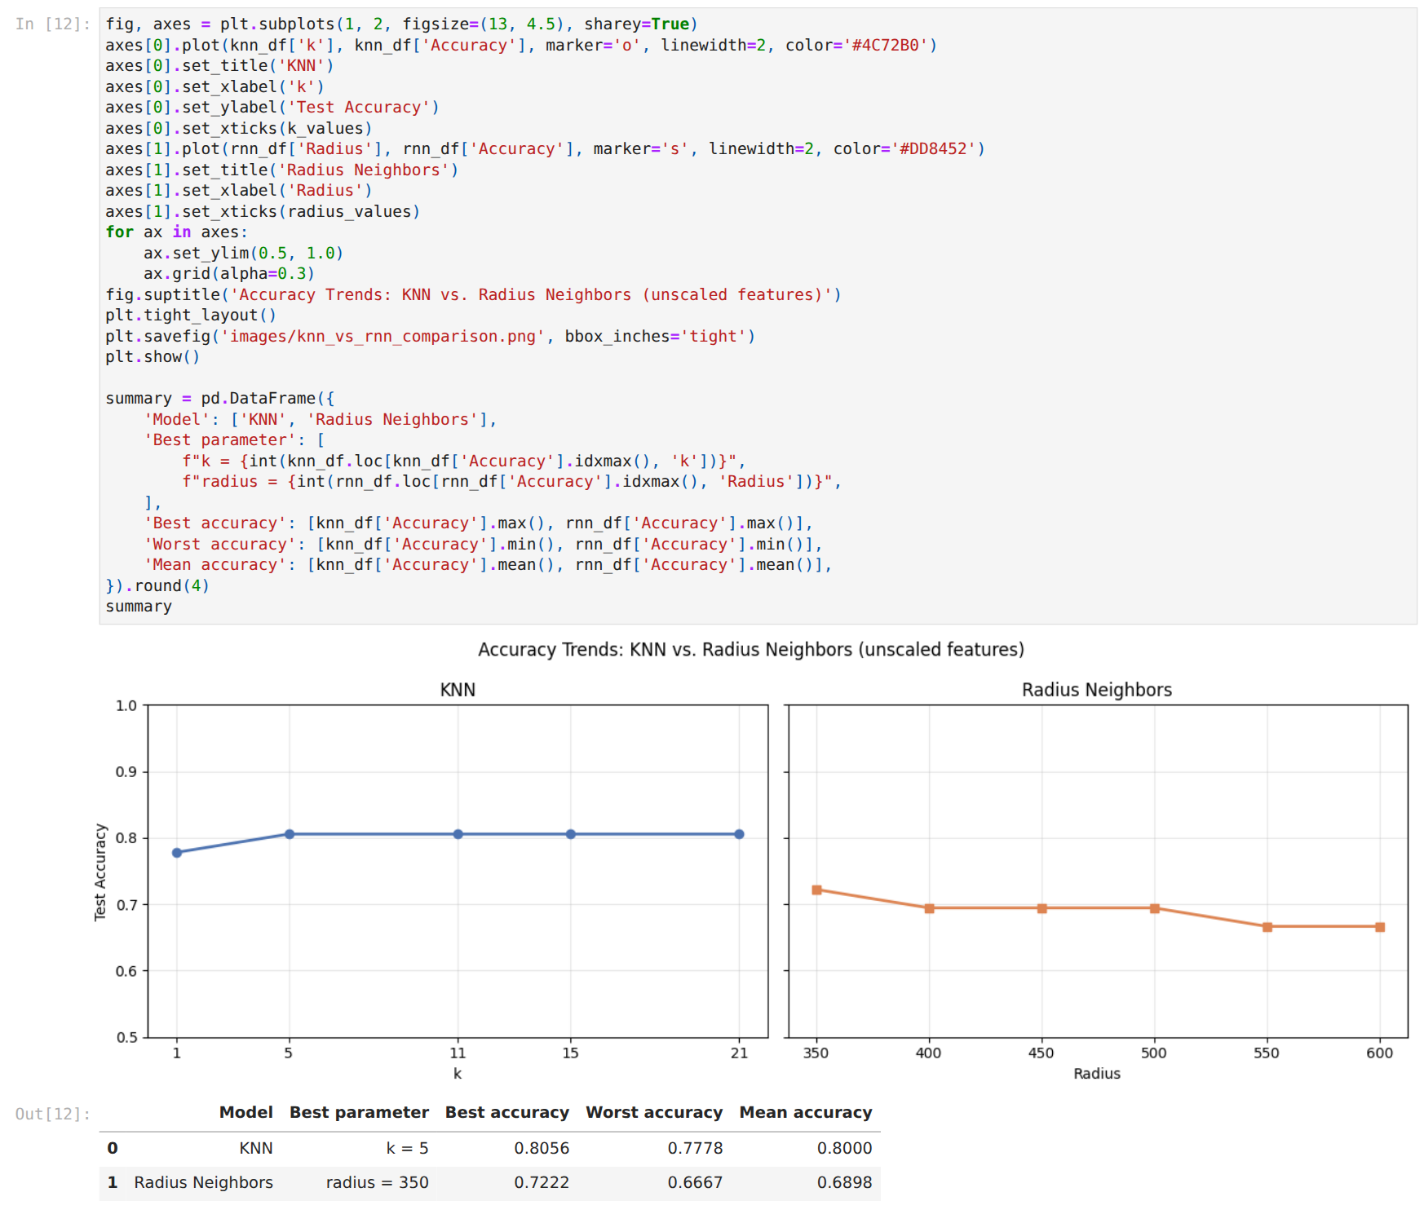

Figure A5
Supplementary Feature-Scaling Check
