**The dorsomedial hypothalamic nucleus and its role in ingestive behavior and body weight regulation**

(Bellinger and Bernardis, 2002)

-stimulation in sheep produced hyperphagia

-DMH lesions (rats) = hypophagia, hypdispia, but normal % fat and lean body mass

-DMHL rats have normal plasma GH

- “The ad libitum-fed DMNL rats showed the typical lesion-induced hypophagia and lost BW compared to the ad libitum-fed sham-operated group.”

-“After about 20 days, the BWs of the ad libitum-fed lesioned rats stabilized on a lower growth curve.”

-“In sharp contrast to this, the restricted rats after DMNL lesioning showed an immediate hyperphagia and their food intake remained higher than that of the ad libitum-fed group for 10 days.”

-“ After DMNL, the restricted group immediately began to gain BW and approached the attenuated BW of the ad libitum-fed DMNL rats and began to parallel their weight gain.”

-“At the end of the 28-day study, body composition of the DMNL groups was comparable to the control animals. These data demonstrated that the DMNL rats not only actively regulated their BW, but also did so with normal body composition.”

- “DMNL rats given **high fat** or ‘junk food’ diets **did become obese** compared to chow fed DMNL rats”

- “However, DMNL rats given a **high-fat diet** do not become **as obese as control animals**, when fed **other palatable diets**, they can become **as obese or even more obese** than similarly fed sham-operated rats”

-”The data taken as a whole suggest that DMNL may attenuate high-fat induced obesity but do not completely eliminate it”

- “The DMNL groups showed their typical hypophagia, reduced BW gain, reduced linear growth, but normal body composition.”

-OVX does not change growth in DMHL rats vs sham

-“ These data [45] suggested that even though the DMNL lowered the rat's ‘BW settling point’, they appeared to be fully capable of responding to other regulatory challenges, i.e., the loss of estrogens that increased BW (fat and lean body mass) and linear growth”

**Central stress-integrative circuits: forebrain glutamatergic and GABAergic projections to the dorsomedial hypothalamus, medial preoptic area, and bed nucleus of the stria terminalis**

(Myers at al., 2014)

-“Glutamatergic and GABAergic neurons play important roles in stress regulation, directly exciting and inhibiting, respectively, paraventricular hypothalamic (PVN) corticotropin releasing hormone (CRH) neurons”

-DMH projects GABAergically to the PVN

-DMH projects glutamatergically to the PVN

-^ show pronounced activation by stress

-“Descending input from the limbic forebrain is thought to influence the role of the DMH, POA, and BST in stress integration”

-ventrolateral region of DMH sends stress-activated projections to the parvocellular PVN

-DMH got lots of vGluT2-psoitive input from extreme dorsal region of the PVT (paraventricular thalamus)

-input from periaqueductal gray involved dorsolateral DMH

-GABA neurons scattered

-“innervation of the predominantly GABAergic DMH, mPOA, and BST by GABAergic neurons of the MeA and CeA supports the hypothesis that these amygdalar regions promote HPA axis activation by disinhibition, using sequential GABAergic synapses.”

-“In contrast, there is evidence for excitatory innervation of the DMH, mPOA, and BST by hippocampal and prefrontal cortical neurons, consistent with the glutamatergic signature of outputs from these stress-inhibitory sites.”

-“all three PVN-projecting regions receive mixed GABA and glutamate input from hypothalamic nuclei which may be relevant to intra-hypothalamic mechanisms governing the integration of stress responses.”

-“As an upstream regulator of the PVN, the DMH is highly sensitive to psychogenic stressors”

-“With regard to HPA axis integration, the ventrolateral subdivision of the DMH sends stress-activated GABAergic projections to the PVN”

-“The vast majority of these PVN-projecting neurons contain GAD65, indicating that this is likely a stress-inhibitory region of the DMH. In contrast, the dorsomedial portion of the DMH predominantly expresses vGluT2 and provides glutamatergic innervation of the PVN”

-“Our group has demonstrated that local injection of a panionotropic glutamate receptor antagonist into the DMH enhances corticosteroid responses to restraint stress”

-“Microstimulation of the dorsal component of the DMH results in an increase in ACTH release while inhibition has the opposite effect”

-ventrolateral DMH = GABA projections to PVN

-dorsomedial DMH = glutamatergic projections to the PVN

-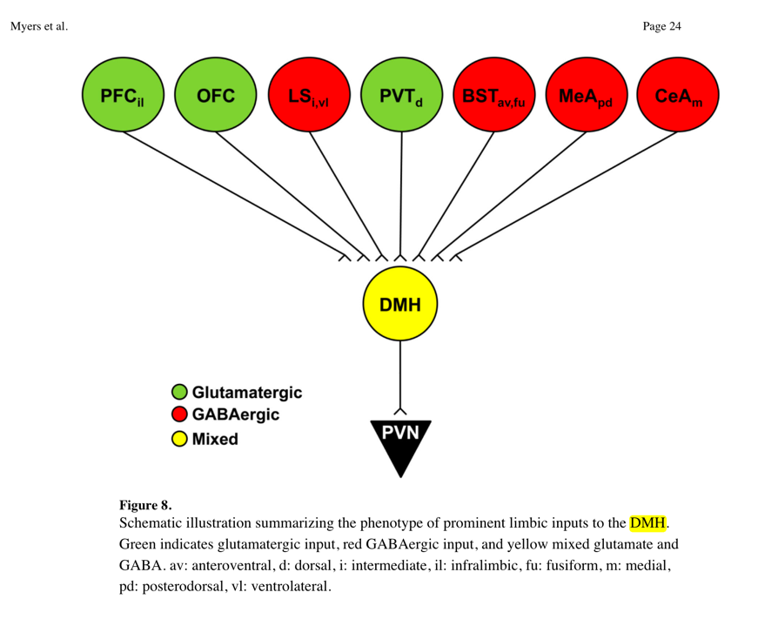

**The dorsomedial hypothalamus and the response to stress: Part renaissance, part revolution**

(DiMicco et al., 2002)

-“ The physiological response to emotional stress consists of an integrated pattern of endocrine and autonomic changes that is highly conserved across mammalian species.”

-picrotoxin (block GABAa) increases HR, sympathetic activity, and plasma catecholamines

-same thing^ if you add microinjections of excitatory amino acids

-disinhibition of DMH neurons = classic defence reaction (sympathetic)