Results
Acute stress alters basal glutamatergic transmission in young female rats
To determine if a single, 30-minute physical restraint affects glutamate signalling in the DMH, recordings of DMH neurons in hypothalamic slices from female Sprague-Dawley rats were obtained (Fig 1). The amplitude of the evoked excitatory postsynaptic currents (eEPSC) was measured and compared between naïve and acutely stressed females. Acute stress significantly increased the amplitude of the evoked EPSCs (acute stress: 66.60 ± 9.68, n = 8; naïve: 41.52 ± 5.88, n = 10; p = 0.047, independent t-test, Fig. 1A).
However, the paired-pulse ratio (PPR) did not differ significantly between groups (acute stress: 1.02 ± 0.28, n = 8; naïve: 1.02 ± 0.38, n = 10; p = 0.99, independent t-test, Fig. 1B), suggesting that acute stress increases basal glutamate transmission, but not due to a change in presynaptic probability in DMH neurons of young female rats.

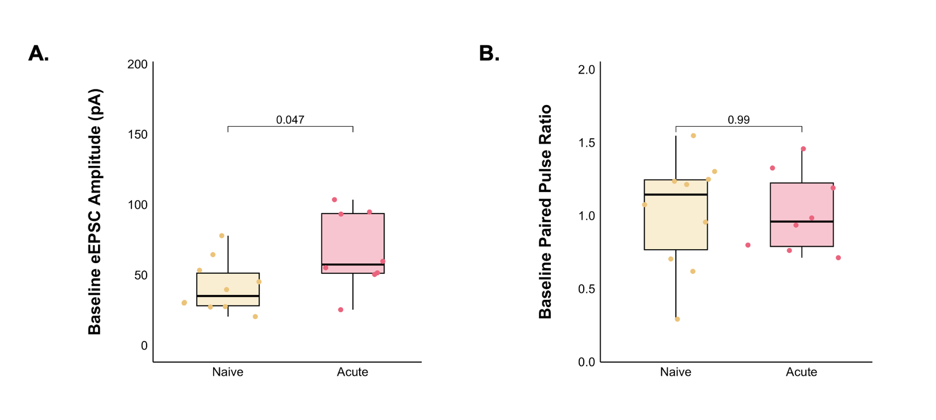Figure 1: The strength of basal glutamatergic current amplitude (A) is greater under acute stress, but this is not due to an increase in PPR (B). Points represent individual cells, the horizontal bar represents the median and the error bars represent SE. * = p < 0.05.

Acute stress results in long-term depression in response to high frequency stimulation
To study activity-dependent plasticity in the DMH after acute stress, high-frequency stimulation (HFS) was applied to determine the effects on glutamate synapses (Fig. 2). In naïve animals, there was no change in amplitude of evoked EPSCs following HFS, assessed by examining the amplitude of the evoked EPSCs in the final 5-minute interval compared to the 5-minute baseline period (109.98 ± 9.38% of baseline, paired t-test, p = 0.876; Fig. 2A). In animals who underwent acute stress, HFS elicited a long-term depression (LTD) in glutamate synapses during the 25-to-30-minute period (42.67 ± 11.37% of baseline, paired t-test, p = 0.006; Fig. 2A).

The PPR did not change after HFS in naïve animals (1.02 ± 0.12 at baseline to 1.00 ± 0.12 post-HFS, n = 10, paired t-test, p = 0.78; Fig. 2B) but increased for those who underwent acute stress (1.02 ± 0.10 at baseline to 1.46 ± 0.17 post-HFS, n = 8, paired t-test, p = 0.025, Fig. 2C) corresponding with decreased current amplitude in the long term.

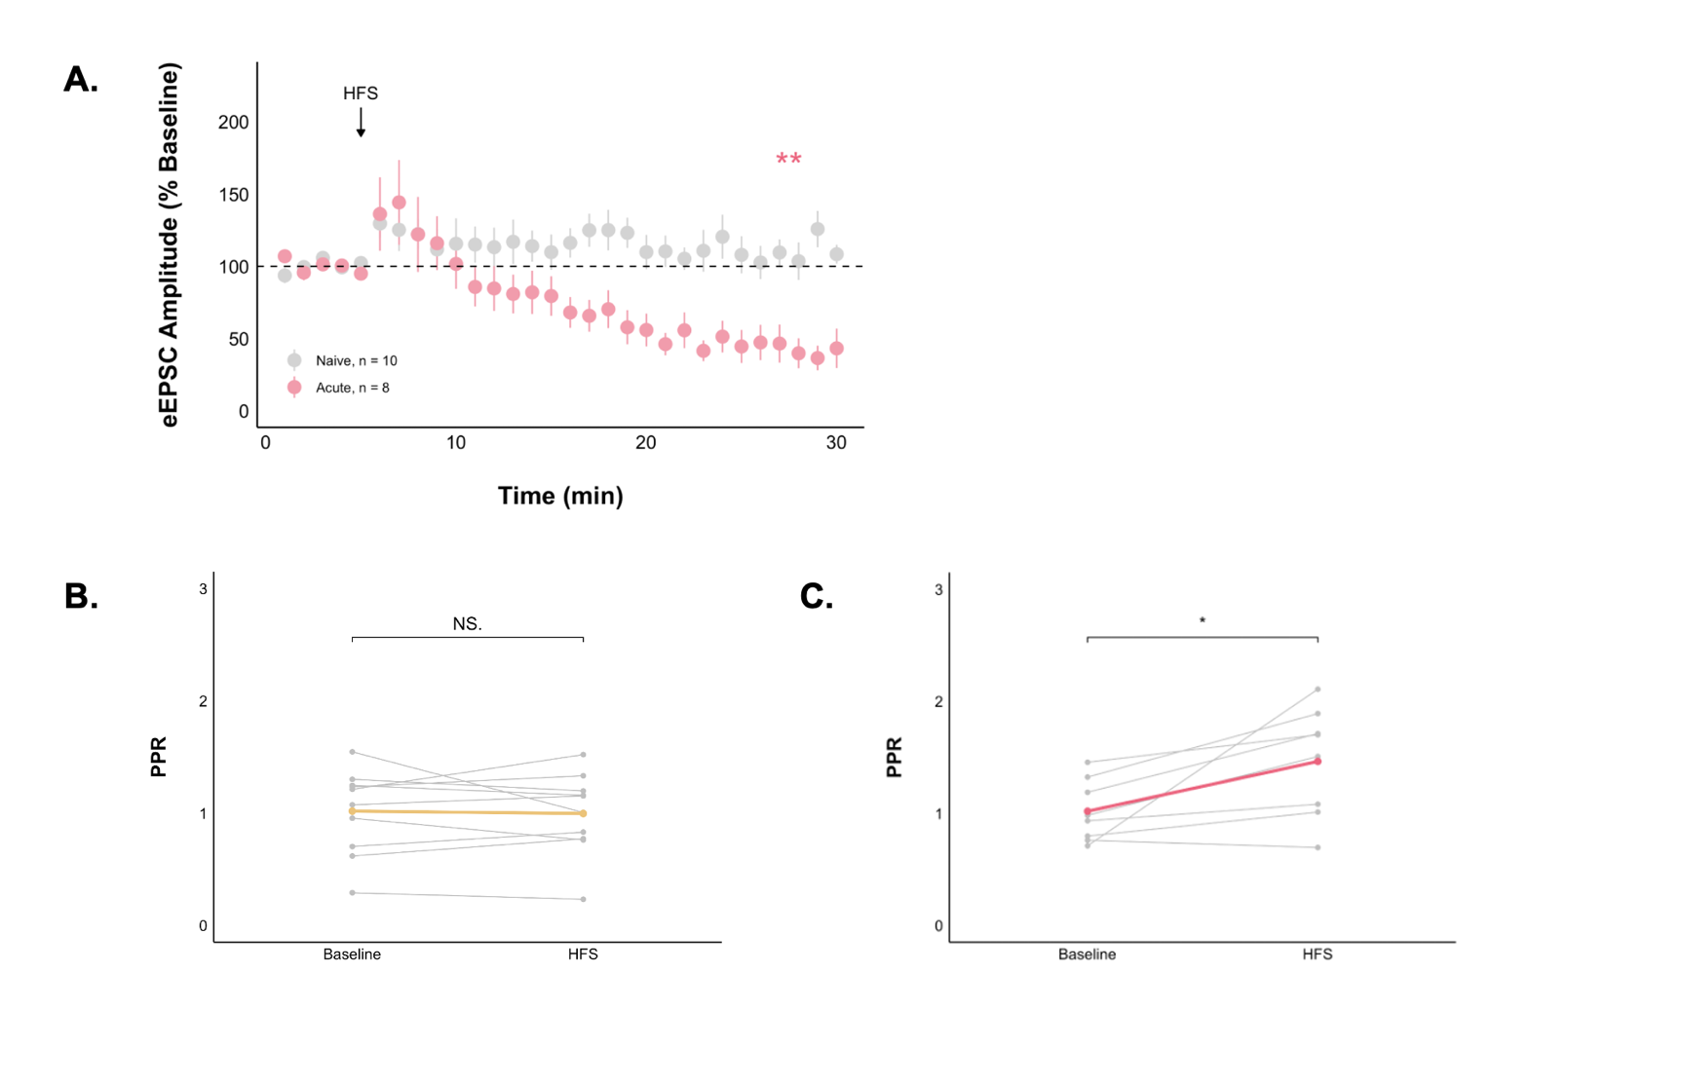
Figure 2: Acute stress decreases evoked EPSC amplitude following HFS. Summary data (A) of naïve animals (n = 10) showing no change in evoked EPSCs and acute stress (n = 8) showing a long-lasting depression in evoked EPSC amplitude. Each point represents the mean ± SE eEPSC amplitude per minute. PPR (B) did not change overtime in naïve animals, but increased in acute stress, each point represents the mean PPR of a single cell averaged over the baseline period (0 to 5 minutes) or the final period (25 to 30 minutes) of the evoked current protocol. The coloured line represents the mean PPR ± SE for each group. * = p < 0.05, ** = p < 0.01.

The type I cannabinoid receptor mediates the LTDobserved in stressed animals
To determine if the endocannabinoid system is involved in the LTD seen in animals who underwent acute stress, 5µm of AM251, an inverse agonist of CB1R, was utilized (Fig. 3). Despite undergoing acute stress, with CB1Rs blocked, there was no longer a significant change in eEPSC amplitude after HFS (64.43 ± 14.71% of baseline, paired t-test, p = 0.194; Fig. 3A), nor in the PPR (1.05 ± 0.09 to 1.07 ± 0.13, n = 10, paired t-test, p = 0.78; Fig. 3B).

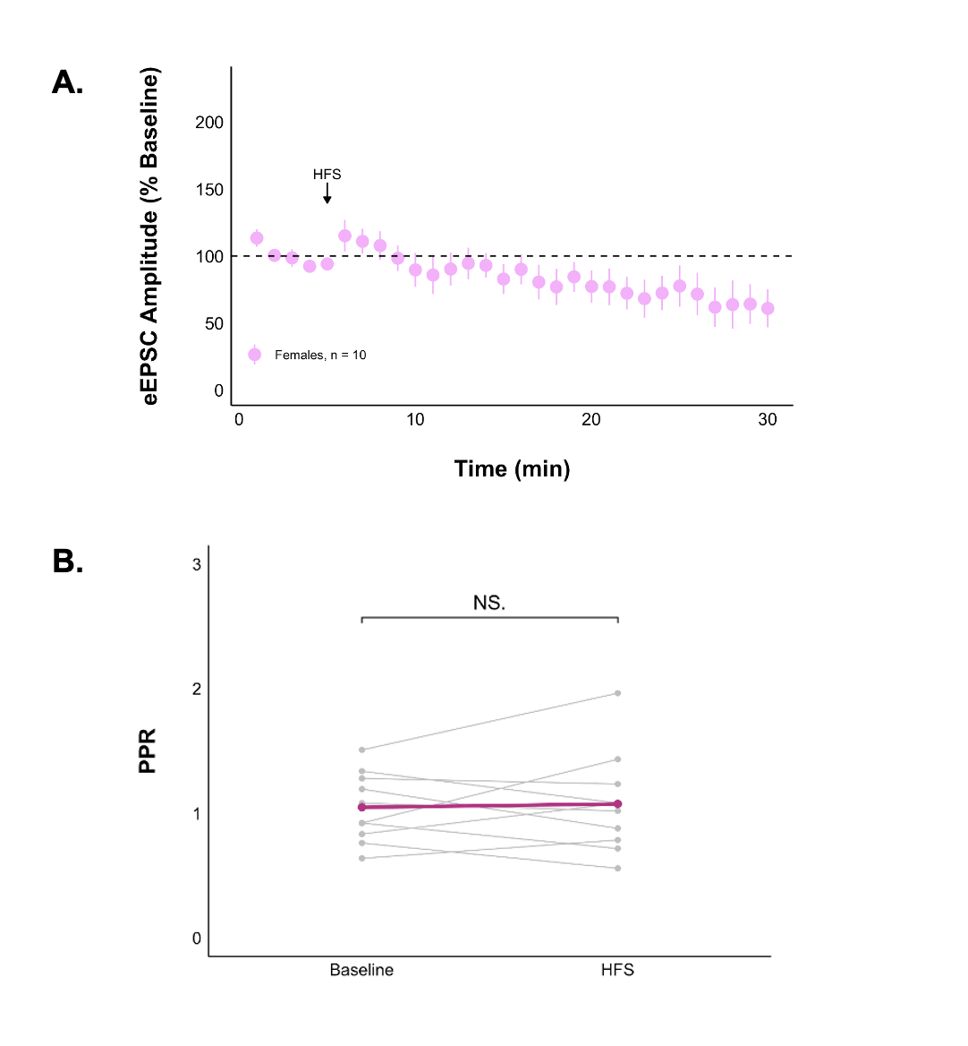
Figure 3: Acute stress when CB1Rs are blocked does not change evoked EPSC amplitude following HFS (A). Each point represents the mean ± SE eEPSC amplitude per minute. PPR (B) did not change after HFS, each point represents the mean PPR of a single cell averaged over the baseline period (0 to 5 minutes) or the final period (25 to 30 minutes) of the evoked current protocol. The coloured line represents the mean PPR ± SE for each group.

Repeated stress does not alter glutamatergic transmission in young female rats
To determine if five consecutive days of a 30-minute physical restraint affects glutamate signalling in the DMH, recordings of DMH neurons in hypothalamic slices were obtained (Fig. 4). Unlike acute stress, there was no significant change in eEPSC amplitude after HFS (74.00 ± 12.34% of baseline, paired t-test, p = 0.204; Fig. 4A), nor in the PPR (1.29 ± 0.18 to 1.35 ± 0.22, n = 9, paired t-test, p = 0.61; Fig. 4B).

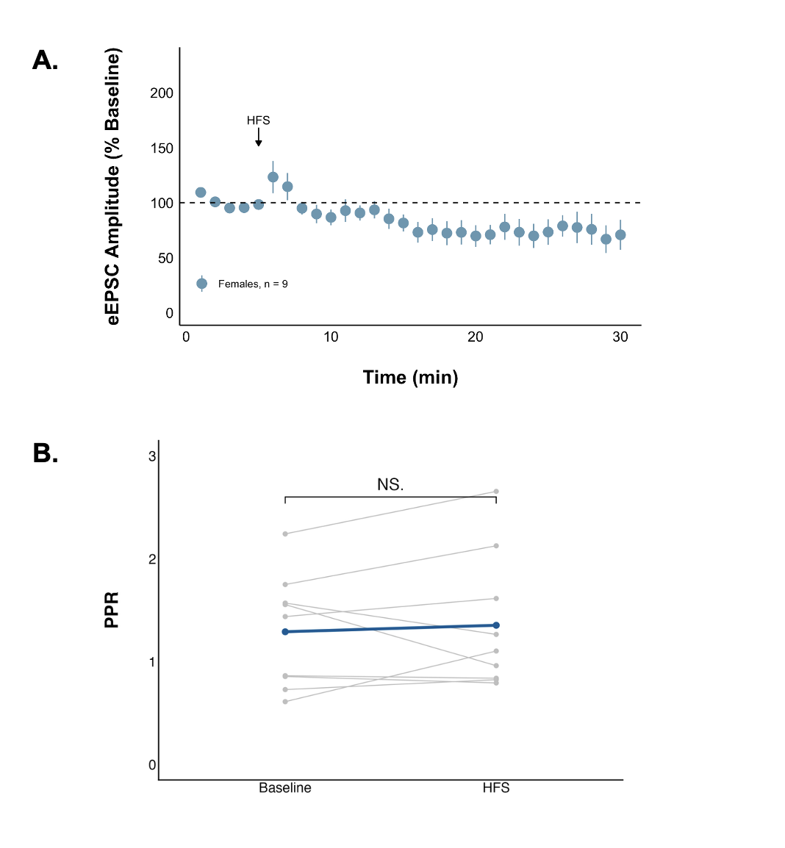
Figure 4: Repeated stress does not change evoked EPSC amplitude following HFS (A). Each point represents the mean ± SE eEPSC amplitude per minute. PPR (B) did not change after HFS, each point represents the mean PPR of a single cell averaged over the baseline period (0 to 5 minutes) or the final period (25 to 30 minutes) of the evoked current protocol. The coloured line represents the mean PPR ± SE for each group. * = p < 0.05.

There is no clear contribution of synaptic parameters to the LTD seen after acute stress
To determine if more could be understood about the mechanism underlying the plasticity in acute stress, or lack of plasticity in acute stress when CB1Rs are blocked, variance analyses were conducted (Table 1). The variance to mean ratio (VMR) depends on presynaptic release probability (P_{r}) and quantal size (Q) and can be used to determine if altered synaptic transmission is due to a change in number of active vesicle release sites (N). The inverse square of the coefficient of variation (1/CV²) depends on N and Pr, but not Q, allowing for determining if the change is predominately postsynaptic by change in Q.
There were no significant changes in VMR or 1/CV² for any of the groups tested (Table 1), giving no further information about the mechanism of plasticity seen after acute stress.

Table 1: Variance analysis of eEPSCs, p-values from Wilcoxon test.
 | VMR | 1/CV²
Naïve | 0.16 | 0.084
Acute stress | 0.46 | 0.078
Acute stress with CB1Rs blocked | 0.084 | 0.32
Repeated stress | 0.91 | 0.91

DMH neurons are less excitable in the long-term after an acute stress
To determine if stress alters neuronal excitability, a current clamp steps protocol was performed before and after HFS (Fig. 5). Peak amplitude decreased in the long-term after an acute stressor (n = 5, Wilcoxon test, p = 0.01216; Fig. 5A) and repeated stressor (n = 9, Wilcoxon test, p = 0.2531; Fig. 5E), but not under acute stress when CB1Rs were blocked (n = 6, Wilcoxon test, p = 0.1024; Fig. 5C). The difference in frequency after HFS was significantly lower in acute stress from current injection of -10 pA (sweep 5.0) to the highest current injection of 40 pA (sweep 10.0) (n = 8, Wilcoxon test, p = 0.031, 0.021, 0.022, 0.022, 0.022, 0.025; Fig. 5B), but did not exist when CB1Rs were blocked (n = 10, Wilcoxon test, p = 0.37, 0.35, 0.30, 0.35, 0.83, 0.90; Fig. 5D). Despite the long-term change in peak amplitude for repeated stress, there was no effect on the frequency of action potentials n = 0, Wilcoxon test, p = 0.37, 0.17, 0.090, 0.074, 0.16, 0.089; Fig. 5F).
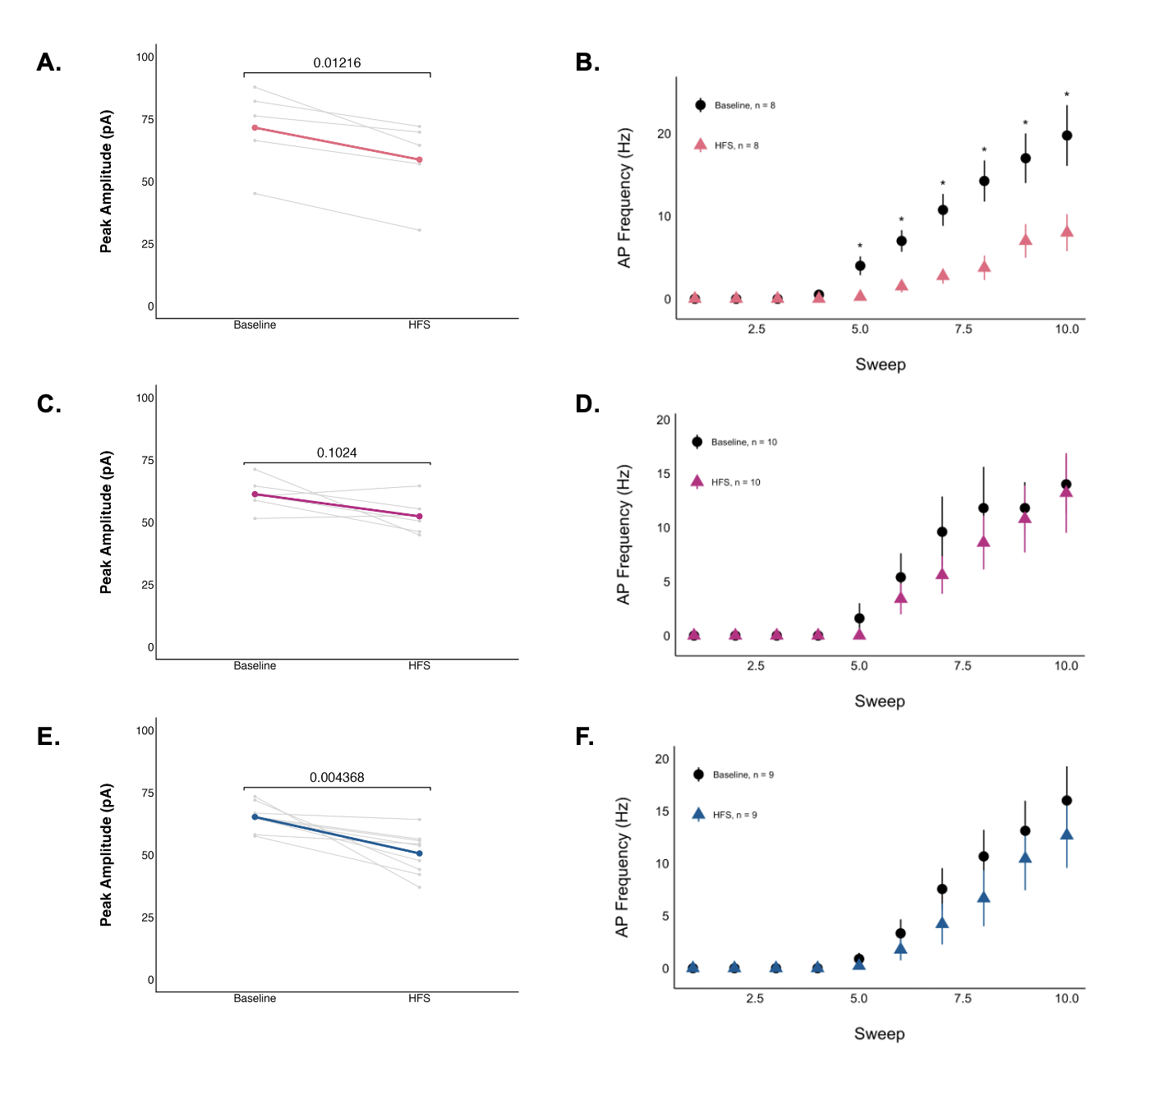
Figure 5: Acute stress decreases the excitability of DMH neurons in the long term. Data was recorded before and 25 minutes after HFS. Each point represents the mean peak amplitude of a single cell averaged over the baseline period (0 to 5 minutes) or the final period (25 to 30 minutes) of the evoked current protocol, and the colour line represents the mean ± SE for each group, any cells that did not fire action potentials were removed (A, C, E). Each point represents the mean frequency ± SE for each cell for each state (B, D, F). Wilcoxon signed-rank test, * = p < 0.05.

