FIGURE BASED ON THE STORY, NOT STATS!

Baseline glutamate release
-evoked (naïve vs acute)
*Presenting as single independent t-test between means*
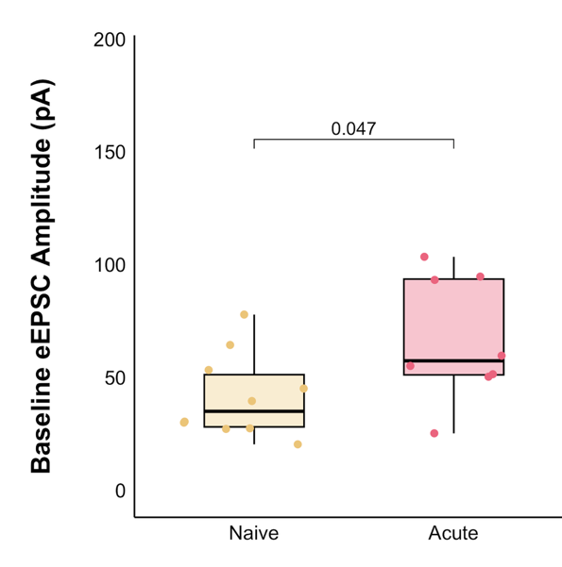
-PPR (naïve vs acute)
*Presenting as single independent t-test between means*
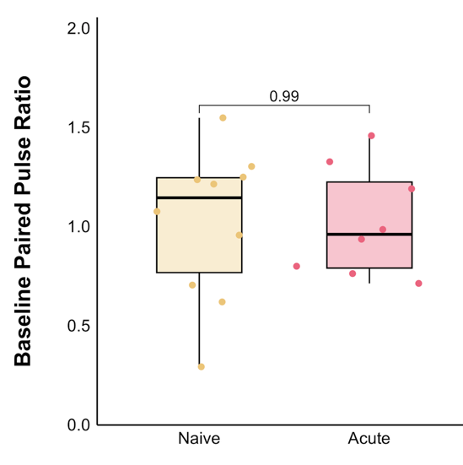

HFS
-summary plot (naïve)
-summary plot (acute)
*Either I am going to finish up the repeated measures ANOVA that says there is a significant effect with acute stress, or I will present it as a t-test comparing only the baseline to the final 5-minute period*
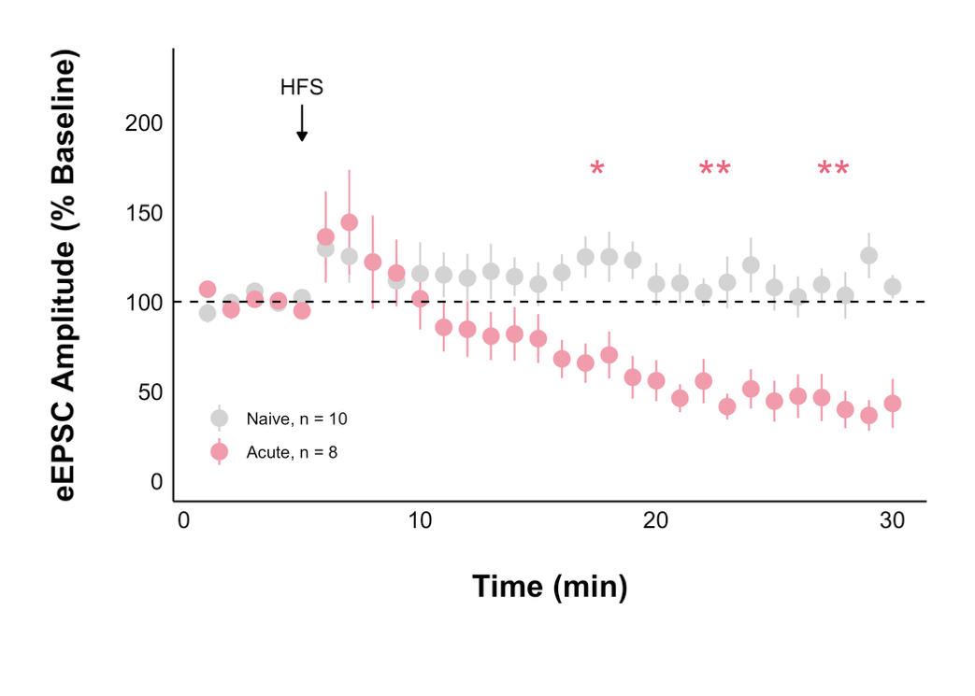
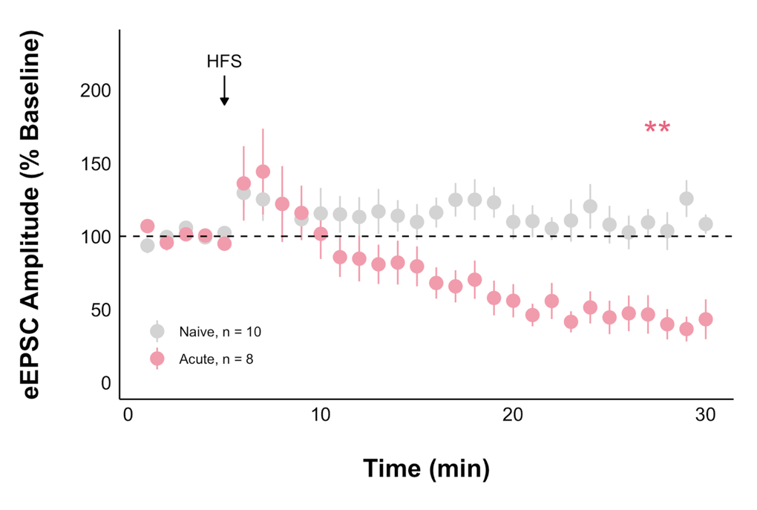

HFS mechanism
-baseline vs final PPR (naïve)
- baseline vs final PPR (acute)
*Presenting each as a paired t-test within the group*
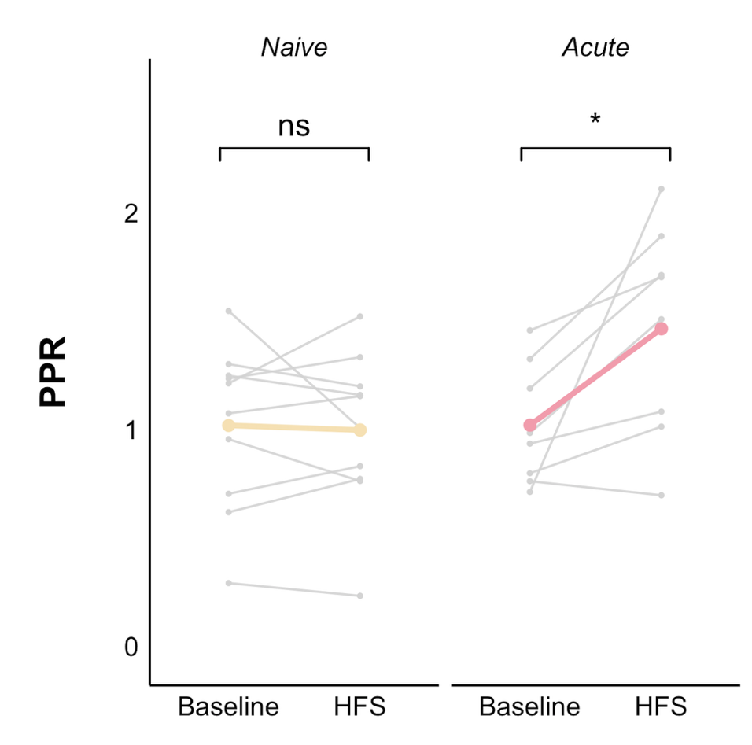

ENTER AM251
-summary plot
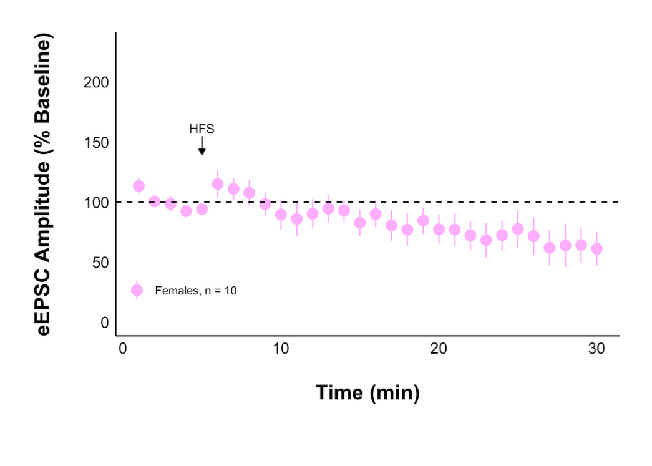
-PPR (before and after)
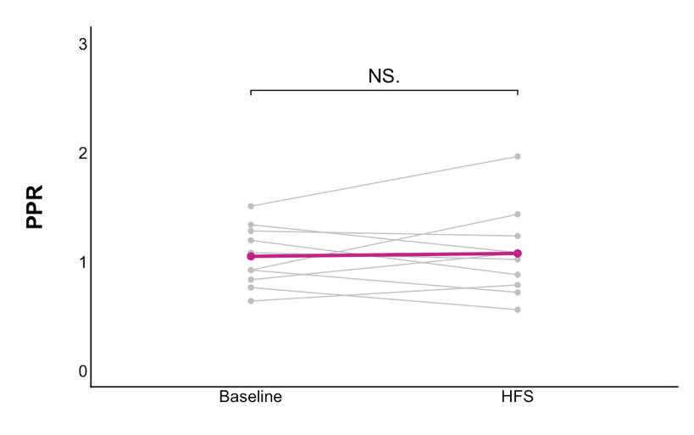
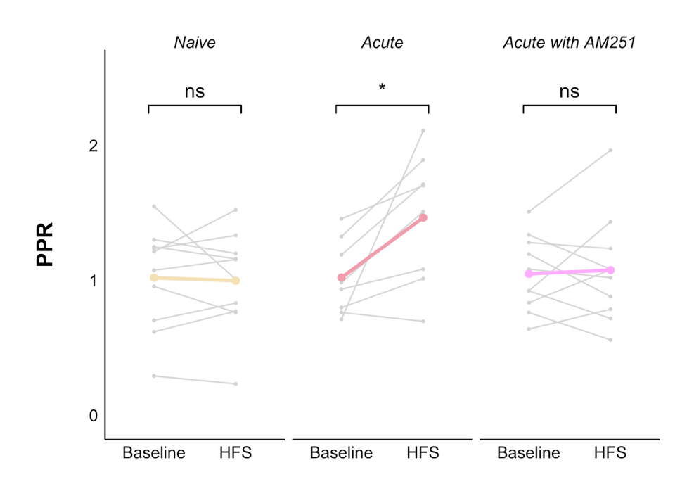

LET’S EXAMINE ACUTE MORE
-AP amplitude before and after (acute)
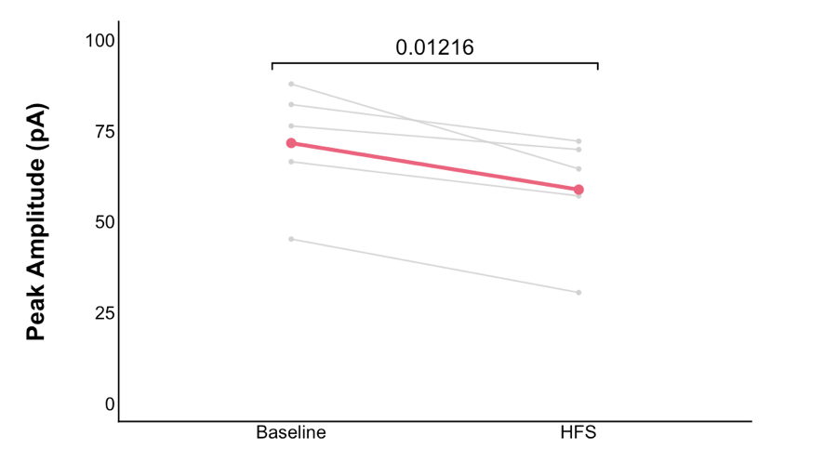
-AP amplitude before and after (AM251)
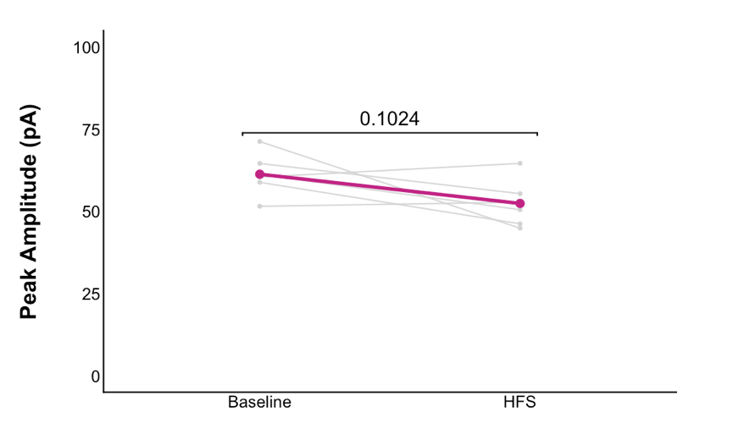

EXTRA/IDK
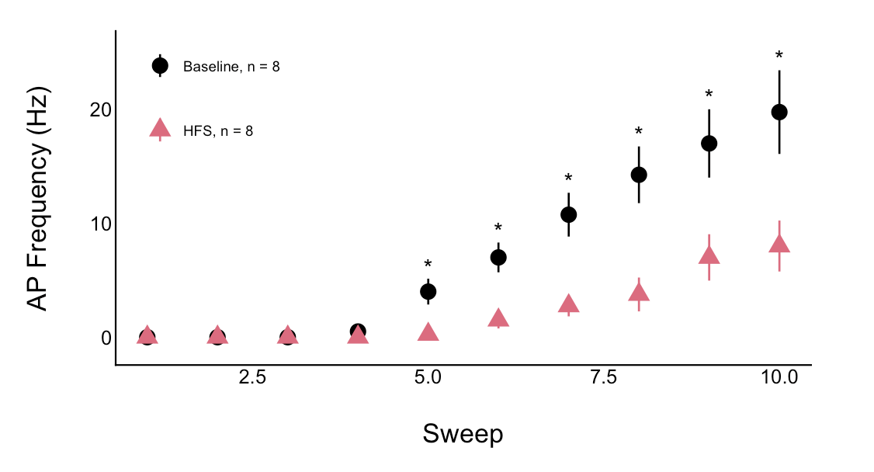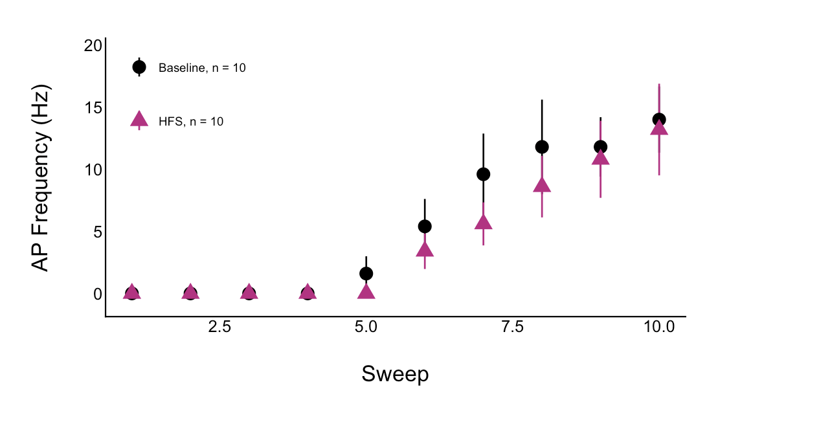
Haven’t figured out how to test assumptions so it is currently a Wilcoxon test.

Want to leave them somehow with AM251 being APART of this but not the WHOLE story… into the upcoming corticosterone experiments.

