Chapter 3: Results
3.1 Acute stress decreases basal glutamatergic transmission
To determine if an acute physical restraint affects glutamate signalling in the DMH, recordings of DMH neurons in hypothalamic slices from female Sprague-Dawley rats were obtained (Fig. 2). The amplitude of the evoked excitatory postsynaptic currents (eEPSC) was greater in acute stress (66.60125 ± 9.676361 pA) than naïve (41.51900 ± 5.877376 pA) neurons (t = -2.3144; df = 16; p = 0.03426; two sample t-test; Fig. 2A). However, this was not accompanied by a difference in the paired pulse ratio (PPR), an inverse measure of presynaptic neurotransmitter release probability, between naïve (1.02 ± 0.12) and acute stress (1.02 ± 0.10) neurons (t = -1.7424; df = 34; p = 0.09049; two sample t-test; Fig. 2B).

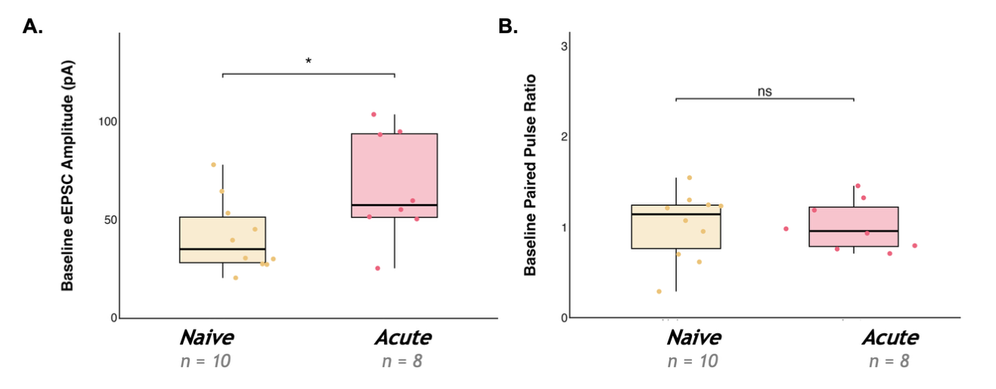
Figure 2. Acute stress increases basal glutamate current amplitude, independent of presynaptic glutamate release. Each point represents the mean A: evoked excitatory postsynaptic current amplitude (eEPSC) or B: paired pulse ratio (PPR) of a single neuron averaged over the baseline period (0-to-5 minutes). The horizontal line represents the median, the box represents the 25th to 75th percentile, and the vertical lines represent the upper and lower 25th percentiles. The asterisks indicate a statistically significant difference between groups (two sample t-test; * = p < 0.05).

To determine if the acute physical restraint affects passive membrane properties of DMH neurons, the membrane capacitance and resting membrane potential of acute stress neurons were compared to those of naïve neurons (Fig. 3). There was no difference in membrane capacitance (Fig. 3A), which is the ability of the neuron to store charge, nor in resting membrane potential (Fig. 3B), which determines intrinsic excitability.

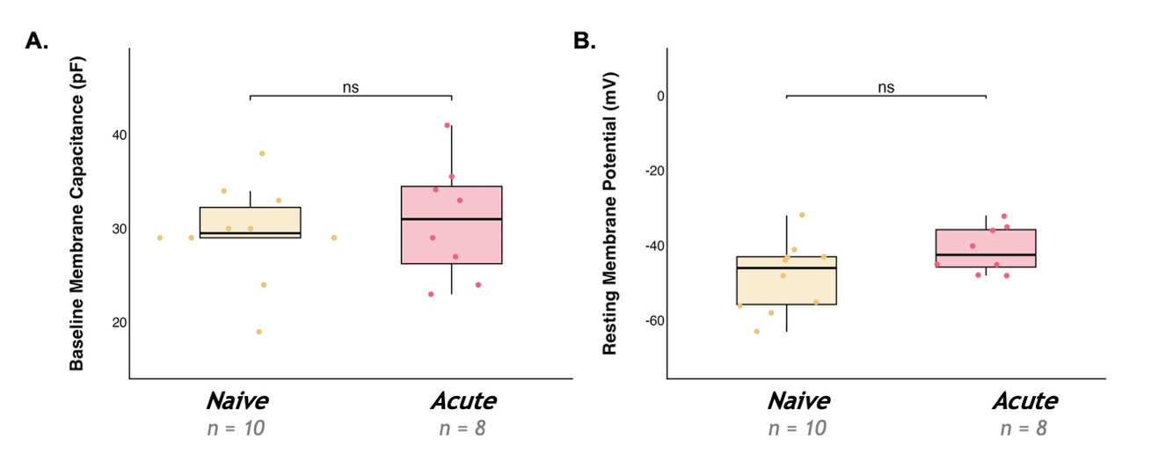
Figure 3. Acute stress does not change basal neuron size or excitability. Each point represents the mean A: membrane capacitance or B: resting membrane potential of a single neuron. The horizontal line represents the median, the box represents the 25th to 75th percentile, and the vertical lines represent the upper and lower 25th percentiles.

3.2 Acute stress results in long-term depression in response to high frequency stimulation
To determine whether stress alters the ability of DMH synapses to undergo activity-dependent plasticity, high-frequency stimulation (HFS) was applied to determine the effects on glutamate synapses (Table 1).

Table 1. Evoked excitatory postsynaptic current (eEPSC) amplitude varies over time, and this effect differs across groups following high frequency stimulation (HFS). Results of linear mixed-effects model examining eEPSC amplitude across groups (naïve, acute, acute with AM251, repeated) and time following high frequency stimulation (HFS), evaluated for significance at α = 0.05.
 | Numerator DF | Denominator DF | F-value | p-value
Group | 3 | 33 | 0.6853 | 0.5674
Time | 5 | 165 | 10.2715 | < 0.0001
Group x Time | 15 | 165 | 2.1958 | 0.0083

Because a significant interaction of group and time was detected, main effects were not directly interpreted. Instead, the effect of time within each group was examined using group-specific models (Table 2).

Table 2. Acute stress produces a time-dependent reduction in evoked excitatory postsynaptic current (eEPSC) amplitude. A: Within-group effects of time from group-specific linear mixed models, evaluated for significance at α = 0.05. B: Post hoc contrasts to baseline, evaluated at Bonferroni-adjusted α = 0.01.
A |  | Numerator DF | Denominator DF | F-value | p-value
 | Naïve | 5 | 45 | 2.0259 | 0.093
 | Acute Stress | 5 | 35 | 7.3222 | 0.0001
 | Acute Stress with AM251 | 5 | 45 | 2.7939 | 0.0279
 | Repeated Stress | 5 | 40 | 3.1615 | 0.0169
B | Interval | Group | DF | F-value | p-value
 | 5-to-10 min | Acute | 1, 7 | 0.8323 | 0.3919511
 | 10-to-15 min |  |  | 1.5804 | 0.2490239
 | 15-to-20 min |  |  | 9.0148 | 0.0198726
 | 20-to-25 min |  |  | 14.491 | 0.0066564
 | 25-to-30 min |  |  | 14.930 | 0.00618
 | 5-to-10 min | Acute with AM251 | 1, 9 | 0.6813 | 0.430472
 | 10-to-15 min |  |  | 0.5034 | 0.495999
 | 15-to-20 min |  |  | 1.1566 | 0.310160
 | 20-to-25 min |  |  | 2.4 | 0.15574
 | 25-to-30 min |  |  | 6.4939 | 0.031281
 | 5-to-10 min | Repeated | 1, 8 | 0.0199 | 0.342114
 | 10-to-15 min |  |  | 1.9508 | 0.200030
 | 15-to-20 min |  |  | 3.5638 | 0.095749
 | 20-to-25 min |  |  | 2.8729 | 0.128527
 | 25-to-30 min |  |  | 2.0476 | 0.190323

In naïve animals, there was no change in eEPSC amplitude, relative to baseline, following HFS at any time interval (final amplitude 109.98 ± 9.38% of baseline; linear mixed model; df = 5, 45; F = 2.0259; p = 0.093; Fig. 4).

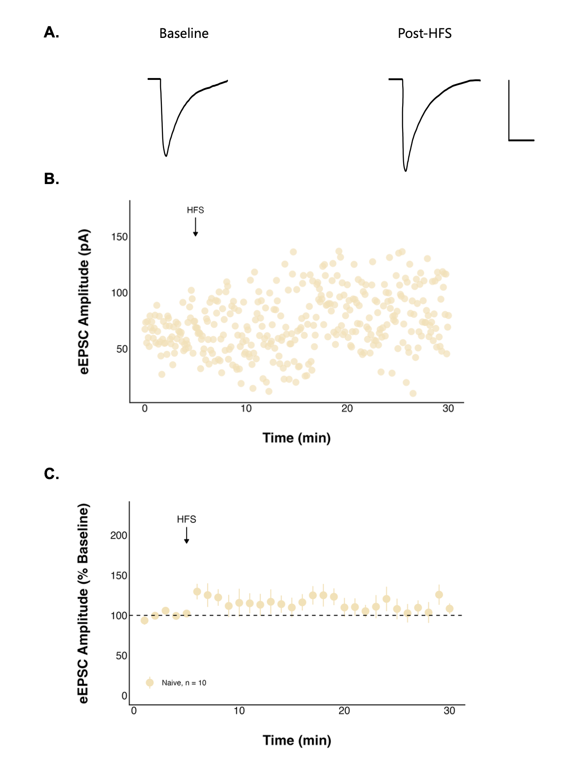
Figure 4. High frequency stimulation (HFS) has no effect on evoked excitatory postsynaptic current (eEPSC) amplitude in naïve neurons. A: Representative traces consisting of eEPSCs from one neuron averaged over the baseline period (0-to-5 minutes) and last period (25-to-30 minutes) of the recording with a scale bar that represents 50 pA/10 msec, and B: a representative recording from one neuron. C: Summary data in which each point represents the eEPSC amplitude ± standard error across all neurons and n represents the number of unique neurons.

Additionally, neither the paired pulse ratio (PPR) (1.02 ± 0.12 at baseline to 1.00 ± 0.12 post-HFS; n = 10; t = -0.28857; df = 9; p = 0.7794; paired t-test; Fig. 5A) nor the coefficient of variation (t = -2.0771; df = 9; p = 0.06758; paired t-test; Fig. 5B) changed over time in naïve neurons.

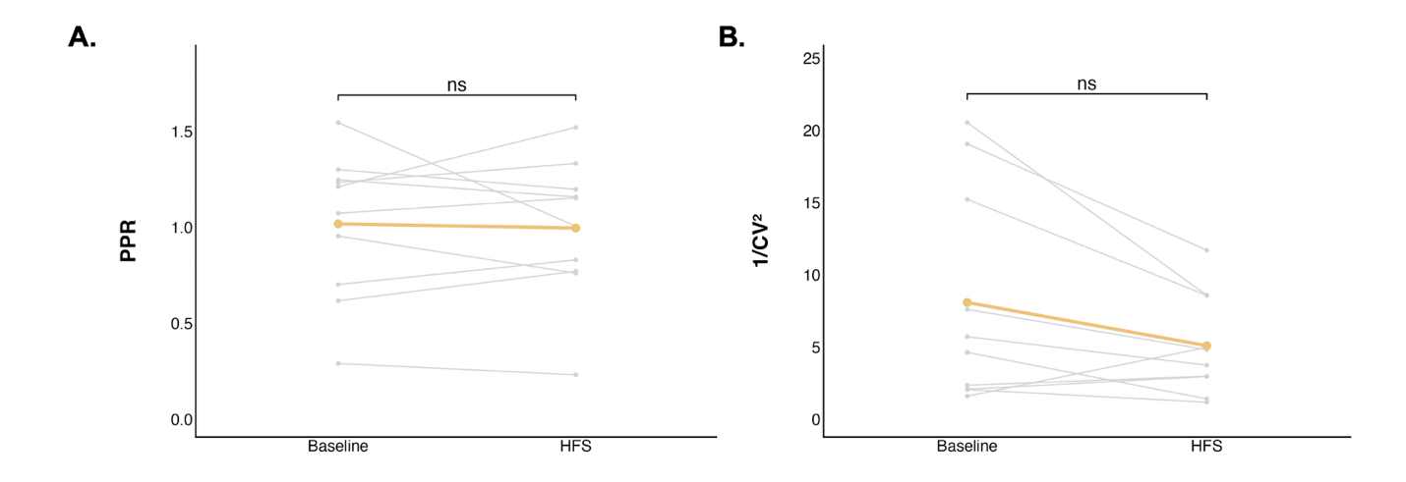
Figure 5. The paired pulse ratio (PPR) and coefficient of variation did not change significantly after high frequency stimulation (HFS) in naïve neurons. Each grey point (n = 10) represents the mean A: PPR or B: coefficient of variation of a single neuron averaged over the baseline period (0-to-5 minutes) or the final period (25-to-30 minutes). The coloured line represents the mean PPR or coefficient of variation ± standard error for the group.

To determine if stress alters neuronal excitability, a current clamp steps protocol was performed before and after HFS. Action potential peak amplitude did not decrease following HFS in naïve neurons (n = 3; t = 3.7555; df = 2; p = 0.06416; paired t-test; Fig. 6). Further, action potential frequency at various current injections was compared between the baseline and post-HFS periods (Table 3). While there was a significant overall effect on action potential frequency post-HFS compared to baseline, this was not significant in naïve neurons (df = 1, 56; F = 2.074709; p = 0.1553; Table 4).

Table 3. Action potential (AP) frequency differs between baseline and post-high frequency stimulation (HFS) states across groups. Results of a linear mixed-effects model assessing AP frequency by group and state (baseline and post-HFS), evaluated for significance at α = 0.05.
 | Numerator DF | Denominator DF | F-value | p-value
Group | 4 | 32 | 0.16829 | 0.9530
State | 1 | 698 | 27.81099 | < 0.0001
Group x State | 4 | 698 | 2.22751 | 0.0645

Table 4. Acute stress produces a decrease in action potential (AP) frequency following high frequency stimulation (HFS). Within-group effects of state (baseline vs post-HFS) on AP frequency from group-specific linear mixed-effect models, evaluated for significance at α = 0.05.
Group | Numerator DF | Denominator DF | F-value | p-value
Naive | 1 | 56 | 2.074709 | 0.1553
Acute | 1 | 151 | 22.10576 | < 0.0001
Acute with AM251 | 1 | 189 | 1.485248 | 0.2245
Repeated | 1 | 170 | 2.446259 | 0.1197

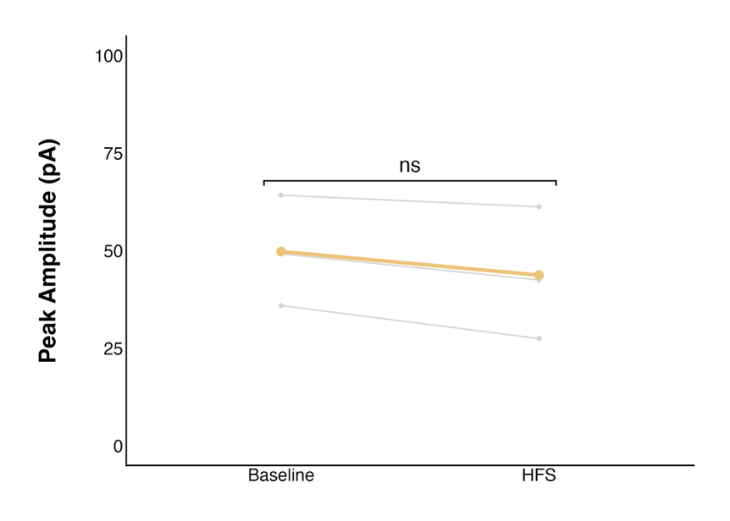
Figure 6. The action potential (AP) peak amplitude did not change significantly after high frequency stimulation (HFS) in naïve neurons. Each grey point (n = 3) represents the mean AP peak amplitude of a single neuron averaged over the baseline period (0-to-5 minutes) or the final period (25-to-30 minutes). The coloured line represents the mean AP peak amplitude ± standard error for the group.

In neurons from animals exposed to acute stress, HFS elicited a significant long-term depression (LTD) in the strength of glutamate synapses when compared to baseline (df = 5, 35; F = 7.3222; p = 0.0001; linear mixed model). Post hoc contrasts revealed that eEPSC amplitude was significantly reduced relative to baseline during the 20-to-25 (F = 14.491; p = 0.0066564; evaluated against α = 0.01; Fig. 7) and 25-to-30-minute periods (F = 14.930; p = 0.00618; evaluated against α = 0.01; Fig. 7), with a final amplitude of 42.67 ± 11.37% of baseline.

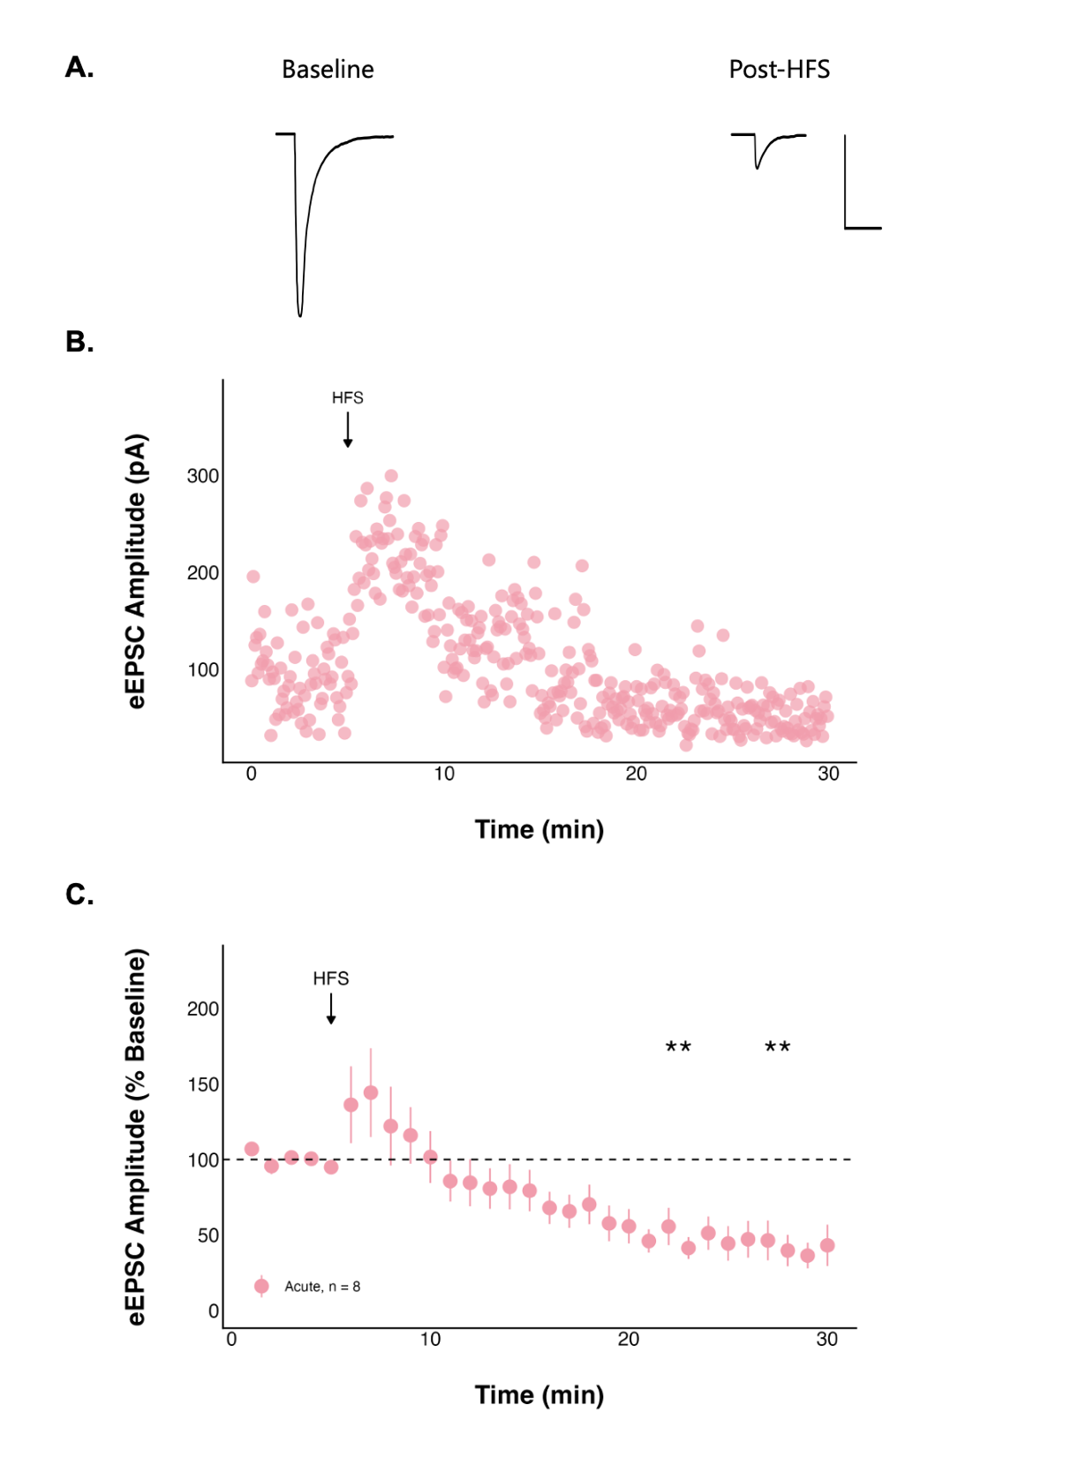
Figure 7. High frequency stimulation (HFS) following acute stress decreases evoked excitatory postsynaptic current (eEPSC) amplitude over time. A: Representative traces consisting of eEPSCs from one neuron averaged over the baseline period (0-to-5 minutes) and last period (25-to-30 minutes) of the recording with a scale bar that represents 50 pA/10 msec, and B: a representative recording from one neuron. C: Summary data in which each point represents the eEPSC amplitude ± standard error across all neurons and n represents the number of unique neurons. The asterisks indicate a statistically significant change in current amplitude relative to the baseline (post hoc contrast; ** = p < 0.01).

PPR increased significantly over time in neurons from animals exposed to acute stress (1.02 ± 0.10 at baseline to 1.46 ± 0.17 post-HFS; n = 8; t = 2.8363; df = 7; p = 0.02518; paired t-test; Fig. 8A), consistent with a decreased probability of presynaptic glutamate release. In contrast, the coefficient of variation did not change (t = -2.2068; df = 7; p = 0.06309; paired t-test, Fig. 8B).

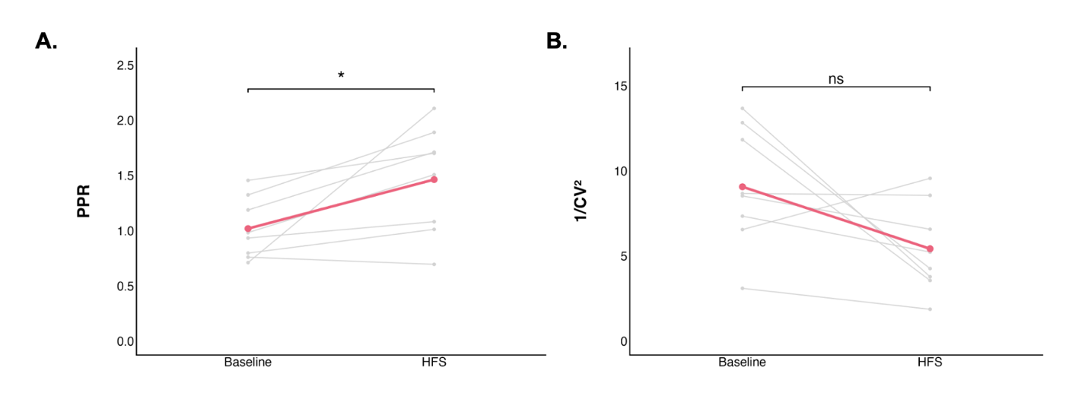
Figure 8. The paired pulse ratio (PPR) significantly increased, and coefficient of variation did not change after high frequency stimulation (HFS) following acute stress. Each grey point (n = 8) represents the mean A: PPR or B: coefficient of variation of a single neuron averaged over the baseline period (0-to-5 minutes) or the final period (25-to-30 minutes). The coloured line represents the mean PPR or coefficient of variation ± standard error for the group. The asterisks indicate a statistically significant change in PPR relative to the baseline (paired t-test; * = p < 0.05).

Action potential peak amplitude significantly decreased following HFS after an acute stressor (t = 4.3501; df = 4; p = 0.01216; paired t-test; Fig. 9). Additionally, a significant decrease in action potential frequency post-HFS was found in neurons from animals exposed to acute stress (df = 1, 151; F = 22.10576; p < 0.0001).

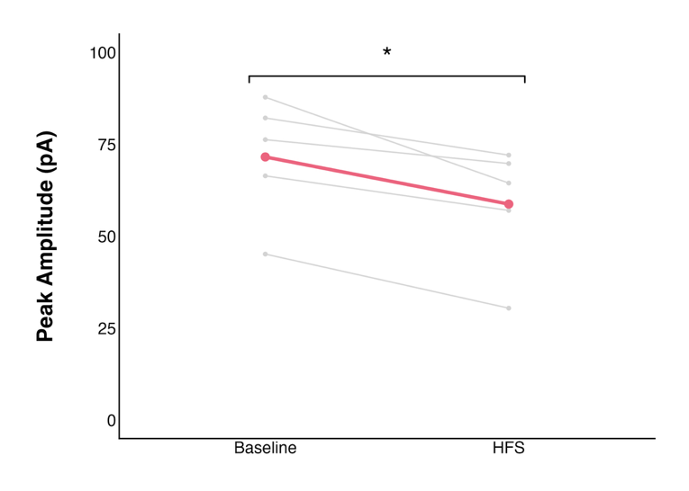
Figure 9. The action potential (AP) peak amplitude significantly decreased after high frequency stimulation (HFS) following acute stress. Each grey point (n = 5) represents the mean AP peak amplitude of a single neuron averaged over the baseline period (0-to-5 minutes) or the final period (25-to-30 minutes). The coloured line represents the mean AP peak amplitude ± standard error for the group. Paired t-test; * = p < 0.05.

3.3 The type I cannabinoid receptor mediates the long-term depression observed in acute stress neurons
Acute stress induced a long-term depression (LTD) of excitatory synaptic transmission. Given that endocannabinoid signalling mediates suppression of glutamate release, we next tested whether the endocannabinoid CB1 receptors contribute to this effect using AM251 (5 µM), a CB1R inverse agonist (Fig. 10). Despite undergoing acute stress, when CB1 receptors were blocked there was no significant change in eEPSC amplitude relative to baseline during any time interval (final amplitude 64.43 ± 14.71% of baseline). Additionally, neither the PPR (PPR: 1.05 ± 0.09 at baseline to 1.07 ± 0.13 post-HFS; n = 10; t = 0.29187; df = 9; p = 0.777; paired t-test; Fig. 11A), nor the coefficient of variation (t = 1.0427; df = 9; p = 0.3243; paired t-test; Fig. 11B) changed.
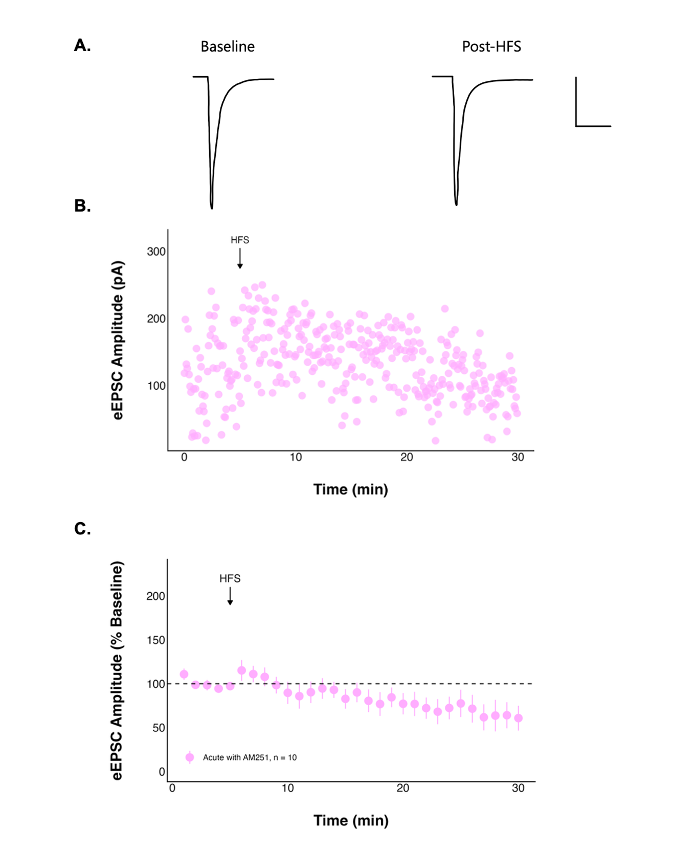
Figure 10. The effect of high frequency stimulation (HFS) on evoked excitatory postsynaptic current (eEPSC) amplitude over time following acute stress is no longer seen when CB1 receptors are blocked. A: Representative traces consisting of eEPSCs from one neuron averaged over the baseline period (0-to-5 minutes) and last period (25-to-30 minutes) of the recording with a scale bar that represents 50 pA/10 msec, and B: a representative recording from one neuron. C: Summary data in which each point represents the eEPSC amplitude ± standard error across all neurons and n represents the number of unique neurons.

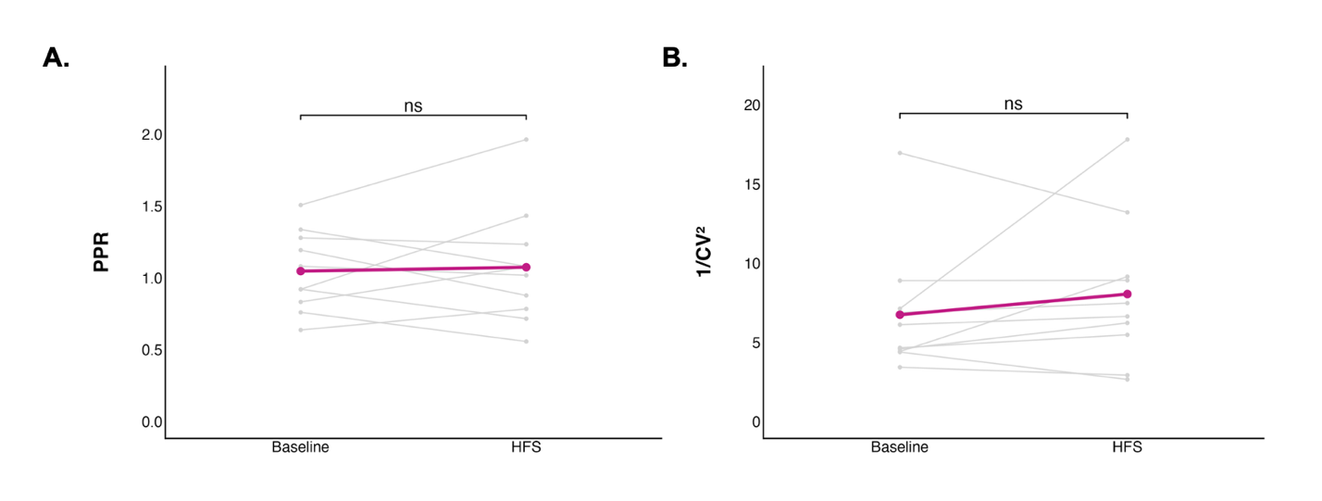
Figure 11. The paired pulse ratio (PPR) and coefficient of variation did not change significantly after high frequency stimulation (HFS) following acute stress when CB1 receptors were blocked. Each grey point (n = 10) represents the mean A: PPR or B: coefficient of variation of a single neuron averaged over the baseline period (0-to-5 minutes) or the final period (25-to-30 minutes). The coloured line represents the mean PPR or coefficient of variation ± standard error for the group.

Despite acute stress, when CB1 receptors were blocked action potential peak amplitude did not significantly change following HFS (t = 1.9964; df = 5; p = 0.1024; paired t-test; Fig. 12), nor did action potential frequency (df = 1, 189; F = 1.485248; p = 0.2245).

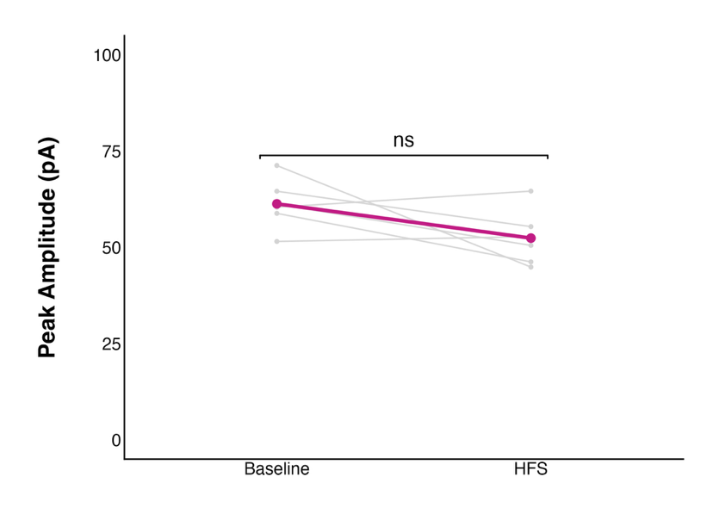
Figure 12. The action potential (AP) peak amplitude did not change significantly after high frequency stimulation (HFS) following acute stress when CB1 receptors were blocked. Each grey point (n = 5) represents the mean AP peak amplitude of a single neuron averaged over the baseline period (0-to-5 minutes) or the final period (25-to-30 minutes). The coloured line represents the mean AP peak amplitude ± standard error for the group.

3.4 Repeated stress does not alter glutamatergic transmission in DMH neurons of young female rats
To determine if five consecutive days of a 30-minute physical restraint affects glutamate signalling in the DMH, recordings of DMH neurons in hypothalamic slices were obtained. Unlike in acute stress, eEPSC amplitude did not change significantly after HFS (final amplitude 74.00 ± 12.34% of baseline; Fig. 13), nor in the PPR (1.29 ± 0.18 at baseline to 1.35 ± 0.22 post-HFS; n = 9; t = 0.53352; df = 8; p = 0.6082; paired t-test; Fig. 14A) or coefficient of variation (t = 0.32925, df = 8, p = 0.7504; paired t-test; Fig. 14B).
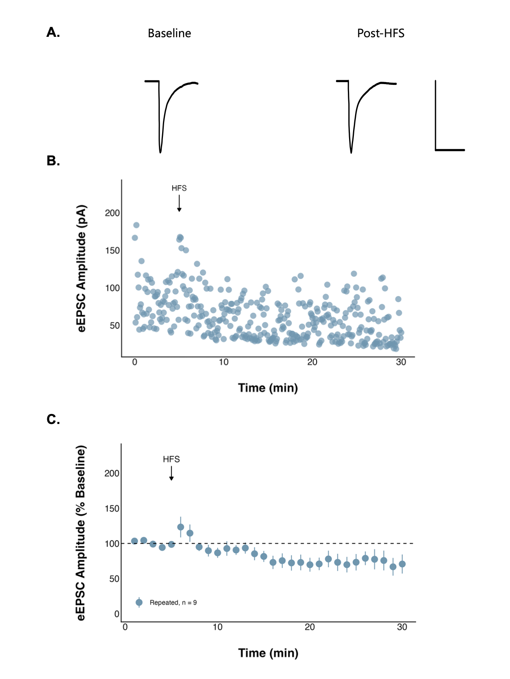
Figure 13. High frequency stimulation (HFS) has no effect on evoked excitatory postsynaptic current (eEPSC) amplitude over time following repeated stress. A: Representative traces consisting of eEPSCs from one neuron averaged over the baseline period (0-to-5 minutes) and last period (25-to-30 minutes) of the recording with a scale bar that represents 50 pA/10 msec, and B: a representative recording from one neuron. C: Summary data in which each point represents the eEPSC amplitude ± standard error across all neurons and n represents the number of unique neurons.

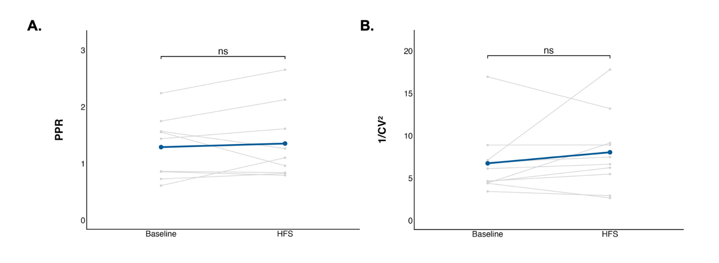
Figure 14. The paired pulse ratio (PPR) and coefficient of variation did not change significantly after high frequency stimulation (HFS) following repeated stress. Each grey point (n = 9) represents the mean A: PPR or B: coefficient of variation of a single neuron averaged over the baseline period (0-to-5 minutes) or the final period (25-to-30 minutes). The coloured line represents the mean PPR or coefficient of variation ± standard error for the group.

Although eEPSC amplitude did not change following repeated stress, action potential peak amplitude decreased significantly following HFS (t = 3.9281; df = 8; p = 0.004368; paired t-test; Fig. 15). This was not accompanied by a significant change in action potential frequency (df = 1, 170; F = 2.446259; p = 0.1197).

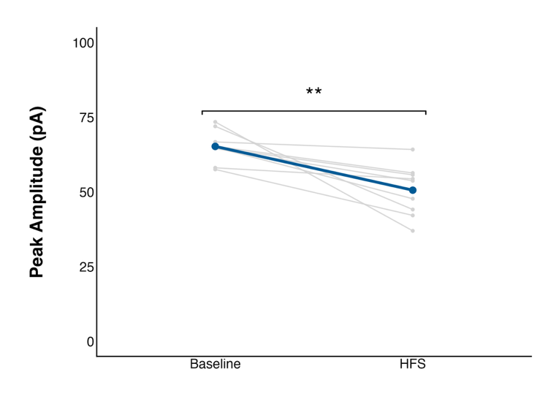
Figure 15. The action potential (AP) peak amplitude significantly decreased after high frequency stimulation (HFS) following repeated stress. Each grey point (n = 9) represents the mean AP peak amplitude of a single neuron averaged over the baseline period (0-to-5 minutes) or the final period (25-to-30 minutes). The coloured line represents the mean AP peak amplitude ± standard error for the group. ** = p < 0.01.

