Results
Basal glutamatergic transmission did not differ significantly across groups
To determine if physical restraint affects glutamate signalling in the DMH, recordings of DMH neurons in hypothalamic slices from female Sprague-Dawley rats were obtained (Fig. 1). The amplitude of the evoked excitatory postsynaptic currents (eEPSC) was measured and compared across naïve, acute stress, acute stress with AM251, and repeated stress groups, and did not differ (chi-squared = 5.9114, df = 3, p = 0.116, Kruskal-Wallis test; Fig. 1).

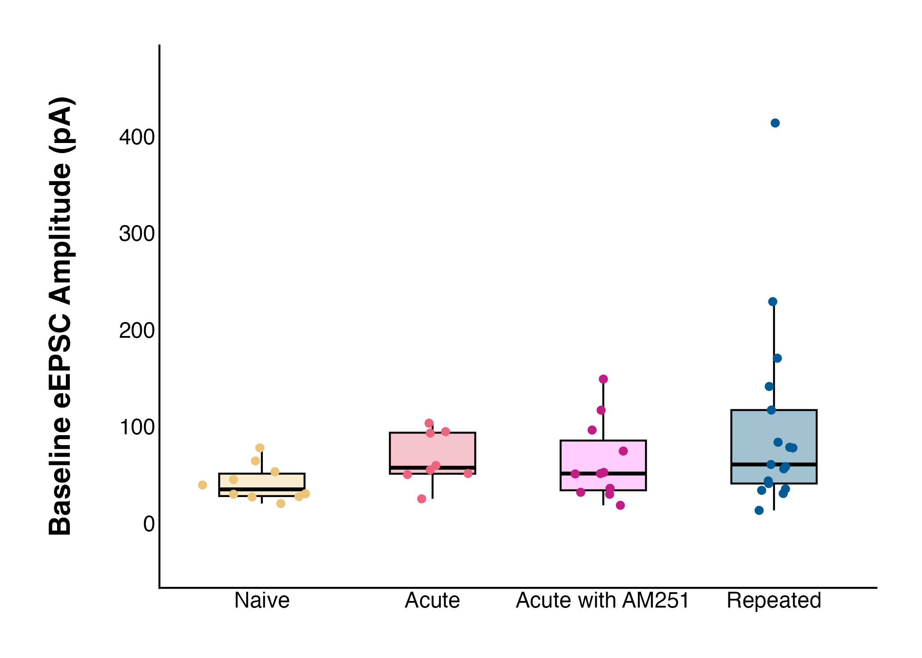
Figure 1. The strength of basal glutamatergic current amplitude does not differ between groups. Naïve (n = 10, 41.51900 ± 5.877376 pA), acute stress (n = 8, 66.60125 ± 9.676361), acute stress with AM251 (n = 11, 64.33000 ± 12.305890 pA), or repeated stress (n = 17, 99.10706 ± 23.944009 pA).

Acute stress results in long-term depression in response to high frequency stimulation
To determine whether stress alters the ability of DMH synapses to undergo activity-dependent plasticity, high-frequency stimulation (HFS) was applied to determine the effects on glutamate synapses (Table 1). Because a significant interaction of group and time was detected, main effects were not directly interpreted. Instead, the effect of time within each group was examined using group-specific models (Table 2).

Table 1. Evoked excitatory postsynaptic current (eEPSC) amplitude varies over time, and this effect differs across groups following high frequency stimulation (HFS). Results of linear mixed-effects model examining eEPSC amplitude across groups (naïve, acute, acute with AM251, repeated) and time following high frequency stimulation (HFS), evaluated for significance at α = 0.05.
 | Numerator DF | Denominator DF | F-value | p-value
Group | 3 | 33 | 0.6853 | 0.5674
Time | 5 | 165 | 10.2715 | < 0.0001
Group x Time | 15 | 165 | 2.1958 | 0.0083

Table 2. Acute stress produces a time-dependent reduction in evoked excitatory postsynaptic current (eEPSC) amplitude. A: Within-group effects of time from group-specific linear mixed models, evaluated for significance at α = 0.05. B: Post hoc contrasts to baseline, evaluated at Bonferroni-adjusted α = 0.01.
A |  | Numerator DF | Denominator DF | F-value | p-value
 | Naïve | 5 | 45 | 2.0259 | 0.093
 | Acute Stress | 5 | 35 | 7.3222 | 0.0001
 | Acute Stress with AM251 | 5 | 45 | 2.7939 | 0.0279
 | Repeated Stress | 5 | 40 | 3.1615 | 0.0169
B | Interval | Group | DF | F-value | p-value
 | 5-to-10 min | Acute | 1, 7 | 0.8323 | 0.3919511
 | 10-to-15 min |  |  | 1.5804 | 0.2490239
 | 15-to-20 min |  |  | 9.0148 | 0.0198726
 | 20-to-25 min |  |  | 14.491 | 0.0066564
 | 25-to-30 min |  |  | 14.930 | 0.00618
 | 5-to-10 min | Acute with AM251 | 1, 9 | 0.6813 | 0.430472
 | 10-to-15 min |  |  | 0.5034 | 0.495999
 | 15-to-20 min |  |  | 1.1566 | 0.310160
 | 20-to-25 min |  |  | 2.4 | 0.15574
 | 25-to-30 min |  |  | 6.4939 | 0.031281
 | 5-to-10 min | Repeated | 1, 8 | 0.0199 | 0.342114
 | 10-to-15 min |  |  | 1.9508 | 0.200030
 | 15-to-20 min |  |  | 3.5638 | 0.095749
 | 20-to-25 min |  |  | 2.8729 | 0.128527
 | 25-to-30 min |  |  | 2.0476 | 0.190323

In naïve animals, there was no change in amplitude of evoked EPSCs following HFS at any time interval (final amplitude 109.98 ± 9.38% of baseline; linear mixed model; df = 5, 45; F = 2.0259; p = 0.093; Fig. 2).

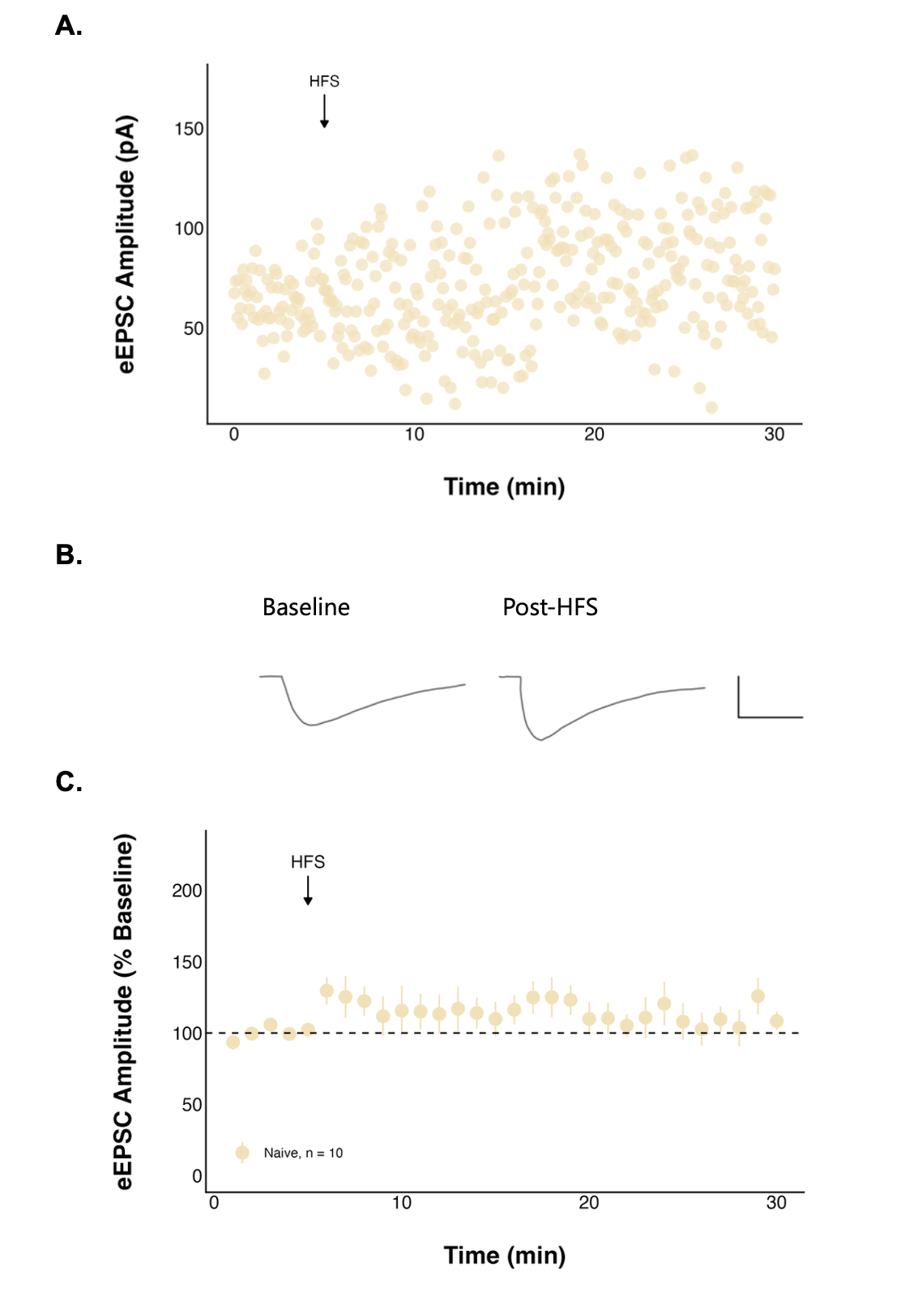
Figure 2. High frequency stimulation (HFS) has no effect on evoked excitatory postsynaptic current (eEPSC) amplitude over time in naïve neurons. A: A representative neuron and B: representative traces consisting of eEPSC from one neuron averaged over the baseline period (0-to-5 minutes) and last period (25-to-30 minutes) of the recording, and the scale bar represents 50 pA/5 msec. C: Summary data in which each point represents the eEPSC amplitude ± standard error across all neurons and n represents the number of unique neurons.

Additionally, neither the paired pulse ratio (PPR), an inverse measure of presynaptic neurotransmitter release probability, (1.02 ± 0.12 at baseline to 1.00 ± 0.12 post-HFS; n = 10; t = -0.28857; df = 9; p = 0.7794; paired t-test; Fig. 3A) nor the coefficient of variation (t = -2.0771; df = 9; p = 0.06758; paired t-test; Fig. 3B) changed over time in naïve neurons.

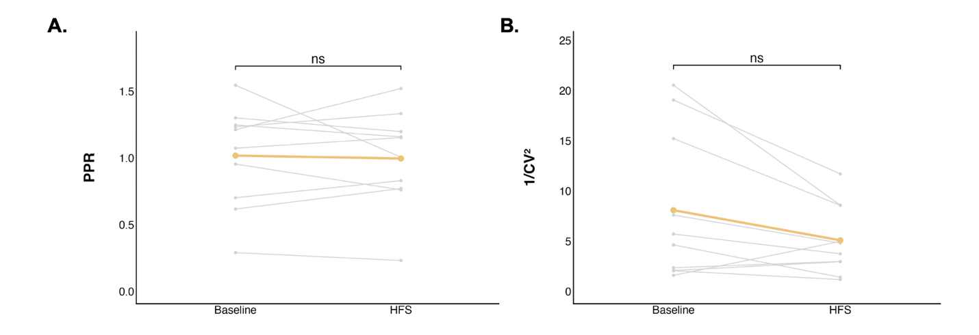
Figure 3. The paired pulse ratio (PPR) and coefficient of variation did not change significantly after high frequency stimulation (HFS) in naïve neurons. Each grey point represents the mean A: PPR or B: coefficient of variation of a single neuron averaged over the baseline period (0-to-5 minutes) or the final period (25-to-30 minutes). The coloured line represents the mean PPR or coefficient of variation ± standard error for the group.

To determine if stress alters neuronal excitability, a current clamp steps protocol was performed before and after HFS. Action potential peak amplitude did not decrease following HFS in naïve neurons (t = 3.7555; df = 2; p = 0.06416; paired t-test; Fig. 4). Further, action potential frequency at various current injections was compared between the baseline and post-HFS periods (Table 3). While there was an overall significant decrease in action potential frequency post-HFS compared to baseline, this was not significant in naïve neurons (df = 1, 56; F = 2.074709; p = 0.1553; Table 4).

Table 3. Action potential (AP) frequency differs between baseline and post-high frequency stimulation (HFS) states across groups. Results of a linear mixed-effects model assessing AP frequency by group and state (baseline and post-HFS), evaluated for significance at α = 0.05.
 | Numerator DF | Denominator DF | F-value | p-value
Group | 4 | 32 | 0.16829 | 0.9530
State | 1 | 698 | 27.81099 | < 0.0001
Group x State | 4 | 698 | 2.22751 | 0.0645

Table 4. Acute stress produces a decrease in action potential (AP) frequency following high frequency stimulation (HFS). Within-group effects of state (baseline vs post-HFS) on AP frequency from group-specific linear mixed-effect models, evaluated for significance at α = 0.05.
Group | Numerator DF | Denominator DF | F-value | p-value
Naive | 1 | 56 | 2.074709 | 0.1553
Acute | 1 | 151 | 22.10576 | < 0.0001
Acute with AM251 | 1 | 189 | 1.485248 | 0.2245
Repeated | 1 | 170 | 2.446259 | 0.1197

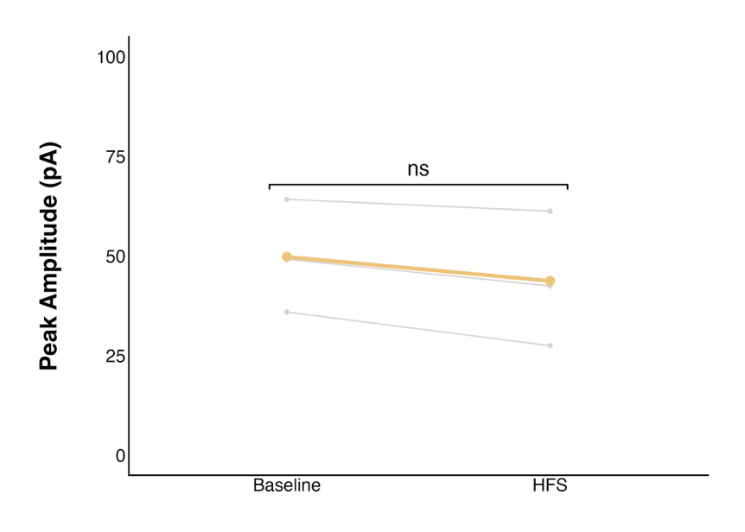
Figure 4. The action potential (AP) peak amplitude did not change significantly after high frequency stimulation (HFS) in naïve neurons. Each grey point represents the mean AP peak amplitude of a single neuron averaged over the baseline period (0-to-5 minutes) or the final period (25-to-30 minutes). The coloured line represents the mean AP peak amplitude ± standard error for the group.

In neurons from animals exposed to acute stress, HFS elicited a significant long-term depression (LTD) in the strength of glutamate synapses when compared to baseline (df = 5, 35; F = 7.3222; p = 0.0001; linear mixed model). Post hoc contrasts revealed that eEPSC amplitude was significantly reduced relative to baseline during the 20-to-25 (F = 14.491; p = 0.0066564; evaluated against α = 0.01; Fig. 5) and 25-to-30-minute periods (F = 14.930; p = 0.00618; evaluated against α = 0.01; Fig. 5), with a final amplitude of 42.67 ± 11.37% of baseline.

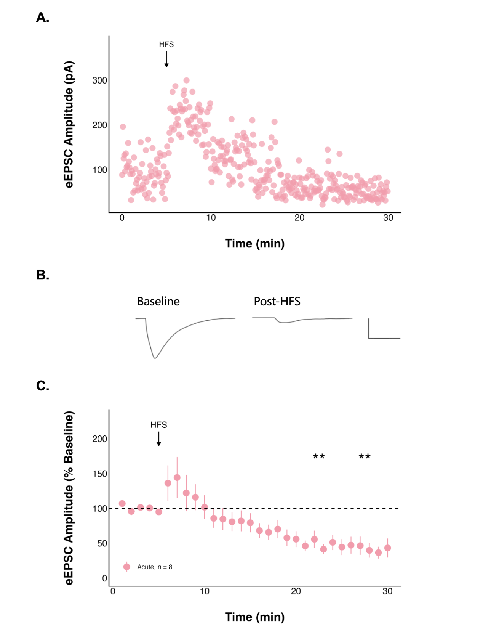
Figure 5. High frequency stimulation (HFS) following acute stress decreases evoked excitatory postsynaptic current (eEPSC) amplitude over time. A: A representative neuron and B: representative traces consisting of eEPSC from one neuron averaged over the baseline period (0-to-5 minutes) and last period (25-to-30 minutes) of the recording, and the scale bar represents 50 pA/5 msec. C: Summary data in which each point represents the eEPSC amplitude ± standard error across all neurons and n represents the number of unique neurons. The asterisks indicate a statistically significant change in current amplitude relative to the baseline (post hoc contrast; ** = p < 0.01).

PPR increased significantly over time in neurons from animals exposed to acute stress (1.02 ± 0.10 at baseline to 1.46 ± 0.17 post-HFS; n = 8; t = 2.8363; df = 7; p = 0.02518; paired t-test; Fig. 6A), consistent with a decreased probability of presynaptic glutamate release. In contrast, the coefficient of variation did not change (t = -2.2068; df = 7; p = 0.06309; paired t-test, Fig. 6B).

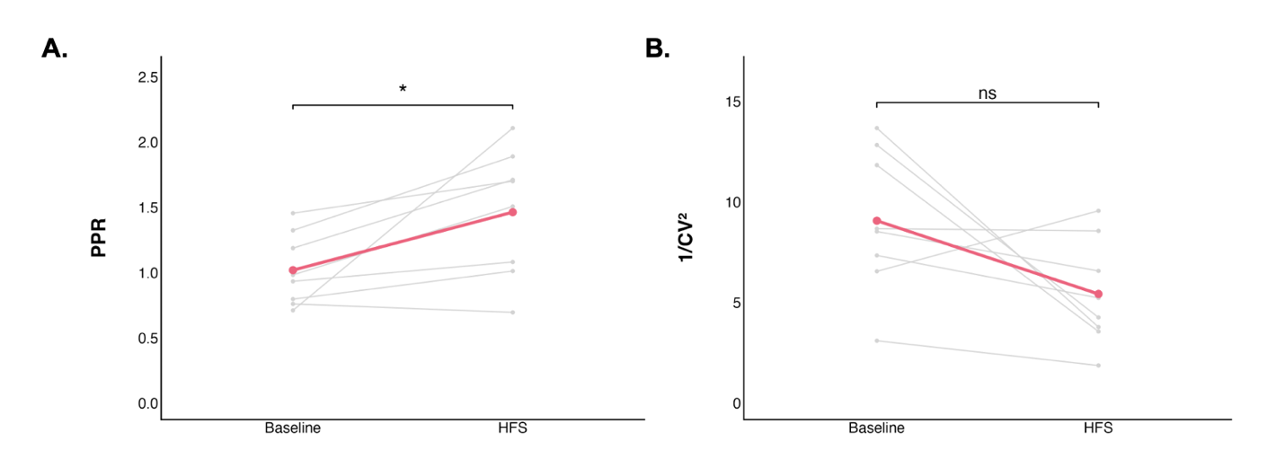
Figure 6. The paired pulse ratio (PPR) significantly increased and coefficient of variation did not change after high frequency stimulation (HFS) following acute stress. Each grey point represents the mean A: PPR or B: coefficient of variation of a single neuron averaged over the baseline period (0-to-5 minutes) or the final period (25-to-30 minutes). The coloured line represents the mean PPR or coefficient of variation ± standard error for the group. The asterisks indicate a statistically significant change in PPR relative to the baseline (paired t-test; * = p < 0.05).

Action potential peak amplitude significantly decreased following HFS after an acute stressor (t = 4.3501; df = 4; p = 0.01216; paired t-test; Fig. 7). Additionally, a significant decrease in action potential frequency post-HFS was found in neurons from animals exposed to acute stress (df = 1, 151; F = 22.10576; p < 0.0001).

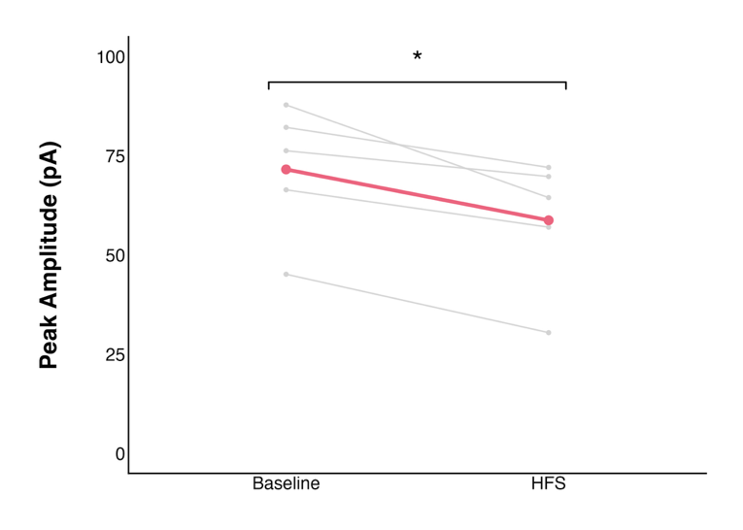
Figure 7. The action potential (AP) peak amplitude significantly decreased after high frequency stimulation (HFS) following acute stress. Each grey point represents the mean AP peak amplitude of a single neuron averaged over the baseline period (0-to-5 minutes) or the final period (25-to-30 minutes). The coloured line represents the mean AP peak amplitude ± standard error for the group. Paired t-test; * = p < 0.05.

The type I cannabinoid receptor mediates the LTD observed in acutely stressed neurons
Acute stress induced a long-term depression (LTD) of excitatory synaptic transmission. Given that endocannabinoid signalling mediates suppression of glutamate release, we next tested whether the endocannabinoid CB1 receptors contribute to this effect using AM251 (5 µM), a CB1R inverse agonist (Fig. 8). Despite undergoing acute stress, when CB1 receptors were blocked there was no significant change in eEPSC amplitude relative to baseline during any time interval (final amplitude 64.43 ± 14.71% of baseline). Additionally, neither the PPR (PPR: 1.05 ± 0.09 at baseline to 1.07 ± 0.13 post-HFS; n = 10; t = 0.29187; df = 9; p = 0.777; paired t-test; Fig. 9A), nor the coefficient of variation (t = 1.0427; df = 9; p = 0.3243; paired t-test; Fig. 9B) changed.
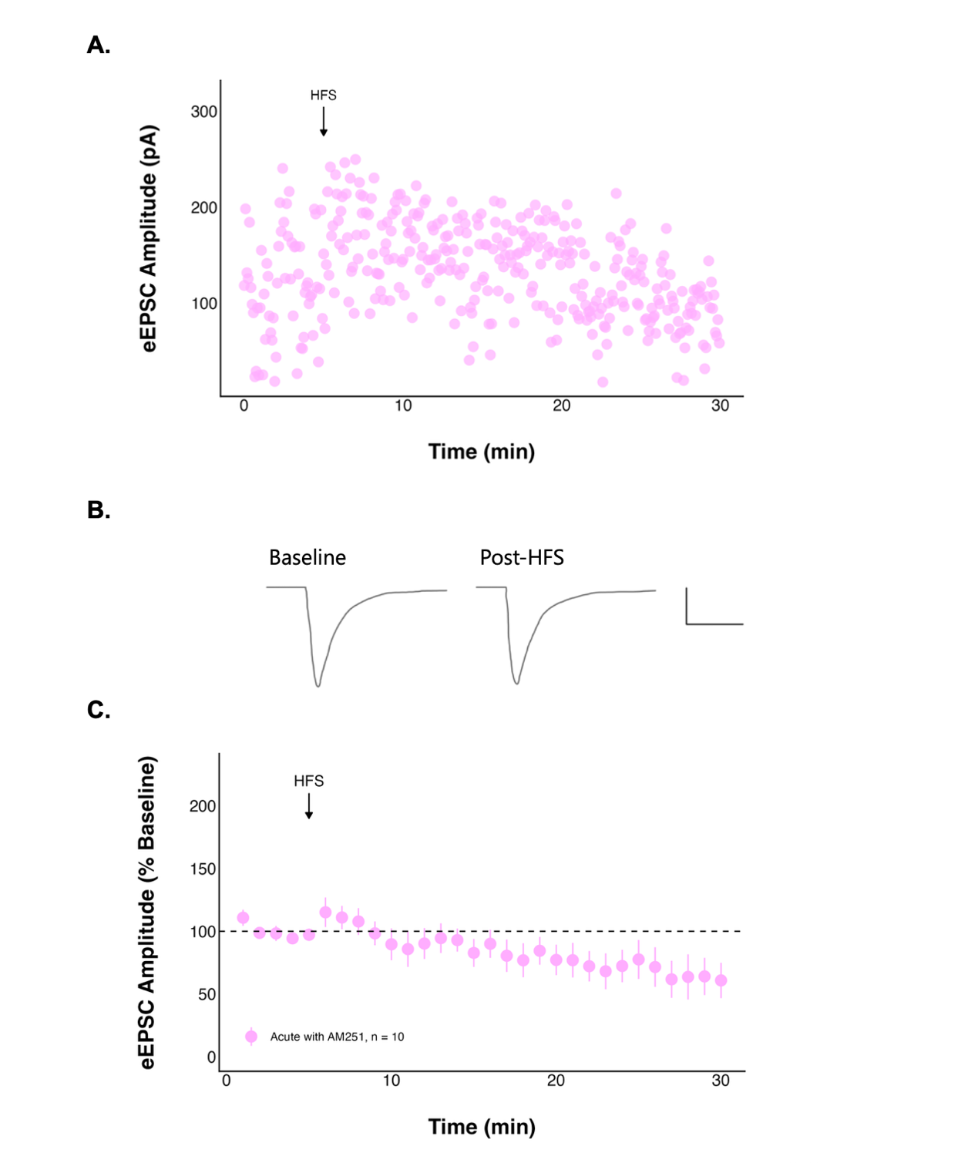
Figure 8. The effect of high frequency stimulation (HFS) on evoked excitatory postsynaptic current (eEPSC) amplitude over time following acute stress is no longer seen when CB1 receptors are blocked. A: A representative neuron and B: representative traces consisting of eEPSC from one neuron averaged over the baseline period (0-to-5 minutes) and last period (25-to-30 minutes) of the recording, and the scale bar represents 50 pA/5 msec. C: Summary data in which each point represents the eEPSC amplitude ± standard error across all neurons and n represents the number of unique neurons.
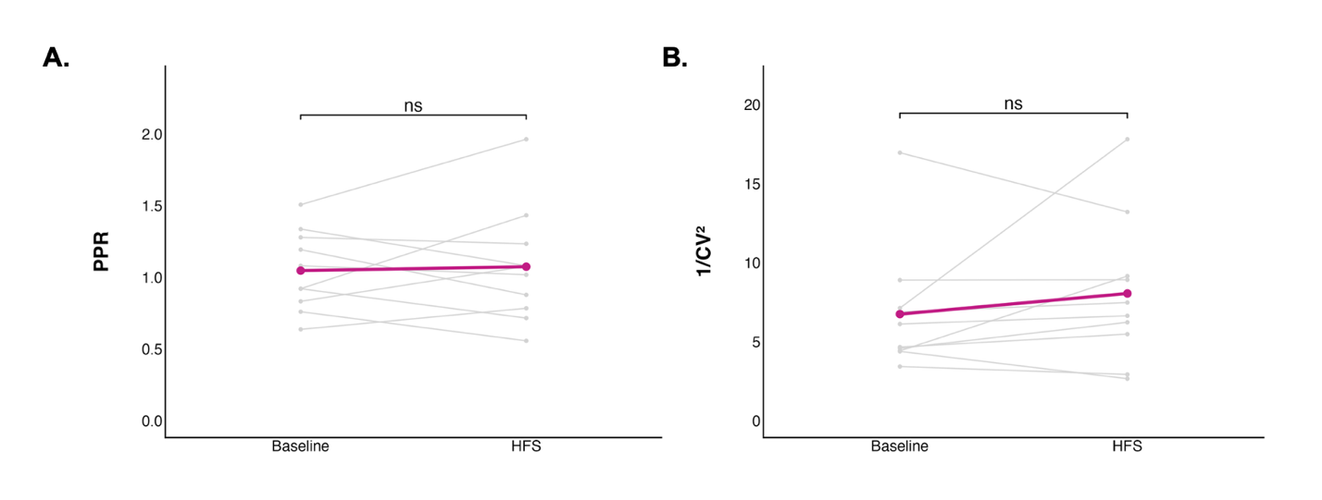
Figure 9. The paired pulse ratio (PPR) and coefficient of variation did not change significantly after high frequency stimulation (HFS) following acute stress when CB1 receptors were blocked. Each grey point represents the mean A: PPR or B: coefficient of variation of a single neuron averaged over the baseline period (0-to-5 minutes) or the final period (25-to-30 minutes). The coloured line represents the mean PPR or coefficient of variation ± standard error for the group.

Despite acute stress, when CB1 receptors were blocked action potential peak amplitude did not significantly change following HFS (t = 1.9964; df = 5; p = 0.1024; paired t-test; Fig. 10), nor did action potential frequency (df = 1, 189; F = 1.485248; p = 0.2245).

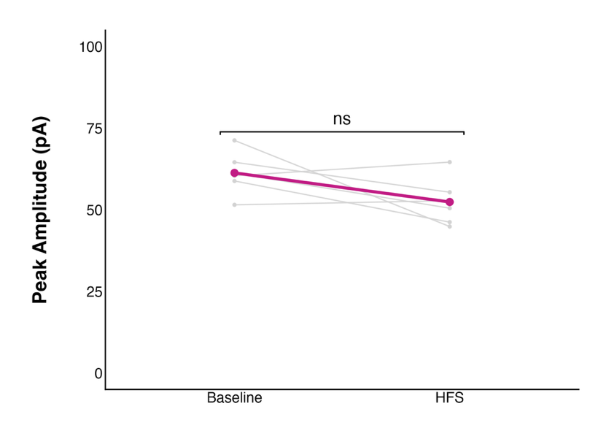
Figure 10. The action potential (AP) peak amplitude did not change significantly after high frequency stimulation (HFS) following acute stress when CB1 receptors were blocked. Each grey point represents the mean AP peak amplitude of a single neuron averaged over the baseline period (0-to-5 minutes) or the final period (25-to-30 minutes). The coloured line represents the mean AP peak amplitude ± standard error for the group.

Repeated stress does not alter glutamatergic transmission in DMH neurons of young female rats
To determine if five consecutive days of a 30-minute physical restraint affects glutamate signalling in the DMH, recordings of DMH neurons in hypothalamic slices were obtained. Unlike in acute stress, eEPSC amplitude did not change significantly after HFS (final amplitude 74.00 ± 12.34% of baseline; Fig. 11), nor in the PPR (1.29 ± 0.18 at baseline to 1.35 ± 0.22 post-HFS; n = 9; t = 0.53352; df = 8; p = 0.6082; paired t-test; Fig. 12A) or coefficient of variation (t = 0.32925, df = 8, p = 0.7504; paired t-test; Fig. 12B).
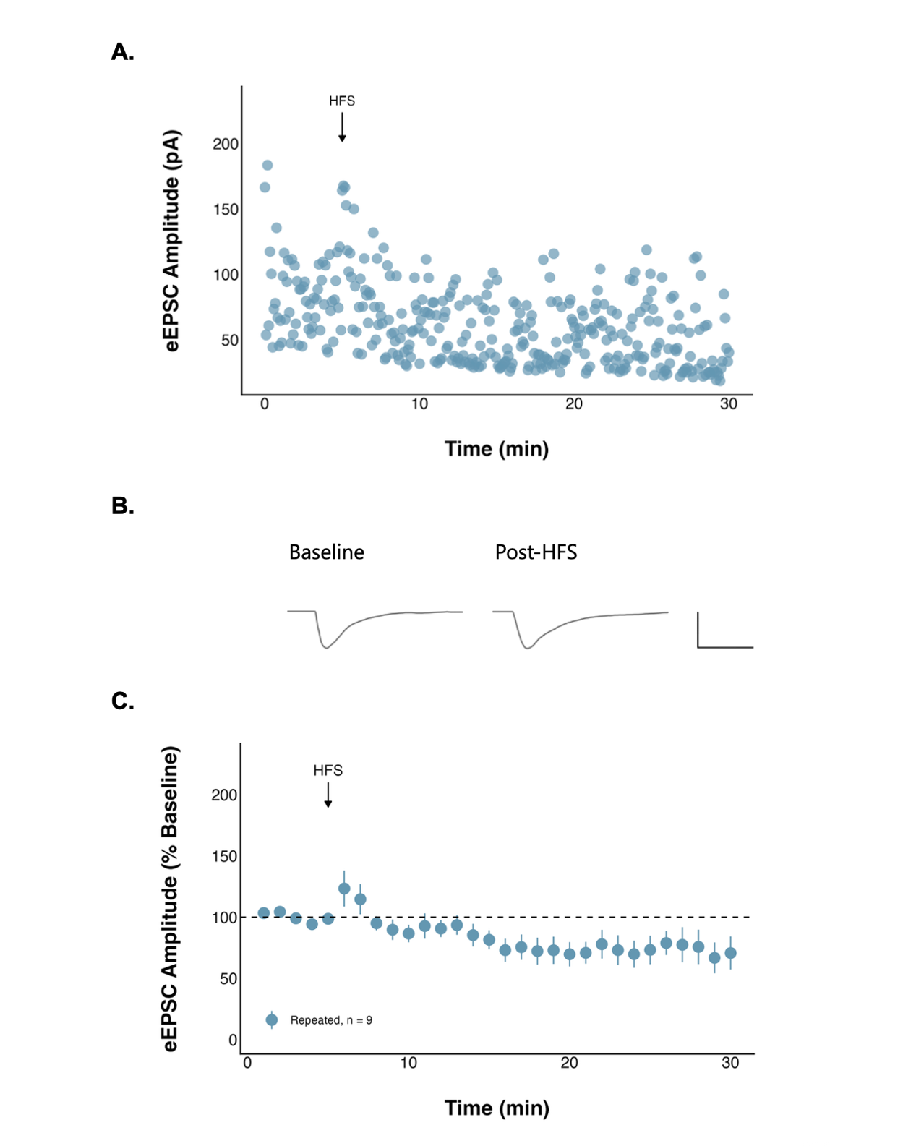
Figure 11. High frequency stimulation (HFS) has no effect on evoked excitatory postsynaptic current (eEPSC) amplitude over time following repeated stress. A: A representative neuron and B: representative traces consisting of eEPSC from one neuron averaged over the baseline period (0-to-5 minutes) and last period (25-to-30 minutes) of the recording, and the scale bar represents 50 pA/5 msec. C: Summary data in which each point represents the eEPSC amplitude ± standard error across all neurons and n represents the number of unique neurons.

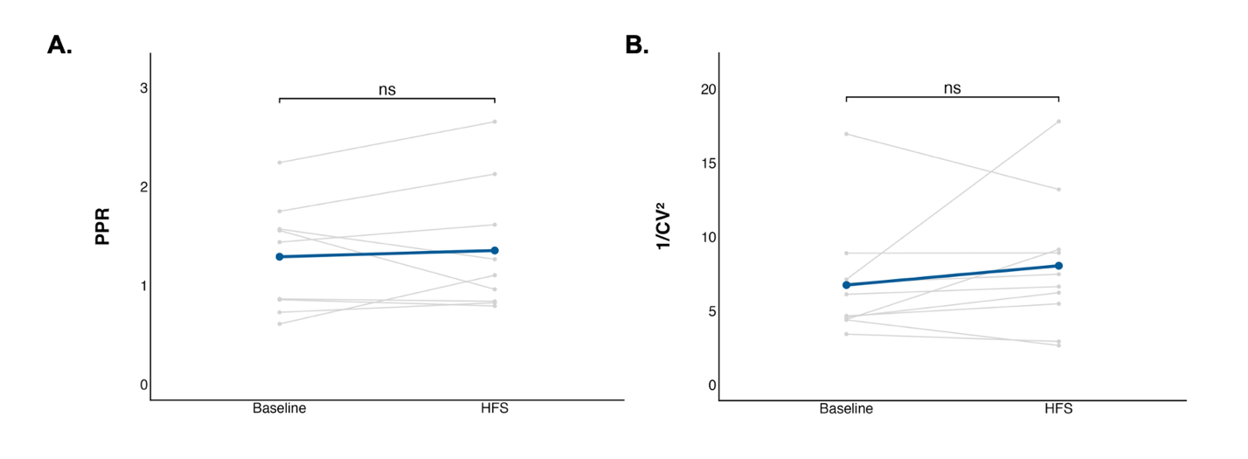
Figure 12. The paired pulse ratio (PPR) and coefficient of variation did not change significantly after high frequency stimulation (HFS) following repeated stress. Each grey point represents the mean A: PPR or B: coefficient of variation of a single neuron averaged over the baseline period (0-to-5 minutes) or the final period (25-to-30 minutes). The coloured line represents the mean PPR or coefficient of variation ± standard error for the group.

Although eEPSC amplitude did not change following repeated stress, action potential peak amplitude decreased significantly following HFS (t = 3.9281; df = 8; p = 0.004368; paired t-test; Fig. 13). This was not accompanied by a significant change in action potential frequency (df = 1, 170; F = 2.446259; p = 0.1197).

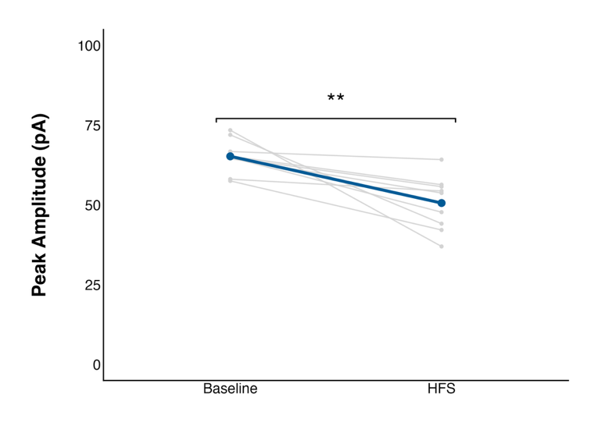
Figure 13. The action potential (AP) peak amplitude significantly decreased after high frequency stimulation (HFS) following repeated stress. Each grey point represents the mean AP peak amplitude of a single neuron averaged over the baseline period (0-to-5 minutes) or the final period (25-to-30 minutes). The coloured line represents the mean AP peak amplitude ± standard error for the group. ** = p < 0.01.

