The Effect of Acute and Repeated Stress on Excitatory Neurons in the Female Rat Dorsomedial Hypothalamus

BY

Ruby Muzzatti

A thesis submitted to the
Department of Biology
Mount Allison University
in partial fulfilment of the requirements for the
Bachelor of Science degree with Honours

April 13, 2026

Abstract
Stress induces both immediate and long-lasting changes in neural circuits that regulate physiological and behavioural responses. The dorsomedial hypothalamus (DMH) is a key regulator of the stress response due to its role in modulating hypothalamic-pituitary-adrenal (HPA) axis activity, yet the mechanisms by which stress alters synaptic transmission and neuronal excitability in this brain region remain unclear, particularly in females. This study investigated how acute and repeated restraint stress influenced glutamatergic transmission, synaptic plasticity, and intrinsic excitability in DMH neurons of young female rats. Whole-cell patch clamp electrophysiology was used to record evoked excitatory postsynaptic currents (eEPSC) and action potential properties in hypothalamic brain slices. Acute stress increased basal glutamatergic transmission without altering presynaptic release probability, suggesting a postsynaptic mechanism. Following high frequency stimulation (HFS), acute stress induced a long-term depression of excitatory transmission accompanied by a decrease in presynaptic glutamate release. This long-term depression was eliminated when type I cannabinoid receptors were blocked with AM251, demonstrating that the effect is mediated by endocannabinoid signalling. Acute stress also reduced neuronal excitability, evidenced by decreased action potential frequency and amplitude following HFS. In contrast, repeated stress did not significantly alter glutamatergic transmission or synaptic plasticity, although it reduced action potential amplitude, suggesting partial adaptation of neuronal function. These findings demonstrate that acute stress engages endocannabinoid-dependent mechanisms to produce long-lasting changes in synaptic transmission and neuronal excitability in the DMH, whereas repeated stress results in more limited effects. This work provides insight into how stress modifies hypothalamic circuits and identifies the DMH as a potential site where stress-induced plasticity may influence future stress responsiveness.

Table of Contents
Abstract 2
List of Figures 4
List of Tables 7
List of Abbreviations 8
Chapter 1: Introduction 9
1.1 Stress Today 9
1.2 The Stress Response 10
1.3 The Dorsomedial Hypothalamus 11
1.4 Neuronal Excitability 13
1.4.1 Stress and Neuronal Excitability 13
1.5 Glutamate Transmission 13
1.5.1 Stress and Synaptic Transmission 14
1.6 Current Study 15
Chapter 2: Methods 16
2.1 Experimental Animals 16
2.2 Restraint Stress 17
2.3 Brain Removal and Slice Preparation 17
2.4 Electrophysiology 18
2.5 Electrophysiological Measurements 19
2.5.1 Evoked Currents 19
2.5.2 Paired Pulse Ratio 20
2.5.3 Inverse Squared Coefficient of Variation 20
2.5.4 High Frequency Stimulation 20
2.5.5 Action Potentials 20
2.5.6 Membrane Properties 21
2.6 Statistical and Data Analysis & Software 21
Chapter 3: Results 22
3.1 Acute stress increases basal glutamatergic transmission 22
3.2 Acute stress results in long-term depression in response to high frequency stimulation 23
3.3 The type I cannabinoid receptor mediates the long-term depression observed in acute stress neurons 33
3.4 Repeated stress does not alter glutamatergic transmission in DMH neurons of young female rats 37
Chapter 4: Discussion 42
4.1 Acute stress and glutamate transmission 42
4.2 Acute stress and neuronal excitability 44
4.3 The acute stress mechanism 44
4.4 Repeated stress and glutamate transmission 47
4.5 Repeated stress and neuronal excitability 47
4.6 Next steps 48
4.7 Conclusions 48
Acknowledgments 50
References 51

List of Figures
Figure 1. Patch-clamp recording configuration of live neuron recording. On the left, a schematic showing the stimulating microelectrode (light blue) stimulating DMH neuron axons (gray) in the surrounding tissue to release neurotransmitter, while the recording microelectrode (dark blue) records from the target DMH neuron (pink). On the right, a differential interference contrast image visualized at 40X magnification. 20
Figure 2. Acute stress increases basal glutamate current amplitude, independent of presynaptic glutamate release. Each point represents the mean A: evoked excitatory postsynaptic current amplitude (eEPSC) or B: paired pulse ratio (PPR) of a single neuron (naïve: n = 10, acute: n = 8) averaged over the baseline period (0-to-5 minutes). The horizontal line represents the median, the box represents the 25th to 75th percentile, and the vertical lines represent the upper and lower 25th percentiles. The asterisks indicate a statistically significant difference between groups (two sample t-test; * = p < 0.05). 23
Figure 3. Acute stress does not change basal neuron size or excitability. Each point represents the mean A: membrane capacitance or B: resting membrane potential of a single neuron (naïve: n = 10, acute: n = 8). The horizontal line represents the median, the box represents the 25th to 75th percentile, and the vertical lines represent the upper and lower 25th percentiles. 24
Figure 4. High frequency stimulation (HFS) has no effect on evoked excitatory postsynaptic current (eEPSC) amplitude in naïve neurons. A: Representative traces consisting of eEPSCs from one neuron averaged over the baseline period (0-to-5 minutes) and last period (25-to-30 minutes) of the recording with a scale bar that represents 50 pA/10 msec, and B: a representative recording from one neuron. C: Summary data in which each point represents the eEPSC amplitude ± standard error across all neurons and n represents the number of unique neurons. 26
Figure 5. The paired pulse ratio (PPR) and inverse squared coefficient of variation did not change significantly after high frequency stimulation (HFS) in naïve neurons. Each grey point (n = 10) represents the mean A: PPR or B: inverse squared coefficient of variation of a single neuron averaged over the baseline period (0-to-5 minutes) or the final period (25-to-30 minutes). The coloured line represents the mean PPR or inverse squared coefficient of variation ± standard error for the group. 27
Figure 6. Action potential (AP) frequency and peak amplitude did not change significantly after high frequency stimulation (HFS) in naïve neurons. A: Each point represents the mean AP frequency ± standard error, sweep corresponds to level of current injection, ranging from -50 to 40 pA, and n represents the number of unique neurons. B: Each grey point (n = 3, neurons that fired action potentials at both states) represents the mean AP peak amplitude of a single neuron averaged over the baseline period (0-to-5 minutes) or the final period (25-to-30 minutes). The coloured line represents the mean AP peak amplitude ± standard error for the group. 29
Figure 7. High frequency stimulation (HFS) following acute stress decreases evoked excitatory postsynaptic current (eEPSC) amplitude over time. A: Representative traces consisting of eEPSCs from one neuron averaged over the baseline period (0-to-5 minutes) and last period (25-to-30 minutes) of the recording with a scale bar that represents 50 pA/10 msec, and B: a representative recording from one neuron. C: Summary data in which each point represents the eEPSC amplitude ± standard error across all neurons and n represents the number of unique neurons. The asterisks indicate a statistically significant change in current amplitude relative to the baseline (post hoc contrast; ** = p < 0.01). 31
Figure 8. The paired pulse ratio (PPR) significantly increased, and inverse squared coefficient of variation did not change after high frequency stimulation (HFS) following acute stress. Each grey point (n = 8) represents the mean A: PPR or B: inverse squared coefficient of variation of a single neuron averaged over the baseline period (0-to-5 minutes) or the final period (25-to-30 minutes). The coloured line represents the mean PPR or inverse squared coefficient of variation ± standard error for the group. The asterisks indicate a statistically significant change in PPR relative to the baseline (paired t-test; * = p < 0.05). 32
Figure 9. The action potential (AP) peak amplitude significantly decreased after high frequency stimulation (HFS) following acute stress. A: Each point represents the mean AP frequency ± standard error, sweep corresponds to level of current injection, ranging from -50 to 40 pA, and n represents the number of unique neurons. B: Each grey point (n = 5, neurons that fired action potentials at both states) represents the mean AP peak amplitude of a single neuron averaged over the baseline period (0-to-5 minutes) or the final period (25-to-30 minutes). The coloured line represents the mean AP peak amplitude ± standard error for the group. The asterisks indicate a statistically significant change in peak amplitude relative to the baseline (paired t-test; * = p < 0.05). 33
Figure 10. The effect of high frequency stimulation (HFS) on evoked excitatory postsynaptic current (eEPSC) amplitude over time following acute stress is no longer seen when CB1 receptors are blocked. A: Representative traces consisting of eEPSCs from one neuron averaged over the baseline period (0-to-5 minutes) and last period (25-to-30 minutes) of the recording with a scale bar that represents 50 pA/10 msec, and B: a representative recording from one neuron. C: Summary data in which each point represents the eEPSC amplitude ± standard error across all neurons and n represents the number of unique neurons. 35
Figure 11. The paired pulse ratio (PPR) and inverse squared coefficient of variation did not change significantly after high frequency stimulation (HFS) following acute stress when CB1 receptors were blocked. Each grey point (n = 10) represents the mean A: PPR or B: inverse squared coefficient of variation of a single neuron averaged over the baseline period (0-to-5 minutes) or the final period (25-to-30 minutes). The coloured line represents the mean PPR or inverse squared coefficient of variation ± standard error for the group. 36
Figure 12. Action potential (AP) frequency peak amplitude did not change after high frequency stimulation (HFS) following acute stress when CB1 receptors were blocked. A: Each point represents the mean AP frequency ± standard error, sweep corresponds to level of current injection, ranging from -50 to 40 pA, and n represents the number of unique neurons. B: Each grey point (n = 5, neurons that fired action potentials at both states) represents the mean AP peak amplitude of a single neuron averaged over the baseline period (0-to-5 minutes) or the final period (25-to-30 minutes). The coloured line represents the mean AP peak amplitude ± standard error for the group. 37
Figure 13. High frequency stimulation (HFS) has no effect on evoked excitatory postsynaptic current (eEPSC) amplitude over time following repeated stress. A: Representative traces consisting of eEPSCs from one neuron averaged over the baseline period (0-to-5 minutes) and last period (25-to-30 minutes) of the recording with a scale bar that represents 50 pA/10 msec, and B: a representative recording from one neuron. C: Summary data in which each point represents the eEPSC amplitude ± standard error across all neurons and n represents the number of unique neurons. 39
Figure 14. The paired pulse ratio (PPR) and inverse squared coefficient of variation did not change significantly after high frequency stimulation (HFS) following repeated stress. Each grey point (n = 9) represents the mean A: PPR or B: inverse squared coefficient of variation of a single neuron averaged over the baseline period (0-to-5 minutes) or the final period (25-to-30 minutes). The coloured line represents the mean PPR or inverse squared coefficient of variation ± standard error for the group. 40
Figure 15. Action potential (AP) peak amplitude decreased after high frequency stimulation (HFS) following repeated stress. A: Each point represents the mean AP frequency ± standard error, sweep corresponds to level of current injection, ranging from -50 to 40 pA, and n represents the number of unique neurons. B: Each grey point (n = 9, neurons that fired action potentials at both states) represents the mean AP peak amplitude of a single neuron averaged over the baseline period (0-to-5 minutes) or the final period (25-to-30 minutes). The coloured line represents the mean AP peak amplitude ± standard error for the group. The asterisks indicate a statistically significant change in peak amplitude relative to the baseline (paired t-test; ** = p < 0.01). 41

List of Tables
Table 1. Evoked excitatory postsynaptic current (eEPSC) amplitude varies over time, and this effect differs across groups following high frequency stimulation (HFS). Results of linear mixed-effects model examining eEPSC amplitude across groups (naïve, acute, acute with AM251, repeated) and time following high frequency stimulation (HFS), evaluated for significance at α = 0.05. 24
Table 2. Acute stress produces a time-dependent reduction in evoked excitatory postsynaptic current (eEPSC) amplitude. A: Within-group effects of time from group-specific linear mixed models, evaluated for significance at α = 0.05. B: Post hoc contrasts to baseline, evaluated at Bonferroni-adjusted α = 0.01. 25
Table 3. Action potential (AP) frequency differs between baseline and post-high frequency stimulation (HFS) states across groups. Results of a linear mixed-effects model assessing AP frequency by group and state (baseline and post-HFS), evaluated for significance at α = 0.05. 28
Table 4. Acute stress produces a decrease in action potential (AP) frequency following high frequency stimulation (HFS). Within-group effects of state (baseline vs post-HFS) on AP frequency from group-specific linear mixed-effect models, evaluated for significance at α = 0.05. 28

List of Abbreviations

1/CV² | Inverse squared coefficient of variation
aCSF | Artificial cerebrospinal fluid
ACTH | Adrenocorticotrophin hormone
AM251 | 1-(2,4-Dichlorophenyl)-5-(4-iodophenyl)-4-methyl-N-(1-piperidyl)pyrazole-3-carboxamide
CB1 | Cannabinoid receptor 1
CRH | Corticotrophin-releasing hormone
DMH | Dorsomedial hypothalamus
eEPSC | Evoked excitatory postsynaptic current
GABA | Gamma-aminobutyric acid
HFS | High frequency stimulation
HPA | Hypothalamic-pituitary-adrenal
LTD | Long-term depression
LTP | Long-term potentiation
PPR | Paired pulse ratio
PTSD | Post-traumatic stress disorder
PVN | Paraventricular nucleus
SAM | Sympathetic adrenomedullary system

Chapter 1: Introduction

1.1 Stress Today
Our modern world is characterized by frequent and prolonged exposure to psychological and social stress. While the stress response is an adaptive mechanism that allows organisms to respond to threats and restore homeostasis, these systems are not yet well adapted to this chronic activation in the absence of immediate physical danger (Smith and Azevedo, 2025; Dallman et al., 2006).
Stress not only produces short-term physiological responses, but can also induce persistent changes in neural circuits. Even a single intense stress may alter synaptic transmission and neuronal excitability in ways that outlast the original stimulus, while repeated stress can further shape these responses and contribute to maladaptive stress reactivity. Such long-lasting changes are seen in stress-related disorders, including post-traumatic stress disorder (PTSD), in which the long-term effects of stress on neural circuits can differ between males and females, with females showing increased vulnerability to stress-related disorders (Koss and Frick, 2017).

1.2 The Stress Response
Physiologically, stress is a challenge to the homeostasis of an organism (Bose et al., 2009) or the perceived threat to homeostasis (Charmandari et al., 2005). In humans and other mammals, stress activates the hypothalamic-pituitary-adrenal (HPA) axis and the sympathetic adrenomedullary system (SAM) in parallel (Adam and Epel, 2007; Charmandari et al., 2005). During acute stress, the SAM drives the release of catecholamines, triggering the “fight or flight” response from the sympathetic division of the autonomic system (James et al., 2023). As part of the HPA axis, the paraventricular nucleus (PVN) of the hypothalamus releases corticotrophin-releasing hormone (CRH), which stimulates adrenocorticotrophin hormone (ACTH) release from the anterior pituitary gland, which in turn stimulates cortisol release from the adrenal cortex (Bose et al., 2009; Adam and Epel, 2007). Glucocorticoids released from the HPA axis can act on the adrenal medulla to promote catecholamine release, highlighting crosstalk between the HPA axis and SAM system (Charmandari et al., 2005).
Following activation of the HPA axis, glucocorticoids are released from the adrenal cortex and act on multiple target tissues. Peripherally, they mobilize energy stores to ensure sufficient fuel is available to support the physiological demands of the stress response (Dallman et al., 2006). In the brain, glucocorticoids regulate neuronal activity through binding to glucocorticoid and mineralocorticoid receptors, influencing gene transcription and neuronal function (Nieuwenhuizen and Rutters, 2008). Following acute stress, glucocorticoid levels rise within 2-5 minutes of the stimulus (Dallman et al., 2006).
To prevent prolonged activation of the stress response, glucocorticoids exert negative feedback on the HPA axis by suppressing CRH and ACTH release (Adam and Epel, 2007; Charmandari et al., 2005). During acute stress, excitatory synaptic input onto CRH neurons is increased, driven in part by increased extracellular glutamate (McEwen, 2017). In the brain, glucocorticoid-dependent negative feedback at excitatory synapses onto CRH neurons is mediated by endocannabinoids, which act as retrograde messengers to suppress glutamate release (Levy and Tasker 2012; Crosby and Bains, 2012). In response to an increase in calcium or activation of metabotropic glutamate receptors, endocannabinoids are synthesized on demand in the postsynaptic neuron and bind to type I cannabinoid (CB1) receptors on presynaptic neurons (Crosby and Bains, 2012). This mechanism allows glucocorticoids to rapidly regulate synaptic input and limit the activation of the stress response.
During prolonged stress, this negative feedback becomes less effective. Sustained activation of the HPA axis disrupts normal endocrine function peripherally, as glucocorticoids suppress the release of growth hormone, promote insulin resistance, and impair immune system function (Charmandari et al., 2005). In addition, prolonged stress exposure reduces the effectiveness of negative feedback, resulting in sustained activation of the stress response system (Dallman et al., 2003). At the synaptic level, reduced endocannabinoid signalling due to CB1 receptor internalization further limits the ability to suppress excitatory input onto CRH neurons, contributing to the dysregulation of the stress response.

1.3 The Dorsomedial Hypothalamus
The hypothalamus is a tiny, yet powerful brain region that regulates key homeostatic functions, including energy balance, autonomic activity, and hormone secretion (Saper and Lowell, 2014; Benedini, 2009; Crosby and Bains, 2012). The hypothalamus integrates multiple signals including hormonal, metabolic, and neural input both from within the hypothalamus and from other brain regions (Goel et al., 2025; Smith and Azevedo, 2025).
The dorsomedial hypothalamus (DMH) is a hypothalamic nucleus located adjacent to the third ventricle, dorsal to the ventromedial hypothalamus (VMH), and caudal to the PVN (Paxinos and Watson, 2009). The DMH is involved in energy expenditure, cardiovascular changes in response to stress, thermoregulation, food intake, and body weight regulation (Goel et al., 2025; DiMicco et al., 2002; Tran et al., 2022). The DMH contains a heterogeneous population of neurons that communicate with various brain regions through both glutamate, the major excitatory neurotransmitter, and GABA (gamma-aminobutyric acid), the major inhibitory neurotransmitter (Myers et al., 2014). These neurons communicate through chemical synapses, where neurotransmitter release from presynaptic terminals activates receptors on postsynaptic neurons to shape neuronal activity (Purves et al., 2001; Fon and Edwards, 2001). The DMH receives input from many brain regions including the prefrontal cortex, amygdala, lateral septum, and pre-optic area, while it projects to areas including the PVN, rostral raphe pallidus of the medulla oblongata, and the locus coeruleus (Myers et al., 2014; Tran et al., 2022).
Importantly, the DMH acts as an upstream regulator of the PVN, positioning it as a key modulator of HPA axis activity. Glutamatergic neurons, located primarily in the dorsomedial region of the DMH, and GABAergic neurons, located primarily in the ventrolateral region of the DMH, project to the PVN, respectively activating or inhibiting CRH neurons (Myers et al., 2014). Through these projections, the DMH contributes to the regulation of endocrine and autonomic stress responses. Stimulation or disinhibition of the DMH increases ACTH secretion, heart rate, blood pressure, and respiratory rate, while inhibition of this region reduces these responses (Myers et al., 2014; DiMicco et al., 2002; DiMicco and Abshire, 1987).
Many DMH neurons express glucocorticoid receptors (Cintra et al., 1990), suggesting that circulating stress hormones can directly influence DMH activity. Through its projections to the PVN and sensitivity to endocrine signals, the DMH may serve as a site where stress signals are integrated and translated into changes in neural activity.
Despite this, the mechanisms through which stress alters excitatory synaptic transmission and neuronal excitability within the DMH remain poorly understood. Given its role in modulating both autonomic and endocrine activity, stress-induced changes in DMH function may play a critical role in shaping how the brain responds to both acute and repeated stress.

1.4 Neuronal Excitability
At rest, neurons maintain a resting membrane potential, which reflects the difference, or polarization, in electrical charge between the intracellular and extracellular environments. Neuronal excitability is characterized by a neuron’s ability to fire an action potential, and a more excitable neuron requires less depolarization to reach an action potential threshold. When glutamate binds to its ionotropic receptors, cations enter the neuron, depolarizing the neuron by making it more positively charged. As the neuron is then more positive, it is closer to the action potential voltage threshold and a smaller change in membrane potential is needed to fire an action potential, demonstrating increased excitability (Barnett and Larkman, 2007).

1.4.1 Stress and Neuronal Excitability
Stress can alter neuronal excitability in addition to synaptic transmission. Chronic unpredictable stress increases intrinsic excitability of neurons in the hypothalamus in both male and female rats (Fang et al., 2023). These effects may reflect glucocorticoid-mediated changes in postsynaptic excitability, as is seen in PVN neurons due to modulation of potassium channels (dos-Santos et al., 2023). As the DMH receives stress-related endocrine signals and projects to the PVN, stress-induced changes in DMH excitability could influence downstream hypothalamic circuit function and alter responsiveness to subsequent stress.

1.5 Glutamate Transmission
Glutamate, the primary excitatory neurotransmitter in the brain, is produced by the conversion of glutamine by the enzyme glutaminase, which is regulated by phosphorylation (Fon and Edwards, 2001). Glutamate activates both ionotropic receptors, ligand-gated ion channels that mediate fast ion movement, and metabotropic receptors, which modulate activity through intracellular signalling pathways (Meldrum, 2000; Siegelbaum and Kandel, 1991; Purves et al., 2001).
Glutamate acts through three families of ionotropic receptors: N-methyl-D-aspartate (NMDA), alpha-amino-3-hydroxy-5-methyl-4-isoxazolepropionic acid (AMPA), and kainate (Meldrum, 2000). AMPA receptor ion channels are permeable to sodium, potassium, and sometimes calcium, depending on subunit composition, specifically the GluR2 subunit. AMPA receptors have a lower affinity for glutamate than NMDA receptors, but faster kinetics involved in excitatory postsynaptic currents (Meldrum, 2000). NMDA receptors are blocked by magnesium, and the blockage is only overcome by partial depolarization, which then allows for the passage of sodium, potassium, and calcium (Siegelbaum and Kandel, 1991; Meldrum, 2000). Additionally, glutamate binds to a family of metabotropic receptors containing three groups (metabotropic glutamate receptors I – III) with specialized functions, which often utilize second messengers like diacylglycerol and cAMP (Meldrum, 2000).
Glutamate is taken up by Vesicular Glutamate Transporter 1 and Vesicular Glutamate Transporter 2 into vesicles for release into the synaptic cleft (Hertz, 2006). Glutamate in the synapse is taken up by glial cells by Glutamate-Aspartate Transporter and Glutamate Transporter-1, converted to glutamine by astrocyte-specific enzyme glutamine synthase, then back up by neurons via Excitatory Amino Acid Carrier 1 for conversion back to glutamate (Fon and Edwards, 2001; Hertz, 2006), or converted to alpha-ketoglutarate by oxidative deamination or transamination (Hertz, 2006).

1.5.1 Stress and Synaptic Transmission
Stress can trigger long-lasting changes in the strength of synapses. These changes can manifest as long-term potentiation (LTP), a long-lasting increase in synaptic strength, or long-term depression (LTD), a long-lasting decrease in synaptic strength (Siegelbaum and Kandel, 1991). These forms of synaptic plasticity are mediated by activity-dependent changes in receptor trafficking, intracellular signalling, and calcium dynamics (Siegelbaum and Kandel, 1991). Stress alters synaptic plasticity in various regions of the brain. In acute stress, glucocorticoids mediate LTP in the amygdala, the site of emotional memory formation (Sarabdjitsingh et al., 2012).
Acute stress also facilitates a glutamatergic receptor-dependent LTP in the hippocampus following acute stress, but this long-lasting change is inhibited under chronic stress (Bartsch et al., 2021). Further, chronic stress can increase glucocorticoid receptor-mediated LTD in some regions of the hippocampus (Xu et al., 2020).
In the DMH, endocannabinoid signalling has been shown to regulate activity-dependent plasticity (Crosby et al., 2011). High frequency stimulation (HFS) induced an endocannabinoid mediated long-term depression at GABAergic synapses, but when the CB1 receptor is blocked, HFS instead elicits a long-term potentiation, a shift that is mediated by corticosterone (Crosby et al., 2011).
Because stress alters glutamatergic transmission and recruits endocannabinoid signalling in the DMH, it has the potential to shape hypothalamic activity through long-term changes in synaptic strength.

1.6 Current Study
While the relationship between stress and hypothalamic function is well established, the underlying neurophysiological mechanisms in the DMH are unclear. In addition to its role in metabolic regulation (Bellinger and Bernardis, 2002; Dalton et al., 1981), there is considerable evidence that the DMH contributes to stress responses and contains receptors that allow it to respond to stress hormones (Myers et al., 2014; Crosby and Bains, 2012). Stress hormones may bind in the DMH, altering neuronal activity and excitability. Given the role of the DMH in integrating endocrine signals and modulating downstream hypothalamic circuits, it is an ideal region in which to investigate how stress alters neuronal communication. Determining how acute and repeated stress affects DMH neurons, particularly in females, may also provide insight into sex-specific responses to stress.
The current study aims to determine whether acute and repeated stress alter glutamatergic transmission and neuronal excitability in the DMH of young female rats, and if so, by what mechanism. We hypothesized that stress would alter neuronal excitability and synaptic communication in the DMH. We predicted that acute stress would decrease glutamatergic activity of DMH neurons and that chronic stress would increase glutamatergic activity of DMH neurons compared to naïve animals. This hypothesis was tested by exposing animals to acute and repeated stress and assessing the neuronal activity and communication of DMH neurons using patch clamp electrophysiology.

Chapter 2: Methods

2.1 Experimental Animals
All experiments were performed using young female (postnatal day (P) 27 to 39) Sprague Dawley rats (RRID:MGI:5651135) obtained from Charles River Laboratories (Quebec, Canada). Rats arrived at P22-24 and were housed in groups of 4 in polycarbonate cages. Cages contained wood shaving bedding, paper towel strips, and a wooden block, green nyla bone, and two Crawl BallsTM (Bio-Serv) for enrichment. Animals were provided with standard rat chow and water ad libitum and housed at 21°C and 50% ± 10% humidity on a 12-hour light/12-hour dark cycle that began at 7:30 am. Following arrival, the animals were given at least 6 days to acclimate to these conditions before experiments began. All experimental protocols were approved by the Mount Allison University Animal Care Committee (protocol #104140) and in accordance with the Canadian Council on Animal Care guidelines.

2.2 Restraint Stress
Rats were randomly assigned into one of three groups: naive, acute stress, or repeated stress. All animals were weighed prior to the restraint. Animals in the acute stress group were removed from their home cage and underwent a single 30-minute restraint on a bench top in a room different to the holding room. Animals in the repeated stress group underwent five consecutive days of a 30-minute restraint and were housed individually after the first restraint. Restraint was performed at approximately the same time each morning for the five consecutive days, in the same location, and the timing was kept as close as possible across animals (between 7:32 am and 8:56 am). The restraint was performed using Flat-Bottom Rodent Restrainers (Braintree Scientific), with size selection based on animal weight (2 x 5 ” for 30 - 125g; 2.5 x 6 ” for 125 - 250g).

2.3 Brain Removal and Slice Preparation
Between 8:00 am and 10:00 am, immediately following the single (acute) or fifth day of restraint (repeated) for the stress groups, the animal was anesthetized with 5% gaseous isoflurane in oxygen, and approximately 2 mL of liquid added to the corner of the chamber. To confirm anesthesia, a toe pinch reflex test was performed. When no reflex was present, the animal was decapitated using a guillotine (World Precision Instruments), and a carotid blood sample was obtained. The brain was quickly removed and immersed in ice-cold slicing solution that contained (in mM): 75 sucrose, 25 glucose, 87 NaCl, 25 NaHCO₃, 2.5 KCl, 0.5 CaCl₂ * 2 H₂O, 7 MgCl₂ * 6 H₂O, 1.25 NaH₂PO₄, saturated with 95% O₂ and 5% CO₂ for a minimum of 20 minutes prior to brain removal.
The brain was then placed on a petri dish, and the anterior, posterior, and dorsal (cortex) regions were cut off. The brain was glued (Krazy Glue) to a vibratome plate with the posterior side down. A small piece of agar was glued on the ventral side of the brain to prevent movement during slicing. The vibratome plate was placed such that the brain was submerged in the ice-cold slicing solution and a line with 95% O₂ and 5% CO₂ was inserted. Coronal slices (250 µm) containing the DMH, identified using a rat atlas (Paxinos & Watson, 2009), were obtained using a vibrating slicer (Leica) and cut into hemi-sections along the midline. Slices were incubated in 32.5°C artificial cerebrospinal fluid (aCSF) that contained (in mM): 10 glucose, 126 NaCl, 26 NaHCO₃, 2.5 KCl, 2.5 CaCl₂ * 2 H₂O, 1.5 MgCl₂ * 6 H₂O, 1.25 NaH₂PO₄, saturated with 95% O₂ and 5% CO₂, for a minimum of 60 minutes, until recording began.

2.4 Electrophysiology
Hypothalamic slices were submerged in a recording chamber and superfused with aCSF. The solution, continuously bubbled with 95% O₂ and 5% CO₂, was delivered at a flow rate of 1 mL/min and kept at 32.5°C using TC-344C Automatic Temperature Controller and Inline Heater (Warner Instruments). The brain slice was kept still using two ~1 cm metal weights placed horizontally on each end and was visualized with an upright microscope (Olympus BX51 WI) and Infinity 2 Camera, live footage of which was projected onto a computer monitor. The DMH was located by using the third ventricle as a landmark.
Whole-cell patch clamp electrophysiological recordings were obtained (Figure 1) using borosilicate glass microelectrodes with tip resistances ranging from 4.0 to 6.0 MΩ (Model P-1000 Pipette Puller, Sutter Instruments). Two microelectrodes were used for each recording, one for stimulating and one for recording. Neurons were stimulated extracellularly, using a microelectrode filled with aCSF, while the recording electrode in a neuron of interest was filled with an internal solution that contained (in mM): 108 KGluconate, 8 KCl, 8 NaGluconate, 10 HEPES, 2 MgCl₂, 1 K₂EGTA, 4 K₂ATP, 0.3 Na₃GTP, corrected to pH 7.2 with KOH, and between 285-300 mOsm with sterile water. The recording microelectrode was connected to a positive pressure line, and ~1.5 mLs of positive pressure was applied before the recording microelectrode was submerged in the bath. When a DMH neuron of interest was located, the recording microelectrode was gently pushed towards the neuron until a dimple was formed in the cell membrane, then the positive pressure was released and the neuron sealed around the electrode. When the seal reached the giga-ohm range, the neuron was held at -70mV in voltage-clamp mode, and suction was used to break into the cell. If the initial access (Ra) to the cell was between 1 and 2.5 MΩ, the recording proceeded. To measure excitatory currents, picrotoxin (50 µM), a GABA_{A} antagonist, was included in all treatment solutions. Picrotoxin blocked inhibitory GABAergic currents, allowing for only excitatory, glutamatergic currents to be recorded.

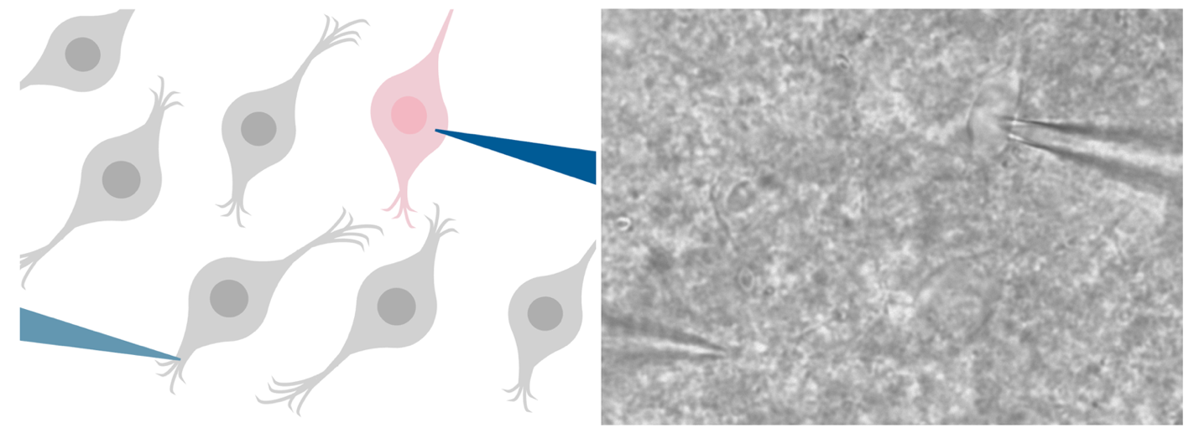
Figure 1. Patch-clamp recording configuration of live neuron recording. On the left, a schematic showing the stimulating microelectrode (light blue) stimulating DMH neuron axons (gray) in the surrounding tissue to release neurotransmitter, while the recording microelectrode (dark blue) records from the target DMH neuron (pink). On the right, a differential interference contrast image visualized at 40X magnification.

Electrophysiological signals were amplified using the Multiclamp700B amplifier (Molecular Devices) filtered at 1 kHz, digitized at 10 kHz using the Digidata 1550B system (Molecular Devices), and pCLAMP acquisition software (Version 11, Molecular Devices).

2.5 Electrophysiological Measurements
To determine the effects of acute and repeated stress on glutamate transmission in the DMH, the following parameters were measured: evoked current amplitude, paired pulse ratio, action potential frequency and amplitude.

2.5.1 Evoked Currents
In voltage-clamp mode, cells were held at -70mV. Evoked excitatory postsynaptic currents (eEPSCs) were evoked by a stimulating microelectrode, at a frequency of 0.2 Hz, twice, 50 milliseconds apart, every 5 seconds for the duration of the recording. The first current is classified as eEPSCs, as they are artificially stimulated (evoked) and the result of the release of the excitatory neurotransmitter, glutamate, onto postsynaptic cells, which was measured.

2.5.2 Paired Pulse Ratio
The paired stimulation results in two currents, with the first being eEPSCs. The paired pulse ratio (PPR), calculated as the amplitude of the second peak divided by the first peak, was used to determine presynaptic release probability. The PPR is inversely proportional to the probability of presynaptic release (Glasgow et al., 2019).

2.5.3 Inverse Squared Coefficient of Variation
The coefficient of variation (CV) is calculated by dividing the standard deviation of the data by the mean, and the 1/CV² is the result of squaring and taking the inverse of that result. 1/CV² gives additional insight into mechanisms that may be driving changes in presynaptic release including quantal size and number of release sites (Van Huijstee and Kessels, 2020).

2.5.4 High Frequency Stimulation
The eEPSCs were recorded for a 5-minute baseline period, then to study activity-dependent plasticity in the DMH, high frequency stimulation (HFS) was applied at 100 Hz for 4 seconds, repeated twice, 20 seconds apart. This protocol has been previously used to determine the effect of stress on long-lasting changes at DMH GABA synapses (Crosby et al., 2011). After HFS, eEPSCs were recorded for 25 minutes, for a total of 30 minutes. In a subset of experiments, recordings were also obtained in the presence of an CB1 receptor inverse agonist (1-(2,4-Dichlorophenyl)-5-(4-iodophenyl)-4-methyl-N-(1-piperidyl)pyrazole-3-carboxamide; AM251; 5 µM).

2.5.5 Action Potentials
Action potential data was collected immediately with each new cell as a baseline, and again after 25 minutes of eEPSCs after HFS (see 2.5.1 Evoked). In current-clamp mode the resting membrane potential (V_{m}) was noted, and a current injection was applied until the V_{m} reached -70mV, and this current was noted. While holding at -70mV, a current-clamp steps protocol was utilized to assess action potential firing at a series of hyperpolarizing and depolarizing steps. The current clamp steps protocol stimulates the cell for 500 milliseconds with current injections that increase in magnitude by 10 pA from -50 pA to 40 pA, with 250 milliseconds between each step.
The lowest current injection needed to elicit an action potential was used for action potential parameter analysis, and the first action potential of that current injection is used for threshold determination. Using the first derivative method (Farries et al., 2010), action potential peak amplitude was determined.
Action potential frequency (Hz) per current injection was determined by counting the number of action potentials at each current injection.

2.5.6 Membrane Properties
Using the membrane test, after each 5-minute interval the capacitance (C_{m}), membrane resistance (R_{m}), cell access (R_{a}), membrane time constant (Tau), and holding current (I_{hold}) were recorded.

2.6 Statistical and Data Analysis & Software
Data was analyzed using Clampfit (Version 11, Molecular Devices). Statistical analysis was performed using R Statistical Software (Version 4.5.2) in RStudio (Version 2026.01.0+392). Graphs were made using the theme from the package patchclampplotteR (Laureijs, 2025). Data was considered significantly different if the p-value was less than 0.05, unless otherwise stated.
Repeated measures analyses were conducted using a linear mixed effects model with an autoregressive correlation structure, as assumptions of sphericity were not met. Log transformation allowed for assumptions of normality and homoscedasticity to be met. This model used the within-subject factor of time interval and between-subject factor of treatment group. The subject was neuron, a random factor. Subsequently, post hoc contrasts were performed to compare the time intervals to the baseline period, where relevant. PPR and 1/CV² were calculated using patchclampplotteR (Laureijs, 2025).

Chapter 3: Results

3.1 Acute stress increases basal glutamatergic transmission
To determine if an acute physical restraint stress affects glutamate signalling in the DMH, recordings of DMH neurons in hypothalamic slices from female Sprague-Dawley rats were obtained (Figure 2). The amplitude of the evoked excitatory postsynaptic currents (eEPSC) was greater in acute stress (66.60125 ± 9.676361 pA) than naïve (41.51900 ± 5.877376 pA) neurons (t = -2.3144; df = 16; p = 0.03426; two sample t-test; Figure 2A). However, this was not accompanied by a difference in the paired pulse ratio (PPR), an inverse measure of presynaptic neurotransmitter release probability, between naïve (1.02 ± 0.12) and acute stress (1.02 ± 0.10) neurons (t = -1.7424; df = 34; p = 0.09049; two sample t-test; Figure 2B). This suggests that while there is enhanced glutamate transmission in DMH neurons, it is not likely a result of an increase in presynaptic glutamate release.

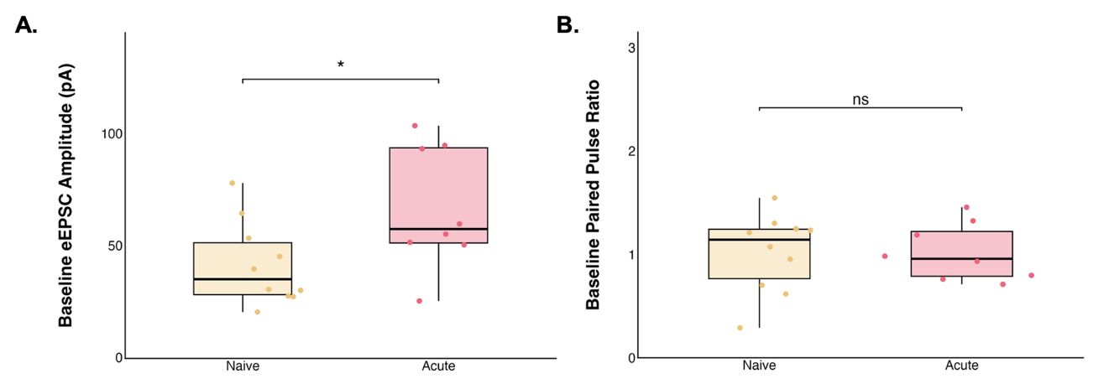
Figure 2. Acute stress increases basal glutamate current amplitude, independent of presynaptic glutamate release. Each point represents the mean A: evoked excitatory postsynaptic current amplitude (eEPSC) or B: paired pulse ratio (PPR) of a single neuron (naïve: n = 10, acute: n = 8) averaged over the baseline period (0-to-5 minutes). The horizontal line represents the median, the box represents the 25th to 75th percentile, and the vertical lines represent the upper and lower 25th percentiles. The asterisks indicate a statistically significant difference between groups (two sample t-test; * = p < 0.05).

To determine if the acute physical restraint affects passive membrane properties of DMH neurons, the membrane capacitance and resting membrane potential of acute stress neurons were compared to those of naïve neurons (Figure 3). There was no difference in membrane capacitance (Figure 3A), which is the ability of the neuron to store charge, proportional to neuron size, nor in resting membrane potential (Figure 3B), which determines intrinsic excitability.

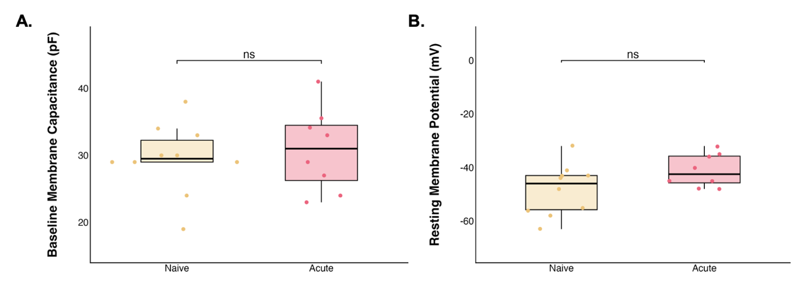
Figure 3. Acute stress does not change basal neuron size or excitability. Each point represents the mean A: membrane capacitance or B: resting membrane potential of a single neuron (naïve: n = 10, acute: n = 8). The horizontal line represents the median, the box represents the 25th to 75th percentile, and the vertical lines represent the upper and lower 25th percentiles.

3.2 Acute stress results in long-term depression in response to high frequency stimulation
To determine whether stress alters the ability of DMH synapses to undergo activity-dependent plasticity, high frequency stimulation (HFS) was applied to determine the effects on glutamate synapses (Table 1).

Table 1. Evoked excitatory postsynaptic current (eEPSC) amplitude varies over time, and this effect differs across groups following high frequency stimulation (HFS). Results of linear mixed-effects model examining eEPSC amplitude across groups (naïve, acute, acute with AM251, repeated) and time following high frequency stimulation (HFS), evaluated for significance at α = 0.05.
 | Numerator DF | Denominator DF | F-value | p-value
Group | 3 | 33 | 0.6853 | 0.5674
Time | 5 | 165 | 10.2715 | < 0.0001
Group x Time | 15 | 165 | 2.1958 | 0.0083

Because a significant interaction of group and time was detected, main effects were not directly interpreted. Instead, the effect of time within each group was examined using group-specific models (Table 2).

Table 2. Acute stress produces a time-dependent reduction in evoked excitatory postsynaptic current (eEPSC) amplitude. A: Within-group effects of time from group-specific linear mixed models, evaluated for significance at α = 0.05. B: Post hoc contrasts to baseline, evaluated at Bonferroni-adjusted α = 0.01.
A |  | Numerator DF | Denominator DF | F-value | p-value
 | Naïve | 5 | 45 | 2.0259 | 0.093
 | Acute Stress | 5 | 35 | 7.3222 | 0.0001
 | Acute Stress with AM251 | 5 | 45 | 2.7939 | 0.0279
 | Repeated Stress | 5 | 40 | 3.1615 | 0.0169
B | Interval | Group | DF | F-value | p-value
 | 5-to-10 min | Acute | 1, 7 | 0.8323 | 0.3919511
 | 10-to-15 min |  |  | 1.5804 | 0.2490239
 | 15-to-20 min |  |  | 9.0148 | 0.0198726
 | 20-to-25 min |  |  | 14.491 | 0.0066564
 | 25-to-30 min |  |  | 14.930 | 0.00618
 | 5-to-10 min | Acute with AM251 | 1, 9 | 0.6813 | 0.430472
 | 10-to-15 min |  |  | 0.5034 | 0.495999
 | 15-to-20 min |  |  | 1.1566 | 0.310160
 | 20-to-25 min |  |  | 2.4 | 0.15574
 | 25-to-30 min |  |  | 6.4939 | 0.031281
 | 5-to-10 min | Repeated | 1, 8 | 0.0199 | 0.342114
 | 10-to-15 min |  |  | 1.9508 | 0.200030
 | 15-to-20 min |  |  | 3.5638 | 0.095749
 | 20-to-25 min |  |  | 2.8729 | 0.128527
 | 25-to-30 min |  |  | 2.0476 | 0.190323

In naïve animals, there was no change in eEPSC amplitude, relative to baseline, following HFS at any time interval (final amplitude 109.98 ± 9.38% of baseline; linear mixed model; df = 5, 45; F = 2.0259; p = 0.093; Figure 4).

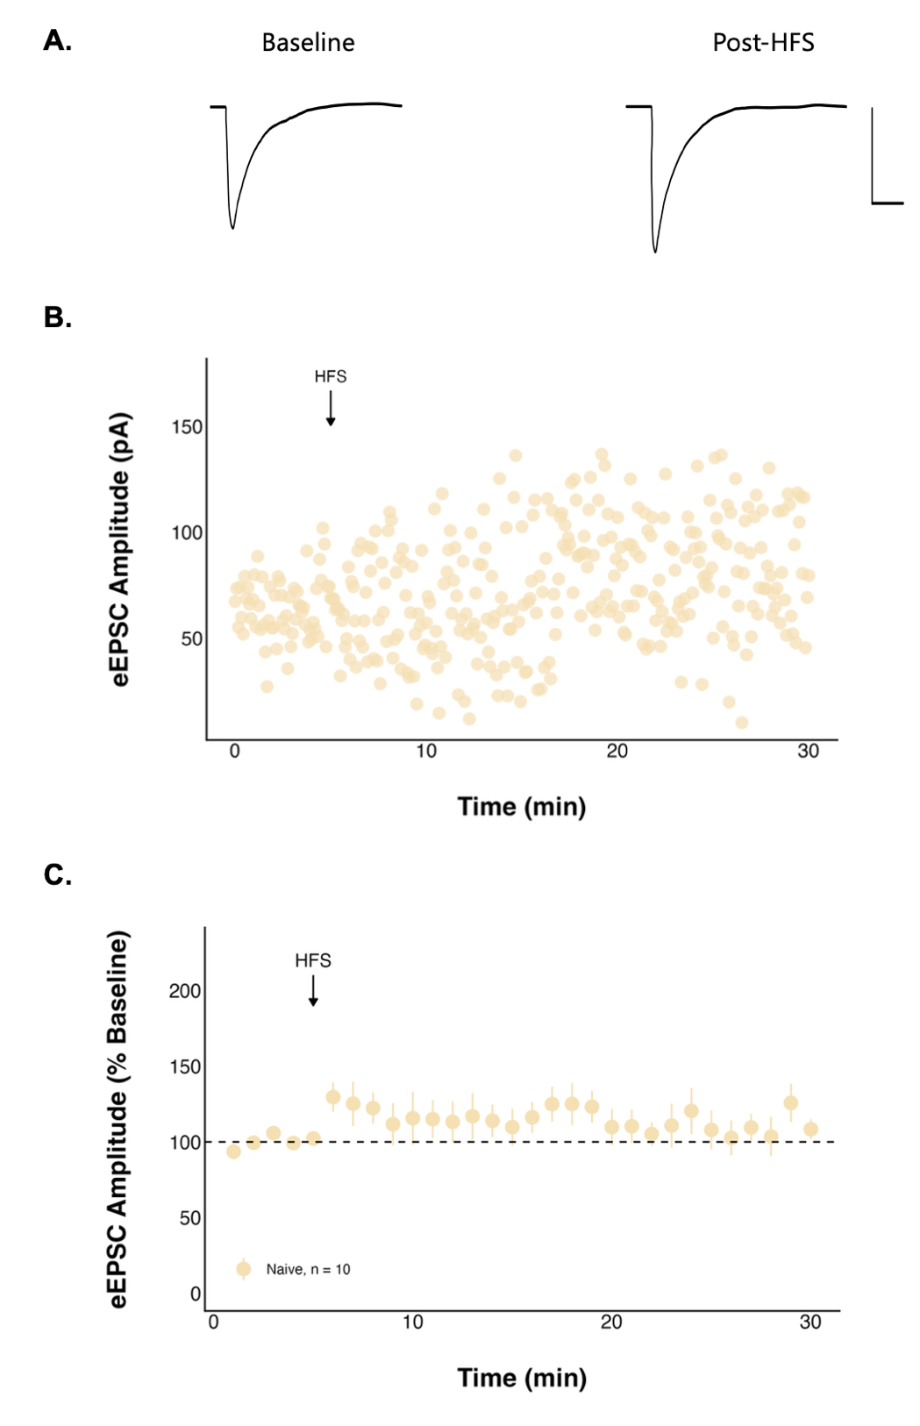
Figure 4. High frequency stimulation (HFS) has no effect on evoked excitatory postsynaptic current (eEPSC) amplitude in naïve neurons. A: Representative traces consisting of eEPSCs from one neuron averaged over the baseline period (0-to-5 minutes) and last period (25-to-30 minutes) of the recording with a scale bar that represents 50 pA/10 msec, and B: a representative recording from one neuron. C: Summary data in which each point represents the eEPSC amplitude ± standard error across all neurons and n represents the number of unique neurons.
Additionally, neither the paired pulse ratio (PPR) (1.02 ± 0.12 at baseline to 1.00 ± 0.12 post-HFS; n = 10; t = -0.28857; df = 9; p = 0.7794; paired t-test; Figure 5A) nor the inverse squared coefficient of variation (t = -2.0771; df = 9; p = 0.06758; paired t-test; Figure 5B) changed over time in naïve neurons. These findings suggest no detectable change in presynaptic release probability, quantal size, or number of release sites, which is consistent with the lack of current amplitude change.

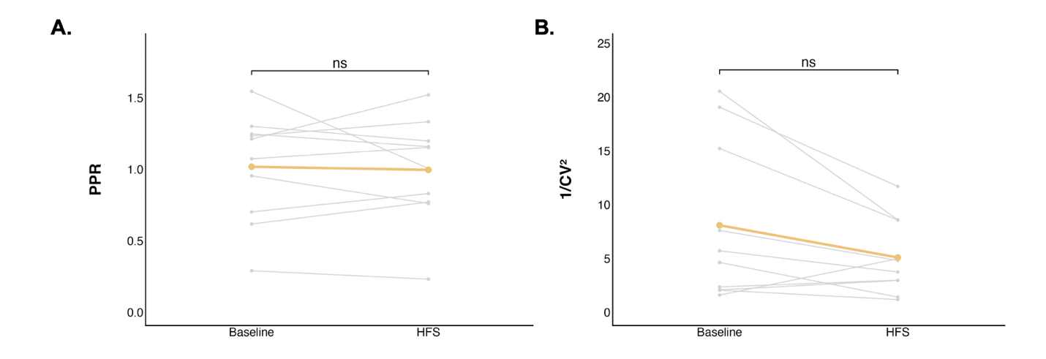
Figure 5. The paired pulse ratio (PPR) and inverse squared coefficient of variation did not change significantly after high frequency stimulation (HFS) in naïve neurons. Each grey point (n = 10) represents the mean A: PPR or B: inverse squared coefficient of variation of a single neuron averaged over the baseline period (0-to-5 minutes) or the final period (25-to-30 minutes). The coloured line represents the mean PPR or inverse squared coefficient of variation ± standard error for the group.

To determine if stress alters neuronal excitability, a current clamp steps protocol was performed before and after HFS. Further, action potential frequency at various current injections was compared between the baseline and post-HFS periods (Table 3). While there was a significant overall effect on action potential frequency post-HFS compared to baseline, this was not significant in naïve neurons (df = 1, 56; F = 2.074709; p = 0.1553; Table 4; Figure 6A). Action potential peak amplitude did not decrease following HFS in naïve neurons (n = 3; t = 3.7555; df = 2; p = 0.06416; paired t-test; Figure 6B).

Table 3. Action potential (AP) frequency differs between baseline and post-high frequency stimulation (HFS) states across groups. Results of a linear mixed-effects model assessing AP frequency by group and state (baseline and post-HFS), evaluated for significance at α = 0.05.
 | Numerator DF | Denominator DF | F-value | p-value
Group | 4 | 32 | 0.16829 | 0.9530
State | 1 | 698 | 27.81099 | < 0.0001
Group x State | 4 | 698 | 2.22751 | 0.0645

Table 4. Acute stress produces a decrease in action potential (AP) frequency following high frequency stimulation (HFS). Within-group effects of state (baseline vs post-HFS) on AP frequency from group-specific linear mixed-effect models, evaluated for significance at α = 0.05.
Group | Numerator DF | Denominator DF | F-value | p-value
Naive | 1 | 56 | 2.074709 | 0.1553
Acute | 1 | 151 | 22.10576 | < 0.0001
Acute with AM251 | 1 | 189 | 1.485248 | 0.2245
Repeated | 1 | 170 | 2.446259 | 0.1197

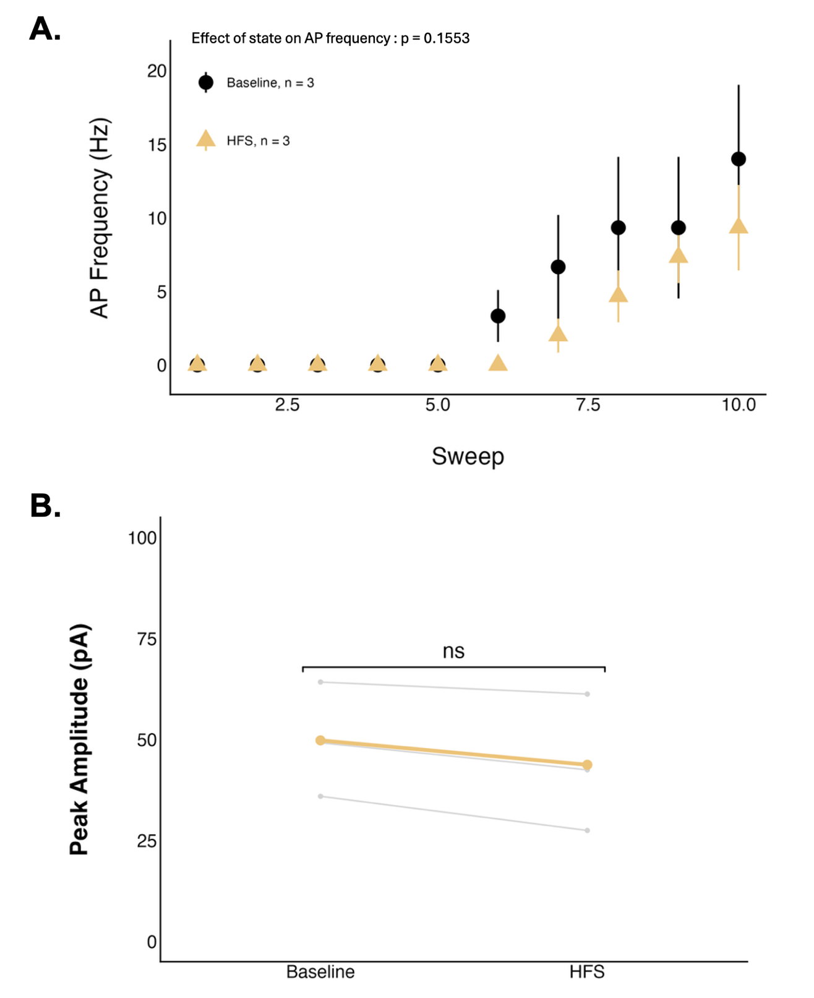
Figure 6. Action potential (AP) frequency and peak amplitude did not change significantly after high frequency stimulation (HFS) in naïve neurons. A: Each point represents the mean AP frequency ± standard error, sweep corresponds to level of current injection, ranging from -50 to 40 pA, and n represents the number of unique neurons. B: Each grey point (n = 3, neurons that fired action potentials at both states) represents the mean AP peak amplitude of a single neuron averaged over the baseline period (0-to-5 minutes) or the final period (25-to-30 minutes). The coloured line represents the mean AP peak amplitude ± standard error for the group.

In neurons from animals exposed to acute stress, HFS elicited a significant long-term depression (LTD) in the strength of glutamate synapses when compared to baseline (df = 5, 35; F = 7.3222; p = 0.0001; linear mixed model). Post hoc contrasts revealed that eEPSC amplitude was significantly reduced relative to baseline during the 20-to-25 (F = 14.491; p = 0.0066564; evaluated against α = 0.01; Figure 7) and 25-to-30-minute periods (F = 14.930; p = 0.00618; evaluated against α = 0.01; Figure 7), with a final amplitude of 42.67 ± 11.37% of baseline.

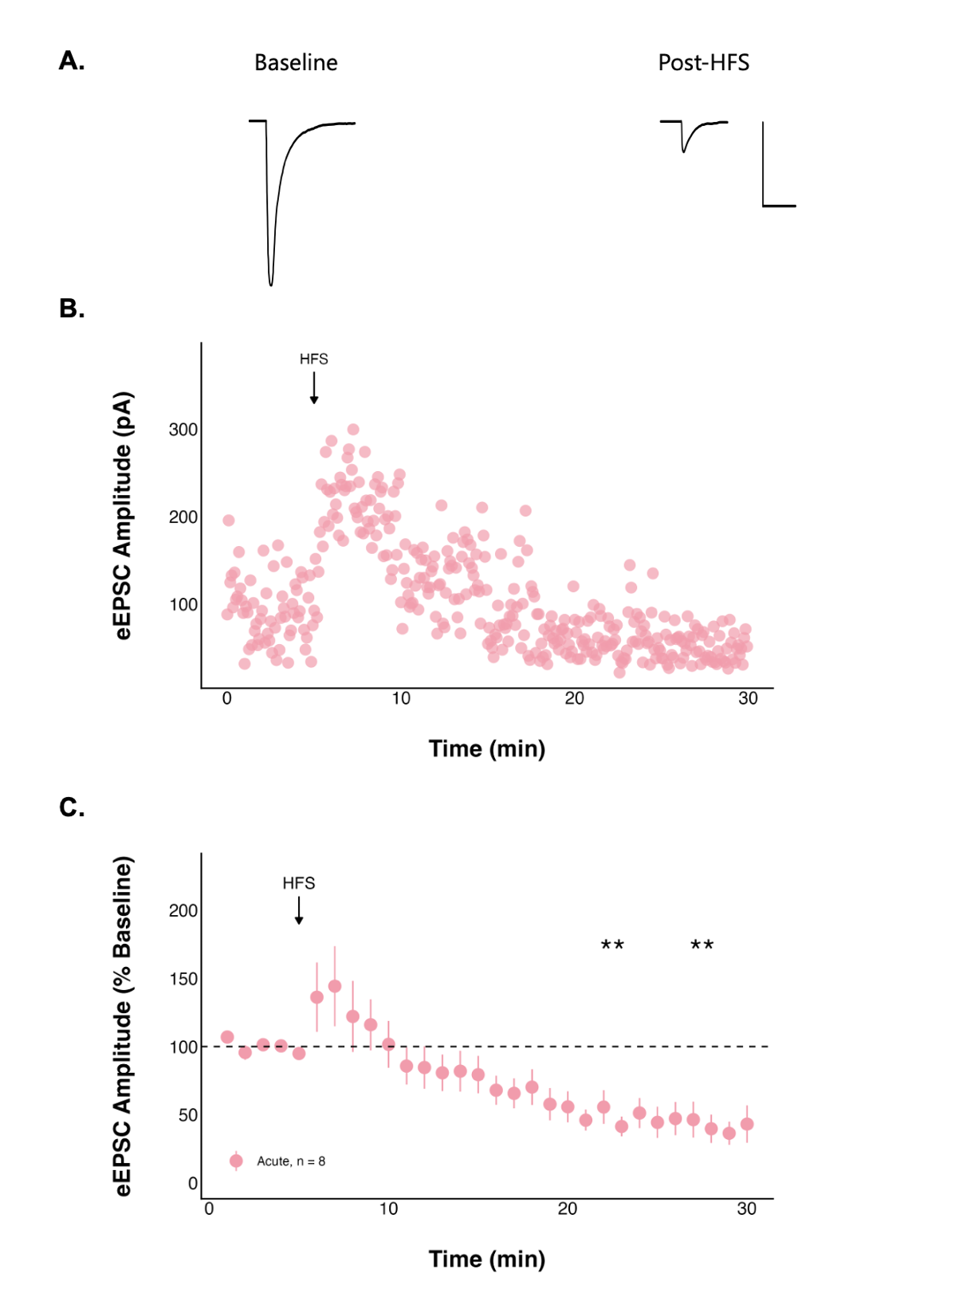
Figure 7. High frequency stimulation (HFS) following acute stress decreases evoked excitatory postsynaptic current (eEPSC) amplitude over time. A: Representative traces consisting of eEPSCs from one neuron averaged over the baseline period (0-to-5 minutes) and last period (25-to-30 minutes) of the recording with a scale bar that represents 50 pA/10 msec, and B: a representative recording from one neuron. C: Summary data in which each point represents the eEPSC amplitude ± standard error across all neurons and n represents the number of unique neurons. The asterisks indicate a statistically significant change in current amplitude relative to the baseline (post hoc contrast; ** = p < 0.01).

The PPR increased significantly over time in neurons from animals exposed to acute stress (1.02 ± 0.10 at baseline to 1.46 ± 0.17 post-HFS; n = 8; t = 2.8363; df = 7; p = 0.02518; paired t-test; Figure 8A), consistent with a decreased probability of presynaptic glutamate release. In contrast, the inverse squared coefficient of variation did not change (t = -2.2068; df = 7; p = 0.06309; paired t-test, Figure 8B), suggesting no clear evidence for changes in quantal size or number of release sites.

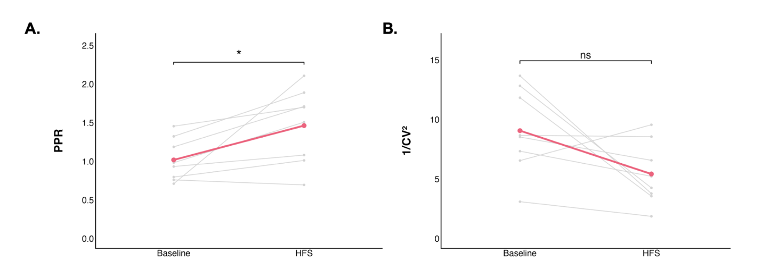
Figure 8. The paired pulse ratio (PPR) significantly increased, and inverse squared coefficient of variation did not change after high frequency stimulation (HFS) following acute stress. Each grey point (n = 8) represents the mean A: PPR or B: inverse squared coefficient of variation of a single neuron averaged over the baseline period (0-to-5 minutes) or the final period (25-to-30 minutes). The coloured line represents the mean PPR or inverse squared coefficient of variation ± standard error for the group. The asterisks indicate a statistically significant change in PPR relative to the baseline (paired t-test; * = p < 0.05).

Action potential peak frequency (df = 1, 151; F = 22.10576; p < 0.0001; Table 4; Figure 9A) and peak amplitude (t = 4.3501; df = 4; p = 0.01216; paired t-test; Figure 9B) significantly decreased post-HFS in neurons from animals exposed to acute stress.

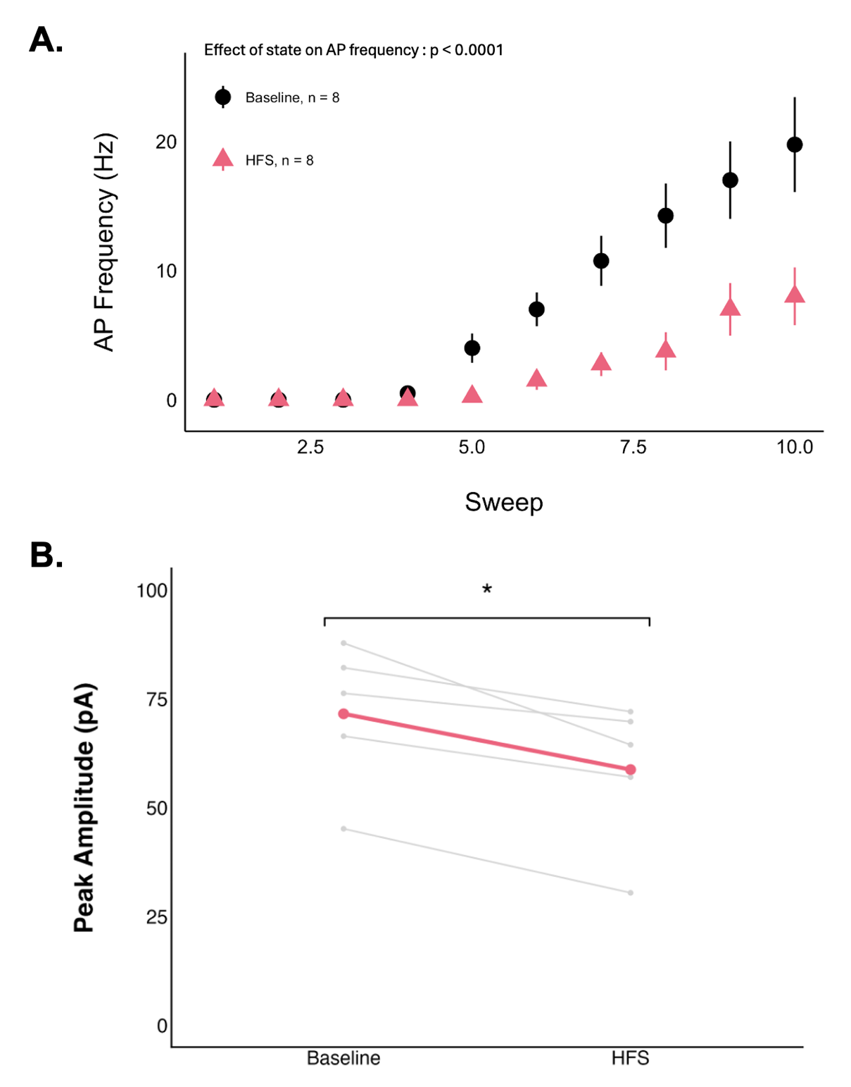
Figure 9. The action potential (AP) peak amplitude significantly decreased after high frequency stimulation (HFS) following acute stress. A: Each point represents the mean AP frequency ± standard error, sweep corresponds to level of current injection, ranging from -50 to 40 pA, and n represents the number of unique neurons. B: Each grey point (n = 5, neurons that fired action potentials at both states) represents the mean AP peak amplitude of a single neuron averaged over the baseline period (0-to-5 minutes) or the final period (25-to-30 minutes). The coloured line represents the mean AP peak amplitude ± standard error for the group. The asterisks indicate a statistically significant change in peak amplitude relative to the baseline (paired t-test; * = p < 0.05).

3.3 The type I cannabinoid receptor mediates the long-term depression observed in acute stress neurons
Acute stress induced a long-term depression (LTD) of excitatory synaptic transmission. Given that endocannabinoid signalling mediates suppression of glutamate release, we next tested whether type I cannabinoid (CB1) receptors contribute to this effect using AM251 (5 µM), a CB1 receptor inverse agonist (Figure 10). Despite undergoing acute stress, when CB1 receptors were blocked there was no significant change in eEPSC amplitude relative to baseline during any time interval (final amplitude 64.43 ± 14.71% of baseline). Additionally, neither the PPR (PPR: 1.05 ± 0.09 at baseline to 1.07 ± 0.13 post-HFS; n = 10; t = 0.29187; df = 9; p = 0.777; paired t-test; Figure 11A), nor the inverse squared coefficient of variation (t = 1.0427; df = 9; p = 0.3243; paired t-test; Figure 11B) changed, suggesting no detectable change in presynaptic release probability, quantal size, or number of release sites, which is consistent with the lack of current amplitude change.
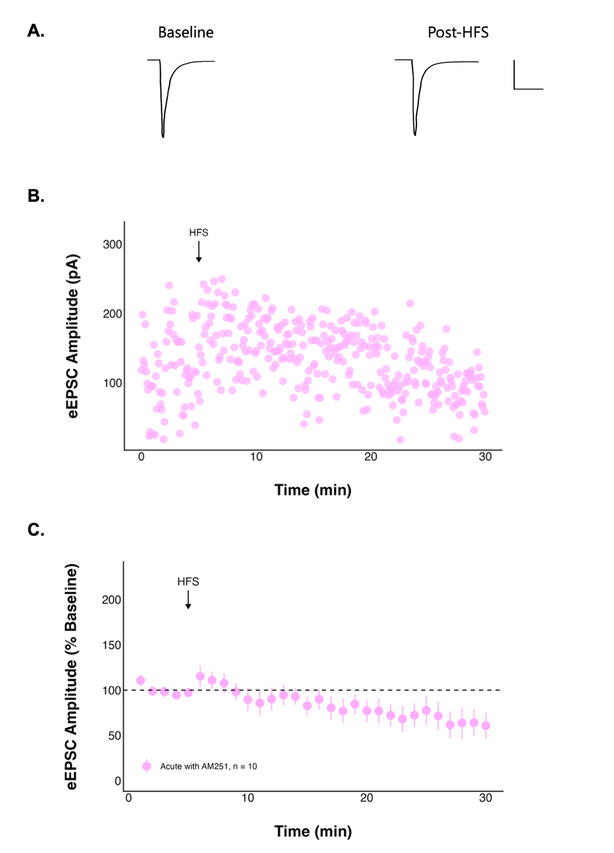
Figure 10. The effect of high frequency stimulation (HFS) on evoked excitatory postsynaptic current (eEPSC) amplitude over time following acute stress is no longer seen when CB1 receptors are blocked. A: Representative traces consisting of eEPSCs from one neuron averaged over the baseline period (0-to-5 minutes) and last period (25-to-30 minutes) of the recording with a scale bar that represents 50 pA/10 msec, and B: a representative recording from one neuron. C: Summary data in which each point represents the eEPSC amplitude ± standard error across all neurons and n represents the number of unique neurons.

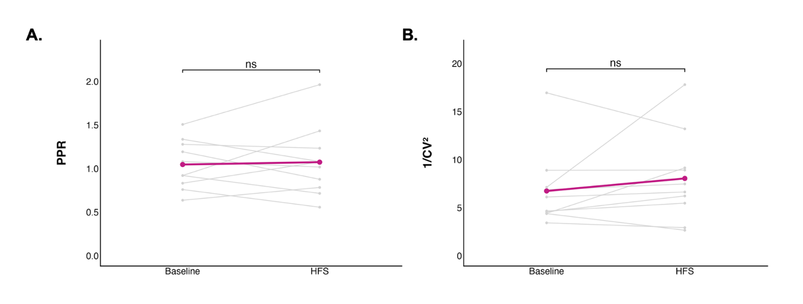
Figure 11. The paired pulse ratio (PPR) and inverse squared coefficient of variation did not change significantly after high frequency stimulation (HFS) following acute stress when CB1 receptors were blocked. Each grey point (n = 10) represents the mean A: PPR or B: inverse squared coefficient of variation of a single neuron averaged over the baseline period (0-to-5 minutes) or the final period (25-to-30 minutes). The coloured line represents the mean PPR or inverse squared coefficient of variation ± standard error for the group.

Despite acute stress, when CB1 receptors were blocked action potential frequency (df = 1, 189; F = 1.485248; p = 0.2245; Table 4; Figure 12A) and peak amplitude (t = 1.9964; df = 5; p = 0.1024; paired t-test; Figure 12B) did not significantly differ following HFS.

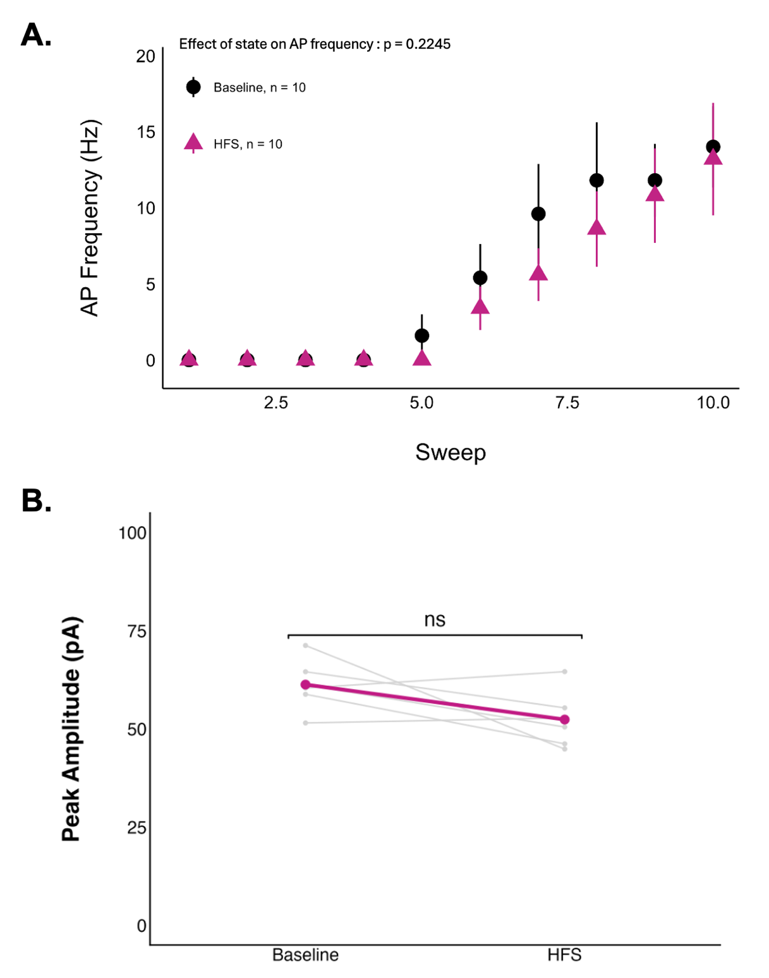
Figure 12. Action potential (AP) frequency peak amplitude did not change after high frequency stimulation (HFS) following acute stress when CB1 receptors were blocked. A: Each point represents the mean AP frequency ± standard error, sweep corresponds to level of current injection, ranging from -50 to 40 pA, and n represents the number of unique neurons. B: Each grey point (n = 5, neurons that fired action potentials at both states) represents the mean AP peak amplitude of a single neuron averaged over the baseline period (0-to-5 minutes) or the final period (25-to-30 minutes). The coloured line represents the mean AP peak amplitude ± standard error for the group.

3.4 Repeated stress does not alter glutamatergic transmission in DMH neurons of young female rats
To determine if five consecutive days of a 30-minute physical restraint affects glutamate signalling in the DMH, recordings of DMH neurons in hypothalamic slices were obtained. Unlike in acute stress, eEPSC amplitude did not change significantly after HFS (final amplitude 74.00 ± 12.34% of baseline; Figure 13), nor in the PPR (1.29 ± 0.18 at baseline to 1.35 ± 0.22 post-HFS; n = 9; t = 0.53352; df = 8; p = 0.6082; paired t-test; Figure 14A) or inverse squared coefficient of variation (t = 0.32925, df = 8, p = 0.7504; paired t-test; Figure 14B), suggesting no detectable change in presynaptic release probability, quantal size, or number of release sites, which is consistent with the lack of current amplitude change.
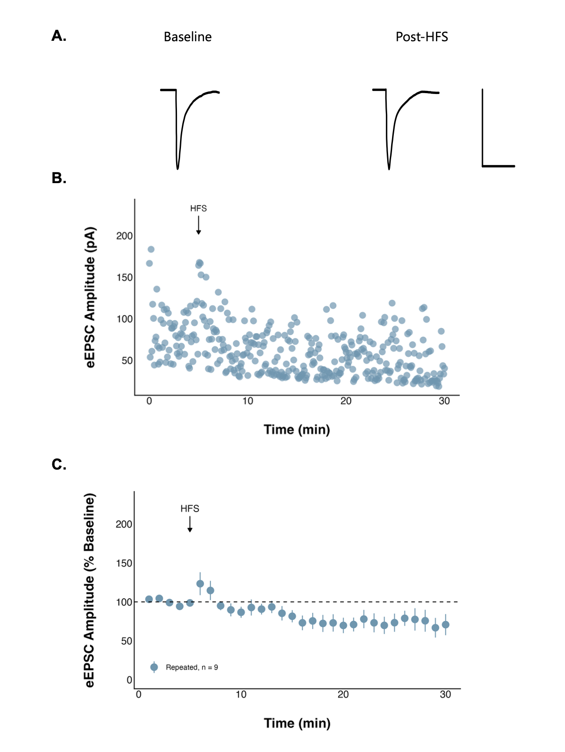
Figure 13. High frequency stimulation (HFS) has no effect on evoked excitatory postsynaptic current (eEPSC) amplitude over time following repeated stress. A: Representative traces consisting of eEPSCs from one neuron averaged over the baseline period (0-to-5 minutes) and last period (25-to-30 minutes) of the recording with a scale bar that represents 50 pA/10 msec, and B: a representative recording from one neuron. C: Summary data in which each point represents the eEPSC amplitude ± standard error across all neurons and n represents the number of unique neurons.

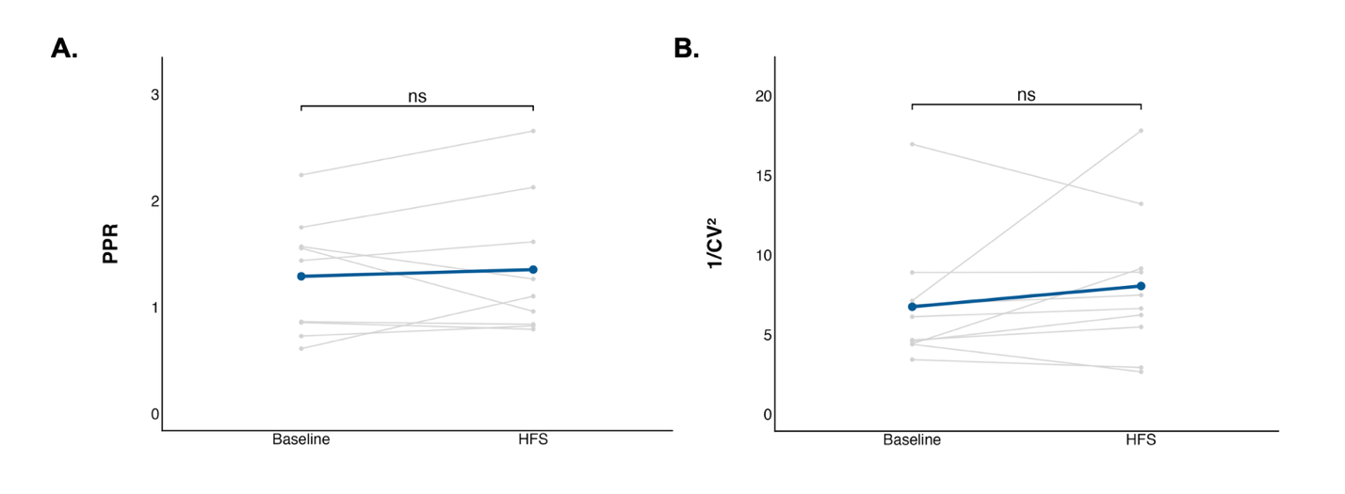
Figure 14. The paired pulse ratio (PPR) and inverse squared coefficient of variation did not change significantly after high frequency stimulation (HFS) following repeated stress. Each grey point (n = 9) represents the mean A: PPR or B: inverse squared coefficient of variation of a single neuron averaged over the baseline period (0-to-5 minutes) or the final period (25-to-30 minutes). The coloured line represents the mean PPR or inverse squared coefficient of variation ± standard error for the group.

While action potential frequency did not differ significantly post-HFS (df = 1, 170; F = 2.446259; p = 0.1197; Table 4; Figure 15A), peak amplitude significantly decreased (t = 3.9281; df = 8; p = 0.004368; paired t-test; Figure 15B).

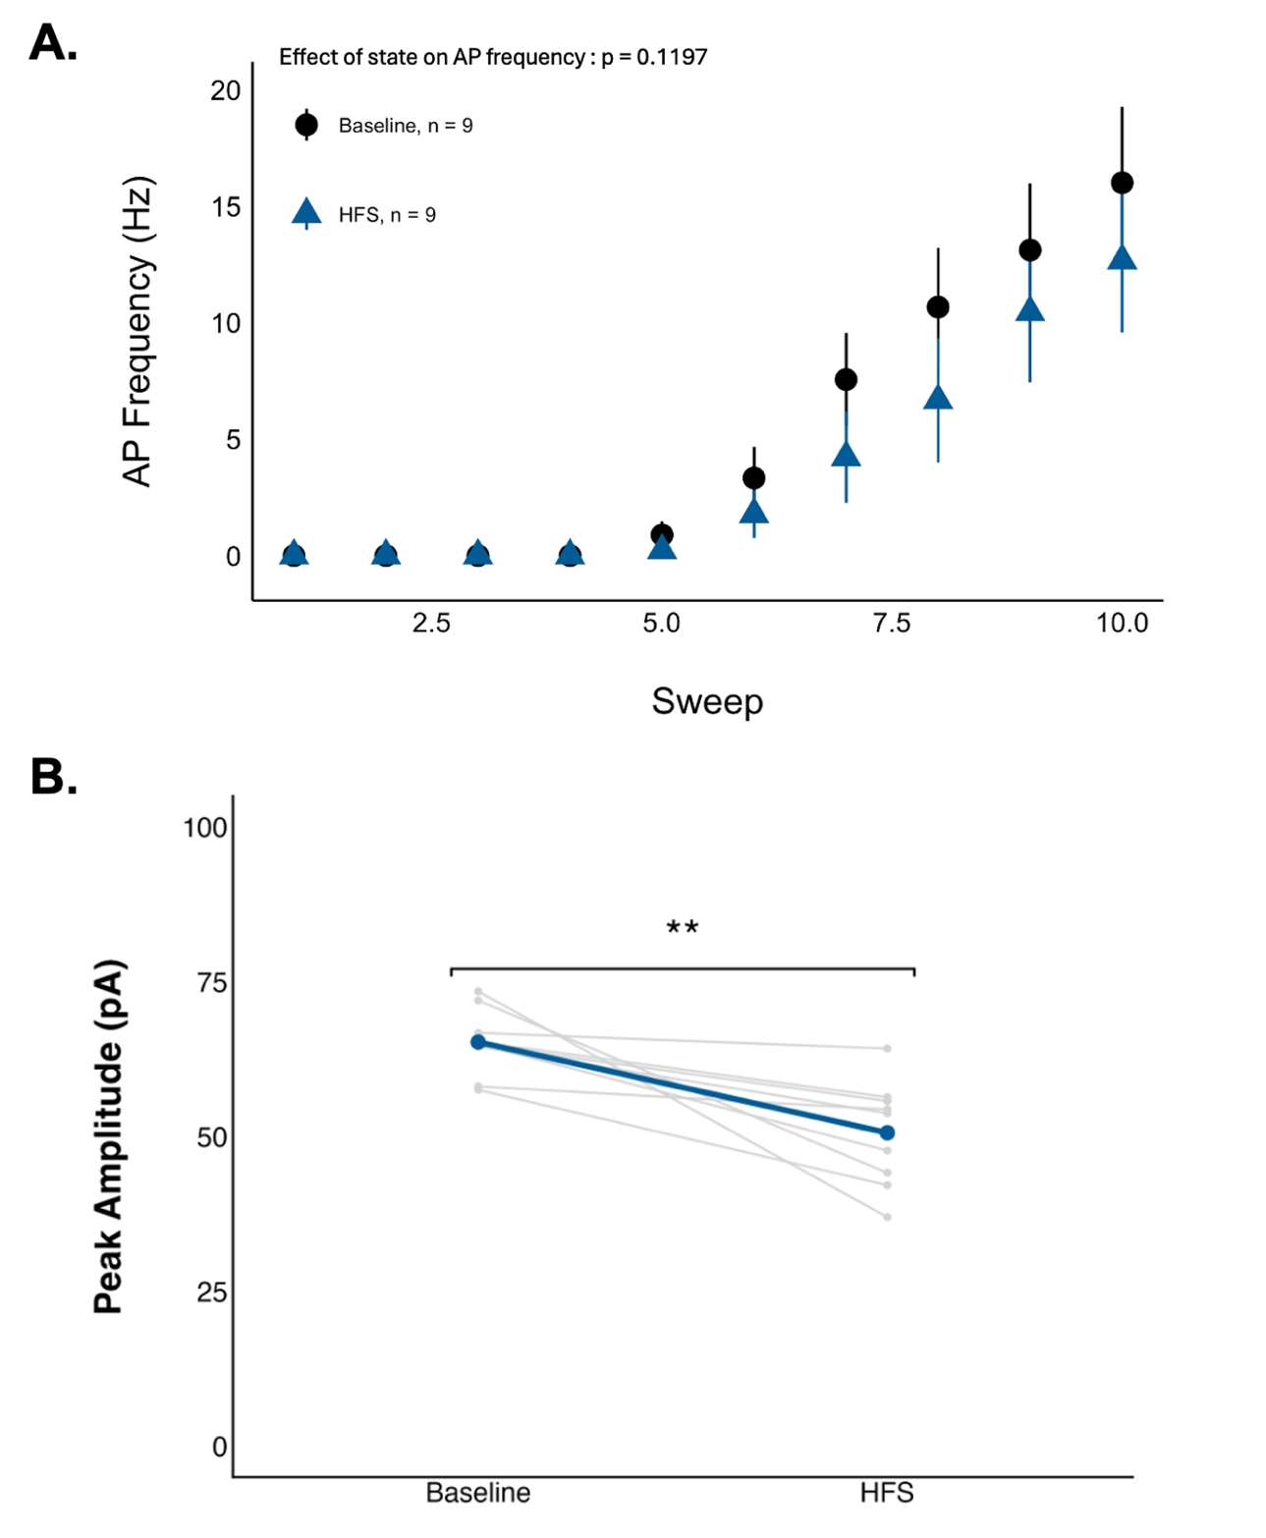
Figure 15. Action potential (AP) peak amplitude decreased after high frequency stimulation (HFS) following repeated stress. A: Each point represents the mean AP frequency ± standard error, sweep corresponds to level of current injection, ranging from -50 to 40 pA, and n represents the number of unique neurons. B: Each grey point (n = 9, neurons that fired action potentials at both states) represents the mean AP peak amplitude of a single neuron averaged over the baseline period (0-to-5 minutes) or the final period (25-to-30 minutes). The coloured line represents the mean AP peak amplitude ± standard error for the group. The asterisks indicate a statistically significant change in peak amplitude relative to the baseline (paired t-test; ** = p < 0.01).

Overall, these findings demonstrate that acute stress alters both synaptic transmission and neuronal excitability in DMH neurons of young female rats, while repeated stress produces more limited changes, suggesting differential adaptation of hypothalamic circuits to stress exposure.

Chapter 4: Discussion
The goal of this study was to determine how stress alters glutamatergic signalling and neuronal excitability in neurons of the dorsomedial hypothalamus (DMH) in young female rats. Although the hypothalamus plays a central role in the stress response, the mechanisms through which stress alters synaptic transmission and plasticity in the female DMH are not well understood. We therefore examined how acute and repeated restraint stress influence basal glutamatergic transmission, synaptic plasticity, and neuronal excitability in DMH neurons by recording synaptic transmission and action potential properties. Our results demonstrate that acute stress alters basal synaptic transmission of DMH neurons and produces long-lasting changes, which appear to be mediated by the type I cannabinoid (CB1) receptor. These findings partially support the hypothesis and predictions of the study, and provide insight into how stress alters neuronal communication, highlighting a potential mechanism through which stress may alter overall stress reactivity in the female DMH.

4.1 Acute stress and glutamate transmission
Acute stress significantly modified both basal glutamatergic transmission and activity-dependent synaptic plasticity at DMH synapses. Basal glutamatergic transmission was enhanced following acute stress, as indicated by the increased evoked excitatory postsynaptic current (eEPSC) amplitude, while the paired pulse ratio (PPR) did not differ between naïve and stressed animals, suggesting that this increase in synaptic strength was not due to a change in presynaptic release probability. Instead, this effect may reflect a postsynaptic mechanism, such as changes in postsynaptic glutamate receptor functioning or trafficking to the postsynaptic membrane, which can increase excitatory currents without altering presynaptic release probability. Activity dependent trafficking of AMPA receptors is a well-established mechanism underlying changes in excitatory synaptic strength and plasticity (Savtchouk and Liu, 2011).
Stress-induced increases in glutamatergic transmission have been reported in several brain regions, including the hypothalamus and hippocampus (McEwen, 2017). Acute stress can rapidly elevate extracellular glutamate levels through mechanisms that can depend on adrenal hormones and HPA axis activation (Moghaddam, 2002). These increases in glutamate availability may temporarily strengthen excitatory transmission, promoting rapid activation of neural pathways involved in the stress response.
Despite the increase in basal transmission, synaptic plasticity in the DMH was strongly altered by acute stress. HFS did not induce significant changes in eEPSC amplitude in naïve animals. However, in animals exposed to acute stress, the same stimulation protocol produced a long-term depression (LTD) of synaptic transmission. This LTD was accompanied by a significant increase in PPR, which is inversely related to presynaptic release probability (Glasgow et al., 2019), indicating a decrease in presynaptic glutamate release probability. Consistent with these observations, studies in the hypothalamus have shown that stress can initially increase excitatory synaptic activity. In paraventricular nucleus (PVN) neurons, an early increase in excitatory miniature EPSC frequency has been reported following stress hormone exposure (Boychuk et al., 2013), suggesting that stress can quickly enhance presynaptic glutamate release before longer-term adaptations occur. The effect includes a TRPV1/4 receptor mediated transient increase in glutamate release, followed by CB1 receptor-mediated suppression of glutamate release (Boychuk et al., 2013). This biphasic mechanism is consistent with the pattern observed in the present study, where acute stress increased basal transmission but facilitated a CB1 receptor-dependent LTD after HFS, suggesting involvement of endocannabinoid signalling. Stress-induced facilitation of LTD has been described in several neural circuits, as stress hormones such as glucocorticoids and corticotropin-releasing hormone (CRH) can modify glutamatergic signalling and intracellular calcium, influencing synaptic plasticity (dos-Santos et al., 2023). For example, cortisol has been shown to enhance synaptic depression of eEPSCs in cortical pyramidal neurons following HFS (Wang et al., 2024), indicating that glucocorticoids can influence synaptic plasticity. In hypothalamic circuits, such plasticity may help terminate the stress response by reducing excitatory drive onto neurons that promote autonomic and endocrine activation.
The absence of changes in membrane capacitance further suggests that these effects are not due to differences in cell size, as capacitance is proportional to cell surface area (Kodirov, 2023), supporting a synaptic rather than structural mechanism.

4.2 Acute stress and neuronal excitability
We found that acute stress produces persistent changes in the intrinsic excitability of neurons in the DMH. Following HFS, acute stress neurons showed a decrease in the peak amplitude of action potentials, and a decrease in action potential firing frequency across several current injections. No long-lasting changes in neuronal excitability were observed in naïve neurons.
Resting membrane potential was not significantly different in naïve and acute neurons, suggesting that these changes in excitability are not due to differences in baseline membrane polarization, but instead activity-dependent mechanisms.
The reduced excitability observed may represent a compensatory mechanism that limits the prolonged activation of stress pathways. Acute stress activates hypothalamic pathways involved in automatic and endocrine responses (DiMicco et al., 2002; Crosby and Bains, 2012), such that following the termination of the stressor, mechanisms that dampen neuronal activity may be necessary to restore homeostasis. Glucocorticoids can rapidly alter neuronal excitability through non-genomic mechanisms. For example, cortisol has been shown to decrease action potential firing frequency following HFS in glutamatergic cortical pyramidal neurons by activating Kv2.2 potassium channels, which increases potassium efflux, hyperpolarizing the cell and reducing neuronal excitability (Wang et al., 2024). Reduced excitability in DMH neurons after HFS may contribute to the termination of the stress response by limiting sustained activation of downstream stress circuits.

4.3 The acute stress mechanism
The changes in eEPSC amplitude, PPR, action potential firing frequency, and action potential amplitude seen in acute stress were not observed when CB1 receptors were blocked, indicating that the reduction in excitability depends on endocannabinoid signalling.
The present findings strongly implicate the endocannabinoid system in mediating stress-induced plasticity of the DMH. Blockage of CB1 receptors with AM251, an inverse agonist, prevented the LTD observed following acute stress and eliminated the associated increase in PPR. These findings indicate that activation of presynaptic CB1 receptors is required for the induction or maintenance of stress-induced LTD at glutamatergic synapses.
Endocannabinoids function as retrograde signalling molecules that are synthesized in postsynaptic neurons and released in response to increased intracellular calcium or activation of metabotropic receptors. Once released, endocannabinoids diffuse across the synaptic cleft and bind to CB1 receptors located on presynaptic terminals. Activation of these receptors inhibits adenylate cyclase activity and suppresses presynaptic voltage-gated calcium channels, ultimately reducing calcium dependent glutamate release from presynaptic terminals (Crosby and Bains, 2012).
This mechanism is consistent with previous observations in hypothalamic circuits, where stress-induced suppression of glutamatergic transmission has been shown to be mediated by endocannabinoid signalling. In PVN neurons, long-term decreases in spontaneous excitatory current frequency following exposure to stress hormones were blocked by the CB1 receptor antagonist AM251 (Boychuk et al., 2013), suggesting that CB1 receptor activation contributes to stress-induced suppression of excitatory synaptic input.
Endocrine signalling is closely linked to glucocorticoid feedback regulation of the HPA axis. Following acute stress, glucocorticoids can stimulate the synthesis of endocannabinoids, such as 2-Arachidonoylglycerol (2-AG), which acts to suppress excitatory synaptic input onto neurons involved in the stress response (Levy and Tasker, 2012). This mechanism serves as an important regulator of excessive activation of stress responses. Acute stress may elevate glucocorticoid levels, which in turn stimulate endocannabinoid production in DMH neurons. When synapses are subsequently stimulated by HFS, endocannabinoids could be released from postsynaptic neurons and act on presynaptic CB1 receptors to reduce glutamate release, resulting in LTD. The increase in PPR observed after LTD supports this, as CB1 receptor-mediated suppression of neurotransmitter release would be expected to increase PPR.
The DMH is an important regulator of the stress response due to its role in projections to the PVN. The DMH contains heterogenous populations of neurons that project to the PVN, including both glutamatergic and GABAergic neurons capable of modulating the activity of CRH neurons (Myers et al., 2014; Bains et al., 2015). Because the PVN is the primary site of HPA axis activation, synaptic changes within the DMH have the potential to influence downstream stress hormone release (Bains et al., 2015). These findings suggest that acute stress reduces excitatory input onto DMH neurons that may normally inhibit PVN CRH neurons, regulating the HPA axis. The DMH receives excitatory input from several brain regions involved in stress processing, including the prefrontal cortex, and activation of these inputs may normally recruit DMH circuits that help regulate HPA axis activity. If the neurons recorded in the present study correspond to DMH neurons that inhibit PVN CRH neurons, a reduction in glutamatergic input through CB1 receptor-dependent LTD could decrease the activity of these inhibitory neurons. This could reduce inhibitory output from the DMH to the PVN, leading to disinhibition of CRH neurons and potentially enhancing HPA activation during subsequent stress exposure. Such a mechanism could increase the sensitivity of hypothalamic stress circuits following an initial stressor.
Altered regulation of the HPA axis is a key feature of stress-related disorders, and dysregulated feedback within hypothalamic circuits can contribute to prolonged or exaggerated stress responses (Moghaddam, 2002). This is particularly relevant given that females show increased vulnerability to development of stress-related disorders characterized by hyperarousal and dysregulated stress responses. Neurobiological models of post-traumatic stress disorder (PTSD) suggest that altered neural circuits and dysregulation of the HPA axis contribute to the heightening sensitivity to stress seen in this disorder (Olff, 2017). Because hypothalamic circuits coordinate endocrine and autonomic responses to stress, synaptic plasticity within nuclei such as the DMH may contribute to long-lasting changes in stress reactivity that increase vulnerability to stress-related disorders. Although the present study did not directly identify the projection targets of recorded DMH neurons, the observed stress-induced LTD suggests that acute stress can modify synaptic regulation within hypothalamic circuits that influence the activity of the HPA axis.

4.4 Repeated stress and glutamate transmission
In contrast to the effects of acute stress, repeated stress did not significantly alter synaptic transmission or plasticity in the present study. Repeated stress exposure often leads to adaptations that restore synaptic signalling to baseline levels, limiting further stress-induced plasticity. These adaptations may involve changes in receptor expression, neurotransmitter release, or intracellular signalling pathways (dos-Santos et al., 2023). Sex differences in stress responses in rodents have been reported, with males often showing more pronounced synaptic changes following repeated restraint stress compared to females, despite similar stress hormone levels (Nalepa et al., 2025; McEwen et al., 2017). The lack of significant synaptic plasticity after repeated restraint stress may suggest that DMH glutamatergic synapses undergo compensatory adjustments that stabilize synaptic function after repeated stress exposure.

4.5 Repeated stress and neuronal excitability
In further contrast to acute stress, repeated stress did not alter firing frequency after HFS, but did decrease peak action potential amplitude, suggesting that long-lasting changes in intrinsic DMH neuronal excitability may arise through different mechanisms following acute compared to repeated stress exposure.
Changes in neuronal excitability are a common feature of stress-induced neural plasticity, as stress exposure can modify the intrinsic electrical properties of neurons and alter their firing patterns and responsiveness to input. For example, repeated restraint stress has been shown to reduce the intrinsic excitability of CRH neurons, coinciding with decreased responsiveness of their HPA axis in response to stress (Matovic et al., 2020). Repeated stress did not produce the same decrease in action potential firing frequency as acute stress. In females, repeated or chronic stress can induce adaptive changes that stabilize neuronal activity despite continued exposure to stress (McEwen, 2017).

4.6 Next steps
While the present findings identify endocannabinoid signalling as a key mediator of the stress-induced synaptic plasticity in the DMH, the upstream mechanism through which stress hormones engage this pathway remain unclear. The specific endocannabinoid responsible for the observed LTD is unknown, as both anandamide and 2-AG can activate CB1 receptors and contribute to decreased glutamate release. Further study using inhibitors of endocannabinoid synthesis or degradation could help determine which ligand underlies this plasticity. In addition, acute stress may alter postsynaptic glutamate receptor expression or trafficking. The increased basal eEPSC amplitude observed following acute stress may reflect changes in AMPA receptor number or subunit composition, which could influence synaptic strength independent of presynaptic release probability (Savtchouk and Liu, 2011). Finally, future work should determine whether acute stress-induced long-term depression in glutamatergic DMH synapses alters behavioural and neuronal responses to subsequent stress exposure, particularly through mechanism that may disinhibit the HPA axis and alter stress reactivity.

4.7 Conclusions
In summary, acute stress alters both synaptic transmission and intrinsic excitability in DMH neurons, increasing basal excitatory synaptic transmission and inducing a CB1 receptor-dependent long-term depression of excitatory inputs and neuronal excitability. In contrast, repeated stress only decreased long-term action potential amplitude. These findings suggest that acute stress engages endocannabinoid signalling within the DMH to regulate glutamatergic synaptic transmission and neuronal activity.
Understanding how stress modifies DMH function provides insight into neural mechanisms underlying stress-related disorders, particularly in females, and highlights the DMH as a site where stress-induced plasticity may shape responses to future stress. Collectively, these findings indicate that the DMH could serve as a potential target for therapeutic intervention to mitigate stress-related changes and disorders.

Acknowledgments
I want to thank and express my appreciation for my supervisor, Dr. Crosby, without whom none of this would have been possible. At times this work was very challenging, but she consistently supported me as a student, a scientist, a communicator, and a person through every step. I am incredibly grateful for my time at Mount Allison, and I hope to proudly represent the Crosby Lab as I move on.
Thank you so much to Jackie Jacob-Vogels for welcoming me into the animal wing, and Salma Ismail for their animal care expertise.
Thank you to Dr. Rourke, for your insight and feedback as my second reader and committee member, and as a professor, who has contributed immensely to my experience at Mount Allison, whether through Together Time, as a classroom TA for BIOC1001, or as a in Molecular Analyses.
And to my dog Millie, without whom I would not be graduating. For the past four years she has been by my side, from many walks around Waterfowl to patiently listening to an endless number of practice presentations.
This work was supported by grant held by Dr. Crosby from Natural Sciences and Engineering Research Council of Canada (NSERC). Additionally, my summer research was supported by an NSERC Undergraduate Student Research Award and a Mount Allison Independent Student Research Grant.

References
Adam, T. C., & Epel, E. S. (2007). Stress, eating and the reward system. Physiology & Behavior, 91(4), 449–458. https://doi.org/10.1016/j.physbeh.2007.04.011
Bains, J. S., Cusulin, J. I. W., & Inoue, W. (2015). Stress-related synaptic plasticity in the hypothalamus. Nature Reviews Neuroscience, 16(7), 377–388. https://doi.org/10.1038/nrn3881
Barnett, M. W., & Larkman, P. M. (2007). The action potential. Practical Neurology, 7(3), 192–197.
Bartsch, J. C., Von Cramon, M., Gruber, D., Heinemann, U., & Behr, J. (2021). Stress-Induced Enhanced Long-Term Potentiation and Reduced Threshold for N-Methyl-D-Aspartate Receptor- and β-Adrenergic Receptor-Mediated Synaptic Plasticity in Rodent Ventral Subiculum. Frontiers in Molecular Neuroscience, 14, 658465. https://doi.org/10.3389/fnmol.2021.658465
Bellinger, L. L., & Bernardis, L. L. (2002). The dorsomedial hypothalamic nucleus and its role in ingestive behavior and body weight regulation. Physiology & Behavior, 76(3), 431–442. https://doi.org/10.1016/s0031-9384(02)00756-4
Benedini, S. (2009). The hypothalamus and energy balance. Sport Sciences for Health, 5(2), 45–53. https://doi.org/10.1007/s11332-009-0079-5
Bose, M., Oliván, B., & Laferrère, B. (2009). Stress and obesity: The role of the hypothalamic–pituitary–adrenal axis in metabolic disease. Current Opinion in Endocrinology, Diabetes & Obesity, 16(5), 340–346. https://doi.org/10.1097/MED.0b013e32832fa137
Boychuk, C.R., Zsombok, A., Tasker, J. G., & Smith, N. (2013). Rapid glucocorticoid-induced activation of TRP and CB1 receptors causes biphasic modulation of glutamate release in gastric-related hypothalamic preautonomic neurons. Frontiers in Neuroscience. https://doi.org/10.3389/fnins.2013.00003
Charmandari, E., Tsigos, C., & Chrousos, G. (2005). ENDOCRINOLOGY OF THE STRESS RESPONSE. Annual Review of Physiology, 67(1), 259–284. https://doi.org/10.1146/annurev.physiol.67.040403.120816
Cintra, A., Fuxe, K., Wikstro¨m, A.-C., Visser, T., & Gustafsson, J.-A. (1990). Evidence for thyrotropin-releasing hormone and glucocorticoid receptor-immunoreactive neurons in various preoptic and hypothalamic nuclei of the male rat. Brain Research, 506(1), 139–144. https://doi.org/10.1016/0006-8993(90)91210-8
Crosby, K. M., & Bains, J. S. (2012). The intricate link between glucocorticoids and endocannabinoids at stress-relevant synapses in the hypothalamus. Neuroscience, 204, 31–37. https://doi.org/10.1016/j.neuroscience.2011.11.049
Crosby, K. M., Inoue, W., Pittman, Q. J., & Bains, J. S. (2011). Endocannabinoids Gate State-Dependent Plasticity of Synaptic Inhibition in Feeding Circuits. Neuron, 71(3), 529–541. https://doi.org/10.1016/j.neuron.2011.06.006
Dallman, M. F., Pecoraro, N., Akana, S. F., La Fleur, S. E., Gomez, F., Houshyar, H., Bell, M. E., Bhatnagar, S., Laugero, K. D., & Manalo, S. (2003). Chronic stress and obesity: A new view of “comfort food”. Proceedings of the National Academy of Sciences, 100(20), 11696–11701. https://doi.org/10.1073/pnas.1934666100
Dallman, M. F., Pecoraro, N. C., La Fleur, S. E., Warne, J. P., Ginsberg, A. B., Akana, S. F., Laugero, K. C., Houshyar, H., Strack, A. M., Bhatnagar, S., & Bell, M. E. (2006). Glucocorticoids, chronic stress, and obesity. In Progress in Brain Research (Vol. 153, pp. 75–105). Elsevier. https://doi.org/10.1016/S0079-6123(06)53004-3
Dalton, L. D., Carpenter, R. G., & Grossman, S. P. (1981). Ingestive behavior in adult rats with dorsomedial hypothalamic lesions. Physiology & Behavior, 26(1), 117–123. https://doi.org/10.1016/0031-9384(81)90086-X
DiMicco, J. A., & Abshire, V. M. (1987). Evidence for GABAergic inhibition of a hypothalamic sympathoexcitatory mechanism in anesthetized rats. Brain Research, 402(1), 1–10. https://doi.org/10.1016/0006-8993(87)91041-9
DiMicco, J. A., Samuels, B. C., Zaretskaia, M. V., & Zaretsky, D. V. (2002). The dorsomedial hypothalamus and the response to stress. Pharmacology Biochemistry and Behavior, 71(3), 469–480. https://doi.org/10.1016/s0091-3057(01)00689-x
dos-Santos, R. C., Sweeten, B. L. W., Stelly, C. E., & Tasker, J. G. (2023). The Neuroendocrine Impact of Acute Stress on Synaptic Plasticity. Endocrinology, 164(11), bqad149. https://doi.org/10.1210/endocr/bqad149
Fang, X., Chen, Y., Wang, J., Zhang, Z., Bai, Y., Denney, K., Gan, L., Guo, M., Weintraub, N. L., Lei, Y., & Lu, X.-Y. (2023). Increased intrinsic and synaptic excitability of hypothalamic POMC neurons underlies chronic stress-induced behavioral deficits. Molecular Psychiatry, 28(3), 1365–1382. https://doi.org/10.1038/s41380-022-01872-5
Farries, M. A., Kita, H., & Wilson, C. J. (2010). Dynamic Spike Threshold and Zero Membrane Slope Conductance Shape the Response of Subthalamic Neurons to Cortical Input. The Journal of Neuroscience, 30(39), 13180–13191. https://doi.org/10.1523/JNEUROSCI.1909-10.2010
Fon, E. A., & Edwards, R. H. (2001). Molecular mechanisms of neurotransmitter release. Muscle & Nerve, 24(5), 581–601. https://doi.org/10.1002/mus.1044
Glasgow, S. D., McPhedrain, R., Madranges, J. F., Kennedy, T. E., & Ruthazer, E. S. (2019). Approaches and Limitations in the Investigation of Synaptic Transmission and Plasticity. Frontiers in Synaptic Neuroscience, 11, 20. https://doi.org/10.3389/fnsyn.2019.00020
Goel, M., Mittal, A., Jain, V. R., Bharadwaj, A., Modi, S., Ahuja, G., Jain, A., & Kumar, K. (2025). Integrative Functions of the Hypothalamus: Linking Cognition, Emotion and Physiology for Well-being and Adaptability. Annals of Neurosciences, 32(2), 128–142. https://doi.org/10.1177/09727531241255492
Hertz, L. (2006). Glutamate, a neurotransmitter—And so much more. Neurochemistry International, 48(6–7), 416–425. https://doi.org/10.1016/j.neuint.2005.12.021
James, K. A., Stromin, J. I., Steenkamp, N., & Combrinck, M. I. (2023). Understanding the relationships between physiological and psychosocial stress, cortisol and cognition. Frontiers in Endocrinology, 14. https://doi.org/10.3389/fendo.2023.1085950
Kodirov, S. A. (2023). Whole-cell patch-clamp recording and parameters. Biophysical Reviews, 15(2), 257–288. https://doi.org/10.1007/s12551-023-01055-8
Koss, W. A., & Frick, K. M. (2017). Sex differences in hippocampal function. Journal of Neuroscience Research, 95(1–2), 539–562. https://doi.org/10.1002/jnr.23864
Laureijs, C. (2025). patchclampplotteR: Plot and Analyze Raw Patch Clamp Electrophysiology Data (Version 0.1.0) [Computer software]. https://christelinda-laureijs.github.io/patchclampplotteR/, https://github.com/christelinda-laureijs/patchclampplotteR.
Levy, B. H., & Tasker, J. G. (2012). Synaptic regulation of the hypothalamic–pituitary–adrenal axis and its modulation by glucocorticoids and stress. Frontiers in Cellular Neuroscience, 6. https://doi.org/10.3389/fncel.2012.00024
Matovic, S., Ichiyama, A., Igarashi, H., Salter, E. W., Sunstrum, J. K., Wang, X. F., Henry, M., Kuebler, E. S., Vernoux, N., Martinez‐Trujillo, J., Tremblay, M., & Inoue, W. (2020). Neuronal hypertrophy dampens neuronal intrinsic excitability and stress responsiveness during chronic stress. The Journal of Physiology, 598(13), 2757–2773. https://doi.org/10.1113/JP279666
McEwen, B. S. (2017). Neurobiological and Systemic Effects of Chronic Stress. Chronic Stress, 1, 2470547017692328. https://doi.org/10.1177/2470547017692328
Meldrum, B. S. (2000). Glutamate as a Neurotransmitter in the Brain: Review of Physiology and Pathology. The Journal of Nutrition, 130(4), 1007S-1015S. https://doi.org/10.1093/jn/130.4.1007S
Moghaddam, B. (2002). Stress activation of glutamate neurotransmission in the prefrontal cortex: Implications for dopamine-associated psychiatric disorders. Biological Psychiatry, 51(10), 775–787. https://doi.org/10.1016/S0006-3223(01)01362-2
Myers, B., Mark Dolgas, C., Kasckow, J., Cullinan, W. E., & Herman, J. P. (2014). Central stress-integrative circuits: Forebrain glutamatergic and GABAergic projections to the dorsomedial hypothalamus, medial preoptic area, and bed nucleus of the stria terminalis. Brain Structure and Function, 219(4), 1287–1303. https://doi.org/10.1007/s00429-013-0566-y
Nalepa, I. F., Nielsen, V., Wolf, T. E., Touma, C., Grupe, M., Asuni, A. A., & Ratner, C. (2025). Sex differences in the murine HPA axis after acute and repeated restraint stress. Stress, 28(1), 2447079. https://doi.org/10.1080/10253890.2024.2447079
Nieuwenhuizen, A. G., & Rutters, F. (2008). The hypothalamic-pituitary-adrenal-axis in the regulation of energy balance. Physiology & Behavior, 94(2), 169–177. https://doi.org/10.1016/j.physbeh.2007.12.011
Olff, M. (2017). Sex and gender differences in post-traumatic stress disorder: An update. European Journal of Psychotraumatology, 8(sup4), 1351204. https://doi.org/10.1080/20008198.2017.1351204
Paxinos, G., & Watson, C. (2009). The rat brain in stereotaxic coordinates (6th ed.). Elsevier.
Purves, D., Augustine, G. J., Fitzpatrick, D., Katz, L. C., LaMantia, A.-S., McNamara, J. O., & Williams, S. M. (2001). Two Families of Postsynaptic Receptors. In Neuroscience. 2nd edition. Sinauer Associates. https://www.ncbi.nlm.nih.gov/books/NBK10855/
Saper, C. B., & Lowell, B. B. (2014). The hypothalamus. Current Biology, 24(23), R1111–R1116. https://doi.org/10.1016/j.cub.2014.10.023
Sarabdjitsingh, R. A., Kofink, D., Karst, H., De Kloet, E. R., & Joëls, M. (2012). Stress-Induced Enhancement of Mouse Amygdalar Synaptic Plasticity Depends on Glucocorticoid and ß-Adrenergic Activity. PLoS ONE, 7(8), e42143. https://doi.org/10.1371/journal.pone.0042143
Savtchouk, I., & Liu, S. J. (2011). Remodeling of synaptic AMPA receptor subtype alters the probability and pattern of action potential firing. The Journal of Neuroscience: The Official Journal of the Society for Neuroscience, 31(2), 501–511. https://doi.org/10.1523/JNEUROSCI.2608-10.2011
Siegelbaum, S. A., & Kandel, E. R. (1991). Learning-related synaptic plasticity: LTP and LTD. Current Opinion in Neurobiology, 1(1), 113–120. https://doi.org/10.1016/0959-4388(91)90018-3
Smith, W., & Azevedo, E. P. (2025). Hunger Games: A Modern Battle Between Stress and Appetite. Journal of Neurochemistry, 169(2). https://doi.org/10.1111/jnc.70006
Tran, L. T., Park, S., Kim, S. K., Lee, J. S., Kim, K. W., & Kwon, O. (2022). Hypothalamic control of energy expenditure and thermogenesis. Experimental & Molecular Medicine, 54(4), 358–369. https://doi.org/10.1038/s12276-022-00741-z
Van Huijstee, A. N., & Kessels, H. W. (2020). Variance analysis as a tool to predict the mechanism underlying synaptic plasticity. Journal of Neuroscience Methods, 331, 108526. https://doi.org/10.1016/j.jneumeth.2019.108526
Wang, Y., Zhang, Y., Hu, J., Pan, C., Gao, Y., Liu, Q., Xu, W., Xue, L., & Hu, C. (2024). Glucocorticoids modulate neural activity via a rapid non-genomic effect on Kv2.2 channels in the central nervous system. Neurobiology of Stress, 28, 100593. https://doi.org/10.1016/j.ynstr.2023.100593
Xu, W., Yao, X., Zhao, F., Zhao, H., Cheng, Z., Yang, W., Cui, R., Xu, S., & Li, B. (2020). Changes in Hippocampal Plasticity in Depression and Therapeutic Approaches Influencing These Changes. Neural Plasticity, 2020, 1–16. https://doi.org/10.1155/2020/8861903

