FALL 2018 ENPM691 HW3

Richard M. Vook

113482977
Table of Contents
ENPM691 HW3 1
Richard M. Vook 1
113482977 1
Figure 7: ret2text.c 1
Figure 8: ret2bss.c 1
Figure 10: strptr.c 1
Figure 11: funcptr.c 1
Figure 20: ret2pop.c 1
Figure 23: ret2esp.c 2
Figure 29: ret2got.c 2

Figure 7: ret2text.c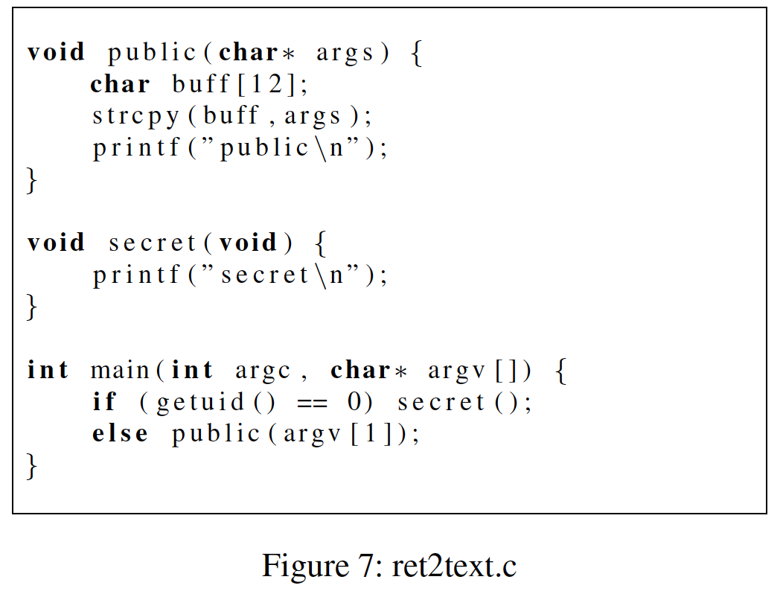
This was rather straight forward. I compiled the code, the first few tries with the stack protector failed, so I compiled without it. Then I followed their instructions and ran the following line.

./ret2text `perl -e 'print "A"x16; print"\x96\x84\x04\x08"'`
I obtained this address by running gdb and running print secret.
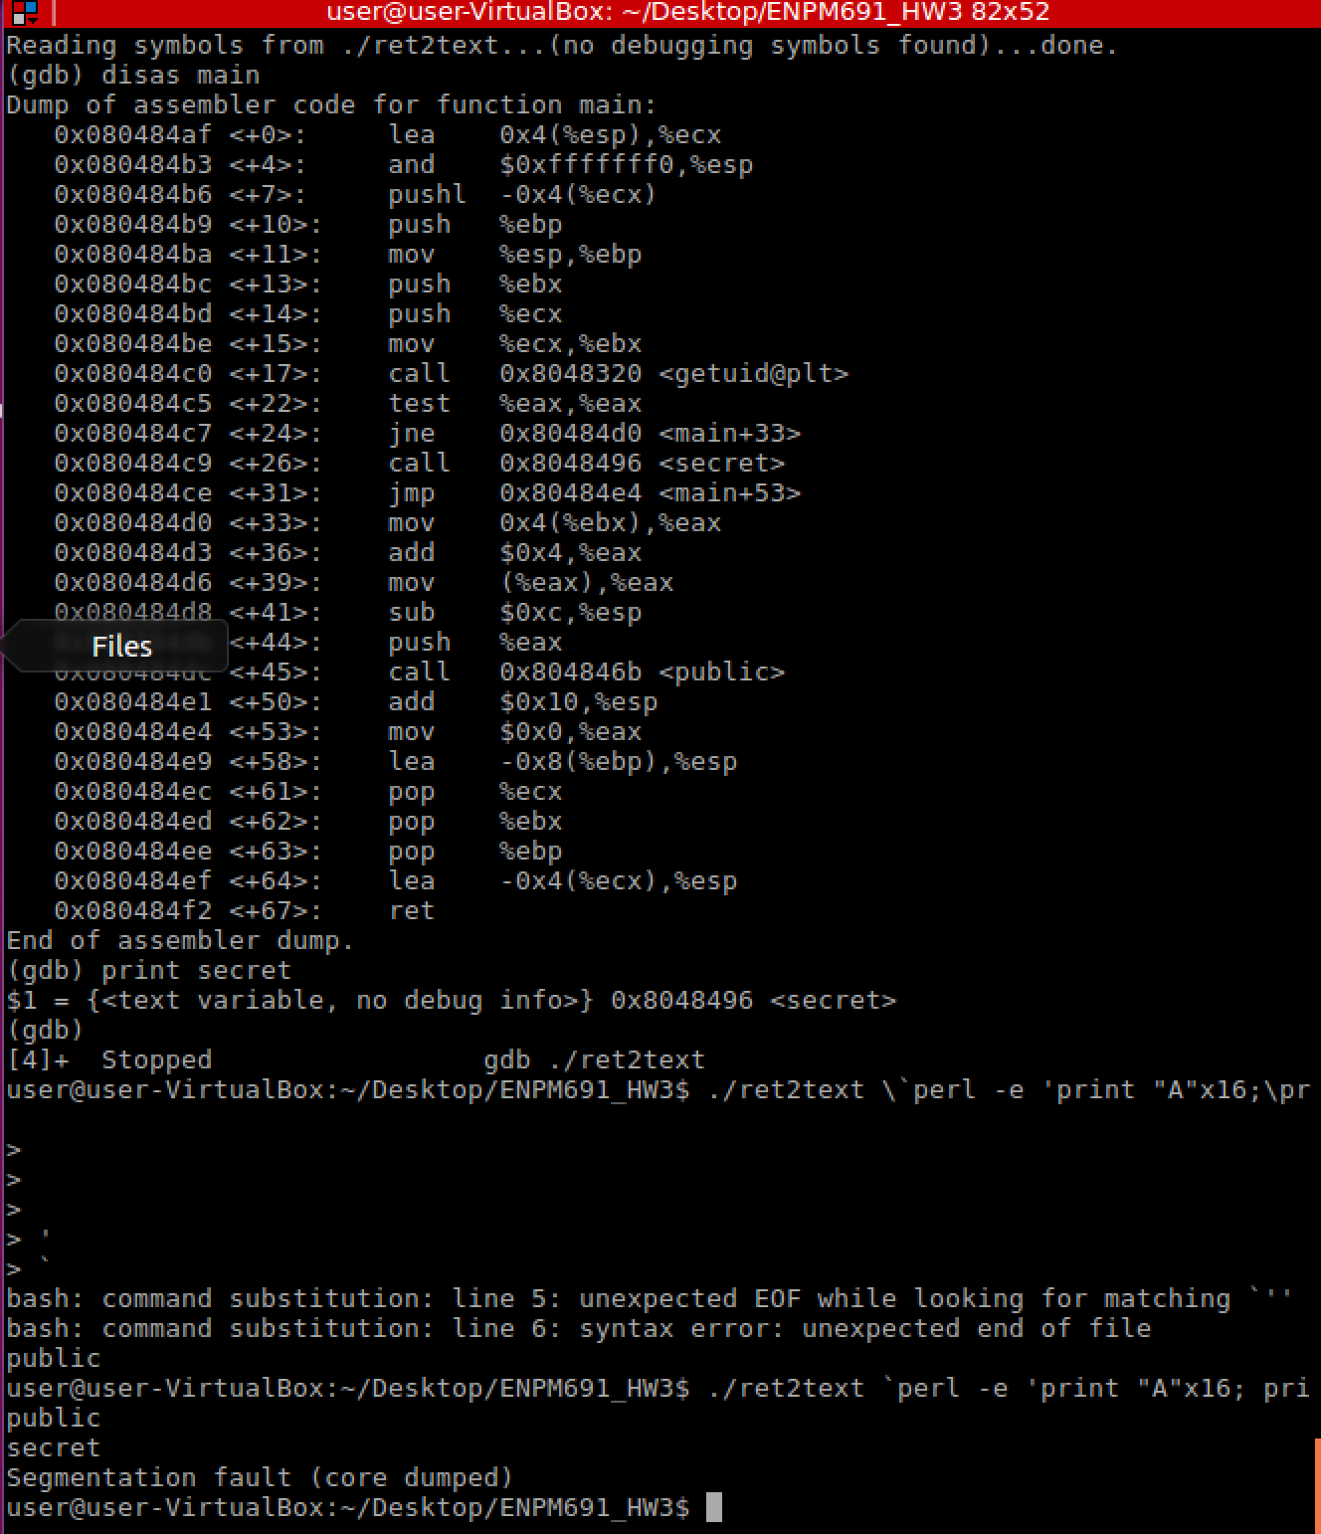

Figure 8: ret2bss.c

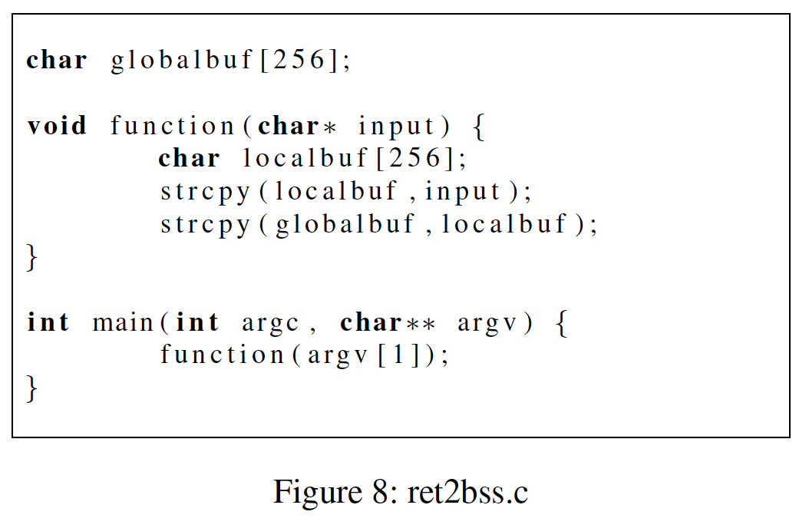

Figure 10: strptr.c

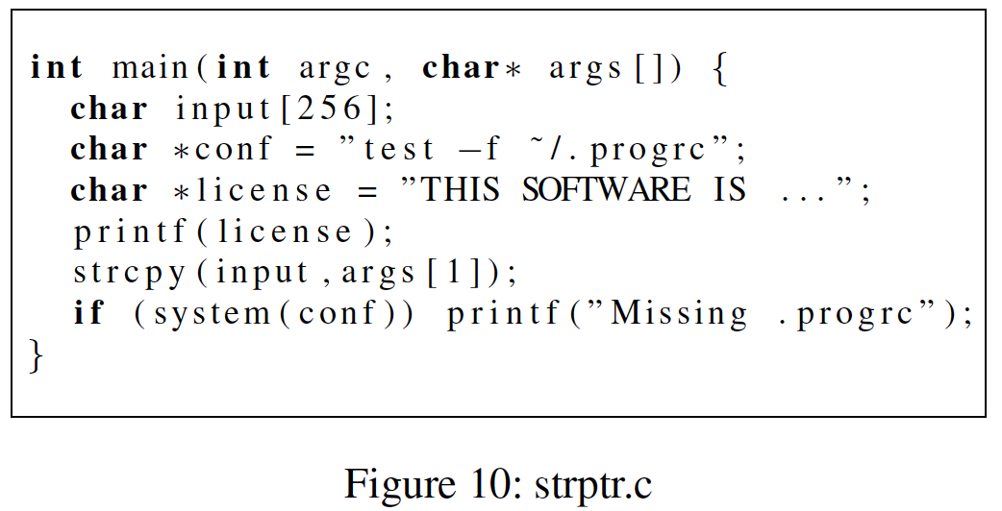

Figure 11: funcptr.c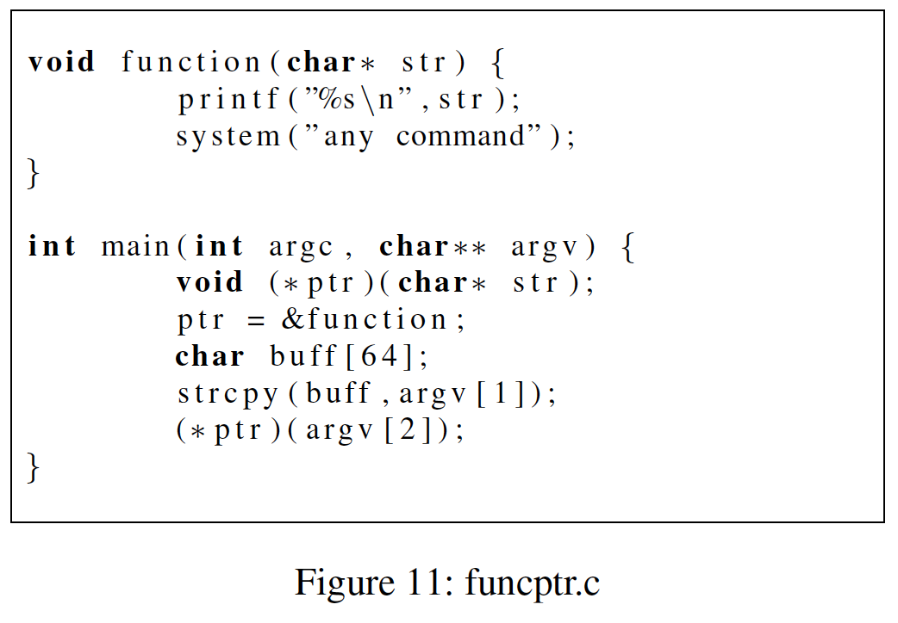

Figure 20: ret2pop.c
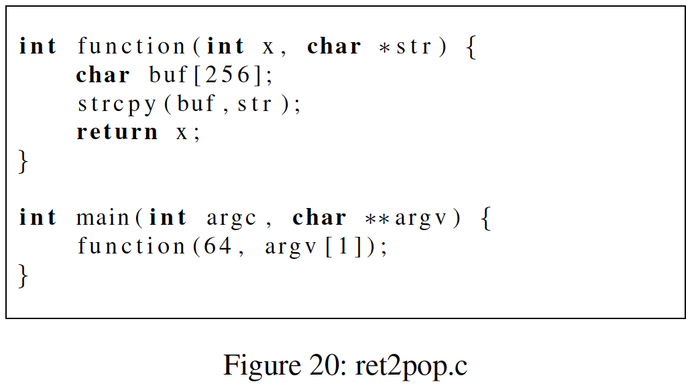

Figure 23: ret2esp.c

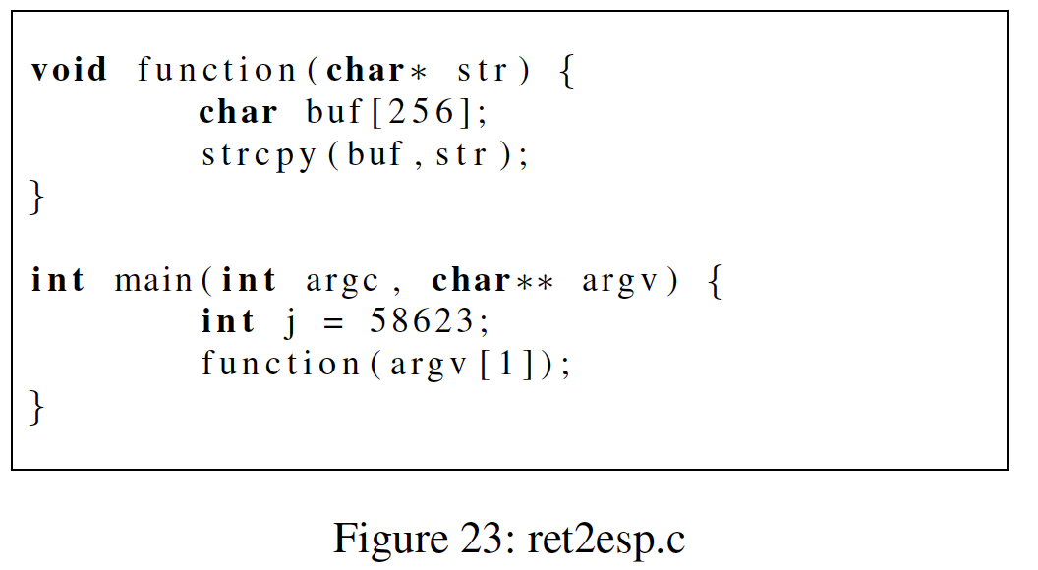

Figure 29: ret2got.c
