Dixie Biggs
www.dixiebiggs.com
email: dixie@dixiebiggs.com

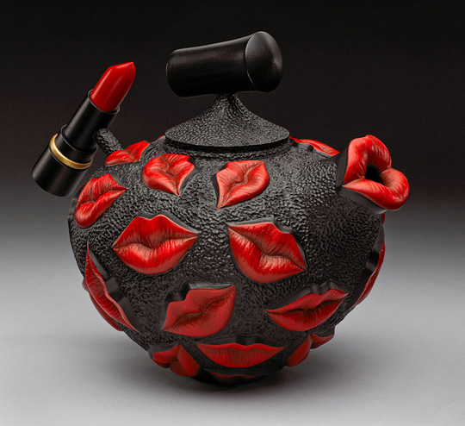

Tools & supplies students should bring:

Rotary power carver – either micro motor, flex shaft, or as simple as dremel tool. Be sure
to have a 3/32” collet for your tool. If you bring a flex-shaft I would recommend bringing a portable tool stand.
My personal preference for what I do is a micro motor. Contact me if you need help or have questions.

Variety of carving burrs – Bring what you have, plus
Basic recommendations from MDI Woodcarvers Supply
www.mdiwoodcarvers.com 1-800-866-5728
stump cutter #20-B5 $6.75 ea.
(I highly recommend getting 2)
mini stump cutters # 21-SET36 $4.95
and # 21-SET39 $4.95
Diamond cutter set #17-20SET $9.50
Kutzalls bur and, or #12-3F1 $12.00
Typhoon bur #37-3F1Y $12.95

Woodburner, if you have one.

Bring turned vessel or bowl, that is dried and ready to carve or can bring practice board (cherry or maple would be good choices). That way you will be ready to spend time on the techniques we will be learning. Be sure turned pieces have at least ¼” or more wall thickness for relief carving. The thicker the piece the more relief you can carve.

We will start by creating a sampler disc to practice the various embellishing techniques that I will be demonstrating and then move on to enhancing the pieces you brought. It is very important that the work you bring is dry. Wet wood will gum up your carving burs.

Bring safety glasses, dust mask and ear plugs. If you need magnifiers for detail work, don’t forget to bring those.

