
Poudre Valley Hospital Foundation Spring Benefit

You have made the Poudre Valley Hospital Foundation Spring Benefit a success for 32 years – Thank You! We rely on the generosity of our business partners to continue making this event the largest event of its kind in Northern Colorado. On May 7, 2011, join us for a ‘Classic to Retro’ 1950’s style bash.

Donations to the silent and live auctions benefit the Foundation’s general fund: the PVH Health Trust — our most powerful tool. All donations to the Health Trust are disbursed when and where they are needed most, allowing us to be most effective at meeting our community’s emerging – and emergency – health care needs.

For your support, your business will receive:
- Exposure to over 1,000 community leaders and business professionals throughout the region.
- Multi-media promotion of your business during the event.
- Recognition of your support on the Foundation Web site for two months after the event.

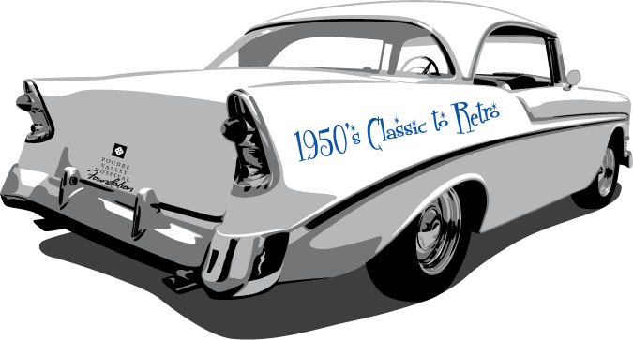
Please complete the enclosed form and return it to the PVH Foundation. After
receipt of your completed form, we will contact
you to make arrangements to pick up your
donation. Please contact
Shannon at (970) 237-7406 or smm13@pvhs.org with questions for this year’s Spring Benefit or to reserve a table for your business.

Thank you for your continued support!

