

Rocky Mountain
Woodturners

Newsletter
June 2007

www.woodturner.org

A Chapter of the American
Association of Woodturners

Next Meeting at the Loveland Woodcraft.
Next to The Merchantile, off the Crossroads Exit

>>> June 7, 6:00 pm Thursday <<<

3718 Draft Horse Drive
Loveland, CO 80538

Note the SPECIAL time of

6:00 PM !!!

for Malcolm Tibbetts

Malcolm, www.tahoeturner.com will be our guest wood turner for the evening. He will be demonstrating for the first hour, then we’ll take a break to squeeze in a short meeting and I mean SHORT! Then Malcolm will resume with the demonstration for an additional 1.5-2 hours. So if you miss the first hour, there will still be plenty of action for those that can’t make it till later.

He is considered one of the best if not the best segmented turner in the world. His works are nothing short of amazing. Do check out his gallery for examples of his work.

This piece shown is called ADRIFT. It is made of Brazilian Tulipwood & Macassar Ebony. It is 35" tall. The world's continents are depicted.

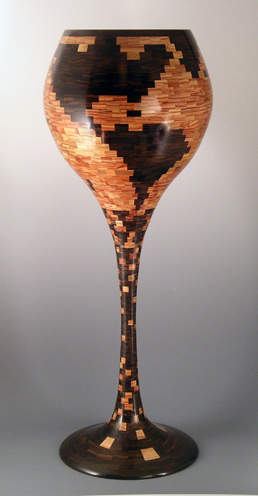

SPECIAL ANNOUNCEMENT !!
By Woodcraft-Loveland

Malcolm Tibbetts will be Woodcraft in Loveland, Wednesday, June 6th from 9am – 5pm.

This is an all day demo with limited hands on, featuring Segmented Wood Turning.

Registration is at
Woodcraft Loveland 970- 292-5940

Cost: $55.00 for paid members of Front Range and Rocky Mountain Woodturners,
$100 for non members.

http://www.woodcraft.com/stores/store.aspx?id=566&nav=classes

~~~~~~~~~~~~~~~~~~~~~~~~~~~~

Upcoming Demonstrators !!!!

July –
Bruce Hover on
Sanding tips and tricks

May Demo Highlights

Pete Holtus gave us a fun, informative and witty performance of his talents. I’ll pass on my notes that I scribbled out.

1. He prefers burls for the lidded boxes.
2. Do the drop test. If it doesn’t break, you’re good to go!
3. Look for the prettiest side for the lid or topside. It will be viewed the most.
4. Spalted wood must not be inhaled. It is full mold and rot. Use your dust collector.
5. His parting tool is made from a reciprocating blade.
6. Pete uses a stabilization solution so as to swell the fibers. He lets that quickly dry and then does the final cut before sanding. This gives the piece a cleaner surface, and no tear out from end grain.
7. The solution is ½ sanding sealer and ½ lacquer thinner.
8. When making your lid, keep the lid loose. A tight fitting lidded box will not sell as the customer will have trouble getting your perfect fitting lid apart!

~~~~~~~~~~~~~~~~~~~~~~~~~~~~~~~

Please return all video tapes
One of our members volunteered to convert our tape library to DVD format. So we need the VCR tapes back for a short period of time. This will be great to have our videos on DVD.

Friendly Reminder☺
A ten minute break allows more time for the demonstrator. Lights will be turned on and off to signal when it’s time for the main demo to start!

Membership Dues Are Due

2006 Membership dues are $35. Dues may be given or sent to Treasurer, Richard Bailey (12519 Locust Pl., Thornton, CO, 80602).

Your membership card will get you a discount at several local turning supply retail stores. You can get your membership card from Drew Nichols. He will have a table set up, to hand them out, at the next meeting! Drew will NOT be at May’s meeting as he will be out of town. I, Kevin Dunn, will fill in, but I will be not be able to get to the meeting until 8pm, as I’m preparing for inventory that we take the next day.

Notes From The President

The AAW would like to remind the membership about the Return to the Community Project. This is a service activity in which the woodturning community can express its gratitude to the city that hosts our annual Symposium. This year the AAW chapters in the Portland area have selected the Doernbecher Children's Hospital as the recipient of the project Doernbecher Children's Hospital cares for youngsters from all over the Pacific Northwest and is an excellent facility. It is another one of those hospitals that is bursting at the seams with patients. The age of the patients run from neo-natal to teenagers.

If you have an opportunity to visit the hospital while you are here you will find it a very cheerful, but sobering experience. Any toy that kids can play with, turned or otherwise, will be gratefully appreciated. Suggestions include finger tops, pull string tops, toy cars and trucks, as well as rattles for the little ones, but we are certain that the ingenuity of AAW members will produce some inventive toys. One word of caution: these kids are often very sick and sensitive to lots of things. As a result of the medications that they receive they often become extra sensitive. So, any finish that is put on the toys should be as neutral as possible and digestible. We suggest mineral oil as a finish. If you have something else, that is fine, but the finish on all toys needs to be identified.

The Pacific Northwest chapters of AAW wish to thank all woodturners in advance for the work that they will be contributing to the hospital for the use and enjoyment of the children, and look forward to being the local hosts for the upcoming Symposium.

HOST FAMILY VOLUNTEERS NEEDED!

World Heritage is seeking families, couples or single parents who are interested in hosting a high-school-aged foreign exchange student. By hosting a student from another country, your entire family will discover a world of enlightening adventure. Students who spend a semester or year in the US are fulfilling a lifetime dream.
These students have full medical & liability coverage, speak English and have personal spending money. Host families provide room and board and the opportunity for the student to learn about democracy and the American lifestyle, while attending the 2007-2008 high school year at the public school.
TO BEGIN THIS EXCITING CULTURAL EXPERIENCE, PLEASE CALL JODY, World Heritage Area Representative, at 970-482-1022 or the WORLD HERITAGE offices at 1-800-888-9040. Visit our website at www.world-heritage.org or contact Jody at: jody95@gmail.com

FOR SALE:

18" Laguna bandsaw with four blades, including a 1-1/4" carbide tipped re-saw blade, and mobility kit. Three H.P. 220 V. motor. Excellent Condition. John Harpold (970)-482-0439, jmharpold@worldnet.att.net
FOR SALE - Continued…
Stilh 031AV chainsaw.24" bar (almost new) and 16" bar. Engine is really strong. New starter, Air cleaner and clutch overhauled. $250 OBO contact:
Ray Cole 481-3084

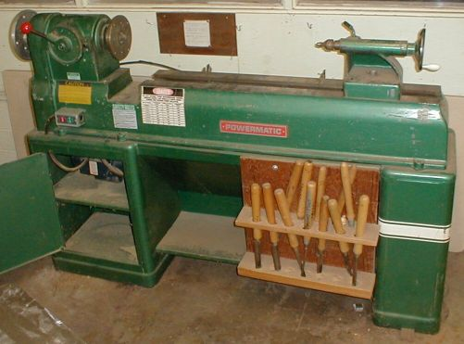
Woodturners: we have 3 model 90 Powermatic wood lathes that were donated to us by CSU. The one that I have runs on 120 volt, single phase. The two that are at Dan Bailey's, run on 480 volt 3 phase. There is only one banjo, no tool rests or any other accessory. Lathe shown is a representation of the model, but not one of the actual lathes. To see the lathes, you can make arrangements by contacting Dan Bailey or me, Dave Wilson.

Dan Bailey has purchased a converter for one that he has so that it will run on either 120 or 240 volts. I'm not sure which voltage. The bidding on that lathe will begin at $500. Dan has offered to buy it for $300 plus the $200 he has put into it. The other two are up for grabs. All three run OK. For more information, call Dave Wilson – 970-667-6601 or Dan Bailey @ 303-252-1405.

The auction will be at the July meeting.

Announcements
I'm looking for a ride back to Boulder from Provo on Saturday June 23rd after the symposium. Please let me know!
Thanks,
Cindy
--
Cindy Drozda
PO Box 19065
Boulder CO 80308
303-449-7170
www.cindydrozda.com

Anderson Ranch Arts Center would like to offer members of the American Association of Woodturners a 25% discount on tuition to any open woodturning class this summer beginning May 1, 2007.
Anderson Ranch is located in the Rocky Mountains, about 10 miles outside of Aspen. Our turning classes are limited to just eight students. So if you are interested in taking advantage of this discount, I'd recommend calling our registrar, Carrie Hennefeld as soon as possible. Her phone number is 970.923.3181 ext 215 and her email is chennefeld@andersonranch.org. Please tell her you are a member of the AAW and would like to take advantage of the discount-- She can then update you as to which classes still have space available.
As of this date (4/30/07) there is still at least one seat open in one week workshops taught by Alan Lacer, Bonnie Klein, Sharon Doughtie and Beth Ireland, as well as a two-week long workshop co-taught by Jack Slenz and Mark Gardner. Full course descriptions can be found on our website, www.andersonranch.org, and everyone is welcome to call or email me with descriptions-- my contact info can be found at the bottom of this letter. Please note that the discount may not be applied retroactively, and is for wood turning classes offered this summer 2007 only, on a space-available basis.
A bit about the Ranch: Anderson Ranch is a year-round non-profit arts educational center founded about 40 years ago. The Furniture Design and Woodworking Program has been an important part of the Ranch since the beginning. About six years ago, we expanded to include woodturning in the curriculum. Our turning studio is very well equipped with a complete set of turning tools at each station , and a variety of accessories and specialty tools on hand. You don't need to bring a thing. We have nine first-class lathes, including Oneway, Vicmarc, Stubby, Poolewood and Powermatic. Our faculty includes many of the most respected wood artists working in the field today, and we limit turning classes to just eight students and provide highly qualified assistants in every class to give each student maximum personal attention.
I hope you'll join us this summer!
Best regards,
Susan Working
Director, Furniture Design and Woodworking Program
Anderson Ranch Arts Center
5263 Owl Creek Rd P.O. Box 5598
Snowmass Village CO 81615
970.923.3181 ext. 234
sworking@andersonranch.org
www.andersonranch.org

Learn from the best…
Our Club is becoming known around the nation because we have some of the best turners, nationally known demonstrators and best teachers of Basic Turning, Intermediate, and Advanced and Specialty turning right here in our own back yard.

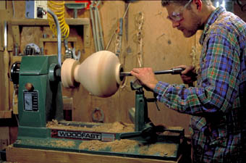

Trent Bosch Woodturning Workshops

Workshops are held in Trent’s studio in Fort Collins, Colorado. There is a maximum of four people in each class which allows for lots of individualized instruction. The cost is $500 for the 3-day intensive workshop and $650 for the 4-day. Meals are also provided at no extra charge. His studio is also equipped with the highest quality equipment available for your use.

2007 Dates
July 20-23, 2007 Advanced Workshop 4-day
August 17-19, 2007
September 7-9, 2007
October 25-27, 2007
November 8-10, 2007

2007 Available Dates
July 25-27, 2007 Special Sculpting, and Carving on Turnings Workshop

For detailed information on workshops visit www.trentbosch.com or contact Trent via email or phone.

Trent Bosch
Trent Bosch Studios Inc.
trent@trentbosch.com
970 568 3299
Curt Theobald offers three-day workshops in Segmented Woodturning in his studio in Pine Bluffs, Wyoming.
Call Curt Theobald at 307.245.3310
E-mail cwtheobald@wyoming.com

Lee Carter operates the Rocky Mountain School of Woodturning in
LaPorte. He offers classes in Basics, Intermediate and Advanced.

Call Lee Carter at 970.221.4382 to sign up or have him answer any questions.
e-mail LLJTC4X4149@ CS.COM

Wood Suppliers

Woodcraft
3718 Draft Horse Drive, Loveland

10% Guild discount at the following:

The Wood Emporium

618 N Garfield Ave Loveland, Co 80537

Sears Trostel
1500 Riverside Ave Ft. Collins, CO 80524

Rockler’s in Denver – You have to show your membership card.

______________________________________
Dan Bailey has bowl blanks for sale, all roughed out, dried and ready to turn. He also has access to CA glue that is less expensive than other sources. Call Dan 970.482.1604

~~~~~~~~~~~~~~~~~~~~~~~~~~~~~~~~~~~

2007 Officers, Directors and Committees

President: Dave Wilson
970-667-6601
davidwilsonk@frii.com

VP: Drew Nichols
970.566.4662
dcnichols2004@msn.com

Treasurer: Richard Bailey
303-252-1405

Secretary / Newsletter: Kevin Dunn
970.221-4894
dnnkk@msn.com

Program Director: Trent Bosch
970.568.3299
trentbosch@yahoo.com

Librarian: Mike Davis
970.484.9190
MIKELDAVISLLC@MSN.COM

Symposium Dir: Allen Jensen
970-663-1868
Rajconst@aol.com

Webpage - Joy
jswearengen@yahoo.com

Rocky Mountain Woodturners
1817 Rangeview Drive
Fort Collins, CO 80524

Clubs and Member’s Websites

Rocky Mountain Wood Turners
www.rmwt.org (under construction)

AAW – American Assoc of Woodturners
www.woodturner.org

Trent Bosch
www.trentbosch.com
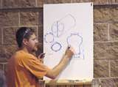

David Nittmann
www.davidnittmann.com


Cindy Drozda
www.cindydrozda.com 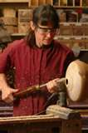

John Lynch
www.johnlynchwoodworking.com
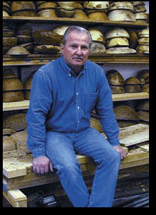

I know there are more. Please email me your website and I will post them here!

My email is dnnkk@msn.com
Attention Kevin

Thank you and I hope you have enjoyed some of my shavings and sawdust!

