

Rocky Mountain
Woodturners

Newsletter
Sept. 2007

www.woodturner.org

A Chapter of the American
Association of Woodturners

Next Meeting at the Loveland Woodcraft.
Next to The Merchantile, off the Crossroads Exit

>>> Sep 6, 7:00 pm Thursday <<<

3718 Draft Horse Drive
Loveland, CO 80538

7:00 pm Start Time
The demonstrator for the September meeting will be Cindy Drozda. The subject will be “Tie-dyed Burl”. The “official description is: “Here is a method for coloring wood that is very fast and easy, with a spectacular result! Using multiple layers of dye, I will show how to enhance the figure of the wood and get creative with color. The result reminds me of tie-dyed tee shirts, right out of the ‘60s!” This is a ‘must see’ demo!

Cindy is also well known for her elegant lidded vessels. Her work is exhibited in the finest galleries and art shows around the country.

Check out her website at www.cindydrozda.com Here is a sample of her work.

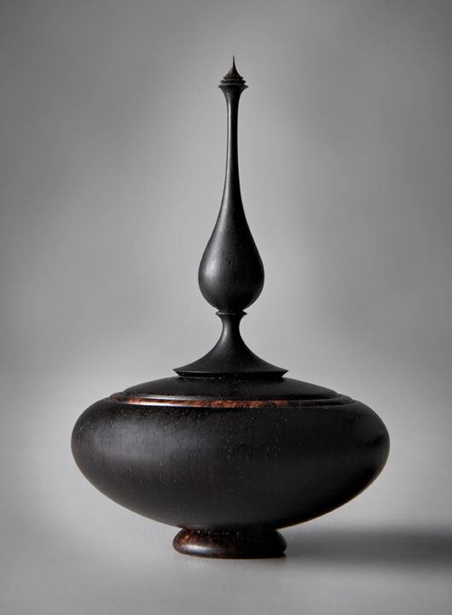

~~~~~~~~~~~~~~~~~~~~~~~~~~~~
Upcoming Demonstrators !!!!

Rocky Mountain Woodturning Symposium
Sept 15-16
Allan Batty
Oct 24 All Day demo
Oct 25 Hands on Class
Oct 25 7:00 RMWT Club Meeting
Oct 26 Hands on Class
John Jordan
Nov 15 7:00 RMWT Club Meeting
Nov 17 All day demo
Christmas Party
Dec ? date to be announced
Larry Fox
Jan 3 - 7:00 RMWT Club Meeting
Doug Schneider
Feb 7 - 7:00 RMWT Club Meeting
Frank Amigo
Mar 6 -7:00 RMWT Club Meeting

Please return all video tapes
One of our members volunteered to convert our tape library to DVD format. So we need the VCR tapes back for a short period of time. This will be great to have our videos on DVD.

Friendly Reminder☺
A ten minute break allows more time for the demonstrator. Lights will be turned on and off to let us know that the meeting is ready to resume.

Attention Members!
Club members cannot sell videos or other items at Woodcraft during meetings. Woodcraft's sales tax license will not allow this. Any questions should be directed to David Wilson, our president.

Membership Dues Are Due

2007 Membership dues are $35. Dues may be given or sent to Treasurer, Richard Bailey (12519 Locust Pl., Thornton, CO, 80602).

Your membership card will get you a discount at several local turning supply retail stores. You can get your membership card from Drew NicholsI,

Notes From The President

Woodcraft has given RMWT, not one, but two JET Mini lathes. We will come up with stickers or tags indicating that they are "Donated by Loveland Woodcraft.

The club is the proud owner of a 3520B Powermatic lathe. Powermatic sold the lathe, to the club, at the class room rate which was too good to turn down. This worked out to be about half of retail! I also ordered a remote on/off switch for the 3520. Thanks to Woodcraft and WMH Tool Group. Roydan , store manager, made the call to WMH Toll Group to get us the great price break. Thank You Roydan.

Also, the owners of Woodcraft gave us a mini jet lathe to replace the Delta mini. A Thank You note will be sent to Eric and Denise. (is this part of the same two Jet Mini Lathes? ed.)

Also, a reminder to all RMWT club members. The club 10% discount is only good on our meeting nights.

Shop Tips and Favorite Tools!

- My favorite tool is the half flat round nosed scrapers that are made by Benjimin. Walt Patch

- Anthony Prough’s is the 3/8” bowl gouge and/or the round nose scraper. Anthony Prough
- Sand light and fast, not hard and slow – by Anthony Prough
- The Nova Chuck – Kevin Dunn

FOR SALE:
Delta Q3 18"scroll saw, used for one project, works great $295 obo.

Magnifier light with flex arm and clamp. $45 obo.

Oneway Vari-grind Jig for Wolverine system. $40.

Oneway Skew Grinding Jig for Wolverine system. $20.

S-curve bowl rest (item108-0200, page 40 in Crafts Supply catalog) with 1"x 3" toolpost. $40 for the set.

1/2" stub center No. 2 MT (item163-0250 Pg 54). $52.

Nova Revolving Multi function Center (Item 100-4200 pg 55). $90.

Apprentice Angle Sander (item 3791600 pg 67). $25.

Contact Andy Zartman awzartman@gmail.com

Submitted by Roger Nelson…
I just put a beautiful cap of black ash burl on e-bay. It has super tight birds-eye. I never seen a burl with more solid, tight birds-eye in my life. I was wondering if you could ask your club members to take a look at it for me. It would be under (black ash burl) on e-bay. The seller name is bigherm4964. Thank you and hope turning is well for all. Tami

~~~~~~~~~~~~~~~~~~~~~~~~~~~~~~~
Utah Symposium Highlights

Written by David Nittmann

The Utah Woodturning Symposium is a family affair dedicated to the education of woodturners around the world. In its 28 year, the longest running symposium hosted 437 participants and showcased 23 demonstrators. Professor Kip Christensen heads up the three day event held at Brigham Young University in Provo, Utah. Kip’s expertise keeps the symposium operating smoothly. The schedule is full and is kicked off each year with a social gathering Wednesday night at Mike & Jenny Mahoney’s beautiful home in nearby Orem. Thursday morning begins the demonstrator introductions and a breakfast buffet treat, then for the next three days participants have a choice of 100 rotations, 7 evening presentations, plus the “great egg-cup race”, the swap meet and barbecue; a menu to satisfy the largest appetite.

Richard Raffan, Allan & Stuart Batty, and Dale Nish were long time repeat presenters backed up by an all-star supporting cast including Johannes Rieber, Terry Scott, Stuart Mortimer, the list goes on, one and all world-class artists.

I had a full rotation schedule (6 rotations plus1 evening session) and still managed to see Max Krimmel work his alabaster magic, Michael Werner make one of his signature off-center pieces, and Jason Marlow doing Celtic bowls. I also peeked in on Vaughn Richman talking about hot melt glue chucking techniques, and never to be missed, Dale Nish “working green wood”. The Stuart Batty (and father Allan banter) “Everything about the Bowl Gouge” was educational and entertaining. Cindy Drozda and I preformed our “Right Brain/Left Brain” demonstration twice and received rave reviews. There was so much more I couldn’t see, but then, there is next year.

The “Great Egg-Cup Race” is always a well attended evening session that showcases some of the best turners in the world making some of the worst looking cups-but fast. Many participants also get into the act with fun and prizes awarded in various categories.

I think a “cup” was made in less than 20 seconds. Stuart Batty and Johannes Rieber had the distinction of fastest and best cups. We had some very good young turners participate as well.

Great weather accompanied the barbecue Friday night in beautiful Rock Canyon Park overlooking Provo. Students at BYU sponsor the feed; everyone left smiling. The Swap Meet followed. Participants exchanged wood and tools in a low key market environment.

This is one of the finest symposiums available to the woodturners; always well organized, well attended, with tremendous demonstrations and in an atmosphere that is friendly to young or experienced, new or old. It’s about exchange of ideas and raising the level of woodturning in the world today.

A full list of demonstrators is available visit www.utahwoodturning.com

~~~~~~~~~~~~~~~~~~~~~~~~~~~~~~~

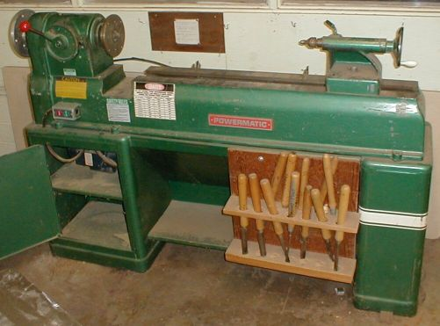
Hey woodturners! We have three model 90 Powermatic wood lathes that were donated to us by CSU. The one that I have runs on 120 volt, single phase. The two that are at Dan Bailey's, run on 480 volt 3 phase. There is only one banjo, no tool rests or any other accessory. Lathe shown is a representation of the model, but not one of the actual lathes. To see the lathes, you can make arrangements by contacting Dan Bailey or me, Dave Wilson.

Dan Bailey has purchased a converter for one that he has so that it will run on either 120 or 240 volts. I'm not sure which voltage. The bidding on that lathe will begin at $500. Dan has offered to buy it for $300 plus the $200 he has put into it. The other two are up for grabs. All three run OK. For more information on purchasing these lathes, call Dave Wilson @ 970-667-6601 or Dan Bailey @ 303-252-1405.
~~~~~~~~~~~~~~~~~~~~~~~~~~~~~~~

Learn from the best…
Our Club is becoming known around the nation because we have some of the best turners, nationally known demonstrators and best teachers of Basic Turning, Intermediate, and Advanced and Specialty turning right here in our own back yard.

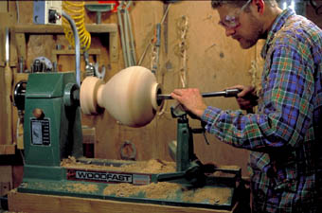

Trent Bosch Woodturning Workshops

Workshops are held in Trent’s studio in Fort Collins, Colorado. There is a maximum of four people in each class which allows for lots of individualized instruction. The cost is $500 for the 3-day intensive workshop and $650 for the 4-day. Meals are also provided at no extra charge. His studio is also equipped with the highest quality equipment available for your use.

2007 Dates

September 7-9, 2007
October 25-27, 2007
November 8-10, 2007
For detailed information on workshops visit www.trentbosch.com or contact Trent via email or phone.

Trent Bosch
Trent Bosch Studios Inc.
trent@trentbosch.com
970 568 3299

~~~~~~~~~~~~~~~~~~~~~~~~~~~~~~~~~~~~
Curt Theobald offers three-day workshops in Segmented Woodturning in his studio in Pine Bluffs, Wyoming.
Call Curt Theobald at 307.245.3310
E-mail cwtheobald@wyoming.com
Website is www.curttheobald.com

Lee Carter operates the Rocky Mountain School of Woodturning in
LaPorte. He offers classes in Basics, Intermediate and Advanced.

Call Lee Carter at 970.221.4382 to sign up or have him answer any questions.
e-mail LLJTC4X4149@ CS.COM

Woodcraft has classes for beginners in woodworking, shop safety, intro the machines, bowl turning, pen and pencil turning, hollow forms, Christmas tree ornaments, tool sharpening, etc. Please check out the class being offered at web page www.woodcraft.com

Wood Suppliers

Woodcraft
3718 Draft Horse Drive, Loveland

10% Guild discount at the following:

The Wood Emporium

618 N Garfield Ave Loveland, Co 80537

(continued)

Sears Trostel
1500 Riverside Ave Ft. Collins, CO 80524

Rockler’s in Denver – You have to show your membership card.
~~~~~~~~~~~~~~~~~~~~~~~~~~~~~~~

______________________________________
Dan Bailey has bowl blanks for sale, all roughed out, dried and ready to turn. He also has access to CA glue that is less expensive than other sources. Call Dan 970.482.1604


2007 Officers, Directors and Committees
President: Dave Wilson
970-667-6601
davidwilsonk@frii.com

VP: Drew Nichols
970.566.4662
dcnichols2004@msn.com

Treasurer: Richard Bailey
303-252-1405

Secretary / Newsletter: Kevin Dunn
970.221-4894
dnnkk@msn.com

Program Director: Trent Bosch
970.568.3299
trentbosch@yahoo.com

Librarian: Mike Davis
970.484.9190
MIKELDAVISLLC@MSN.COM

Symposium Dir: Allen Jensen
970-663-1868
Rajconst@aol.com

Webpage - Joy
jswearengen@yahoo.com

Clubs and Member’s
Websites

Rocky Mountain Wood Turners
www.rmwt.org

AAW – American Assoc of Woodturners
www.woodturner.org

Trent Bosch
www.trentbosch.com
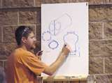

David Nittmann
www.davidnittmann.com

Cindy Drozda
www.cindydrozda.com 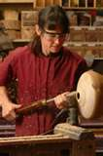

John Lynch
www.johnlynchwoodworking.com
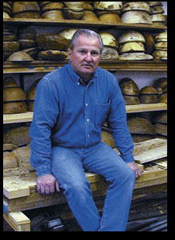

Curt Theobald
www.curttheobald.com
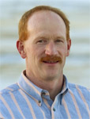

I know there are more. Please email me your website and I will post them here!

My email is dnnkk@msn.com
Attention Kevin

Thank you and I hope you have enjoyed some of my shavings and sawdust!

