


Upcoming meetings
April 2007- TBA

Newsletter March 2007
Rocky Mountain Woodturners
A Chapter of the American Association of Woodturners

Next Meeting Loveland Woodcraft.
April 7, 7pm
3718 Draft Horse Drive
Loveland, CO 80538

Have A Seat !:
An unknown woodturner donated 25 additional folding chairs to the club. The generosity is timely as our clubs membership is swelling. There were approximately 70 people at the last meeting.

Febuary Demo
Northern Colorado woodturners, including many new members, turned out in mass to watch and learn from Stuart Batty. Stuart took on a challenging carobwood blank he brought from L.A. . The blank had an inconvenient knot which was converted into an artistic embellishment in a wonderfully thin bowl.
Prior to turning, Stuart addressed sharpening relating to the various powdered metals available in today’s turning tools.
Stuart feels you need to reconsider grinding methods for steels from 2060 and harder. Conventional grinders have trouble with these steels. For these, Stuart uses the new Jooltool sharpening system with 3M discs. Getting tools razor sharp, maintaining specific tool geometry and a lot of turning expertise makes it possible to turn pieces as thin and pleasing as Stuart does. The technique he uses, in his words, makes the tool heavier with his left hand (with only downward pressure), while his right hand pushes only along the axis of the tool. This allows clean vibration free cuts.



EMPTY BOWLS PROJECT

The Empty Bowls program will be held at the Hilton on Tuesday, February 27th - starting at 5:30. Cost is $50 for one and $95 for two people. This will the 10th Anniversary and usually sells out. Heather has not sent out invitations as of this date because it takes time for the printers to do it.
This is a good opportunity to get visibility for Woodturners in our community.

If you would care to donate a bowl, you can still contact Dick Branecky. Mike McCarthy said the larger bowls sold for there asking price, but all the bowls sold, and that all are appreciated.

Thanks Again

Dick Navratil
484-3914 ---h
218-6485---c

Please return all video tapes
One of our members volunteered to convert our tape library to DVD. This will be great to have our videos on DVD so we need the tapes back for a while.
Reminder: A ten minute break allows more demo time. Recently, the break time has increased, making the meeting run long. Thanks

Instant Gallery
There was some nice work in the instant gallery as seen in the following pictures.
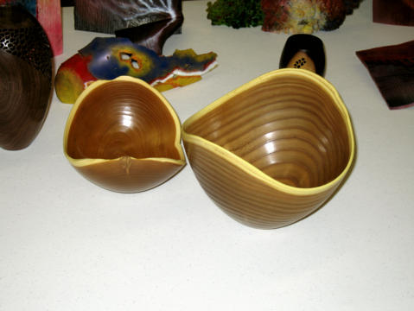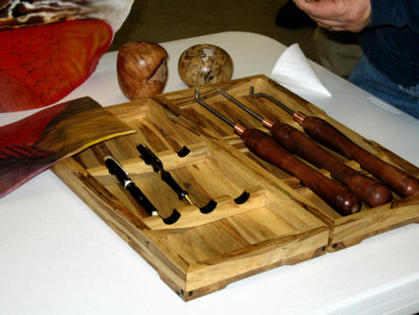

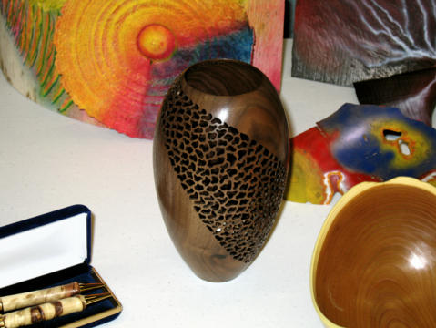
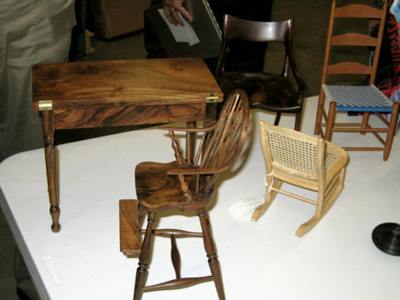

Notes from the President

We will be auctioning off the old library at the meeting so bring your checkbooks.

Membership Dues Are Due
2006 Membership dues are $35. Dues may be given or sent to Treasurer, Richard Bailey (12519 Locust Pl., Thornton, CO, 80602).

Your membership card will get you a discount at several local turning supply retail stores. You can get your membership card from Secretary Ray Cole.

Newsletter Items
Send pictures and news items to:
Ray Cole elocyar@msn.net

Ads from Members
.
8 inch Delta grinder with stand $50. I have a couple grinding wheels that you can choose from. Call Ray Cole 970-481-3084.

HOST FAMILY VOLUNTEERS NEEDED!
World Heritage is seeking families, couples or single parents who are interested in hosting a high-school-aged foreign exchange student. By hosting a student from another country, your entire family will discover a world of enlightening adventure. Students who spend a semester or year in the US are fulfilling a lifetime dream.
These students have full medical & liability coverage, speak English and have personal spending money. Host families provide room and board and the opportunity for the student to learn about democracy and the American lifestyle, while attending the 2007-2008 high school year at the public school.
TO BEGIN THIS EXCITING CULTURAL EXPERIENCE, PLEASE CALL JODY, World Heritage Area Representative, at 970-482-1022 or the WORLD HERITAGE offices at 1-800-888-9040. Visit our website at www.world-heritage.org or contact Jody at: jody95@gmail.com

Learn from the best…
Our Club is becoming known around the nation because we have some of the best turners, nationally known demonstrators and best teachers of Basic Turning, Intermediate, and Advanced and Specialty turning right here in our own back yard.

Trent Bosch Woodturning Workshops

Workshops are held in Trent’s studio in Fort Collins, Colorado. There is a maximum of four people in each class which allows for lots of individualized instruction. The cost is $500 for the 3-day intensive workshop and $650 for the 4-day. Meals are also provided at no extra charge. His studio is also equipped with the highest quality equipment available for your use.

2007 Dates
March 23-25, 2007
April 20-22, 2007
July 20-23, 2007 Advanced Workshop 4-day
August 17-19, 2007
September 7-9, 2007
October 25-27, 2007
November 8-10, 2007

For detailed information on workshops visit www.trentbosch.com or contact Trent via email or phone.

Trent Bosch
Trent Bosch Studios Inc.
trent@trentbosch.com
970 568 3299

Curt Theobald offers three-day workshops in Segmented Woodturning in his studio in Pine Bluffs, Wyoming.
Call Curt Theobald at 307.245.3310
E-mail cwtheobald@wyoming.com

Lee Carter operates the Rocky Mountain School of Woodturning in La Porte. He offers classes in Basics, Intermediate and Advanced.

February 13-15 Basic Woodturning
February 20-22 Intermediate Woodturning
March 6-8 Turning Basic & Novelty Boxes
March 20-22 Advanced Woodturning
March 27-29 Turning Hollow Vessels
April 17-19 Turning Green, Dry and
Natural Edge Bowls
April 24-26 Basic Woodturning

Call Lee Carter at 970.221.4382 to sign up or have him answer any questions.
e-mail LLJTC4X4149@ CS.COM

Wood Suppliers
Woodcraft
3718 Draft Horse Drive, Loveland

10% Guild discount at the following:

The Wood Emporium
618 N Garfield Ave Loveland, Co 80537

Sears Trostel
1500 Riverside Ave Ft. Collins, CO 80524

Rockler’s in Denver – You have to show your membership card.

Kevin Kyhl also sells hardwood and turning stock in Ft. Collins once a month. You can email him at: kyhlwood@hughes.net to get on the notification list of when he will be in town. He will give us a 15% discount on turning stock. Just mention that you are with the RMWT and he’ll take care of you.

Dan Bailey has bowl blanks for sale all roughed out, dried and ready to turn. He also has access to CA glue that is less expensive than other sources. Call Dan 970.482.1604

2007 Officers, Directors and Committees

President: Dave Wilson Treasurer: Richard Bailey Secretary: Kevin Dunn
970-667-6601 303-252-1405 970.221-4894
davidwilsonk@frii.com dnnkk@msn.com

VP: Drew Nichols Program Director: Trent Bosch Librarian: Mike Davis
970.566.4662 970.568.3299 970.484.9190
dcnichols2004@msn.com trentbosch@yahoo.com MIKELDAVISLLC@MSN.COM

Web Site: Brandon Mackie Symposium Dir: Allen Jensen Newsletter: Ray Cole
303.507.5206 970-663-1868 970.481.3084
info@495dollarwebsites.com Rajconst@aol.com elocyar@msn.com
Rocky Mountain Woodturners
1817 Rangeview Drive
Fort Collins, CO 80524

