

Rocky Mountain
Woodturners

Newsletter
February 2008

www.woodturner.org

A Chapter of the American
Association of Woodturners

Next Meeting at the Loveland Woodcraft.
Next to The Merchantile, off the Crossroads Exit

>>> Feb 7th, 7:00 pm Thursday <<<

3718 Draft Horse Drive
Loveland, CO 80538

Doug Schneiter - Feb 7th

Upcoming events!
Feb 7 - 7:00 RMWT Club Meeting
Doug Schneiter – demonstrator
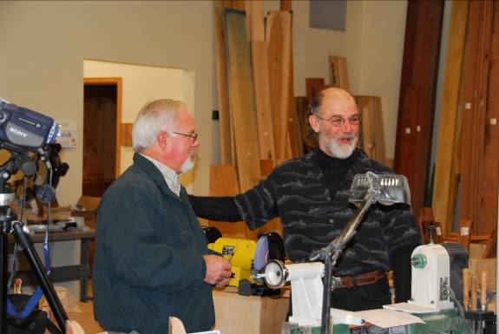
Doug Schneiter – Newest lifetime member of RMWT
Lifetime Member Award

At the last meeting, there was a surprise presentation, by David Nittmann, for our 4th lifetime

member. That turned out to be none other than Doug Schneiter! Huge congratulations! The previous members are Lee Carter, Doc Thode, and also David Nittmann. Again, thank you for your lifetime of work and dedication to the art of woodturning! And with that, here is a little about Doug’s background. Since he is also the demonstrator for February, he gets double exposure this month!
Bio: Doug Schneiter has been in the Industrial Technology department, at the Loveland High School since 1993. He teaches the construction classes and the upper level drafting curriculum. He also teaches the college level drafting classes offered in conjunction with Aims Community College.
Doug keeps busy with his wood turning and is an active manager of the Rocky Mountain Wood Turners Club. Mr. Schneiter holds a BS in Industrial Arts from the University of Northern Iowa and a MS in Construction and Drafting from the Colorado Department of Education. Mr. Schneiter is an active member of the Colorado Technology Education Association.
Courses that he teaches are Technical Drawing, Architectural Drawing, Invention and Design, and Construction I & II
~~~~~~~~~~~~~~~~~~~~~~~~~~~~~~~
Mar 6 -7:00 RMWT Club Meeting

Frank Amigo – demonstrator ???

2008 Membership Dues Are Due

The dues for this year are $35. Dues may be given or sent to Treasurer, Richard Bailey (12519 Locust Pl., Thornton, CO, 80602).

New Officers For 2008
Your new officers are as follows:
President – Drew Nichols
Vice President – John Giem
Treasurer – Richard Bailey
Newsletter/Secretary – Kevin Dunn
Librarian – David Amos
Program Director – Trent Bosch
Symposium – Mike Davis and Allen Jensen

Their phone numbers and email addresses are at the end of the newsletter. Congratulations to all. Let’s make this a banner year. And it all starts with you, as members in the audience too! ☺
Educational Opportunity Grant Winners Named
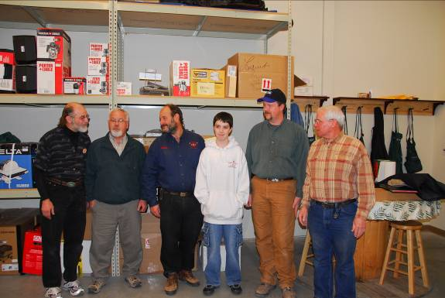
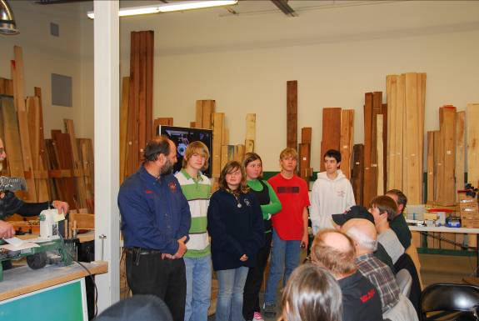
Anthony Prough and students

For 2007, the directors of RMWT authorized the Educational Opportunity Grant Committee to award up to $2,500 in grants. Committee members, David Nittmann (chairman), Allen Jensen, and John Harpold, received and scrutinized five grant applications. Three educational opportunity grants were made.

A $500 award was made to 14 year-old turner, Sam Chambers. Sam has already used some of his award money to purchase a grinder, a few turning tools, some books on pen turning (his current passion), and a new membership to AAW. He will purchase more new turning tools that he hopes will expand and improve his present skills. In addition to turning at home, Sam is a student at Milliken Middle School, where he has been further exposed to woodturning in Anthony Prough’s shop class. Sam also hopes to share those new skills with his shop classmates.

A $1,000 grant was made to Anthony Prough, shop teacher at Milliken Middle School. On numerous occasions in 2007, Anthony has brought some of his students to RMWT meetings. Unfortunately, woodshop budgets seem to be a low priority in most school districts. Anthony will use the RMWT grant money to purchase much needed woodturning tools for his shop classes.

Also, a $1,000 educational opportunity grant was made to Doug Schneiter, wood turner extraordinaire and shop teacher at Loveland High School. Like Anthony, Doug will use the RMWT grant money to purchase needed woodturning tools for the school, allowing an expansion of the woodturning portion of his woodshop classes.

The EOG committee hopes these grants will, in-fact, provide educational opportunities in woodturning that otherwise would not have occurred. The committee also hopes that you, a member of RMWT, feel these grants are worthwhile, and will continue to support them in the future.
From left to right - David Nittmann, Doug Schneiter, Anthony Prough, Sam Chambers
Notes from the January Demo!
Turquoise Inlays and Outlays
In Wooden Bowls
Presented by: Larry Fox
Reported by: John Giem

On January 3, 2008, Larry Fox demonstrated his techniques for constructing turquoise decorations on wooden bowls. Larry’s techniques enable him to place a ring of turquoise on the top edge of a bowl or on the outer rim of a platter, an outlay. He can also use his techniques to place (inlay) turquoise in patterns on any surface of the bowl.

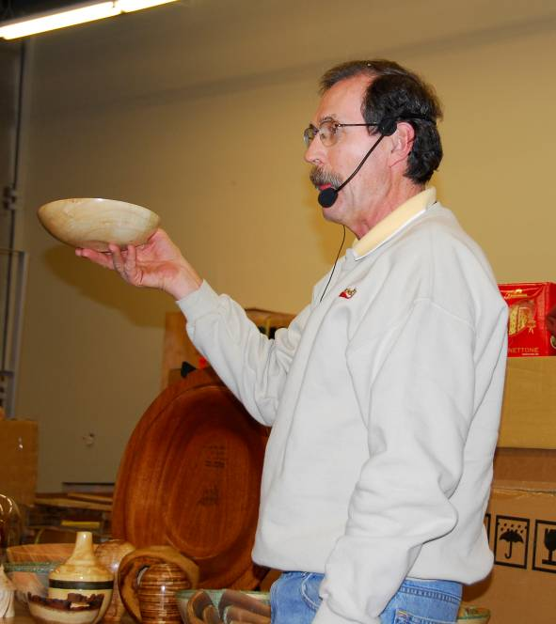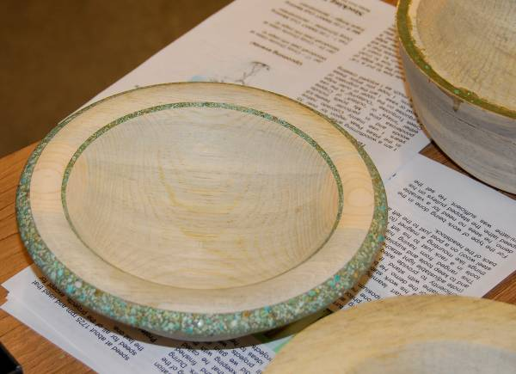
Larry Fox and a finished bowl with turquoise ‘outlay’

Larry helped us understand his process of inlaying by using an analogy of building items using concrete. To make an object using concrete, the craftsman first builds a form, usually from wood, such that the interior shape is the same as the final desired item. Then concrete is mixed and poured into the form and allowed to harden. When the form is removed, the item of the desired shape is revealed. Often, the craftsman then goes over the item fixing any flaws in the concrete.

Larry’s process follows the same steps. Using the lathe, he cuts a recess into the bowl blank (creates a form), fills the recess with a mixture of crushed turquoise and epoxy (the concrete) and lets it harden. The bowl is then mounted on the lathe and he removes the unwanted wood (removes the forms).
Outlay: A turquoise outlay is the band of turquoise that is placed on the top edge or outside rim of a bowl. The final band will be attached to the bowl on only one side, three sides are exposed. See above photo.
Inlay: An inlay is the placing of the turquoise in a depression cut into the inner or outer surface of the bowl. It can be of any shape cut by carving or on the lathe. Three sides of the inlay will be in contact with the bowl with only one side visible to the viewer. See inner inlay ring in photo above.
Preparation of the wood: The turquoise inlays and outlays can not be applied to green wood since the movement during drying would fracture the epoxy mixture. Most of Larry’s bowls are made from beetle kill lodge pole pine. The color of the pine as the result of the beetle infestation is bluish and complements the turquoise. Using pine that has been dead for about two years, he cuts them into appropriate lengths and then cuts them in half through the center (through the pith). After rough turning them into bowl blanks, they will have a moisture content of about 20%. Each blank is then put into paper bags and ‘microwaved’ twice at full power for five minutes each time. (Neither the power of the microwave nor the time between treatments were given.) This usually brings the moisture down to about 16%. He then allows the blanks to air dry on a shelf for 1 to 2 weeks bringing the moisture down to acceptable levels. Note: Larry lives in Woodland Park, CO, where the normal humidity levels are quite low and someone at another location may need to adjust the shelf time accordingly.
Preparation for the turquoise outlay, top edge: The bowl blank is placed over a jam chuck and held in place using the tailstock so that the tenon and outer surface can be shaped up removing warpage from drying. Note: The live center was placed in the same hole in the tenon that was created when the original tenon was cut. The bowl was then remounted grasping the tenon with a chuck. The position of the #1 jaw of the chuck was marked on the bowl so that later remounting can result in proper alignment.

At this point, the objective is to true up the upper rim. The inside of the bowl is trued up leaving the upper rim about a half inch thick. Larry took great care to make the top edge and outer surface of the rim flat and ninety degrees to each other. This is essential to getting good results on the outlay.

Larry used a parting tool to cut a groove in the top of the rim about one sixteenth of an inch in from the outer edge. The groove was ¼ inch wide and ¼ inch deep. Again it is important that the sides of the groove be straight and parallel to the outer edge. The bottom of the groove must be perfectly flat. Any imperfections may show up in the final product.

If by chance, the side of the groove gets broken out, it can be repaired by using masking tape to fill in the gap.
Placing the turquoise: Larry had previously prepared the turquoise by crushing it and then separated it into three sizes using screens (flour sifters). The large color variations in Cripple Creek Turquoise gives better results than the more uniformly colored higher grades.

Using two part epoxy (fast setting 5 minute type), he mixed up a batch to place in the groove. Use ‘small’ batches and work fast. The joint between batches will not show in the final product. Using 3x3 post-it notes as a mixing surface, he placed both parts of the epoxy on it and mixed them with a small stick. Then he sprinkled on coarse turquoise leaving gaps between the nuggets. Mix thoroughly, but quickly. Then he sprinkled on medium nuggets covering the surface and followed with the finest turquoise; then mixed again. Note: Slow setting epoxy does not work as well since it allows the larger grains to settle out.

An old wood chisel was used as a spatula to place the mixture into the groove in the bowl. He was careful to tamp down the mixture in the groove to minimize the formation of bubbles in the epoxy. After all of the groove is filled, it should set a minimum of two hours, preferably over night, before further turning.

Final Turning: The hardness of rocks is measured using a scale of 1 to 10. Diamonds have a hardness of 10, Turquoise measures six to seven and aluminum oxide is about 9. Knowing this, Larry is able to shape the turquoise in his bowls with power sanders using aluminum oxide grits.
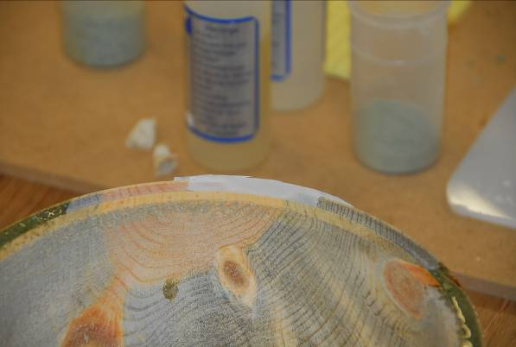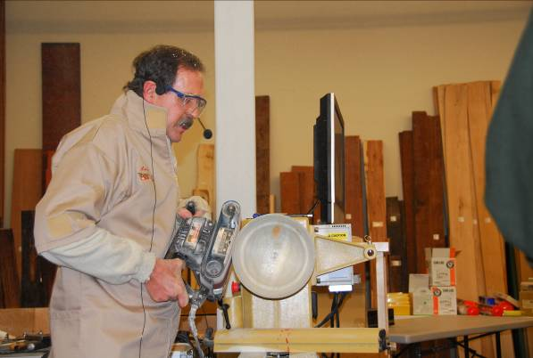
Larry Fox using a belt sander to smooth down the edge

The bowl blank was remounted on the lathe making sure that the previous mark was used to align it with jaw #1. Any unwanted turquoise on outside of wood was removed using power sander. Excess wood was removed using a gouge being careful to avoid getting into the turquoise. Larry used a power belt sander, 80 grit, to remove the remainder of wood and to shape the turquoise both inside and outside. The reversing feature of the lathe was utilized to turn the bowl in the opposite direction of the sander at the location being sanded.

Final sanding was done with a disk sander on an electric drill. He used three inch disks backed with a stiff rubber backing. The concern is that a more flexible back would allow too much wood to be removed due to the differences in the relative hardness.

When the turquoise is first exposed (groove walls removed) there is a black line at the joint between the turquoise band and the wood. The group discussion indicated that it is probably due to the fine turquoise not being able to get into the sharp corners of the forming groove. Larry uses a disk sander on a drill to go around the bowl (without the lathe running) to sand out these lines.

Fine sandpaper wrapped around a wood block is used to remove any undulations in the turquoise (the epoxy is softer than the turquoise) and to do the final sanding. He finish sands his bowls down to 400 grit.
Finishing: Larry finishes his bowls by first sealing them with a mixture of a lacquer based sanding sealer and 50% lacquer thinner. This is followed by buffing using the Beal Buffing system. Instead of using the carnauba wax, he uses Renaissance Wax since it is harder and less likely to show finger prints.

Flying edge: The second bowl he demonstrated had a flying edge, the edge stuck out from the bowl horizontally instead of vertically. The general process was the same with the exception of where and how he cut his groves for the outlay. Since the flying edge will curve downward toward the base, the shape of the groove to hold it can be changed. The bowl blank was mounted and trued up with a flange protruding outward where the flying edge was to be placed. This time Larry cut the groove in the bottom of the flange (toward the base) instead of the top surface. When cutting the groove, the side toward the center of the bowl was straight and parallel to the axis of the spindle as was before, but the bottom of the groove and outer edge was curved to approximate the desired shape of the final rim. This reduces the amount of turquoise needed.

The groove was filled same as before.

After remounting on the lathe, the top surface and outer edge were shaped and sanded as before. To shape the bottom of the outlay, Larry used a drill with a small drum sander, about ¾ inch, to shape the bottom of the outlay and relieve the wood on the under side of the edge.

Inlays: Larry showed us that inlays can easily be added to the bowl. A groove is cut into the
wood edge, while still on the lathe. He may also uses hand carving tools. The wood is then sealed using the sanding sealer mixture. Fine turquoise is then placed in the groove by hand and packed as much a possible. Thin CA glue is then applied to the turquoise powder followed by CA accelerator. After allof the inlay has been placed, the bowl is returned to the lathe to be sanded and finished as before.

Other jewels of Interest:
Heat: When sanding the turquoise and epoxy it may get hot and soften and start to move. If it does, stop and cool it down with an air hose and continue.
Air Bubbles: If air bubbles are found in the turquoise, use compressed air to remove any dust and then fill with clear CA glue. Then re-sand and finish as before.
Cracks: Cracks in the wood or turquoise can be easily repaired. First seal the wood with the sanding sealing mixture from above. After the sealer dries, glue the outside using medium viscosity CA glue and then the inside using thin CA glue. Finish as before.
Signing: Larry signs his work using fine point Sharpe Paint pen found at art supply houses.

Thank you Larry for such an interesting and unusual demonstration. To most of us, it seemed revolutionary, yet it looked surprisingly it easy. Editor

Please return all video tapes
One of our members volunteered to convert our tape library to DVD format. So we need the VCR tapes back for a short period of time. This will be great to have our videos on DVD.

Friendly Reminder☺
A ten minute break allows more time for the demonstrator. Lights will be turned on and off to let us know that the meeting is ready to resume.

Attention Members!
Club members cannot sell videos or other items at Woodcraft during meetings. Woodcraft's sales tax license will not allow this. Any questions should be directed to Drew Nichols, our president.

Woodcraft does offer 10% discount to all members on RMWT Club meeting nights.

Your membership card will get you a discount at several local turning supply retail stores. You can get your membership card from Drew Nichols.

Empty Bowl Project !!

EMPTY BOWLS- Donate a bowl for the Larimer County Food Bank Fundraiser. Please include your name, address. phone #, description and value of the bowl Once again thank you for your donation. I don’t have anymore information on this. I would bring a bowl that you want to DONATE. Bowls will be sold at auction for the fundraiser. Please bring them to the February meeting. Someone will collect them for the auction.

The event this year is Feb. 27 @5:30 at the Hilton Hotel.

Dick Navratil
218-6510

~~~~~~~~~~~~~~~~~~~~~~~~~~
FOR SALE: ???????????
Email me and your item will appear here to over 200 woodturners!

Learn from the best…

Our Club is becoming known around the nation because we have some of the best turners, nationally known demonstrators and best teachers of Basic Turning, Intermediate, and Advanced and Specialty turning right here in our own back yard.

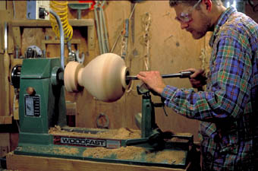

Trent Bosch

Trent Bosch Woodturning Workshops
Workshops are held in Trent’s studio in Fort Collins, Colorado. There is a maximum of four people in each class which allows for lots of individualized instruction. The cost is $500 for the 3-day intensive workshop and $650 for the 4-day. Meals are also provided at no extra charge. His studio is also equipped with the highest quality equipment available for your use.

For detailed information on workshops visit www.trentbosch.com or contact Trent via email or phone.

Trent Bosch
Trent Bosch Studios Inc.
trent@trentbosch.com
970 568 3299

Curt Theobald offers three-day workshops in Segmented Woodturning in his studio in Pine Bluffs, Wyoming.
Call Curt Theobald at 307.245.3310
E-mail cwtheobald@wyoming.com
Website is www.curttheobald.com
Lee Carter operates the Rocky Mountain School of Woodturning in
LaPorte, Colorado. He offers classes in Basics, Intermediate and Advanced. Lee also offers private tutoring. 7 different brands of lathes are available. Due to space limitations, register early! Here is the upcoming schedule.

Feb 12,13,14 – Intermediate W/turn $285

Feb 22 – Introduction to Woodturning $95

Feb 26,27,28 – Advanced W/turning $285

Mar 11,12,13 – Turning Basic/Novelty Boxes using Inlays / Threaded Lids $285

Mar 25,26,27 – Basic Woodturning $285

Call Lee Carter at 970-221-4382 to sign up or have him answer any questions.
e-mail LLJTC4X4149@ CS.COM

Woodcraft has classes for beginners in woodworking, shop safety, intro the machines, bowl turning, pen and pencil turning, hollow forms, Christmas tree ornaments, tool sharpening, etc. Please check out the class being offered at web page www.woodcraft.com

Wood Suppliers
Woodcraft
3718 Draft Horse Drive, Loveland
Woodcraft offers 10% to woodturners, on the night of the meeting. Discount applies to wood and equipment, excluding major power tools

10% Guild discount at the following:

The Wood Emporium

618 N Garfield Ave Loveland, Co 80537

Sears Trostel

1500 Riverside Ave Ft. Collins, CO 80524

Rockler’s in Denver – You have to show your membership card.

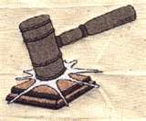
2008 Officers, Directors and Committees
President: Drew Nichols
970-566-4662
dcnichols2004@msn.com

VP: John Giem
970.223.0844
jgiem@comcast.net

Treasurer: Richard Bailey
303-252-1405

Secretary / Newsletter: Kevin Dunn
970.566-0155 Cell
dnnkk@msn.com

Program Director: Trent Bosch
970.568.3299
trentbosch@yahoo.com

Librarian: David Amos
970.834.1432
dcjeamos@juno.com

Symposium Director
Mike Davis - mikeldavisllc@msn.com
Allen Jensen 970-663-1868
Rajconst@aol.com

Webpage - Joy
jswearengen@yahoo.com
Clubs and Member’s
Websites

Rocky Mountain Wood Turners
www.rmwt.org

AAW – American Assoc of Woodturners
www.woodturner.org

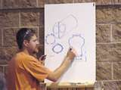
Trent Bosch
www.trentbosch.com


David Nittmann
www.davidnittmann.com

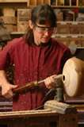
Cindy Drozda
www.cindydrozda.com

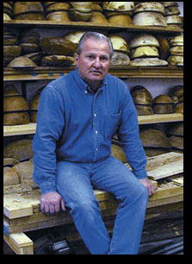
John Lynch
www.johnlynchwoodworking.com

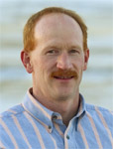
Curt Theobald
www.curttheobald.com

Comments, articles, and any submissions can be sent to this email address. dnnkk@msn.com

Copying of this newsletter is strictly advised. Please do and pass on to another fellow woodworker or woodturner!

