

Rocky Mountain
Woodturners

Newsletter
July 2008

www.woodturner.org

A Chapter of the American
Association of Woodturners

Next Meeting at the Loveland Woodcraft.
Next to The Merchantile, off the Crossroads Exit

>>> July 10th, 6:30 pm Thursday <<<

3718 Draft Horse Drive
Loveland, CO 80538

Demonstration this month
By John Giem
I will not be hosting the Q&A at 6:00 for this meeting. I want to hold the time open for any last minute details needed for the demo.

The demo will be on off-set spindle turning of table legs. Topics covered will include:
- Techniques for making 'identical' turnings
- Designing the legs
- Making a story board
- Turning the pommel
- Dimensioning the turning
- Turning the profile
- Off-setting the leg and turning the knee and ankle
- Turning the foot and pad.

Upcoming Meeting Schedule!

Aug 7th - ?????
Sep 4th - ?????
Sep 13 – 14 – 10th Annual Rocky Mountain Woodturning Symposium at “The Ranch” Budweiser Events Center, Loveland Colorado
Oct 9th - ?????
Nov 6th - ?????
Dec 4th - ?????

RM Woodturning Symposium 2008
The 10th annual Rocky Mountain Wood Turning Symposium will be offering 35 rotations over two days, September 13th and 14th. Some of the turners
www.rmwt.org (updated!)

demonstrating are Mike Mahoney, Stuart Batty, Clay Foster, Molly Winton along with some of our local club turners. Also included are Lee Carter, Dennis Ross, Doug Schneiter and Dave Wilson and more! Get your brochure from any officer, at the next meeting, or print from our website at this link!
www.rmwoodturningsymposium.com/registration-form.pdf Also, there is the form at the end of this newsletter!

!!!!! Meeting Format Changes !!!!!
.
6:00 – 6:30 – John Giem will be hosting the Q&A Session, which will be held in the “Classroom”. Except for the July, John IS the demonstrator.
6:30 – 7:00 – The general business meeting.
7:00 – 8:30 – Demonstrator time (Frank Amigo)
8:30 – 9:00 – Clean up and out by 9 pm sharp!

May meeting highlights!
I apologize for not getting any notes from the May meeting in the last newsletter. So here we go! The instant gallery was shown by David Nittmann and Cindy Drozda. One of the standout pieces was a bowl(?) that was very nicely done. What was unusual about the piece was that it was the individual’s first one and he is ONLY 13 years old!

The main demonstration was “Left Brain – Right Brain”. This was quite an unusual spin on a demonstration, but very effective! The club did tape the entire demonstration for our club’s library. If you missed the meeting, I highly recommend that you check out the video!

Develop your own signature work.
- Copy someone else’s work first, but for learning purposes ONLY!!!!!
- Reasons to copy: to match the flowing lines, catching the symmetry and how the piece has balance.
There are 3 cuts in woodturning. A straight cut, cove cut and a bead cut. This is the shape of the cut. Not to be confused with scraping and shearing, which is HOW you can make the cut. But combining the three shapes, you can make just about anything.

Here is where the left brain right brain part came into play. Cindy is the right brain, the sane one? ☺ And David took the role of being the left brain. I think this was the easy part for him!

Cindy was first by turning a visible vase from another turner. Then Cindy precisely calculated the measurements from the finished piece, then transferred those marks to the blank piece that is mounted on the lathe. Now she turned the blank to match as closely as she could. The result was surprising similar!

David did his the left brain way. He free handed his blank by just looking at the other one, then transferring his marks from memory. No measurements at all. David’s surprisingly came out very close too. Different from Cindy’s, yet both vases were very close to the original piece!

What is to be learned from this exercise? I think we all found out that a lot of us, if not most of us are really left brained woodturners. Following are points to keep in mind.
- Pay attention to ALL the details
- Absorb impressions
- Sharing with other woodturners
- Question everything!
- Take responsibility – Do it yourself!
- Practice, practice, practice
- Be the ARTIST!
Everything you need to know is right in your last piece!

Please return all video tapes
We are missing a lot of video tapes out of the library. Please check to see if you are still have one stuck in your VCR or DVD player! ☺

Attention Members!
Club members cannot sell videos or other items at Woodcraft during meetings. Woodcraft's sales tax license will not allow this. Any questions should be directed to Drew Nichols, our president.

Wood Storage Bank

As we have discussed before, we are collecting wood for our group. There are 3 of us collecting wood. They are Dave Amos, Bruce Pilkington and Kevin Dunn. We are still getting this rolling. But I have a huge boxelder tree and a very nice blue spruce trunk that I acquired. Also, I have past blanks and projects available. Whatever doesn’t get spoken for, goes to feed my fireplace this winter. Kevin Dunn
970-420-9691 dnnkk@msn.com

WOODCRAFT
Woodcraft does offer 10% discount to all members on RMWT Club meeting nights.

Your membership card will get you a discount at several local turning supply retail stores. You can get your membership card from John Giem.

~~~~~~~~~~~~~~~~~~~~~~~~~
Spherical Turnings
From the June Demo!
Presented by: Soren Berger
Reported by: John Giem

On June 5, 2008, Soren Berger was the demonstrator for the Rocky Mountain Woodturners monthly meeting. He came to us from New Zealand during his tour of the US making presentations in Provo Utah and the AAW Symposium in Richmond, VA.

Soren had several interesting comments when he reviewed the Instant Gallery. He indicated that the first thing he looked for in the pieces was to see who was having the most fun. Several of the pieces had spectacular figure in the woods used. He cautioned us to be careful and not to be seduced by the beauty in the wood we are using. After many years of usage or display, the woods will develop a patina and darken. At that point, the wood’s figure will be subdued and the object’s shape will dominate. The message is that an objects shape should not be neglected since it will be the most dominate over time.

In Soren’s demonstration, he turned a large sphere with a handle and then turned a smaller ladle. During the demo, he provided us with many words of wisdom and used many techniques different from what we normally see. [ On Friday, Soren also presented an all day demo. Some of my notes and comments may be from Friday’s information. JIG ]
- Most of his turning during the evening was spindle work, i.e. the wood grain was running parallel to the lathe axis.
- The main tool Soren used was a gouge shaped and sharpened like a roughing gouge. It was ground straight across with about a 40 degree bevel. The width was about 1 1/4 inches and the tang was much stronger that the roughing gouges we see in the US. He also used a similar 1/2 inch gouge which was also sharpened straight across.
- When roughing out your work, by rubbing the bevel of your gouge you can tell when your work is round. It is not necessary to stop the lathe and look.
- You want to feel what is going on through the tool handle.
- Use a light grip on the tool so that you can feel the action on the wood.
- The wood is the primary tool rest, the steel one is secondary.
- You need to refine your turning technique to be able to turn smooth cylinders and tapers.
Turning a Sphere
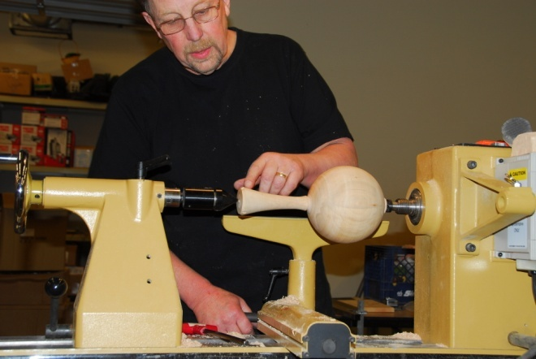
- Started by turning a smooth cylinder.
- The basic principle used was to ‘cage’ the sphere is a series of easy to turn shapes with each successive shape closer approximating a sphere.
- The diameter of the cylinder determines the diameter of the sphere to be turned.
- Turn down a tenon on the left end of the cylinder making sure that the end of the cylinder is flat and perpendicular to the axis of rotation.
- From the left edge of the cylinder, measure and mark it at the point equal to its diameter. Leaving material to the right for a handle, cut down the cylinder at the mark leaving a flat perpendicular shoulder. The sphere is now ‘caged’ in the square cylinder.
- The next step is to cut a smooth 45 degree taper on each end such that they will be tangent to the final sphere thus caging it in the new shape.
- One can calculate where the end positions of the tapers would appear on the above cylinder. Soren has developed a specialized set of calipers that when the diameter of the cylinder is measured with one set of legs, another set of legs provides the proper spacing for the end points of the tapers.
- Using the special calipers, the end points of the 45 degree tapers were marked. The tapers were then cut thus ‘caging’ sphere in a five sided cylindrical shape.
- This new shape is closer to a sphere and can be further refined by making another set of tapers cutting off each of the corners. Soren used another set of divider points on the calipers to define the end points of these new tapers. By cutting these tapers, the sphere will then be caged in a nine sided cylindrical shape.
- Using a pencil, the flat spots between the corners of the new shape were marked. These marks are to be retained while the corners are removed with the gouge.
- After turning off the corners, the shape is close to being the desired sphere. Sanding remains.
- Recall that a flat circle, like the end of a pipe or hollow cylinder, should contact the surface of a sphere evenly. Soren refined the sphere by sanding it with sand paper backed up with a small steel hollow cylinder.
- At this point, he had a large sphere with a cylindrical handle on one side.

Ladle
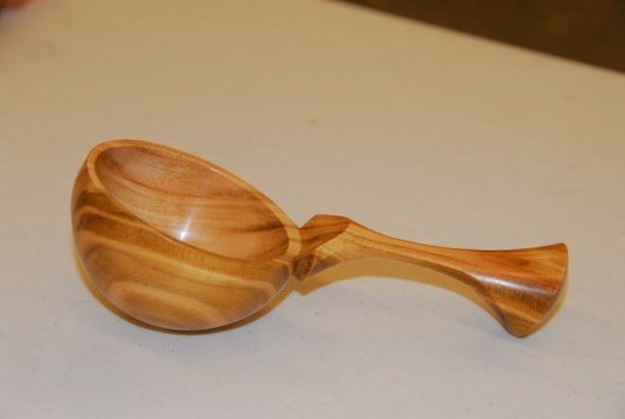
- The first portion of Soren turning a ladle was the same as the above turning of a sphere with the exception of it being smaller.
- After the sphere was turned, the cylindrical handle was shaped.
- Leaving the sphere mounted in the same position on the drive center, the handle was offset on the tail center. The handle was then turned giving it a unique oval like cross section.
- To turn the inside of the scoop, it is necessary to mount the sphere on the lathe. For mounting, he used a short piece of steel tubing, a collet, with a slot cut down one side. Also, one end had been machined to make a sharp edge on the inside. The collet was mounted in the jaws of a chuck with the sharp edge outwards. The sphere was placed into the end of the collet and held in place with the tailstock while the chuck was tightened thereby collapsing the collet. The sharp edges of the collet bit into the sphere capturing it so that the tailstock could be removed.
- The orientation of the sphere and handle were carefully positioned before the chuck was tightened. The long axis of the handle’s oval cross section was set perpendicular to the lathe’s axis of rotation. The long axis of the handle was at an angle toward the tailstock.
- The interior of the sphere was removed creating a bowl for the ladle. The shape of the base of the handle where it meets the bowl was refined.
- After removing the ladle from the collet, a small ring shaped cut was observed. This was easily removed by sanding.
- On Friday, when we turned a similar ladle, a decorative ring was turned on the base of the bowl. The collet was then used to grasp the ladle by that ring.
Friday
- During Friday’s demo, Soren showed us more details and information on turning spheres and usage of the tools he designed.
- He demonstrated how he makes the lidded boxes with the tapered threads.
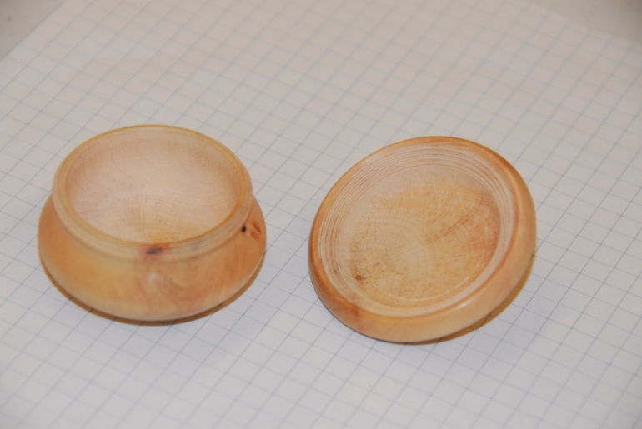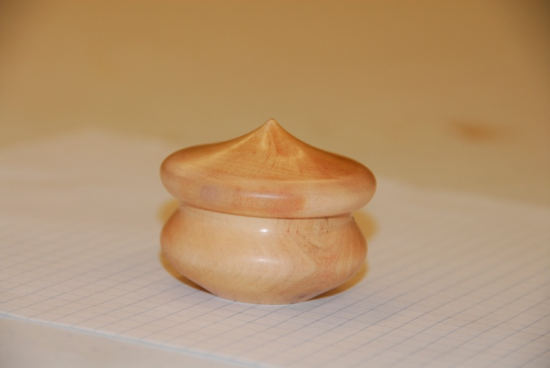
- He demonstrated how to turn a lamp shade with very thin walls. He darkened the room and used a light shining through the side of the wooden shade to gage its thickness while turning.
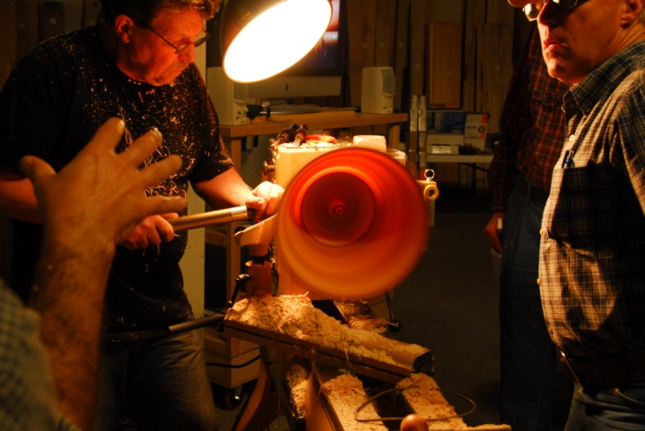

~~~~~~~~~~~~~~~~~~~~~~~~~~~~~~

Learn from the best…
Our Club is becoming known around the nation because we have some of the best turners, nationally known demonstrators and best teachers of Basic Turning, Intermediate, and Advanced and Specialty turning right here in our own back yard.

Trent Bosch Woodturning Workshops
Workshops are held in Trent’s studio in Fort Collins, Colorado. There is a maximum of four people in each class which allows for lots of individualized instruction. The cost is $500 for the 3-day intensive workshop and $650 for the 4-day. Meals are also provided at no extra charge. His studio is also equipped with the highest quality equipment available for your use. For detailed information on workshops visit www.trentbosch.com or contact Trent via email or phone.

Trent Bosch
Trent Bosch Studios Inc.
trent@trentbosch.com
970 568 3299

Curt Theobald offers three-day workshops in Segmented Woodturning in his studio in Pine Bluffs, Wyoming.
Call Curt Theobald at 307.245.3310
E-mail cwtheobald@wyoming.com
Website is www.curttheobald.com

Lee Carter operates the Rocky Mountain School of Woodturning in LaPorte, Colorado. He offers classes in Basics, Intermediate and Advanced. Lee also offers private tutoring. 7 different brands of lathes are available.
Call Lee Carter at 970-221-4382 to sign up or have him answer any questions.
e-mail LLJTC4X4149@ CS.COM

Woodcraft has classes for beginners in woodworking, shop safety, intro the machines, bowl turning, pen and pencil turning, hollow forms, Christmas tree ornaments, tool sharpening, etc. Please check out the class being offered at web page

www.woodcraft.com/stores/store.aspx?id=56

Wood Suppliers

Woodcraft
3718 Draft Horse Drive, Loveland
Woodcraft offers 10% to woodturners, on the night of the meeting. Discount applies to wood and equipment, excluding major power tools

10% Guild discount at the following:

The Wood Emporium

618 N Garfield Ave Loveland, Co 80537

Sears Trostel

1500 Riverside Ave Ft. Collins, CO 80524

Rockler’s in Denver – You have to show your membership card.


2008 Officers, Directors and Committees
President: Drew Nichols
970-566-4662
dcnichols2004@msn.com

VP: John Giem
970.223.0844
jgiem@comcast.net

Treasurer: Richard Bailey
303-252-1405

Secretary / Newsletter: Kevin Dunn
970-420-9691 Cell
dnnkk@msn.com

Program Director: Trent Bosch
970.568.3299
trentbosch@yahoo.com

Librarian: David Amos
970.834.1432
dcjeamos@juno.com

Symposium Director
Mike Davis - mikeldavisllc@msn.com
Allen Jensen 970-663-1868
Rajconst@aol.com

Webpage - Joy
jswearengen@yahoo.com

Clubs and Member’s
Websites

Rocky Mountain Wood Turners
www.rmwt.org

AAW – American Assoc of Woodturners
www.woodturner.org

Trent Bosch
www.trentbosch.com

David Nittmann
www.davidnittmann.com

Cindy Drozda
www.cindydrozda.com

John Lynch
www.johnlynchwoodworking.com

Curt Theobald
www.curttheobald.com

Copying of this newsletter is strictly advised. Please do and pass on to another fellow woodworker or woodturner!

Notice to all. It has been requested that members would like the newsletter than a few days before the meeting. I need all submissions, dates, meeting info, notes, for sales, ect by the 15th of each month. This should help me immensely!
Thank you,

Kevin
Newsletter Editor

Hello Rocky Mountain Woodturners here is a copy of the brochure for the symposium. Don' t miss out on our 10th symposium, it is looking to be one of the best yet. We have a great lineup of local, and national talent in store. Make sure you checkout the new lower price and we want to see all of you out there this year. And be sure to check out the website for updates (www.rmwoodturningsymposium.com) and forward this email to anyone you think is interested in attending.

Your symposium crew
Allen Jensen
Trent Bosch
Mike Davis
Dennis Ross

