

Rocky Mountain
Woodturners

Newsletter
May 2008

www.woodturner.org

A Chapter of the American
Association of Woodturners

Next Meeting at the Loveland Woodcraft.
Next to The Merchantile, off the Crossroads Exit

>>> May 8th, 6:30 pm Thursday <<<

3718 Draft Horse Drive
Loveland, CO 80538
!
May Demonstration by
David Nittmann and Cindy Drozda

Subject is left brain right brain. Cindy and I are going to do a demo called: “Right Brain / Left Brain” aka “creating your signature work”. This is a duo presentation of descriptive interest as well as flying chips on the process of the evolution to developing a signature work. This will definitely be entertaining! Don’t miss this one!

!!!!! Meeting Format Changes !!!!!
Beginning for the April meeting we will be implementing the following format.
6:00 – 6:30 – John Giem will be hosting the Q&A Session, which will be held in the “Classroom”. The topic of the month for April will be "From Log to Lathe". I will also welcome questions on other topics as well.
6:30 – 7:00 – The general business meeting.
7:00 – 8:30 – Demonstrator time (Frank Amigo)
8:30 – 9:00 – Clean up and out by 9 pm sharp!

2008 Membership Dues Are Due
The dues for this year are $35. Dues may be given or sent to Treasurer, Richard Bailey (12519 Locust Pl., Thornton, CO, 80602).

Please return all video tapes
We are missing a lot of video tapes out of the library. Please check to see if you are still have one stuck in your VCR’s! ☺

www.rmwt.org

Attention Members!
Club members cannot sell videos or other items at Woodcraft during meetings. Woodcraft's sales tax license will not allow this. Any questions should be directed to Drew Nichols, our president.

Shop Tour

On Saturday April 12, 2008, Rocky Mountain Woodturners held the first of many Shop Tours of Member’s shops. The tour was of John Giem’s facilities in Fort Collins, CO. Over two dozen people attended, asked lots of questions and shared ideas. Many took advantage of the wood available courtesy of our new Wood Bank.

.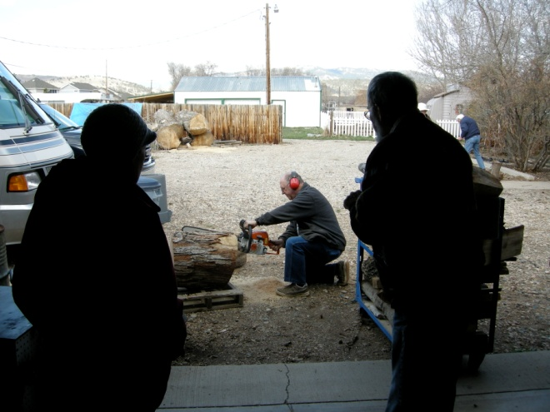
Elizabeth and Frank Amigo watch John Giem
cut wood for them.

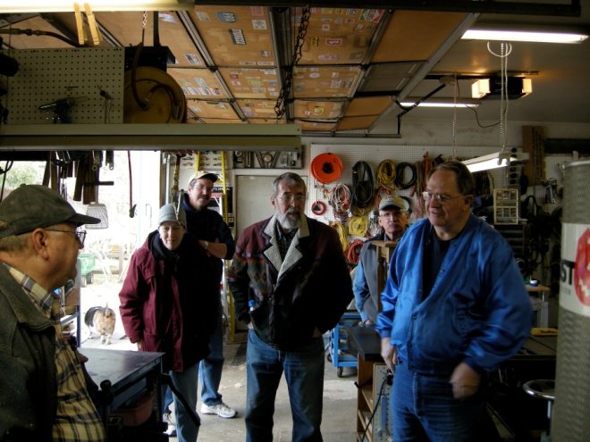
One of many interesting discussions.
Photos by Monty Weymouth.

Sculpted Turnings
Presented by: Frank Amigo
Reported by: John I. Giem
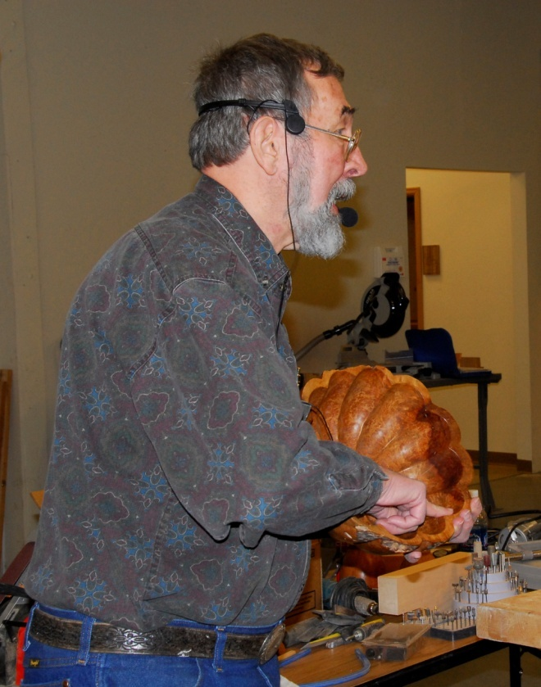
Frank Amigo with one of his bowls.

At the April 3, 2008, meeting of the Rocky Mountain Woodturners, Frank Amigo demonstrated to us some of his work with carved and scalloped turnings and how he shapes them. He started doing wood turnings in the mid-‘70s. After seeing some bowls with carved scallops in them, he started to make scalloped bowls. His first bowls had scallops flowing straight from the upper edge to the bottom center. Frank then developed a technique for putting a ‘twist’ in the scallops so that the spiral down from the edge to the base. When you get the twist just right then you can “feel the energy of the piece”.
- At one time, Frank used ebony for providing accents for his turnings but he always had trouble with it cracking. He now uses black Delrin (a type of engineering plastic) for accents. (Frank did not tell us how he glues the Delrin into his projects.)
- He showed us several of his works most with scallops.
- One items he makes that is popular is a brush that uses natural boar hair for the bristles. One reason is that being natural hair it does not generate static electricity like artificial fibers, thus it is safer around electronics.
- He built his own carving bench based on a design found in a book on carving. (No, I didn’t get the book’s title.) The bench has many features such as tilting, built in clamps, and a carvers screw making it very versatile.
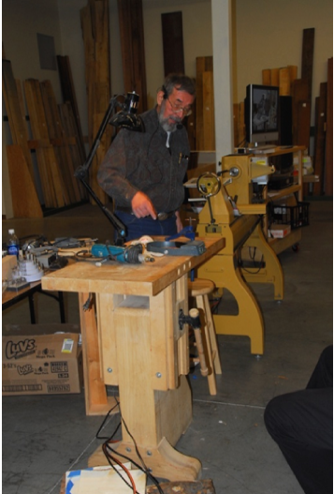
Franks Workbench

- He spent three years in England (he was a Government employee) and learned how to carve using chisels and mallets while there.
- His favorite sharpening method for his carving chisels is to use the Hegner Sharpener. Unfortunately, the system is no longer available. Some of the characteristics that make it desirable include: slow rotating buffing wheels, wheels rotate away from the user, each wheel is charged with a different abrasive compound.
- Frank does most of his carving using rotary carvers but does use hand chisels on some of his work.
- To make one of his carved vessels, he starts by turning and sanding it on the lathe. This process may take about 45 minutes. To allow for carving, the wall is thickness is left around one and a quarter inches depending on the design.
- After sanding and with the vessel still mounted on the lathe, straight lines are placed on it’s sides.
- He had a special tool rest made to help make the straight lines from the top to the bottom of the vessel. The tool rest is a flat square steel plate (about 6” square) that is welded to a tool post. When the tool post is inserted into the banjo of the lathe, the top of the plate is level with the bed ways and parallel to the axis of the lathe. Its height is adjusted to align with the centerline of the spindle.
- He then uses a thin piece of plywood and cuts the profile of the vessel into one edge. By clamping the plywood to the flat tool rest, the cutout will flow from the top to the bottom of the vessel at the same height of the axis of rotation. This allows Frank to scribe a straight pencil line on the vessel. The indexing built into the lathe allows him to make evenly spaced lines around the piece. (The lines are evenly spaced in terms of degrees of rotation of the spindle.)
- Using these lines only, one would get straight scallops from top to bottom. To make the spiral, a string is stretched from the top to the bottom of the vessel moving over one or more lines at the bottom. A pencil line is traced following the string. Frank has his wife help him in this string marking process.
- Now the carving begins using a variety of rotary carving tools. The first cuts are made with a fine saw blade made by Dremel. He makes a series of cuts following the curved line, each one being a little deeper.
- 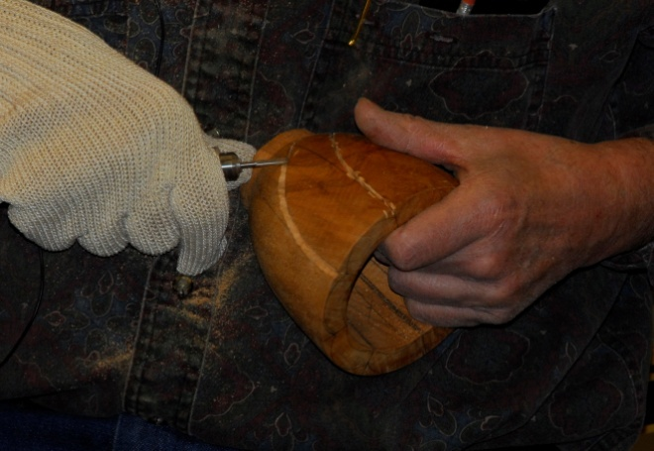
- Note how Frank is using the thumb of his carving hand to stabilize the cutting tool. (This technique is taught to most wood carvers.) In this photo, he has completed his cuts along the pencil lines and is now starting to cut down the scallop on each side of the saw cuts working outward from those cuts.
- After the scallops are finished on the outside, he then cuts/carves flutes on the interior of the vessel to complement the outer shape.
- After using the rotary cutting tools to form the scallops (outside) and flutes (inside), he switches to hand sanding using concave and convex rubber sanding forms to backup the sandpaper. He sands down to 400 grit paper.
- Frank prefers satin finishes on his work as opposed to high gloss finishes. He starts with several coats of Minwax Antique Oil Finish, drying between coats. After the oil finish has hardened, he uses the Beal Buffing System to polish and wax his pieces. The buffing compound used by the system helps remove and remaining fine scratches.
- When he was asked how long it would take to carve a small vessel like the one he was using for demonstration, he indicated that the initial turning and sanding would take about 45 minutes. The carving and sanding of the scallops and flutes would take another two or three weeks. He admitted that he does this carving because of the challenge and the resulting beauty of the finished piece.
- During his demo and following conversations, I learned that Frank also collects and works in stone. I think that he has done similar projects to this in stone. (Is that correct Frank?)

Again, thank you Frank for your demo.

Woodcraft does offer 10% discount to all members on RMWT Club meeting nights.

Your membership card will get you a discount at several local turning supply retail stores. You can get your membership card from John Giem.

~~~~~~~~~~~~~~~~~~~~~~~~~
FOR SALE:
Vicmarc VL100 Lathe, with steel cabinet/stand, motor, foot switch, nova chuck, dust collection hood/hose some tools and accessories. New in 1998(?) and still like new. Rarely used. $350. See Kevin Dunn at the meeting or call 970-566-0155 for details,

3hp Powermatic Shaper $1300. Includes 4 speed Delta power feed and $1000 worth of cutters. Call David Hughes at 970-669-8565.

~~~~~~~~~~~~~~~~~~~~~~~~~~~~~~

Learn from the best…
Our Club is becoming known around the nation because we have some of the best turners, nationally known demonstrators and best teachers of Basic Turning, Intermediate, and Advanced and Specialty turning right here in our own back yard.

Trent Bosch Woodturning Workshops
Workshops are held in Trent’s studio in Fort Collins, Colorado. There is a maximum of four people in each class which allows for lots of individualized instruction. The cost is $500 for the 3-day intensive workshop and $650 for the 4-day. Meals are also provided at no extra charge. His studio is also equipped with the highest quality equipment available for your use. For detailed information on workshops visit www.trentbosch.com or contact Trent via email or phone.

Trent Bosch
Trent Bosch Studios Inc.
trent@trentbosch.com
970 568 3299

Curt Theobald offers three-day workshops in Segmented Woodturning in his studio in Pine Bluffs, Wyoming.
Call Curt Theobald at 307.245.3310
E-mail cwtheobald@wyoming.com
Website is www.curttheobald.com

Lee Carter operates the Rocky Mountain School of Woodturning in LaPorte, Colorado. He offers classes in Basics, Intermediate and Advanced. Lee also offers private tutoring. 7 different brands of lathes are available.
Call Lee Carter at 970-221-4382 to sign up or have him answer any questions.
e-mail LLJTC4X4149@ CS.COM

Woodcraft has classes for beginners in woodworking, shop safety, intro the machines, bowl turning, pen and pencil turning, hollow forms, Christmas tree ornaments, tool sharpening, etc. Please check out the class being offered at web page

www.woodcraft.com/stores/store.aspx?id=56

Here are upcoming Woodcraft classes related to woodturning!

4/5 Introduction to the Wood Lathe, Dave Wilson
4/19 Skew Chisels – Demo and Hands On, Dennis Ross
4/26 Weed Pots on the Lathe, Dave Wilson
5/4 Turning Wooden Pens on the Lathe, Dave Wilson
5/15 Table Building (uses turned legs), John Giem
5/25 Turning Wooden Bowls, Dave Wilson

Details on these classes can be obtained by contacting Woodcraft, looking on the web or contacting the Instructor.

Wood Suppliers

Woodcraft
3718 Draft Horse Drive, Loveland
Woodcraft offers 10% to woodturners, on the night of the meeting. Discount applies to wood and equipment, excluding major power tools

10% Guild discount at the following:

The Wood Emporium

618 N Garfield Ave Loveland, Co 80537

Sears Trostel

1500 Riverside Ave Ft. Collins, CO 80524

Rockler’s in Denver – You have to show your membership card.

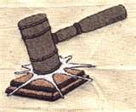
2008 Officers, Directors and Committees
President: Drew Nichols
970-566-4662
dcnichols2004@msn.com

VP: John Giem
970.223.0844
jgiem@comcast.net

Treasurer: Richard Bailey
303-252-1405

Secretary / Newsletter: Kevin Dunn
970.566-0155 Cell
dnnkk@msn.com

Program Director: Trent Bosch
970.568.3299
trentbosch@yahoo.com

Librarian: David Amos
970.834.1432
dcjeamos@juno.com

Symposium Director
Mike Davis - mikeldavisllc@msn.com
Allen Jensen 970-663-1868
Rajconst@aol.com

Webpage - Joy
jswearengen@yahoo.com

Clubs and Member’s
Websites

Rocky Mountain Wood Turners
www.rmwt.org

AAW – American Assoc of Woodturners
www.woodturner.org

Trent Bosch
www.trentbosch.com

David Nittmann
www.davidnittmann.com

Cindy Drozda
www.cindydrozda.com

John Lynch
www.johnlynchwoodworking.com

Curt Theobald
www.curttheobald.com

Copying of this newsletter is strictly advised. Please do and pass on to another fellow woodworker or woodturner!

