

Rocky Mountain
Woodturners

Newsletter
Oct 2008

www.woodturner.org

A Chapter of the American
Association of Woodturners

Next Meeting at the Loveland Woodcraft.
Next to The Merchantile, off the Crossroads Exit

>>> Ocober 9th, 6:30 pm Thursday <<<

3718 Draft Horse Drive
Loveland, CO 80538

Demonstration this month
Allen Jensen
Miniature Hollow Forms

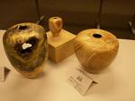

A sample of Allen’s hollow forms. Allen originally was a student of Loveland High School. One of his classes was Industrial Arts, and the teacher was and still is our very own Doug Schneiter.

Upcoming Meeting Schedule!

Oct 9th – Allen Jensen -
Nov 6th - TBA
Dec 4th – Christmas Party?

!!!!! Meeting Format Changes !!!!!
.6:00 – 6:30 –John Giem will be hosting the Q&A Session, which will be held in the “Classroom”. 6:30 – 7:00 – The general business meeting.
7:00 – 8:30 – Demonstrator time.
8:30 – 9:00 – Clean up and out by 9 pm sharp!

Symposium Highlights
There should be highlights discussed from the Symposium, with a full report from Allen. I do know that we had enough attendees to cover our

expenses and them some. All the demonstrations were excellent. The Instant Gallery was absolutely amazing with a wide array of turnings displayed. I took about 100 photos of the instant gallery myself. I will be putting these on a CD and making copies for anyone who wants them!

The beginner turning section was always busy and the vendors were having a lot of fun. Sales seemed to be brisk at all booths.

September meeting demonstration!

Turning Tapered Off-Set Table Legs
Presented and reported by:
John I. Giem

In the Rocky Mountain Woodturning meeting held on September 4, 2008, the demonstration was represented by John Giem. The topic was turning tapered off-set table legs.

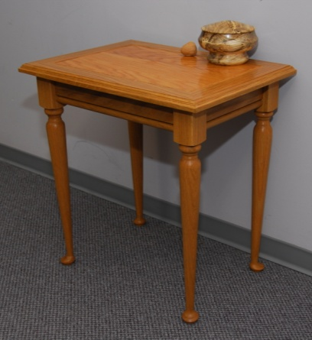
John became interested in turning table legs when his wife asked him to make her an end table. He researched the methods in several books with limited success. Each source gave many hints but no one source provided a complete description of the turning of offset tapered legs. Based on the information found, John turned several prototypes and developed the methods demonstrated.
Figure 1. End Table using the tapered legs.

John has divided the turning of the legs into five steps. To understand the steps, it is first necessary to define the parts of the table leg.

The pommel is the square portion at the top of the leg. With this part being square, it helps in the later construction of the table. The knee is the beginning of the top of the taper which ends at the ankle at the lower end. The toe is the widest part of the foot. The foot pad is not shown and is that the bottom of the leg and makes contact with the floor.
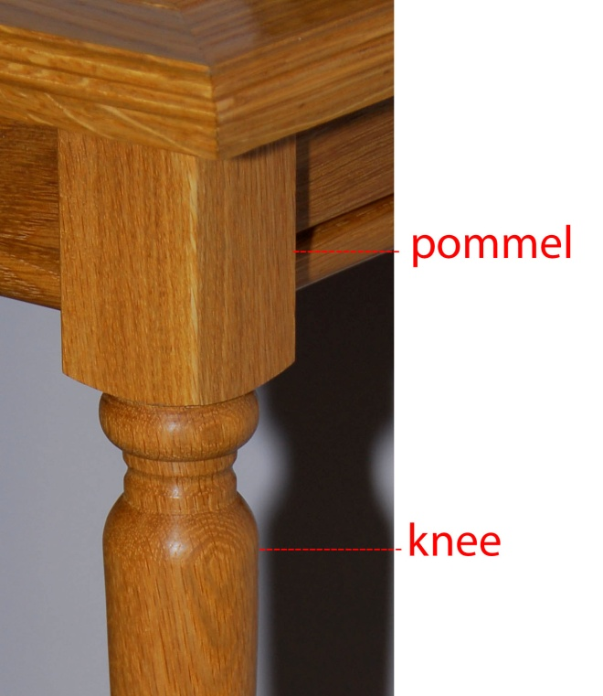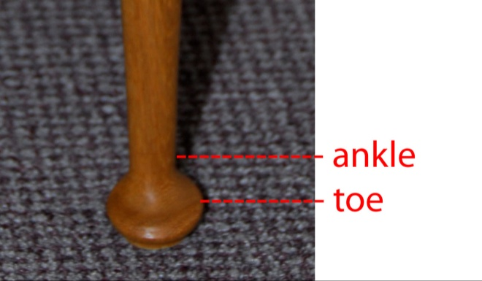
Figure 2. The Parts of the Leg
The five steps in turning the table legs are:
- Design: define the size and shape of the leg.
- Rough and Dimension: rough turn the leg and define the position and diameters of the features.
- Main Axis Turning: turn the shoulder of the pommel, final turn features between the pommel and the knee, final sand these areas. Rough turn the taper from the knee and ankle, and the foot.
- Off-Set turning: Off-set the axis of rotation and do final turning of the taper from the knee and the ankle and the ankle. Do final sanding.
- Final Main Axis Turning: Return to the original main axis and finish turning the toe and foot. Finish sanding and cut to length.
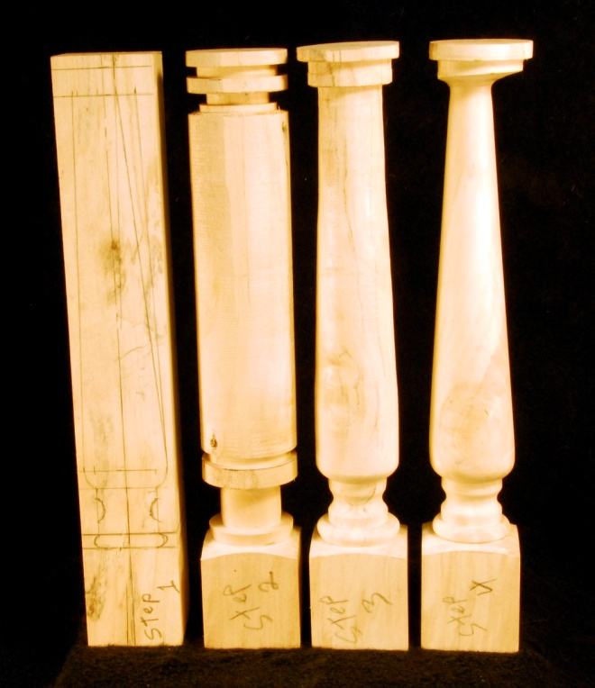
Figure 3 The first four steps in turning the legs
Step 1. Design: During this step, you must define all of the dimensions for the legs. In the above photo, the pommels are square. For the demo, John determined the length of the pommel using the Golden Ratio = 1.61803…. Since the blank was 2 inches across, the length was set at 3 1/4 inches (2 X 1.62 = 3.20).

Another important dimension is the final diameter at the ankle of the leg. The challenge is to set the correct diameter of the ankle for the initial turning during step 3 so that the correct diameter is achieved during step 4. From the literature, John found that the offset center is typically 1/3 of the diameter of the ankle. Using a diameter of 3/4 inches for the final ankle diameter (Df=3/4), the offset at the foot would be 1/4 inch.
The rough ankle diameter, Dr, used in steps 2 and 3 is given by Dr = Df + 2 x offset,
Dr = 3/4 + ( 2 x 1/4) = 3/4 + 2/4 = 5/4 inches,
Dr = 1 1/4 inches.

To make the toe of the foot point the correct direction, at the foot of the leg, the offset center will be 1/4 inch from the center axis of rotation and located on the diagonal running from corner to corner. The offset at the top of the leg will be along the same diagonal but in the opposite direction. The amount of the top offset is determined empirically, more on this later.

The diameters of the other features, beads, fillets, etc. are determined by the designer and his objectives. This leaves the challenge of transferring the dimensions to the turning on the lathe so that the legs look the same. One factor that helps here is that the legs are separated. Thus any imperfections are not easily noticed.

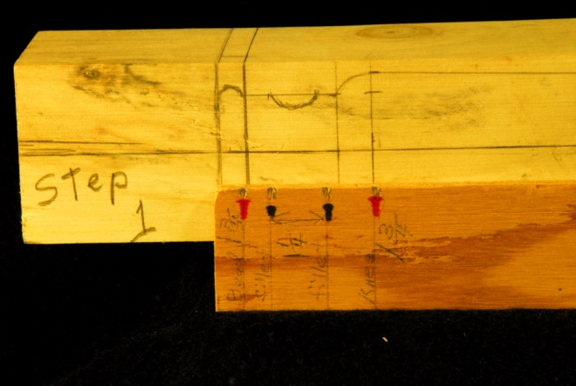
Figure 4. One end of the Story Stick showing notches and markings aligned with features on leg.
To facilitate the dimensioning of the legs on the lathe, John used a story stick. Since the pommel will be square, he designed the story stick to mark the features relative to the bottom edge of the pommel. Using the corner of a file, a notch is cut into the edge of the story stick at each feature. The notches are then labeled with the corresponding diameter (John also color coded the notches with markers.).

Step 2. Rough and dimension. With the pommel already finish sanded, the leg blank is mounted on it’s centers on the lathe. The length of the pommel has been marked on at least one side. (It is desirable to use Steb centers for mounting the blank since they will cause less damage making setting the offsets easier.)

Start by cutting a V notch at the base of the pommel and then rough turn the rest of the blank to a cylinder. Be careful, it is not necessary to turn the wood down to a complete cylinder at this point. It is also easy to turn away too much wood.

With the lathe running slowly, use the story stick to transfer the position of the features to the leg. Align the end of the stick with the base of the pommel and place a pencil point in each of the notches on the stick and scribe lines onto the leg.

Using calipers and a parting tool, cut into and set the diameters of each of the features at the lines scribed above. For John’s demo, several of the diameters were the same thus speeding up the diameter setting process.

Step 3. Main axis turning. Using the depth cuts from above, all that is needed is to ‘connect the dots’. Turn and final sand the features between the base of the pommel and the knee of the leg.

Turn the taper from the knee to the ankle using the depth cuts and a straight edge as guides. Turn the profile of the top of the foot from the toe down to the ankle. Do not try to finish turn and sand this end at this point. Do not turn the foot pad at this time. If you do, then you may destroy the wood needed for the offset center.

Step 4. Offset turning of taper. Remount the foot of the leg 1/4 inch along the diagonal as discussed above. Remount the top of the leg by a small amount along the same diagonal as used on the foot but in the opposite direction. When the top is properly positioned, the knee of the leg will be a at node when the lathe is turned on. This means that when the lathe is turned on the foot and the pommel will wobble and have ‘shadows’ from the offset. At some point near the knee there will be no shadow and that section will appear to be centered. One can run your hand along the leg while the lathe is on to more easily locate this node. Adjust the offset at the top of the leg to move the node to as close to the knee as possible. Reducing the offset toward the original center moves the node toward the top of the leg, increasing the offset moves the node toward the foot.

Turn away the shadow from the knee to the ankle. Use a straight edge as a guide. To minimize vibrations, use your left hand to steady the leg while turning. This has the additional advantage of providing tactile feedback on the progress toward a smooth surface. The straight taper can be facilitated by using a sanding block or straight edge with sandpaper glued to it.

Turn the profile of the foot from the toe to the ankle.

Finish sanding the leg from the knee down to the toe. This cannot be delayed until later since it will not be possible to remount the leg on the offset centers.

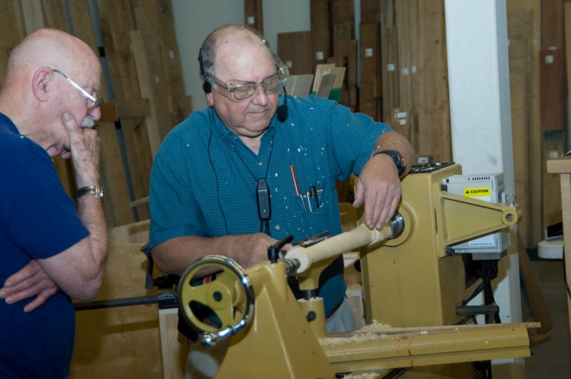
Figure 5. John is turning the taper while being watched by Doc.
Step 5. Final Turning: Remount the leg on the original centers and finish turning the foot and foot pad. Finish sanding the foot and foot pad.

Check the entire leg for flaws and correct them. Complete the leg by cutting it to the correct length.
Your leg is now ready to be incorporated into your table.

Tools: John likes to use a skew chisel for cutting the V notch at the base of the pommel. The taper is cut either with the skew or the roughing gouge depending upon the nature of the wood being used. If the wood is straight grained, like the oak in the table, John likes to use the skew giving a very smooth surface. The wood John used for the demo was highly figured and would tear and chip out if the skew was used. Consequently, he used the roughing gouge to cut the taper. The wood did not tear out and a smooth cut was achieved.

A straight edge/sanding block can be constructed using a ‘good section’ of a used sanding strip from your surface sander. Use spray adhesive to attach the sanding strip to your long straight stick. Let the sanding strip over hang the sides. After the adhesive has dried, place the sanding side down on scrap wood and trim it off (from the backside) using a utility knife.

When cutting your depth grooves in step 2, use calipers that have the corners that touch the wood smoothed and rounded. If those corners have sharp points or edges, they may catch on the rotating wood causing an event that could be unpleasant for you.

If you have any follow-up questions or comments, contact John Giem, 4031 Capitol Dr., Fort Collins, CO 80526, (970)223-0844.

Please return all video tapes
We are missing a lot of video tapes out of the library. Please check to see if you still have one stuck in your VCR or DVD player! ☺
Attention Members!
Club members cannot sell videos or other items at Woodcraft during meetings. Woodcraft's sales tax license will not allow this. Any questions should be directed to Drew Nichols, our president.

Wood Storage Bank
As we have discussed before, we are collecting wood for our group. There are 3 of us collecting wood. They are Dave Amos, Bruce Pilkington and Kevin Dunn. We are still getting this rolling. But I have a huge boxelder tree and a very nice blue spruce trunk that I acquired. Also, I have past blanks and projects available. Whatever doesn’t get spoken for, goes to feed my fireplace this winter. Kevin Dunn
970-420-9691 dnnkk@msn.com

WOODCRAFT
Woodcraft does offer 10% discount to all members on RMWT Club meeting nights.

Your membership card will get you a discount at several local turning supply retail stores. You can get your membership card from John Giem.
~~~~~~~~~~~~~~~~~~~~~~~~~~~~~~

Learn from the best…
Our Club, RMWT, is becoming known around the nation because we have some of the best turners, nationally known demonstrators and best teachers of Basic Turning, Intermediate, and Advanced and Specialty turning right here in our own back yard.

Trent Bosch Woodturning Workshops
Workshops are held in Trent’s studio in Fort Collins, Colorado. There is a maximum of four people in each class which allows for lots of individualized instruction. The cost is $500 for the 3-day intensive workshop and $650 for the 4-day. Meals are also provided at no extra charge. His studio is also equipped with the highest quality equipment available for your use. For detailed information on workshops visit www.trentbosch.com or contact Trent via email or phone.

Trent Bosch
Trent Bosch Studios Inc.
trent@trentbosch.com
970 568 3299

Lee Carter operates the Rocky Mountain School of Woodturning in LaPorte, Colorado. He offers classes in Basics, Intermediate and Advanced. Lee also offers private tutoring. 7 different brands of lathes are available.
Call Lee Carter at 970-221-4382 to sign up or have him answer any questions.
e-mail LLJTC4X4149@ CS.COM
________________________________

Curt Theobald offers three-day workshops in Segmented Woodturning in his studio in Pine Bluffs, Wyoming.
Call Curt Theobald at 307.245.3310
E-mail cwtheobald@wyoming.com
Website is www.curttheobald.com

John Giem, Woodworker
Woodworking instruction customized to the needs of the student. Offering both woodworking on the lathe and combined with regular power tools. Classes are held in John's workshop in Fort Collins, CO, which is equipped with a complete set of woodworking tools. Contact John to discuss rates along with your interests and needs.
jgiem@comcast.net
(970)223-0844, home phone
(970)227-6618, cell phone

Woodcraft has classes for beginners in woodworking, shop safety, intro the machines, bowl turning, pen and pencil turning, hollow forms, Christmas tree ornaments, tool sharpening, etc. Please check out the class being offered at web page

www.woodcraft.com/stores/store.aspx?id=56

Wood Suppliers
Woodcraft
3718 Draft Horse Drive, Loveland
Woodcraft offers 10% to woodturners, on the night of the meeting. Discount applies to wood and equipment, excluding major power tools

10% Guild discount at the following:

The Wood Emporium

618 N Garfield Ave Loveland, Co 80537

Sears Trostel

1500 Riverside Ave Ft. Collins, CO 80524
Rockler’s in Denver – You have to show your membership card.



2008 Officers, Directors and Committees
President: Drew Nichols
970-566-4662
dcnichols2004@msn.com

VP: John Giem
970.223.0844
jgiem@comcast.net

Treasurer: Richard Bailey
303-252-1405

Secretary / Newsletter: Kevin Dunn
970-420-9691 Cell
dnnkk@msn.com

Program Director: Trent Bosch
970.568.3299
trentbosch@yahoo.com

Librarian: David Amos
970.834.1432
dcjeamos@juno.com

Symposium Director
Mike Davis - mikeldavisllc@msn.com
Allen Jensen 970-663-1868
Rajconst@aol.com

Webpage - Joy
jswearengen@yahoo.com

Clubs and Member’s
Websites

Rocky Mountain Wood Turners
www.rmwt.org

AAW – American Assoc of Woodturners
www.woodturner.org

Trent Bosch
www.trentbosch.com

David Nittmann
www.davidnittmann.com

Cindy Drozda
www.cindydrozda.com

John Lynch
www.johnlynchwoodworking.com

Curt Theobald
www.curttheobald.com

Copying of this newsletter is strictly advised. Please do and pass on to another fellow woodworker or woodturner!

