

Rocky Mountain
Woodturners

Newsletter
Sept 2008

www.woodturner.org

A Chapter of the American
Association of Woodturners

Next Meeting at the Loveland Woodcraft.
Next to The Merchantile, off the Crossroads Exit

>>> September 4th, 6:30 pm Thursday <<<

3718 Draft Horse Drive
Loveland, CO 80538

Demonstration this month
By John Giem
I will not be hosting the Q&A at 6:00 for this meeting. I want to hold the time open for any last minute details needed for the demo.

The demo will be on off-set spindle turning of table legs. Topics covered will include:
- Techniques for making 'identical' turnings
- Designing the legs
- Making a story board
- Turning the pommel
- Dimensioning the turning
- Turning the profile
- Off-setting the leg and turning the knee and ankle
- Turning the foot and pad.

Upcoming Meeting Schedule!

Sep 13 & 14 – 10th Annual Rocky Mountain Woodturning Symposium at “The Ranch” Budweiser Events Center, Loveland Colorado
Oct 9th - ?????
Nov 6th - ?????
Dec 4th - ?????

RM Woodturning Symposium 2008
The 10th annual Rocky Mountain Wood Turning Symposium will be offering 35 rotations over two days, September 13th and 14th. Some of the turners

www.rmwt.org (updated!)
demonstrating are Mike Mahoney, Stuart Batty, Clay Foster, Molly Winton along with some of our local club turners. Also included are Lee Carter, Dennis Ross, Doug Schneiter and Dave Wilson and more! Get your brochure from any officer, at the next meeting, or print from our website at this link!
www.rmwoodturningsymposium.com/registration-form.pdf Also, there is the form at the end of this newsletter!

!!!!! Meeting Format Changes !!!!!
.6:00 – 6:30 –John Giem will be hosting the Q&A Session, which will be held in the “Classroom”. (Exception is the September as he IS the demonstrator!
6:30 – 7:00 – The general business meeting.
7:00 – 8:30 – Demonstrator time.
8:30 – 9:00 – Clean up and out by 9 pm sharp!

August meeting highlights!
Metal Spinning
Presented by: Tom Farrell
Reported by: John I. Giem
Tom Farrell
Medlow, TX
tfarrellsrwa@yahoo.com
(806) 548-4621
At the August 7, 2008, meeting of the Rocky Mountain Woodturners, Tom Farrell presented a demonstration on Metal Spinning. As demonstrated by Tom, metal spinning is performed on a standard wood lathe with a few additional tools and forms most of which can be shop fabricated. 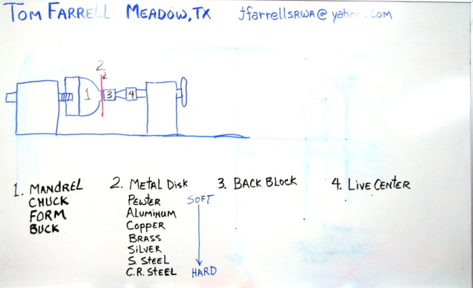

In the above diagram, one can see the basic elements needed for holding and shaping the sheetmetal disk. Mounted on the headstock is the mandrel (chuck, form, buck) upon which the metal is to be spun or formed. The metal disk (2) is held against the mandrel by the Back Block (3) which is mounted on a live center (4).The mating surfaces of the mandrel and the back block have matching complementary surface shapes.

By using a live center with interchangeable tips, one can make custom shaped back blocks to accommodate each situation.

The mandrel is turned from wood to create the internal shape of the part to be spun. You should use a wood that has fine uniform grain without hard and soft spots. Any imperfections in the surface of the mandrel will also show up on the surface of the final spun metal shape. Some woods, such as olive and pine have hard and soft areas corresponding to spring and fall growth. These hard and soft areas may show up as ripples in the final spun piece. There are several alternatives to wood for mandrels. Tom has had good results from using Corian, the same material used for counter tops. Often scraps are available from Installers but you may need to glue several layers together to get the size you need.
When designing and turning your mandrel, be sure that the diameter of the form never decreases when moving from right to left, the direction the material is spun. If a smaller diameter is encountered, the metal will flow into it thus locking the metal onto the form. (Some times this technique is used to make a weighted lamp base.)

The metals used for spinning include: pewter, aluminum, copper, brass, silver, stainless steel, and cold rolled steel. For the demo, Tom used the aluminum alloy 1100-0 which was 16 gauge or 0.050 inches thick.
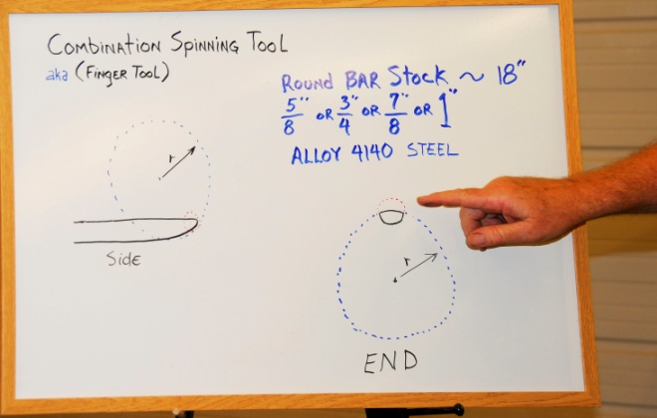
The tool used by Tom to form the aluminum onto the mandrel is called a Combination Spinning Tool or sometimes called a Finger Tool. A large radius is need on both the top and bottom of the tool. Its basic shape is shown in the diagram above. He made his own Finger Tool out of 4140 alloy round bar stock about 18 inches long. (Drill stem sucker rod also works well. )It was mounted in an old shovel handle giving it a total length of around four feet. This long length is necessary to allow placing the non-working end under his arm pit so that his whole body could be used to leverage the tool during the spinning process.

He made his own tool rest from stock steel about one inch square and one foot long. It has a series of holes spaced along the top that are fitted with a pair of movable steel pins. In usage, Tom uses the pins to leverage the finger tool against the spinning aluminum.

While spinning the metal, it must be lubricated to prevent galling or damage.
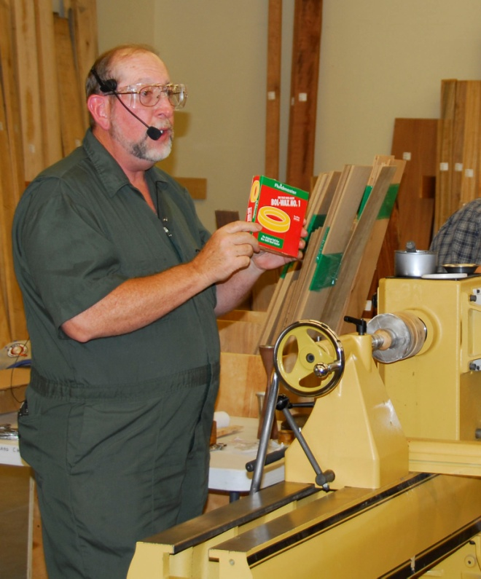
There are a lot of different recommendations as to what should be used but Tom has found that one of the best and yet economical lubricants is the wax from a toilet bowl seal obtained from your local hardware store. (Be sure to get an unused one.)

For first projects, Tom recommends that the mandrel should be designed to make an object that is twice as wide as it is high.
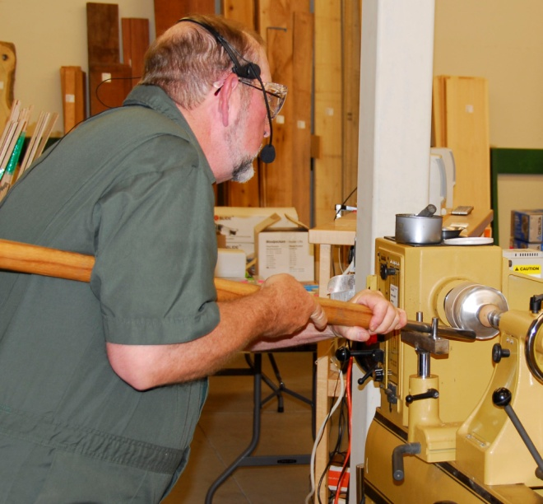
This shows Tom using the finger tool and tool rest to flow the metal down and around the mandrel.

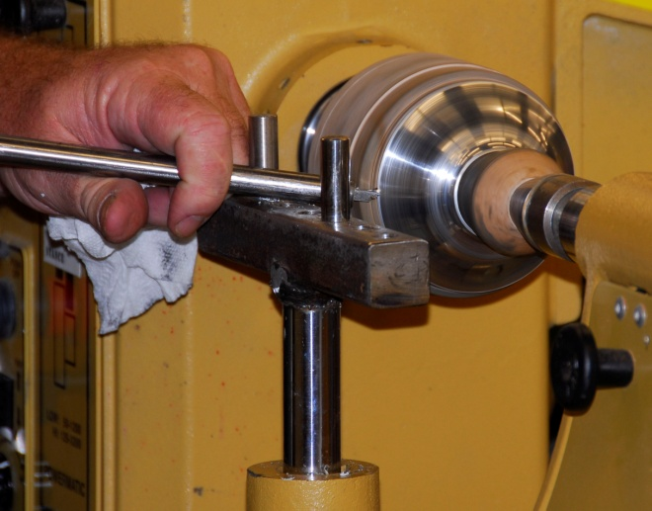
The top of the bowl is trimmed up using a trimming tool, a steel bar fitted with a 1/4 steel lathe cutting tool. Another shop made tool. [I found a box of five carbide tipped 1/4”cutting tools at Harbor Freight for around $5. JIG].
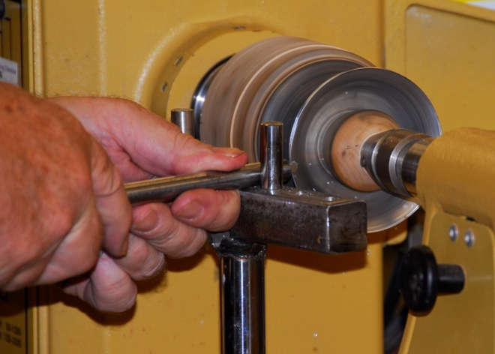
The bowl is then reversed and final trimming of the top is performed
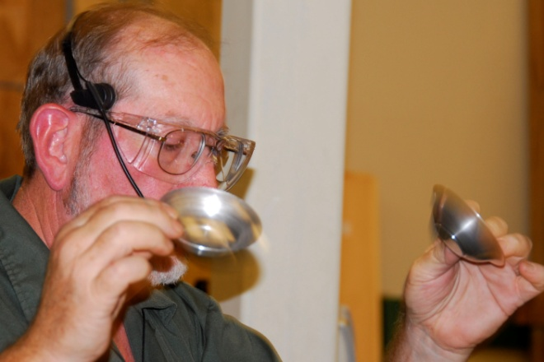
This is what the finished bowls look like.
When spinning the metal, use less pressure as you move further out on the mandrel.

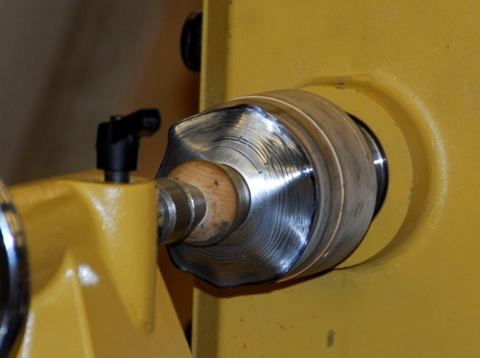
Too much pressure too far out on the mandrel can cause cockling (wrinkling of the metal). If the cockling is not too bad, the end of the finger tool can be used to lift up the edge and move it slightly back toward the tailstock. Then using a backing stick in your left hand, put it under the cockled metal and use the finger tool to iron out the wrinkles. Yes, you are using the backing stick in the left hand and the finger tool in the right hand at the same time. Both tools are across the toolrest prying against the pivot pins trying to iron out your mistake. And yes, you will be very busy at this time. If is not cockled too bad and if you are lucky (good) you will be able to salvage the work, otherwise start over.

After spinning the bowl, Tom sprayed it with WD-40 and wiped it down with a rag to remove all of the wax lubricant.

There are a lot of different style tools available for metal spinning and a lot of opportunities for our incorporating it into our woodturning.

References given by Tom:
Book: The Art of Metal Spinning: A Step by Step Guide to Hand Spinning By Paul G. Wiley, Available from Amazon.com for about $17.00.
Terry Tynan is a professional metal spinner with over 20 years of experience. He is the host of a web site named http://www.metalspinningworkshop.com. The phone number for the Metal Spinning Workshop is 610-277-7460
Metal spinning tools, tool rests, metal disks, videos and polishing compounds are available from http://www.cuttingedgetools.com/
Tom also handed out a ‘Metal Spinning Tutorial’ he downloaded from the internet. V1.0 Metal Spinning P e t e r R u b i n F l e t t e r •perf• 11.10.95, I found it at: http://www.fdp.nu/mikelldevice/spinning.pdf

Please return all video tapes
We are missing a lot of video tapes out of the library. Please check to see if you are still have one stuck in your VCR or DVD player! ☺
Attention Members!
Club members cannot sell videos or other items at Woodcraft during meetings. Woodcraft's sales tax license will not allow this. Any questions should be directed to Drew Nichols, our president.

Wood Storage Bank
As we have discussed before, we are collecting wood for our group. There are 3 of us collecting wood. They are Dave Amos, Bruce Pilkington and Kevin Dunn. We are still getting this rolling. But I have a huge boxelder tree and a very nice blue spruce trunk that I acquired. Also, I have past blanks and projects available. Whatever doesn’t get spoken for, goes to feed my fireplace this winter. Kevin Dunn
970-420-9691 dnnkk@msn.com

WOODCRAFT
Woodcraft does offer 10% discount to all members on RMWT Club meeting nights.

Your membership card will get you a discount at several local turning supply retail stores. You can get your membership card from John Giem.
~~~~~~~~~~~~~~~~~~~~~~~~~~~~~~

Learn from the best…
Our Club, RMWT, is becoming known around the nation because we have some of the best turners, nationally known demonstrators and best teachers of Basic Turning, Intermediate, and Advanced and Specialty turning right here in our own back yard.

Trent Bosch Woodturning Workshops
Workshops are held in Trent’s studio in Fort Collins, Colorado. There is a maximum of four people in each class which allows for lots of individualized instruction. The cost is $500 for the 3-day intensive workshop and $650 for the 4-day. Meals are also provided at no extra charge. His studio is also equipped with the highest quality equipment available for your use. For detailed information on workshops visit www.trentbosch.com or contact Trent via email or phone.

Trent Bosch
Trent Bosch Studios Inc.
trent@trentbosch.com
970 568 3299

Lee Carter operates the Rocky Mountain School of Woodturning in LaPorte, Colorado. He offers classes in Basics, Intermediate and Advanced. Lee also offers private tutoring. 7 different brands of lathes are available.
Call Lee Carter at 970-221-4382 to sign up or have him answer any questions.
e-mail LLJTC4X4149@ CS.COM
________________________________
Curt Theobald offers three-day workshops in Segmented Woodturning in his studio in Pine Bluffs, Wyoming.
Call Curt Theobald at 307.245.3310
E-mail cwtheobald@wyoming.com
Website is www.curttheobald.com
John Giem, Woodworker
Woodworking instruction customized to the needs of the student. Offering both woodworking on the lathe and combined with regular power tools. Classes are held in John's workshop in Fort Collins, CO, which is equipped with a complete set of woodworking tools. Contact John to discuss rates along with your interests and needs.
jgiem@comcast.net
(970)223-0844, home phone
(970)227-6618, cell phone

Woodcraft has classes for beginners in woodworking, shop safety, intro the machines, bowl turning, pen and pencil turning, hollow forms, Christmas tree ornaments, tool sharpening, etc. Please check out the class being offered at web page

www.woodcraft.com/stores/store.aspx?id=56

Wood Suppliers
Woodcraft
3718 Draft Horse Drive, Loveland
Woodcraft offers 10% to woodturners, on the night of the meeting. Discount applies to wood and equipment, excluding major power tools

10% Guild discount at the following:

The Wood Emporium

618 N Garfield Ave Loveland, Co 80537

Sears Trostel

1500 Riverside Ave Ft. Collins, CO 80524
Rockler’s in Denver – You have to show your membership card.

2008 Officers, Directors and Committees
President: Drew Nichols
970-566-4662
dcnichols2004@msn.com

VP: John Giem
970.223.0844
jgiem@comcast.net

Treasurer: Richard Bailey
303-252-1405

Secretary / Newsletter: Kevin Dunn
970-420-9691 Cell
dnnkk@msn.com

Program Director: Trent Bosch
970.568.3299
trentbosch@yahoo.com

Librarian: David Amos
970.834.1432
dcjeamos@juno.com

Symposium Director
Mike Davis - mikeldavisllc@msn.com
Allen Jensen 970-663-1868
Rajconst@aol.com

Webpage - Joy
jswearengen@yahoo.com

Clubs and Member’s
Websites

Rocky Mountain Wood Turners
www.rmwt.org

AAW – American Assoc of Woodturners
www.woodturner.org

Trent Bosch
www.trentbosch.com

David Nittmann
www.davidnittmann.com

Cindy Drozda
www.cindydrozda.com

John Lynch
www.johnlynchwoodworking.com

Curt Theobald
www.curttheobald.com

Copying of this newsletter is strictly advised. Please do and pass on to another fellow woodworker or woodturner!

Hello Rocky Mountain Woodturners here is a copy of the brochure for the symposium. Don' t miss out on our 10th symposium, it is looking to be one of the best yet. We have a great lineup of local, and national talent in store. Make sure you checkout the new lower price and we want to see all of you out there this year. And be sure to check out the website for updates (www.rmwoodturningsymposium.com) and forward this email to anyone you think is interested in attending.

Your symposium crew
Allen Jensen
Trent Bosch
Mike Davis
Dennis Ross
