

Rocky Mountain Woodturners
A chapter of the American Association of Woodturners

February 2010 Newsletter

RMWT Meetings
Each month the Rocky Mountain Woodturners meet at Woodcraft of Loveland, located at 3718 Draft Horse Drive, Loveland, Colorado. We meet on the first Thursday after the first Tuesday of each month.

Meeting Format
6:00 – 6:15 – Setup and Social Time, come visit, share ideas and ask questions
6:15 – 6:45 – The general business meeting.
6:45 – 7:05 Instant Gallery and Raffle
7:05 – 7:15 Break
7:15 – 8:45 – Demonstrator time.
8:45 – 9:00 – Clean up and out by 9 pm sharp!
Next Scheduled Meeting
The regular meeting for February 4, 2010, will be a Hollow Form demonstration by Dale Von Krosigk

2010 Officers, Directors and Committees

President:
Katherine Kowalski
307-637-2874
katherine@daystarhandworks.com

VP:
Dave Dowding
Phone: 970-
dkdowding@lpbroadband.net

Contents of Newsletter
Next RMWT Meeting, Dale Von Krosigk
RMWT Activities
December meeting notes
2010 Membership Dues & Registration
RMWT Board Meeting
EOG Announcement
Member’s web sites, sources of woodturning Instruction and discounts.

February meeting
The next meeting will be February 4, 6:30 p.m. at Woodcraft. February's demonstrator will be Dale Von Krosigk. He is a member of the Rocky Mountain Woodturners from Cheyenne, WY.
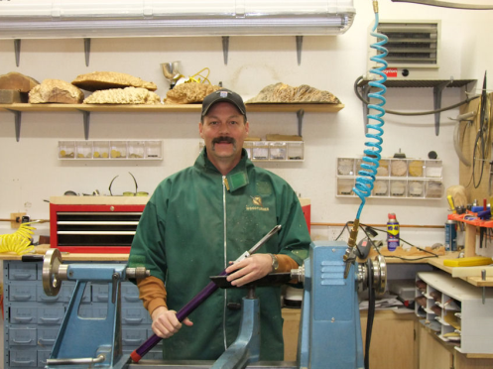
Dale is a member of the Rocky Mountain Woodturners from Cheyenne, WY. He will be presenting the process which he uses to make hollow forms. He will be working with a piece of beetle kill pine, designing a southwest style of a hollow form. Dale will be demonstrating how he achieves the outside shape, and hollowing technique. Plus he will go over how he sharpens bowl gouges, and will talk a little bit about his turning history.
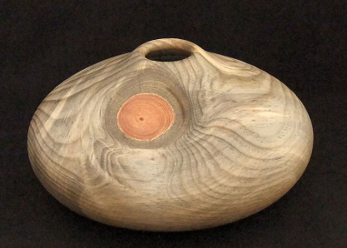

Treasurer:
Pete Herman
(970) 663-1951, home
(585) 259-9486, mobile
Peter_herman@comcast.net

Secretary / Newsletter:
Allen Norris
970-221-5165
allenn1006@yahoo.com

Newsletter Team:
Editor:
Allen Norris
970-221-5165
allenn1006@yahoo.com
Mail Distribution:
Kevin Dunn
970-420-9691 Cell
dnnkk@msn.com
Members:
Pete Herman

RMWT Program Director:
David Nittmann
303.579.6744
david@davidnittmann.com

RMWT Librarian:
David Amos
970.834.1432
dcjeamos@juno.com

Wood Bank Coordinators:
Allen Norris
970.231.5165
allenn1006@yahoo.com
Jerry Sherman
484-2619, home
631-2984, mobile

Wood Lot:
John Giem,
223-0844, home
227-6618, mobile
jgiem@comcast.net
January meeting notes

The January meeting was held January 7th at Woodcraft in Loveland.

Katherine Kowalski called the meeting to order.

The following announcements were made:

Frank Amigo gave us a report on the benefits of AAW membership, and encouraged us all to join the AAW.

John Harpold reminded us that EOG Applications are due January 15, 2010, and encouraged us to apply. Recipients of previous grants gave reports on how those were used. Katherine Kowalski told us how much she enjoyed the woodturning class she attended and thanked us for the opportunity. Doug Schneiter told us how he used the grant to purchase turning tools for his high school classes to use, and got more than he had anticipated thanks to an unanticipated discount from the good folks at the Woodcraft store.

Allen Jensen reported that the Symposium made a profit, and that the auction was successful in raising money for our EOG fund.

After the meeting, those of us who brought items to be auctioned moved those items to the auction table. Allen Norris and Katherine Kowalski assisted Drew Nichols in presenting pieces and encouraging bids. Donators included - and please forgive any inadvertent omissions - Cindy Drozda, David Nittman, Doc Thode, Doug Schneiter, Katherine Kowalski, and Allen Norris.

We raised $730 in funds to begin the new year. Thank you for donating and for bidding.

To view photos of the event go to http://picasaweb.google.com/rockymountainwoodturners/Christmas2009#

It was lots of fun.

Membership Dues
RMWT Symposium
Directors:
Mike Davis
970.484.9190
mikeldavisllc@msn.com
Allen Jensen
970-663-1868
Rajconst@aol.com
Registration:
John Giem
970-223-0844
mailto:jgiem@comcast.net

EOG Committee Chairman:
John Harpold
970.482.0439
jmharpold@skybeam.com

RMWT Webmaster:
Hoyle Curtis
970.613.1415
hoyle.curtis@gmail.com

Club Membership Dues are due and payable. 2010 Membership dues are $40, family $55 and student $25. This year, with the dues, the board is updating membership information. Dues are to be paid to the treasurer, Pete Herman (1762 Rhyolite St, Loveland, CO 80537), or to the vice president, Dave Dowding. We will have a registration table set up at the January meeting for that purpose. If you pay with cash, please fill out a form with current address, telephone number, and e-mail, so we will not lose track of who paid. If you pay with a check, please designate 2010 RMWT membership dues on the check.

Board meeting

The board met
.

Library

If you know of a book, video (tape, DVD, etc) that you would like to have included in our library, please let our librarian, David Amos (dcjeamos@juno.com, 970 834-1432), know. If you have borrowed an item from our library, and are done with it for now, please return it so that others may have the opportunity to use it.

10% Guild discount
Wood Emporium
618 N Garfield Ave
Loveland

Sears Trostel
1500 Riverside Ave
Ft. Collins, CO 80524

Rockler’s in Denver – You have to show your membership card.

Woodcraft
3718 Draft Horse Drive
Loveland, CO 80538
970-292-5940
Discounts on day of Club Meeting.

Clubs and Member’s Websites

Rocky Mountain Wood Turners
www.rmwt.org

AAW – American Assoc of Woodturners
www.woodturner.org

Trent Bosch
www.trentbosch.com

David Nittmann
www.davidnittmann.com

Cindy Drozda
www.cindydrozda.com

John Lynch
www.johnlynchwoodworking.com

Curt Theobald
www.curttheobald.com

Katherine Kowalski
http://www.DaystarHandworks.com

David Nittmann
http://www.davidnittmann.com

Want your Website Listed? Contact a member of the Newsletter Team!!!

Learn From the Best…

Our Club, RMWT, is known around the nation because we have some of the best turners, nationally known demonstrators and best teachers of Basic Turning, Intermediate, and Advanced and Specialty turning right here in our own back yard.

Trent Bosch Woodturning Workshops
Workshops are held in Trent’s studio in Fort Collins, Colorado. There is a maximum of four people in each class, which allows for lots of individualized instruction. The cost is $500 for the 3-day intensive workshop and $650 for the 4-day. Meals are also provided at no extra charge. His studio is also equipped with the highest quality equipment available for your use. For detailed information on workshops visit www.trentbosch.com or contact Trent via email or phone.

Trent Bosch
Trent Bosch Studios Inc.
trent@trentbosch.com
970 568 3299

Lee Carter operates the Rocky Mountain School of Woodturning in LaPorte, Colorado. He offers classes in Basics, Intermediate and Advanced. Lee also offers private tutoring. Seven different brands of lathes are available.
Call Lee Carter at 970-221-4382 to sign up or have him answer any questions.
e-mail LLJTC4X4149@ CS.COM

Curt Theobald offers three-day workshops in Segmented Woodturning in his studio in Pine Bluffs, Wyoming.
Call Curt Theobald at 307.245.3310
E-mail cwtheobald@wyoming.com
Website is www.curttheobald.com

John Giem, Woodworker
Individual or small group woodworking instruction customized to the needs of the student. Offering both woodworking on the lathe and combined with regular power tools. Classes are held in John's workshop in Fort Collins, CO, which is equipped with a complete set of woodworking tools. Contact John to discuss your interests and needs.
jgiem@comcast.net
(970)223-0844, home phone
(970)227-6618, cell phone

David Nittmann
“Airbrush-On-Wood” : airbrushes, accessories and quality woodart specific paint. Lessons available contact David Nittmann david@davidnittmann.com 303.579.6744 or visit his website, http://www.davidnittmann.com.
______________________________________________________________________

Woodcraft has classes for beginners in woodworking, shop safety, intro the machines, bowl turning, pen and pencil turning, hollow forms, Christmas tree ornaments, tool sharpening, etc. Please check out the class being offered at web page

www.woodcraft.com/stores/store.aspx?id=56

