1. Open **jvisualvm** from JDK path (C:\Program Files\Java\jdk1.8.0_45\bin)
2. Do the JMX connection for monitoring.

Set below configs in tomcat/bin/setenv.sh .

export JAVA_OPTS="-Dcom.sun.management.jmxremote -Dcom.sun.management.jmxremote.port=9999 -Dcom.sun.management.jmxremote.authenticate=false -Dcom.sun.management.jmxremote.ssl=false -Djava.rmi.server.hostname=192.168.2.75"

export CATALINA_OPTS="$CATALINA_OPTS -Xms4096m"

export CATALINA_OPTS="$CATALINA_OPTS -Xmx4096m"

export CATALINA_OPTS="$CATALINA_OPTS -XX:MaxPermSize=1024m"

export CATALINA_OPTS="$CATALINA_OPTS -XX:+HeapDumpOnOutOfMemoryError"

export CATALINA_OPTS="$CATALINA_OPTS -XX:HeapDumpPath=/home/ec2-user/apache-tomcat-8.0.29/heapdump/"

1) Add below two arguments in Thread Group

No.of Threads (users) --> ${__P(users,0)}

Ramp Up Period (in seconds) ---> ${__P(rampup,0)}

Note : - Add these arguments then save the jmx file which you wanna run.

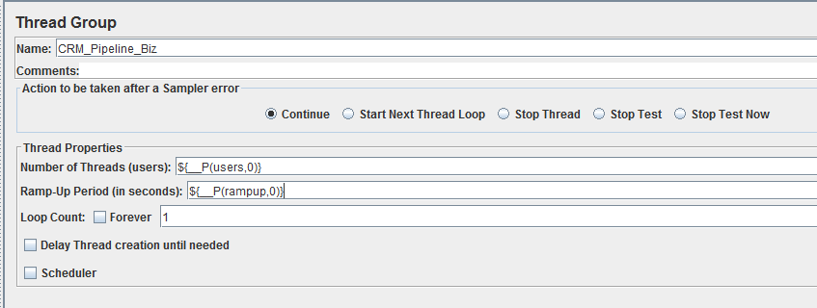

2) jmeter -Jusers=10000 -Jrampup=1000 -n -t <scripts path>\ProfileService_BIZ.jmx -l <output file path>\seeddata.jtl

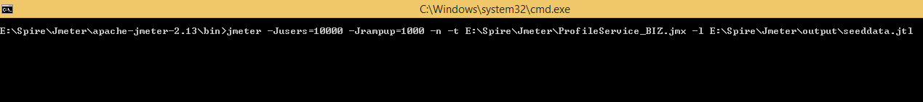

3) Open Jmeter right click on TestPlan -> select Add -> Select Listener -> select Aggregate Report or any other report in the list which you want.

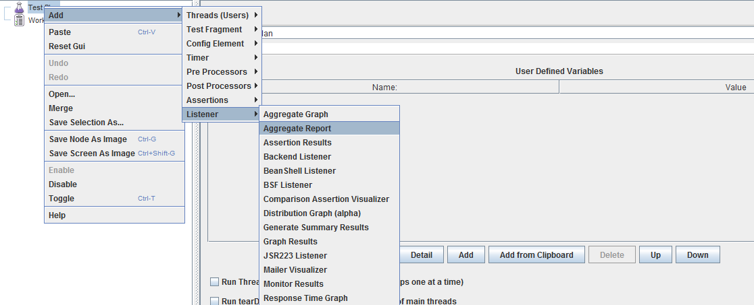

4) Browse to jtl file which created from the script (<output file path>\seeddata.jtl)

Assuming I choose Aggregate Report .

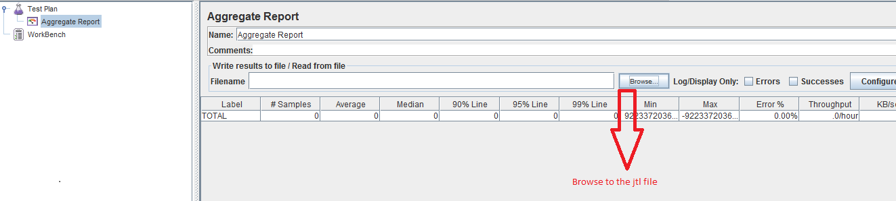

5) After choose the jtl you see the results as below format.

