1. Create an HTML page to validate Name and Email. (Use Bootstrap, JQuery wherever applicable)

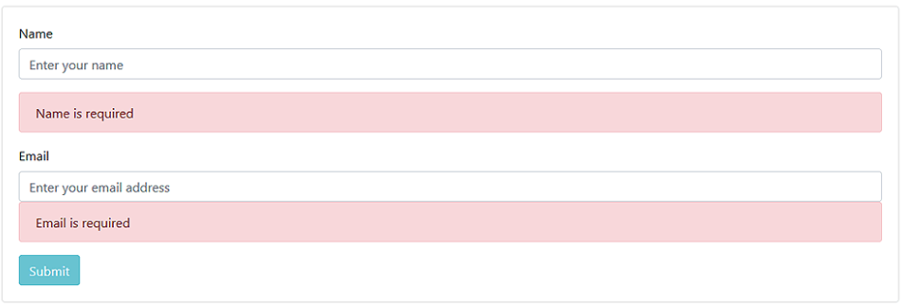

2. If the name and email entered are correct it should dynamically add the details to the below table. The table should look like below:

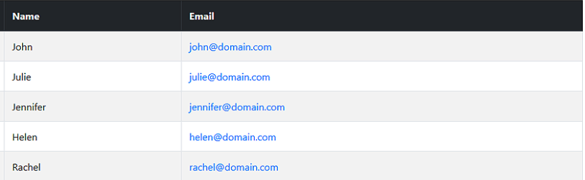

<!DOCTYPE html>

<html>

    <head>

        <link rel="stylesheet" href="https://maxcdn.bootstrapcdn.com/bootstrap/3.3.7/css/bootstrap.min.css" integrity="sha384-BVYiiSIFeK1dGmJRAkycuHAHRg32OmUcww7on3RYdg4Va+PmSTsz/K68vbdEjh4u" crossorigin="anonymous">

        <link rel="stylesheet" href="https://maxcdn.bootstrapcdn.com/bootstrap/3.3.7/css/bootstrap-theme.min.css" integrity="sha384-rHyoN1iRsVXV4nD0JutlnGaslCJuC7uwjduW9SVrLvRYooPp2bWYgmgJQIXwl/Sp" crossorigin="anonymous">

        <script src="https://maxcdn.bootstrapcdn.com/bootstrap/3.3.7/js/bootstrap.min.js" integrity="sha384-Tc5IQib027qvyjSMfHjOMaLkfuWVxZxUPnCJA7l2mCWNIpG9mGCD8wGNIcPD7Txa" crossorigin="anonymous"></script>

        <style>

            .container{

                padding: 16px;

            }

            input[type=email],input[type=text]{

                width: 100%;

                height: 55px;

                padding: 15px;

                margin: 5px 0px 22px 0px;

                display: inline-block;

                border: none;

                background: rgb(221, 220, 220);

            }

        </style>

    </head>

    <body>

        <formx>

            <div class="container">

                <h1>Name and E-mail Validation</h1>

                <hr>

                <label for="nameId">Name</label>

                <input type="text" id="nameId" class="form-control" placeholder="Enter your name" required>

                <label for="E-mail">Email</label>

                <input type="email" id="E-mail" class="form-control" placeholder="Enter your email address" required>

                <button id="butt" class="btn btn-info" onclick="addTable()">Submit</button>

                <hr>

                <div class="container" id="myDiv"></div>

                <table id="oldTable" class="Table"  width="400px" cellspacing="10" cellpadding="10" border="0px">

                    <th>Name</th>

                    <th>Email</th>

                </table>

            </div>

        </form>

        <script>

**function** addTable() {

**var** naMe = document.getElementById("nameId").value;

**var** eMail = document.getElementById("E-mail").value;

**var** divSpace = document.getElementById("myDiv");

**var** table = document.getElementById("oldTable");

**var** newRow = document.createElement('tr');

                newRow.setAttribute('id', 'row1');

**var** newData1 = document.createElement('td');

                newData1.setAttribute('id', 'data1');

**var** newData2 = document.createElement('td');

                newData1.setAttribute('id', 'data2');

                newData1.innerHTML = naMe;

                newData2.innerHTML = eMail;

                newRow.appendChild(newData1);

                newRow.appendChild(newData2);

                table.appendChild(newRow);

            }

        </script>

    </body>

</html>

1. Create a user form like below and perform the validation as shown in the below images:

**Image - 1-4**

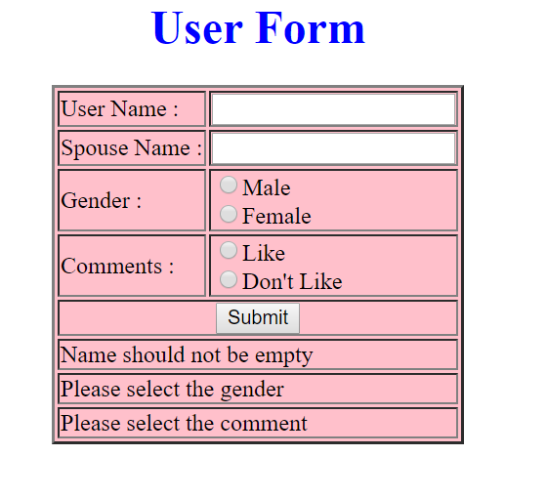

**Image - 2-4**

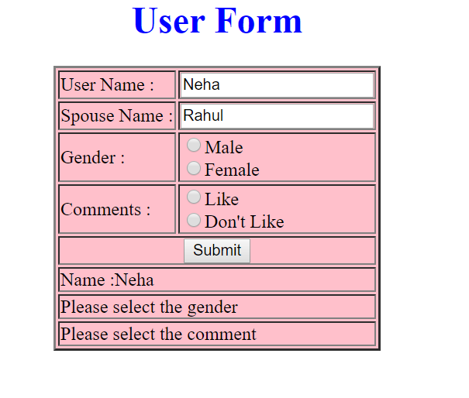

**Image - 3-4**

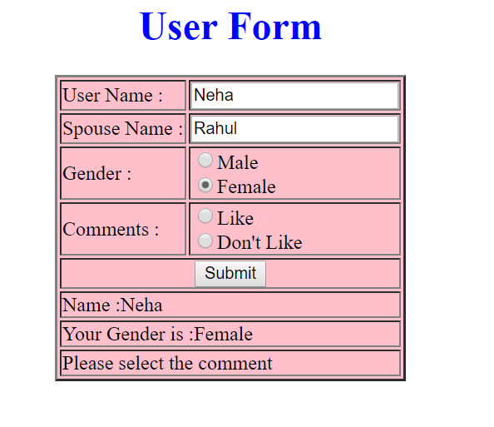

**Image - 4-4 (Success)**

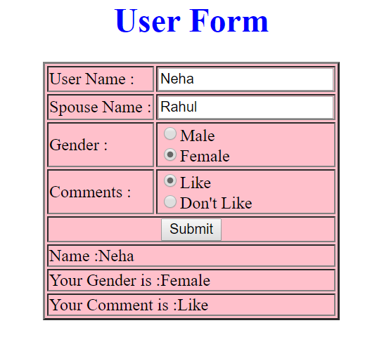

<!DOCTYPE html>

<html lang="en">

<meta charset="UTF-8" />

<head>

    <link rel="stylesheet" href="http://code.jquery.com/ui/1.10.3/themes/smoothness/jquery-ui.css" />

    <link rel="stylesheet" href="https://stackpath.bootstrapcdn.com/bootstrap/4.3.1/css/bootstrap.min.css">

    <script src="http://code.jquery.com/jquery-1.9.1.js"></script>

    <script src="http://code.jquery.com/ui/1.10.3/jquery-ui.js"></script>

    <script>

        $(document).ready(**function** () {

            $("#nameDiv").text("Name shouldn't be empty")

            $("#genderDiv").text("Please Select the Gender")

            $("#commentDiv").text("Please Select the Comment")

            $("#submit").click(**function** () {

**var** username = $("#username").val();

**var** gender = $('input[name=radio1]:checked').val();

**var** comments = $('input[name=radio2]:checked').val();

                if (username) {

                    $("#nameDiv").html("Name : " + username)

                }

                if (gender) {

                    $("#genderDiv").html("Your Gender is : " + gender)

                }

                if (comments) {

                    $("#commentDiv").html("Your Comment is : " + comments)

                }

            })

        });

    </script>

</head>

<body >

    <h1 align="center">User Form</h1>

    <table border="1" bgcolor="pink" align="center" cellspacing="10" cellpadding="10">

        <form>

            <tr>

                <td>User Name</td>

                <td><input type="text" name="username" id="username" /></td>

            </tr>

            <tr>

                <td>Spouse Name</td>

                <td><input type="text" name="spname" id="spname" /></td>

            </tr>

            <tr>

                <td>Gender</td>

                <td>

                    <input type="radio" name="radio1" id="gender" value="Male" />Male

                    <input type="radio" name="radio1" id="gender" value="Female" />Female

                </td>

            </tr>

            <tr>

                <td>Comments</td>

                <td>

                    <input type="radio" name="radio2" id="comments" value="Like" />Like

                    <input type="radio" name="radio2" id="comments" value="Dislike" />Don't Like

                </td>

            </tr>

            <tr>

                <td align="center" colspan="2">

                    <input type="button" value="Submit" id="submit" onclick="check()" />

                </td>

            </tr>

            <tr>

                <td align="left" colspan="2">

                    <div id="nameDiv"></div>

                </td>

            </tr>

            <tr>

                <td align="left" colspan="2">

                    <div id="genderDiv"></div>

                </td>

            </tr>

            <tr>

                <td align="left" colspan="2">

                    <div id="commentDiv"></div>

                </td>

            </tr>

        </form>

    </table>

</body>

</html>

4.

CyberShoppe, Inc. sells toys and books in the United States. It has three branches in different parts of the country. Currently, the three branches maintain data on their local computer systems. The IT manager at CyberShoppe has identified that a centralized data repository on the products sold through its   
e-commerce site is required. The data from all branches must be collated and housed in a centralized location. This data must be made available to the Accounts and Sales sections at the individual branches, regardless of the hardware and software platforms being used at the branches.

1. In addition, the sales personnel require access to the data using palmtops and cellular phones. The product details of CyberShoppe consist of the product name, a brief description, the price, and the available quantity on hand. A product ID uniquely identifies each product. Create a responsive web page to capture these details.
2. The various products at CyberShoppe are purchased from their suppliers through their branch offices. The purchase order details are sent to the head office to generate reports. To ensure that the data can be accessed across all hardware and software used at the head office, the branch offices. On receiving this data, the head office needs to verify that all branches have specified the required information in a consistent format.

The purchase order details sent by the branch offices include the product ID, order ID, date of the purchase order, name and address of the supplier, quantity ordered, and price per unit.

1. The product Id must start with P following by 5 digits
2. The order Id must start with OD followed by 4 digits
3. The remaining fields are mandatory.
4. The look and feel should be consistent throughout the website.

Use jQuery, Bootstrap, JavaScript .

<html>

    <head>

            <link rel="stylesheet" href="http://code.jquery.com/ui/1.10.3/themes/smoothness/jquery-ui.css" />

            <link rel="stylesheet" href="https://stackpath.bootstrapcdn.com/bootstrap/4.3.1/css/bootstrap.min.css">

            <script src="http://code.jquery.com/jquery-1.9.1.js"></script>

            <script src="http://code.jquery.com/ui/1.10.3/jquery-ui.js"></script>

    </head>

    <body>

        <div class="container">

            <div class="row" style="margin-top: 50px">

                <div class="col-xs-12 col-md-8 offset-md-3">

                    <label for="productId">Product Id</label>

                    <input type="text" id="productId" minlength="7" style="width: 80%" required class="form-control">

                </div>

            </div>

        </div>

    </body>

</html>