CS-3113 Intro to Operating Systems

Project #1 (Shared Memory)

Report

Kyumin Lee

kyuminlee@ou.edu

My basic ideas to solve the problem:

Structuring shared memory will be necessary. We will be creating 4 processes, which means we will be calling fork() twice. I'd want a function to handle increments for each process. I’ll have to make sure to wait for all child processes to finish and release shared memory.

Results:

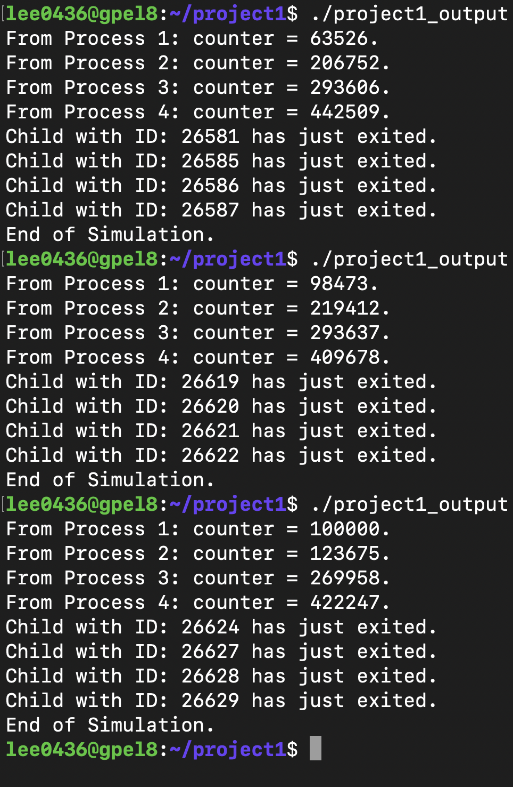

As you can see, the program compiles, runs, and outputs. The code works.

Analysis of the results:

In the screenshot above, you can see that the ‘counter’ values are not exactly 100,000, 200,000, 300,000, and 500,00 respectively. From this, I learned that using shared memory for multiple processes that are running instantaneously is not a good practice.