AMEX Enterprise Credit Risk Platform
Basel III / IFRS 9 Mapping Report -- Notebook 08
Generated: 2026-08-23 22:11
This report combines real, measured model output (each holdout customer's predicted PD, scored live by Notebook 05's champion model) with the actual published Basel II/III IRB formula for Qualifying Revolving Retail Exposures (a real regulatory formula, not an approximation) and with clearly labeled ASSUMPTION constants for LGD and EAD, which the Kaggle AMEX dataset does not contain. It is a worked regulatory-capital methodology, not a substitute for your institution's own Basel/IFRS9 model validation.

1. Model & Data Basis (Measured)
Champion Model | xgboost
Holdout Customers Scored | 91783
Measured Portfolio Avg Pd | 0.2585
Measured Holdout Default Rate | 25.8937%

2. Basel III Regulatory Parameters
- Regulatory standard (fixed by Basel, not chosen by this notebook):
Qrre Correlation R | 0.04
Confidence Level | 99.9%
Pillar1 Minimum Ratio | 8.0%
Capital Conservation Buffer | 2.5%
- Stated assumption (editable):
Lgd Assumption | 45%
Ead Per Account Usd | $5,000

3. Capital Adequacy Summary
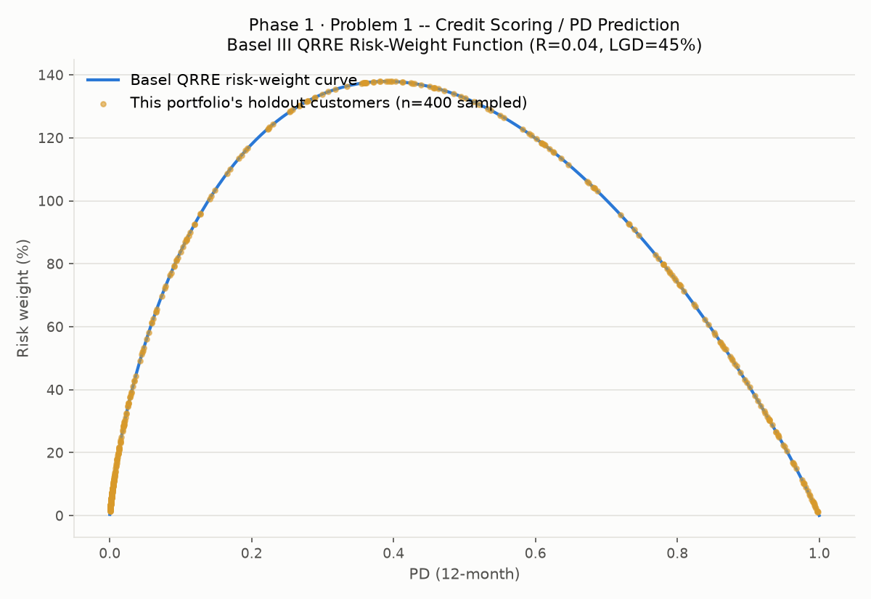
Total Ead Usd | $458,915,000
Total Rwa Usd | $203,644,380
Avg Risk Weight Pct | 44.38
Pillar1 Minimum Capital Usd | $16,291,550
Capital Conservation Buffer Usd | $5,091,109
Total Required Capital Usd | $21,382,660
Lgd Assumption | 0.45
Ead Per Account Usd Assumption | $5,000
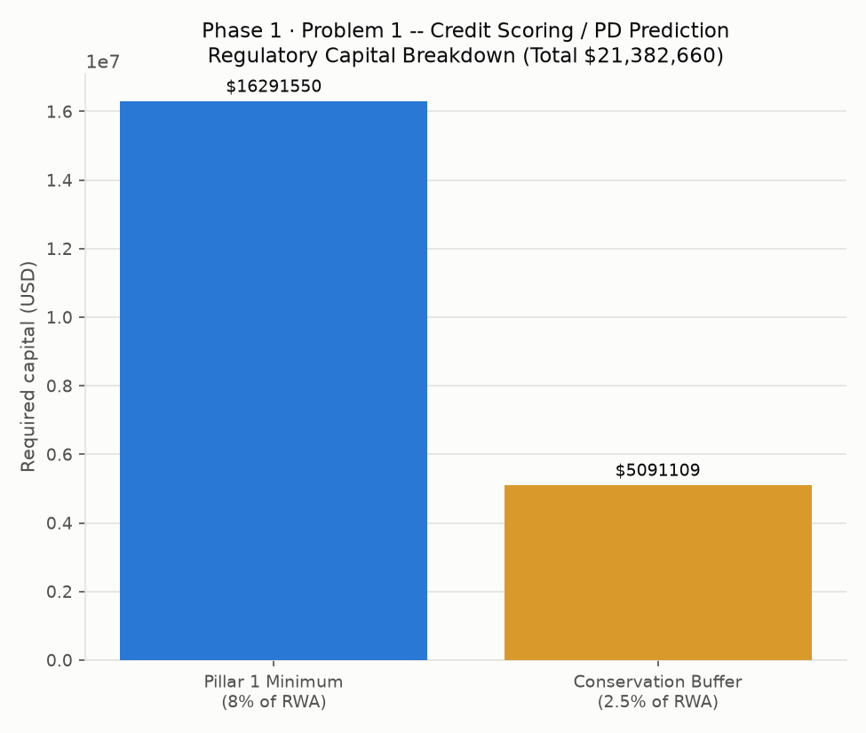

4. IFRS 9 Staging
IMPORTANT LIMITATION: production IFRS9 staging compares a customer's PD today against their PD at origination to detect a significant increase in credit risk (SICR) -- this requires a PD term structure the single-snapshot Kaggle AMEX dataset does not provide. This section instead runs a backtest-style exercise: Stage 3 uses the real, already-known holdout outcome; Stage 2 uses a stated PD-deterioration heuristic. This illustrates the ECL mechanics correctly but is not production-ready staging logic.
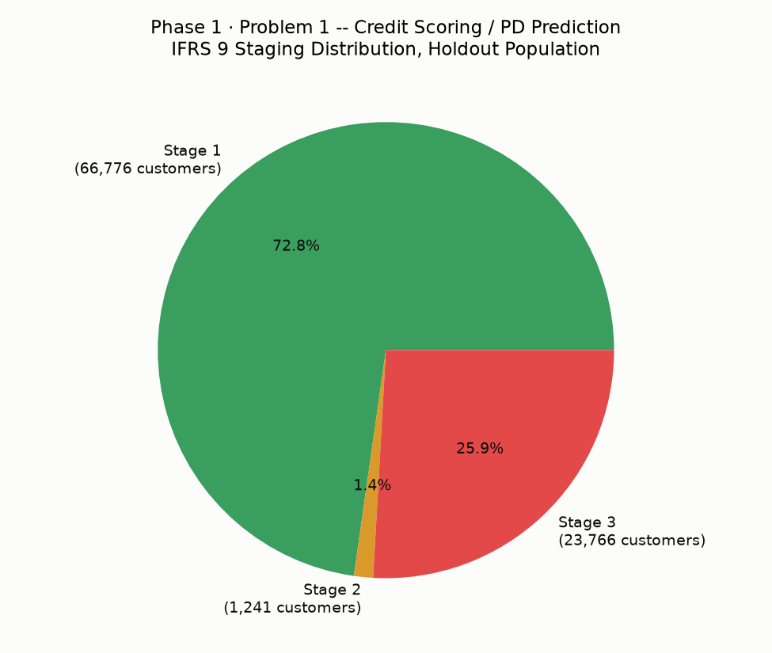
Stage | Customers | Avg PD | Total ECL
1 | 66,776 | 0.0770 | $11,565,156
2 | 1,241 | 0.8602 | $2,792,250
3 | 23,766 | 0.7370 | $53,473,500
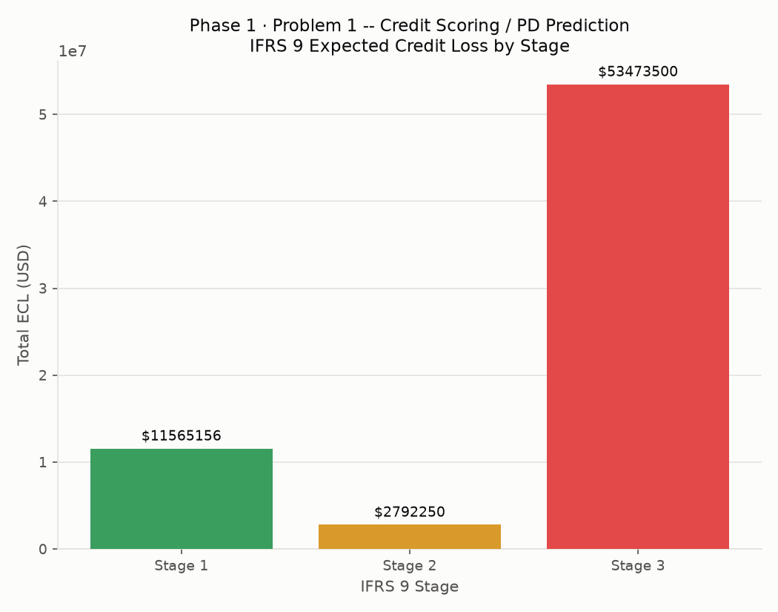

5. Basel vs. IFRS 9 Reconciliation
Total required regulatory capital (unexpected-loss buffer, 99.9% confidence): $21,382,660. Total IFRS 9 ECL (accounting provision, expected loss): $67,830,906. These measure different things by design -- capital covers UNEXPECTED loss at a high confidence level, while ECL provisions for EXPECTED loss. The gap of $-46,448,246 is the expected shape of this comparison.

6. Regulatory Documentation & Disclosure Checklist
Dimension | Status | Evidence
Pillar 1 IRB Capital Calculation (QRRE formula) | Pass | Computed live for 91,783 holdout customers, this run
PD Model Validation (SR 11-7 / MRM) | Pass | Notebook 07 risk tier: Tier 2 (Medium)
LGD Estimation | Assumption Only -- Needs Institution-Specific Estimate | Stated benchmark 45%; dataset has no real recovery-rate data
EAD Estimation | Assumption Only -- Needs Institution-Specific Estimate | Stated benchmark $5,000/account; dataset has no real credit-limit data
IFRS 9 Staging Criteria (SICR) | Illustrative Only -- Needs PD Term Structure | Backtest-style proxy using known holdout outcomes -- see Section 8 limitation note
ECL Model Documentation | Pass | ecl_staging_summary.csv, this run -- total ECL $67,830,906
Capital Adequacy Reporting | Pass | capital_adequacy_summary.csv -- total required capital $21,382,660
Pillar 3 Disclosure Readiness | Partial -- Needs Institution Sign-off | Quantitative tables ready; narrative disclosure requires Compliance review
Fair-Lending / Disparate-Impact Review | Pending | Deferred to Notebook 07's governance checklist / dedicated fair-lending review

7. Model Performance Basis
