AMEX Enterprise Credit Risk Platform
Comprehensive Reporting -- Master Platform Rollup (Notebook 17)
Generated: 2026-08-23 23:33
Platform status: COMPLETE

1. Project At A Glance
Every value below is read live from that pillar's own summary artifact this run -- a pillar that has not yet been run simply contributes nothing here, rather than a fabricated placeholder.
Champion Model | xgboost
Champion Holdout Amex Metric | 0.7936
Champion Holdout Auc | 0.962
Model Risk Tier | Tier 2 (Medium)
Total Rwa Usd | 203644379.53916728
Total Required Capital Usd | 21382659.851612568
Total Ifrs9 Ecl Usd | 67830905.87421922
Inference P99 Latency Ms | 11.58
Batch Throughput Rows Per Sec | 345612.0
Live Api Self Test Passed | True
Dockerfile Lint All Passed | True
Monitoring Alerts This Run | 0
Monitoring Watch This Run | 0
Base 5Yr Roi Pct | 86476.67
Base 5Yr Net Benefit Usd | 1134573962.46
Required Replicas | 1
Monthly Infra Cost Usd | 198.8
Core Pipeline Completion Pct | 100.0
Platform Status | COMPLETE

2. Core Pipeline Completion
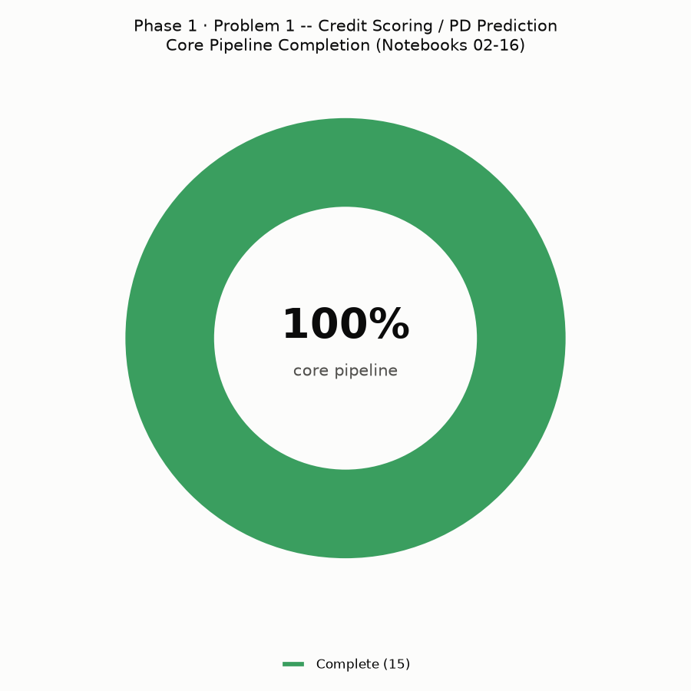
15 of 15 core pipeline notebooks (02-16) have produced a real summary artifact.

3. Per-Notebook Status (All 18 Notebooks)
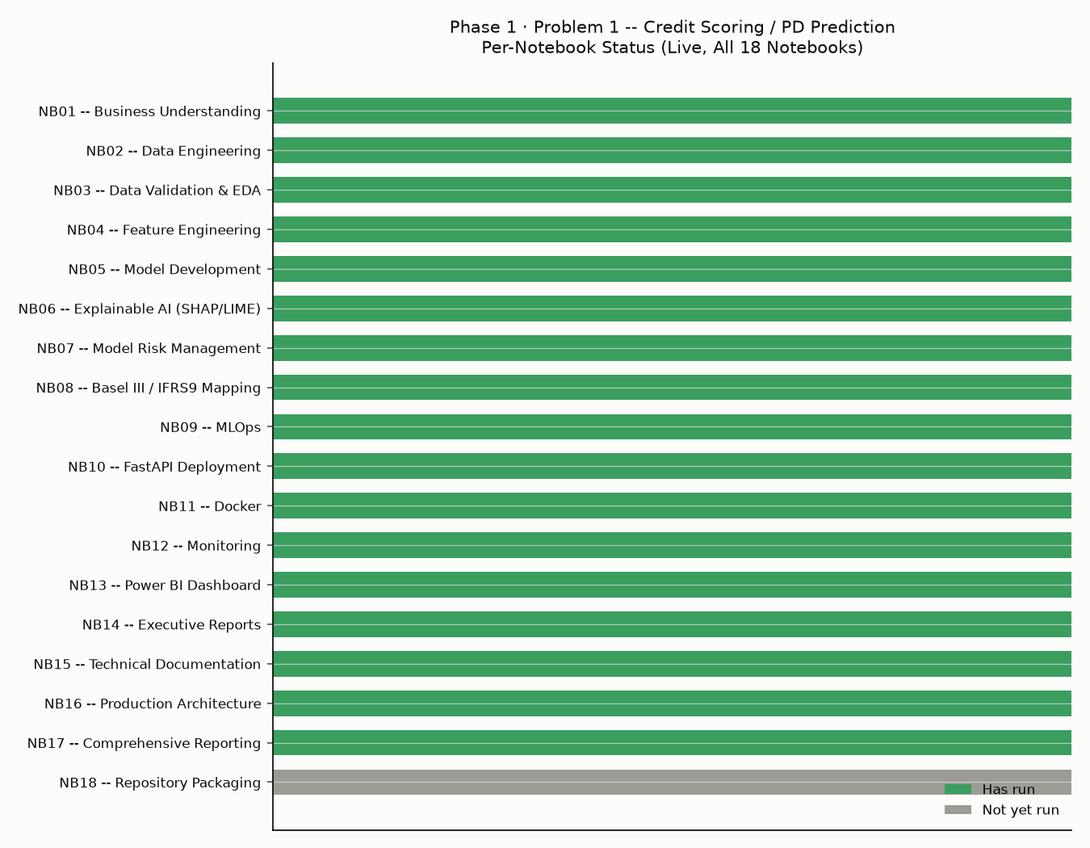
N | Notebook | Crisp Dm Stage | Has Run
1 | Business Understanding | Business Understanding | True
2 | Data Engineering | Data Preparation | True
3 | Data Validation & EDA | Data Understanding | True
4 | Feature Engineering | Data Preparation | True
5 | Model Development | Modeling | True
6 | Explainable AI (SHAP/LIME) | Evaluation | True
7 | Model Risk Management | Evaluation / Governance | True
8 | Basel III / IFRS9 Mapping | Evaluation / Regulatory | True
9 | MLOps | Deployment | True
10 | FastAPI Deployment | Deployment | True
11 | Docker | Deployment | True
12 | Monitoring | Deployment / Ongoing Monitoring | True
13 | Power BI Dashboard | Deployment / Business Intelligence | True
14 | Executive Reports | Deployment / Business Reporting | True
15 | Technical Documentation | Deployment / Documentation | True
16 | Production Architecture | Deployment / Architecture | True
17 | Comprehensive Reporting | Deployment / Rollup | True
18 | Repository Packaging | Deployment / Packaging | False

4. Per-Notebook Detailed Rollup
Real key findings extracted from each notebook's own summary artifact via a schema-aware extractor written specifically for that notebook's real output shape.

4.1. Notebook 02 -- Data Engineering
Metric | Value
Train CSV | 16.39 GB -> 458,913 customers (191.0s)
Test CSV | 33.82 GB -> 924,621 customers (574.9s)
Live default rate (join validation) | 25.89%
Internal train/test split | 80%/20% stratified by target, seed 42

4.2. Notebook 03 -- Data Validation & EDA
Metric | Value
Validation status | PASS
Checks passed | 7 / 7
Charts produced | 4
Reports produced | 4

4.3. Notebook 04 -- Feature Engineering
Metric | Value
Trend features (numeric cols covered) | 177
Ratio features created | 531
Interaction features created | 10
Final engineered train shape | [458913, 1806]
Top new feature by correlation | D_55_trend_slope

4.4. Notebook 05 -- Model Development
Metric | Value
Models trained | logistic_regression, random_forest, extra_trees, hist_gradient_boosting, xgboost, lightgbm, catboost
Models skipped (not installed) | (none)
Champion model | xgboost
Champion holdout AUC (measured) | 0.962
Champion holdout AMEX metric (measured) | 0.7936
CV folds | 5

4.5. Notebook 06 -- Explainable AI (SHAP/LIME)
Metric | Value
Champion model explained | xgboost
SHAP installed / explainer used | True / TreeExplainer (exact, tree-structure-based -- champion is xgboost)
LIME installed | True
Top SHAP features | P_2_last, interaction_P_2_last_x_B_2_last, interaction_P_2_last_x_B_18_last, B_1_last, B_11_last
SHAP vs Notebook 05 importance rank correlation (Spearman) | 0.7268

4.6. Notebook 07 -- Model Risk Management
Metric | Value
Champion validated | xgboost
PSI significant-shift features (measured) | 0
Rank-ordering inversions (measured) | 0
Assigned model risk tier | Tier 2 (Medium)
GPU used for sensitivity analysis | True

4.7. Notebook 08 -- Basel III / IFRS9 Mapping
Metric | Value
Champion (PD source) | xgboost
Measured portfolio avg PD | 25.85%
Total RWA (computed) | $203,644,380
Total required regulatory capital (computed) | $21,382,660
Total IFRS9 ECL (computed) | $67,830,906
IFRS9 stage counts | {'1': 66776, '2': 1241, '3': 23766}
LGD assumption (editable) | 45.00%

4.8. Notebook 09 -- MLOps
Metric | Value
Champion registered | xgboost v1
Registered model SHA256 (first 12 chars) | 253726312ba0
Inference p99 latency (measured) | 11.58 ms
Batch throughput (measured) | 345,612 rows/sec

4.9. Notebook 10 -- FastAPI Deployment
Metric | Value
Champion served | xgboost
Live API self-test | PASSED
API p99 latency (measured) | 67.49 ms

4.10. Notebook 11 -- Docker
Metric | Value
Docker CLI found this run | True
Docker daemon reachable this run | False
Real docker build ran | False
Measured image size | n/a (no daemon reachable)
Dockerfile lint | ALL PASSED

4.11. Notebook 12 -- Monitoring
Metric | Value
Champion model | xgboost
Simulated monitoring windows | 6
Alerts / Watch this run | 0 / 0
Windows with an ALERT | (none)
PSI significant-shift threshold (assumption) | 0.25

4.12. Notebook 13 -- Power BI Dashboard
Metric | Value
Champion model | xgboost
Fact table rows (real, from holdout) | 91,783
Risk tier bands (ASSUMPTION) | [{'risk_tier': 'Prime', 'tier_order': 1, 'pd_lower': 0.0, 'pd_upper': 0.05, 'description': 'ASSUMPTION -- lowest-risk band; typically auto-approved'}, {'risk_tier': 'Near-Prime', 'tier_order': 2, 'pd_lower': 0.05, 'pd_upper': 0.15, 'description': 'ASSUMPTION -- approved with standard terms'}, {'risk_tier': 'Subprime', 'tier_order': 3, 'pd_lower': 0.15, 'pd_upper': 0.35, 'description': 'ASSUMPTION -- approved with risk-adjusted pricing / limits, or manual review'}, {'risk_tier': 'High Risk', 'tier_order': 4, 'pd_lower': 0.35, 'pd_upper': 1.01, 'description': 'ASSUMPTION -- typically declined or requires senior underwriter override'}]
Model version dimension source | model_registry.json (1 version(s))
Monitoring window dimension source | monitoring_windows_report.csv (6 window(s), Notebook 12's own real computation)

4.13. Notebook 14 -- Executive Reports
Metric | Value
Champion (measured) | xgboost
Measured holdout AMEX metric | 0.7936
Measured holdout top-4% capture | 0.663
Live portfolio default rate (measured) | 25.89%
Total one-time investment (ASSUMPTION) | $421,000
Monthly recurring cost (ASSUMPTION) | $16,500
Base-scenario 5yr ROI | 86477%
Base-scenario 5yr net benefit | $1,134,573,962

4.14. Notebook 15 -- Technical Documentation
Metric | Value
Notebooks with a summary found (at Notebook 15's own run time) | [2, 3, 4, 5, 6, 7, 8, 9, 10, 11, 12, 13, 14]
Data dictionary features documented | 1804
API endpoints documented | 3
Model versions documented | 1
Total platform files (live scan) | 132

4.15. Notebook 16 -- Production Architecture
Metric | Value
Technology stack layers built | 10 / 12
Required replicas (real capacity sizing) | 1
SLA met by measured latency | True
Estimated monthly infra cost | $199

5. Comprehensive Reporting Readiness Checklist
Dimension | Status | Evidence
Notebook Architecture Map Built | Pass | 18 notebooks mapped
Core Pipeline Completion Tracked (Live) | Pass | 15/15 core notebooks found (100.0%)
Schema-Aware Per-Notebook Rollup | Pass | 75 rollup rows across 15 extractors
Extraction Ran Without Silent Failures | Pass | 0 fallbacks
Project-At-A-Glance KPI Panel | Pass | 19 KPIs populated
Completion & Pillar Status Charts | Pass | 2 charts generated

