AMEX Enterprise Credit Risk Platform
Docker Deployment Report -- Notebook 11
Generated: 2026-08-23 22:24

1. Docker Availability (This Run)
Docker Cli Found | True
Daemon Reachable | False
Build Ran | False
Build Seconds | None
Image Size Mb | None
Note | Docker CLI is installed but no daemon is reachable (Docker Desktop is not running, or this environment has no Docker daemon). Skipping the real build -- see the manual build command in the Word report instead.
- To build and run this image yourself once Docker Desktop is available:
- cd C:\Users\rnand\Downloads\amex-default-prediction\AMEX_Enterprise_Credit_Risk_Platform\Docker
- docker build -t amex-pd-api:latest .
- docker run -p 8000:8000 -e AMEX_PROJECT_ROOT=/mnt/amex-project -v C:\Users\rnand\Downloads\amex-default-prediction\AMEX_Enterprise_Credit_Risk_Platform:/mnt/amex-project:ro amex-pd-api:latest

2. Dockerfile Structural Lint
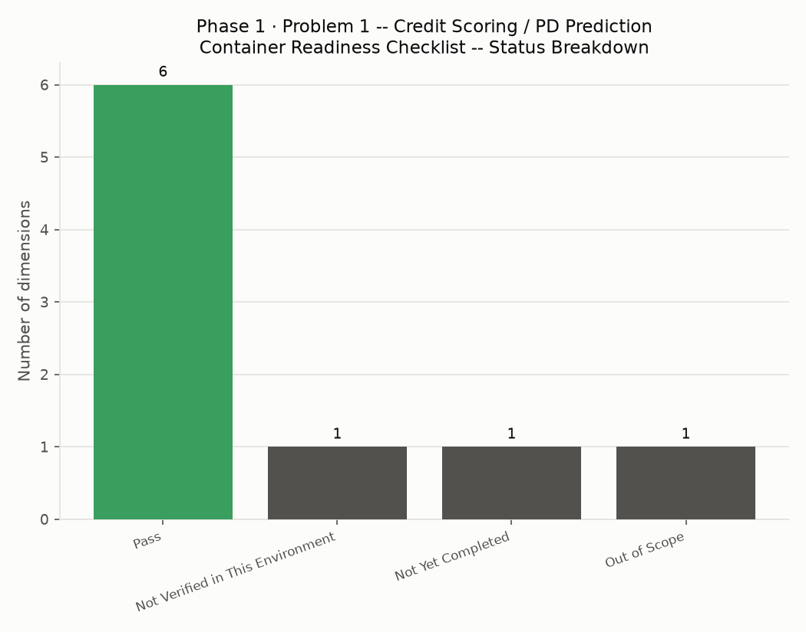
Has From | True
Has Workdir | True
Has Expose | True
Has Cmd | True
Has Healthcheck | True
Runs As Non Root | True
Uses Slim Base Image | True
No Pip Cache Bloat | True
No Hardcoded Secrets | True

3. Container Readiness Checklist
Dimension | Status | Evidence
Dockerfile Generated | Pass | Dockerfile, 12 instructions
Dockerfile Structural Lint | Pass | 9/9 checks passed
Runs as Non-Root User | Pass | USER amexapi
Healthcheck Defined | Pass | HEALTHCHECK against /health
docker-compose.yml Generated & Valid | Pass | docker-compose.yml
Real Docker Build Verified | Not Verified in This Environment | Docker CLI is installed but no daemon is reachable (Docker Desktop is not running, or this environment has no Docker daemon). Skipping the real build -- see the manual build command in the Word report instead.
Model/Artifacts Mounted, Not Baked Into Image | Pass | docker-compose.yml mounts AMEX_PROJECT_ROOT_HOST as a read-only volume
Container Registry Push | Not Yet Completed | Configure your registry target in ci_cd_pipeline.yml (Notebook 09)
Production Orchestration (Kubernetes/ECS/etc.) | Out of Scope | This platform delivers a single-container image; orchestration is an infrastructure-team decision

4. Files Generated
- Dockerfile
- docker-compose.yml
- .dockerignore

