AMEX Enterprise Credit Risk Platform
Financial Impact Report & SMART Team Recommendations -- Notebook 14 (Executive Reports)
Generated: 2026-08-23 23:08
IMPORTANT: this report combines two different kinds of numbers. Champion model performance (holdout AUC, AMEX metric, Top-4% capture) and the live portfolio default rate are MEASURED -- computed by this platform's own code from the real Kaggle AMEX data. Every dollar figure (portfolio size, costs, revenue-per-account, staffing) rests on an explicit, stated ASSUMPTION -- the Kaggle dataset contains no real financial data for any institution. This is a worked financial-impact METHODOLOGY with editable inputs, not investment, accounting, or regulatory-capital advice, and not a substitute for your own institution's real financial figures.

1. Executive Summary
Deploying the xgboost champion model (measured holdout AMEX metric 0.7936, Top-4% default capture 66.3%) into the stated hypothetical production scenario below is modeled to require $421,000 in one-time investment plus $16,500/month ongoing, reaching payback in 7 months and a 5-year cumulative net benefit of $1,134,573,962 (base scenario; see Section 5 for conservative/optimistic variants).

2. Methodology & Assumptions
- MEASURED inputs (computed live by this platform's notebooks):
Champion Model | xgboost
Holdout Auc | 0.9620
Holdout Amex Metric | 0.7936
Holdout Top4Pct Capture | 66.3048%
Live Portfolio Default Rate | 25.8934%
Measured From | notebook_05_summary.json; train_labels.csv (this run)
- ASSUMPTION inputs (stated, editable -- Sections 4-5 of the notebook):
Deployment Portfolio Size Accounts | 2,000,000
Avg Exposure At Default Usd | 3,500
Legacy Model Top4Pct Capture Rate | 25.00%
Collections Intervention Success Rate | 35.00%
New Applicants Per Year | 400,000
Incremental Approval Rate | 3.00%
Avg Annual Net Interest Margin Per Account Usd | 220

3. Investment Breakdown
Category | Amount (USD)
Data Science / ML Engineering (4 FTE x 4 months) | $224,000
Independent Model Risk Validation (1 FTE x 6 weeks) | $24,000
Compliance & Legal Review (Basel/IFRS9, fair-lending sign-off) | $40,000
MLOps / Platform Engineering (2 FTE x 3 months) | $78,000
Change Management & Staff Retraining | $30,000
Cloud Infrastructure Setup & Initial Compute | $25,000
Total one-time investment: $421,000
Total monthly recurring cost post go-live: $16,500/month
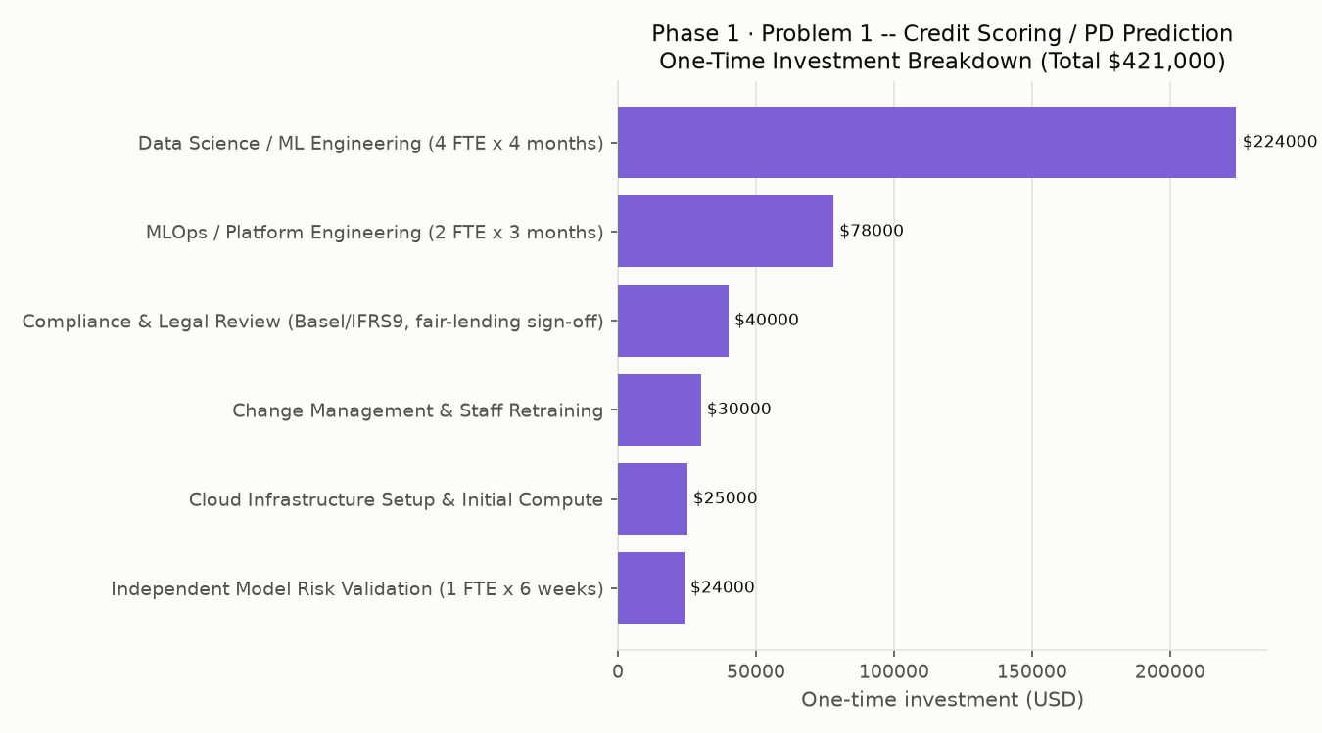

4. Financial Projections (Base Scenario)
Horizon | Cumulative Cost | Cumulative Benefit | Cumulative Net | ROI %
1 Month | $70,167 | $0 | $-70,167 | -100%
3 Months | $210,500 | $0 | $-210,500 | -100%
6 Months | $421,000 | $0 | $-421,000 | -100%
1 Year | $520,000 | $77,196,133 | $76,676,133 | 14745%
2 Years | $718,000 | $341,868,591 | $341,150,591 | 47514%
3 Years | $916,000 | $606,541,048 | $605,625,048 | 66116%
5 Years | $1,312,000 | $1,135,885,962 | $1,134,573,962 | 86477%
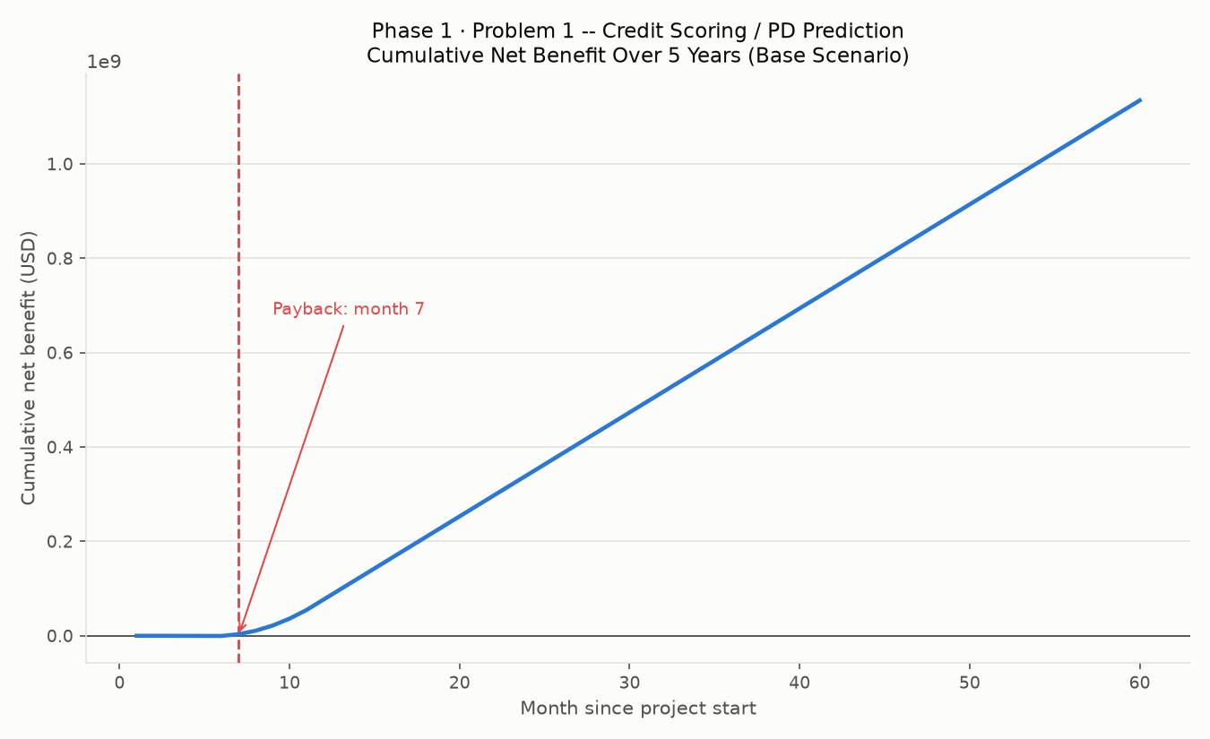
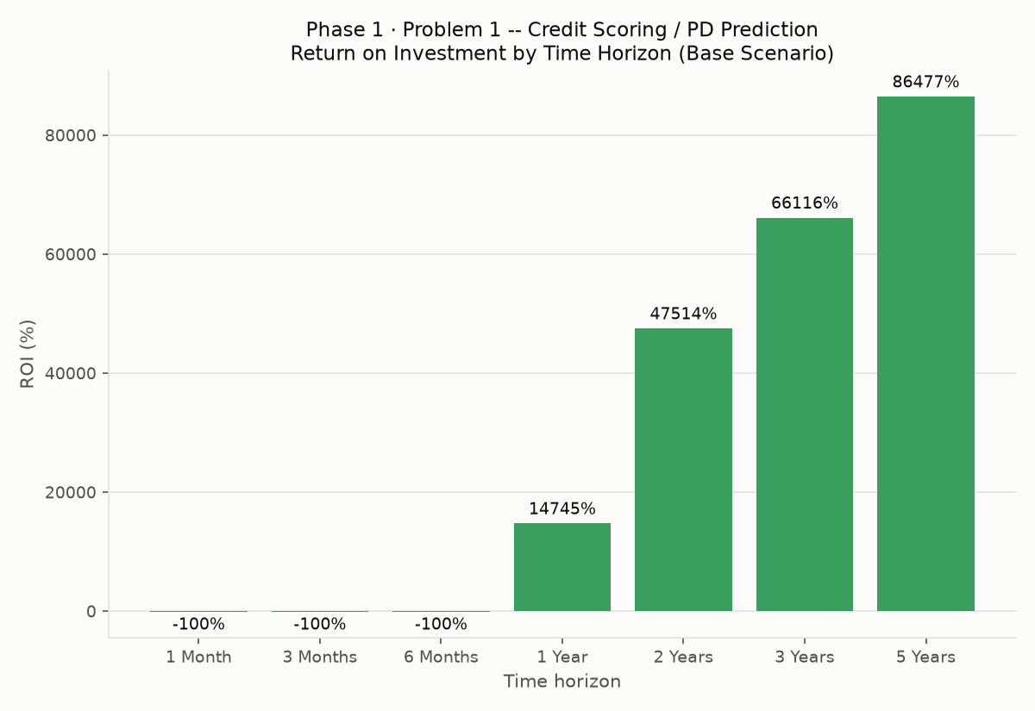
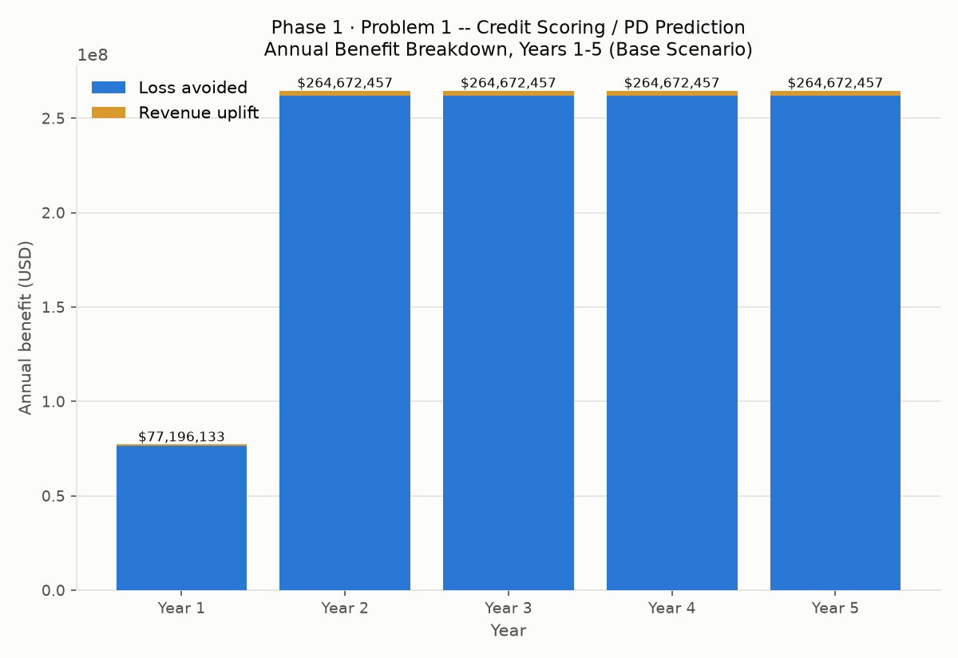

5. Scenario Comparison (Conservative / Base / Optimistic)
Scenarios scale the BENEFIT side only (conservative x0.7, base x1.0, optimistic x1.3) -- costs are held fixed across scenarios since they represent up-front staffing/infrastructure commitments, not outcomes that vary with deployment performance.
Scenario | 5-Year Net Benefit | 5-Year ROI % | Payback (months)
Conservative | $793,808,174 | 60504% | 7
Base | $1,134,573,962 | 86477% | 7
Optimistic | $1,475,339,751 | 112450% | 7

6. Model Performance Basis (Measured)
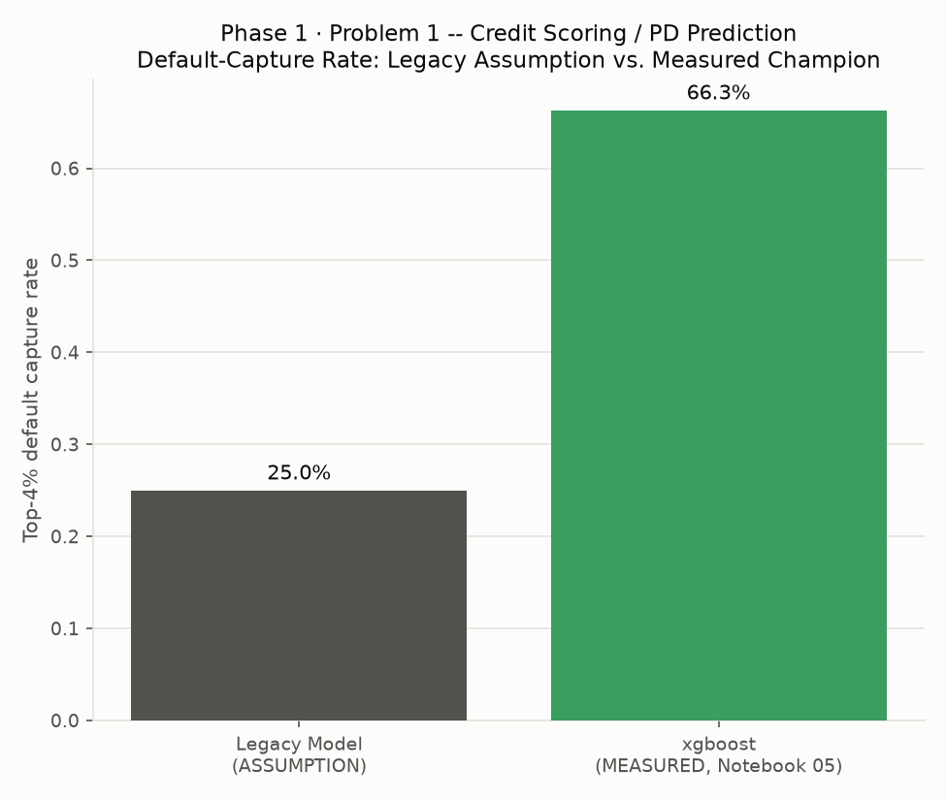
The financial case's loss-avoidance component depends on the measured improvement in Top-4% default capture over the assumed legacy baseline: +41.30% percentage points.

7. Implementation Timeline
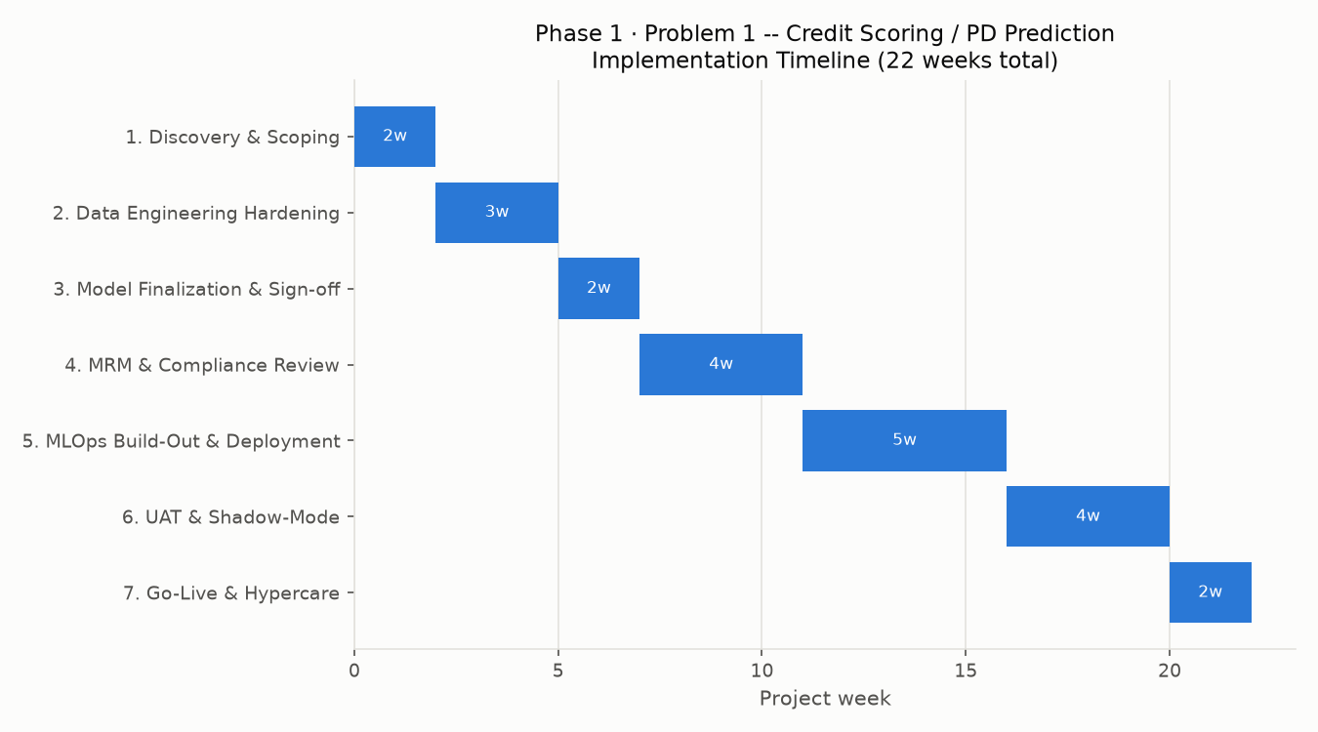
Phase | Start Week | Duration (weeks)
1. Discovery & Scoping | 0 | 2
2. Data Engineering Hardening (productionize Notebooks 02/04 pipelines) | 2 | 3
3. Model Finalization & Sign-off (Notebook 05) | 5 | 2
4. Model Risk Validation & Compliance Review (Notebooks 07/08) | 7 | 4
5. MLOps Build-Out & Deployment (Notebooks 09-11) | 11 | 5
6. UAT & Shadow-Mode Parallel Run | 16 | 4
7. Go-Live & Hypercare | 20 | 2
Total implementation duration: 22 weeks (~5.1 months)

8. Ongoing Monitoring Cost
$16,500/month post go-live, covering cloud hosting/inference, MRM oversight, and amortized quarterly retraining (breakdown in Section 5's monthly recurring cost table).

9. SMART Recommendations by Team

Executive Leadership / CRO
Specific | Approve production deployment funding based on the modeled 5-year net benefit.
Measurable | 5-year cumulative net benefit $1,134,573,962, ROI 86477%, payback in 7 months (base scenario).
Achievable | Champion model measured holdout AMEX metric 0.7936, a real, validated result from Notebook 05.
Relevant | Portfolio-wide default exposure and capital adequacy are the CRO's direct mandate.
Time Bound | Funding decision within 1 sprint of this report; re-review assumptions annually.

Head of Credit Risk / Underwriting
Specific | Replace the legacy scorecard's top-4% flagging logic with the new champion model's output.
Measurable | Measured Top-4% default capture improves from an assumed 25% (legacy) to 66.3% (new model, measured).
Achievable | No new data collection required -- Notebook 05's model scores directly on the existing feature store.
Relevant | Directly drives the loss-avoided component of the financial case.
Time Bound | Cutover during Phase 5-6 of the implementation plan (weeks 11-20).

Model Risk Management / Independent Validation
Specific | Complete (or re-confirm) SR 11-7-style independent validation before go-live.
Measurable | Notebook 07 assigned risk tier 'Tier 2 (Medium)'.
Achievable | Notebook 07 runs PSI, rank-ordering, sensitivity, and challenger-benchmark checks directly against Notebook 05's saved champion.
Relevant | Regulatory and internal governance prerequisite for any credit-decisioning model.
Time Bound | Must complete during Phase 4 (Model Risk Validation & Compliance Review) before Phase 5 begins.

Compliance / Regulatory Affairs
Specific | Complete Basel III / IFRS 9 capital-treatment mapping and fair-lending review.
Measurable | 0 feature(s) flagged with significant population shift (Notebook 07).
Achievable | Notebook 08 (Basel III / IFRS 9 Mapping) produces the required documentation trail.
Relevant | Deployment cannot proceed at a regulated card issuer without this sign-off.
Time Bound | Complete within Phase 4, in parallel with Model Risk Management.

Collections Operations
Specific | Build the intervention workflow (outreach, credit-line adjustment) for accounts newly flagged by the improved model.
Measurable | Assumed 35% intervention success rate drives $262,032,457/year in modeled loss avoidance -- track actual realized success rate against this assumption post go-live.
Achievable | Workflow changes only, no new systems required beyond the model's output feed.
Relevant | Realizing the loss-avoided benefit depends entirely on Collections actually acting on the model's flags.
Time Bound | Operational by end of Phase 6 (UAT & Shadow-Mode).

Data Engineering
Specific | Productionize the Notebook 02/04 Polars feature-store pipeline for daily/real-time scoring.
Measurable | Pipeline must reproduce the same feature set the champion model was trained on (see Notebook 04's engineered feature columns).
Achievable | Pipeline already exists and runs end-to-end in this platform; this is a hardening/scheduling task, not new development.
Relevant | Every downstream number in this report assumes the production feature set matches what Notebook 05 trained on.
Time Bound | Complete during Phase 2 (weeks 2-5).

MLOps / Platform Engineering
Specific | Stand up the FastAPI scoring service, Docker packaging, and monitoring pipeline (Notebooks 09-12).
Measurable | Monthly recurring cost budget: $16,500/month post go-live (assumption, Section 5).
Achievable | Architecture and monitoring triggers (PSI > 0.25) are already defined in this platform's governance docs.
Relevant | Deployment reliability and drift monitoring directly protect the modeled financial benefit from decaying silently.
Time Bound | Complete during Phase 5 (weeks 9-14).

Card Issuing / Product Business Unit
Specific | Adjust approval-policy thresholds to capture the modeled incremental-approval opportunity.
Measurable | $2,640,000/year modeled revenue uplift from a stated 3%-point increase in approvals among 400,000 assumed annual applicants.
Achievable | Requires only a policy-threshold change once the new model's calibration is validated (Notebook 07).
Relevant | New-business revenue is the second major component of the financial case, alongside loss avoidance.
Time Bound | Threshold change effective at go-live (Phase 7).

Finance / CFO Office
Specific | Track realized costs and benefits against this report's modeled figures on a monthly cadence.
Measurable | Total one-time investment $421,000; monthly recurring $16,500; base-scenario payback at month 7.
Achievable | monthly_financial_model.csv (this notebook's own output) gives a ready-made tracking template.
Relevant | Validates or corrects this report's assumptions with real realized figures as they become available.
Time Bound | First realized-vs-modeled variance review at month 3 post go-live, then quarterly.

External Regulator Engagement (e.g. Federal Reserve / OCC)
Specific | Maintain the full documentation trail (Notebooks 01, 05, 07, 08, 14) as supervisory evidence.
Measurable | 9 governance dimensions tracked in Notebook 07's checklist -- current tier: Tier 2 (Medium).
Achievable | Every document already exists as a notebook output; no new artifact type required.
Relevant | SR 11-7 / OCC 2011-12 examinations expect exactly this kind of end-to-end evidentiary trail.
Time Bound | Documentation package finalized before go-live (end of Phase 6).

10. Limitations & Disclaimers
- All dollar figures rest on the stated hypothetical scenario in Sections 4-5, not real AMEX financials -- the Kaggle dataset contains no revenue, cost, or investment data for any institution.
- This report is a worked methodology with editable assumption constants, not investment, accounting, tax, or regulatory advice. Consult your institution's finance, actuarial, and compliance functions before acting on any figure in this report.
- Benefit realization depends on operational execution (e.g. Collections actually acting on model flags) that this report cannot guarantee -- see the SMART recommendations above for the operational prerequisites.

