AMEX Enterprise Credit Risk Platform
FastAPI Deployment Report -- Notebook 10
Generated: 2026-08-23 22:14
This report documents a real, generated FastAPI scoring service that was actually run and tested in-process during this notebook's execution -- every check below reflects the live app's real behavior, not a description of intended behavior.

1. Service Overview
Champion Model | xgboost
Endpoints | /health, /model-info, /predict
Feature Count | 1804
Entry Point | main.py (uvicorn main:app)

2. Live Self-Test Results
A real holdout customer (000084e5023181993c2e1b665ac88dbb1ce9ef621ec5370150fc2f8bdca6202c) was scored through the live API and compared against a direct call to the champion model in the same process. API-returned PD: 0.006822. Directly-computed PD: 0.006822. Absolute difference: 0.00000000. This confirms the API's preprocessing is consistent with the model's real training-time preprocessing.

3. Latency Benchmark (Measured, This Run)
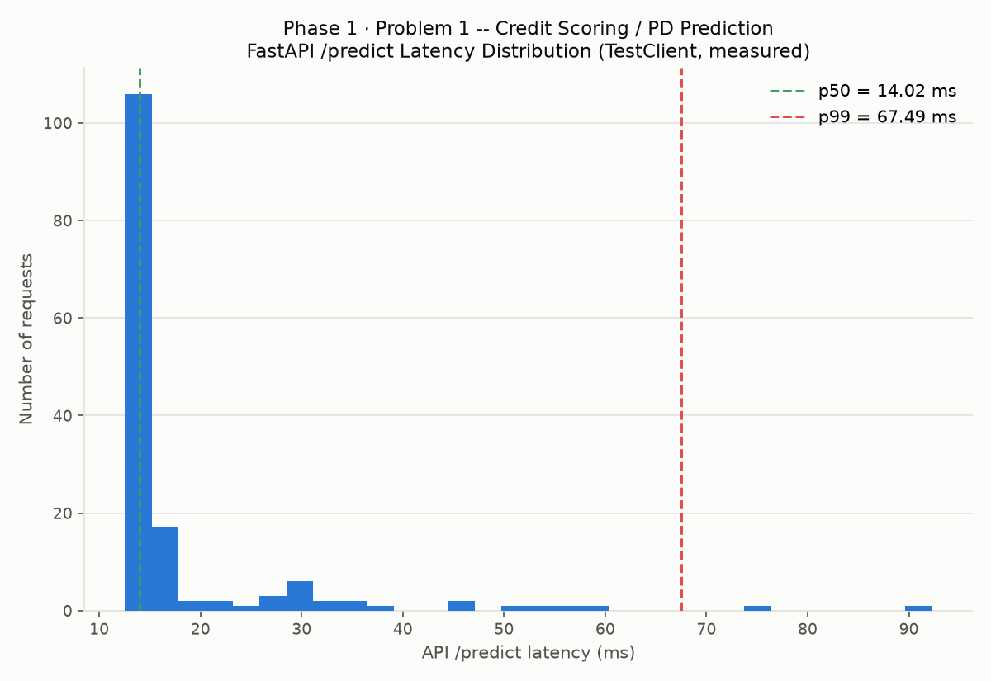
N Samples | 150
P50 Ms | 14.019
P95 Ms | 41.751
P99 Ms | 67.494
Max Ms | 92.295
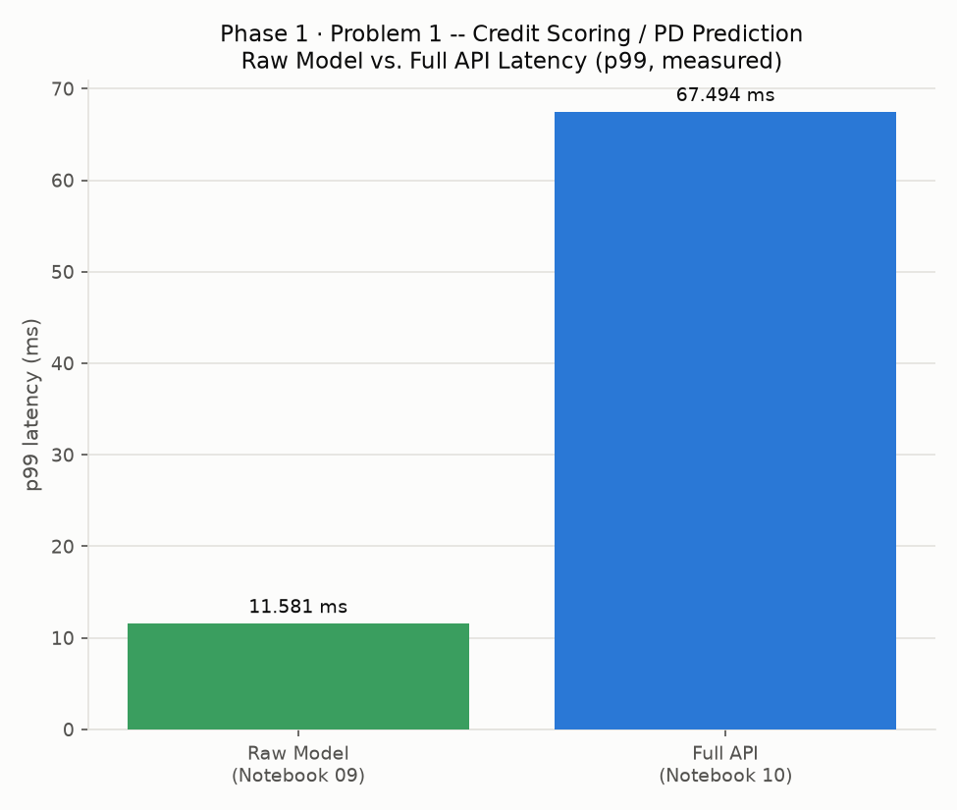

4. Deployment Readiness Checklist
Dimension | Status | Evidence
main.py Generated & Syntax-Checked | Pass | main.py, compiled clean
Live Self-Test (health/model-info/predict) | Pass | API vs. direct-model PD diff = 0.00000000
OpenAPI Spec Exported | Pass | 3 documented endpoints
API Latency Benchmarked | Pass | p99 67.49 ms, 150 requests
Environment Config Externalized (.env) | Pass | .env.example, this run
Minimal Runtime Requirements Pinned | Pass | requirements-api.txt, this run
Malformed-Request Handling | Pass | Unrecognized fields do not crash the endpoint
Containerization (Docker) | Not Yet Completed | Deferred to Notebook 11
Production Monitoring / Alerting | Not Yet Completed | Deferred to Notebook 12
Authentication / Rate Limiting | Not Implemented -- Add Before Internet-Facing Deployment | Out of scope for this platform; add an API gateway or FastAPI security dependency before exposing publicly

5. How to Run
- Copy .env.example to .env and adjust AMEX_PROJECT_ROOT if needed.
- pip install -r requirements-api.txt
- uvicorn main:app --host 0.0.0.0 --port 8000
- Visit http://localhost:8000/docs for interactive API documentation (auto-generated by FastAPI from the real OpenAPI spec).

