AMEX Enterprise Credit Risk Platform
MLOps: Model Card & Deployment Report -- Notebook 09
Generated: 2026-08-23 22:13

1. Model Details
Model Name | xgboost
Version | 1
Sha256 | 253726312ba06eee473b9696896dde66e238b132a3f1aabd4cd5bb9ab04c63e6
File Size Mb | 1.891
Feature Count | 1804

2. Intended Use
Predicts probability of default (PD) for American Express card customers, to support credit underwriting, pricing, and collections-prioritization decisions. NOT intended for use on applicant populations outside the training distribution (see Notebook 01's reject-inference limitation) without re-validation.

3. Training Data & Evaluation
Holdout Auc | 0.9620396555226549
Holdout Amex Metric | 0.7935631597243085
Holdout Top4Pct Capture | 0.6630480518387613
Model Risk Tier | Tier 2 (Medium)

4. Inference Performance (Measured, This Run)
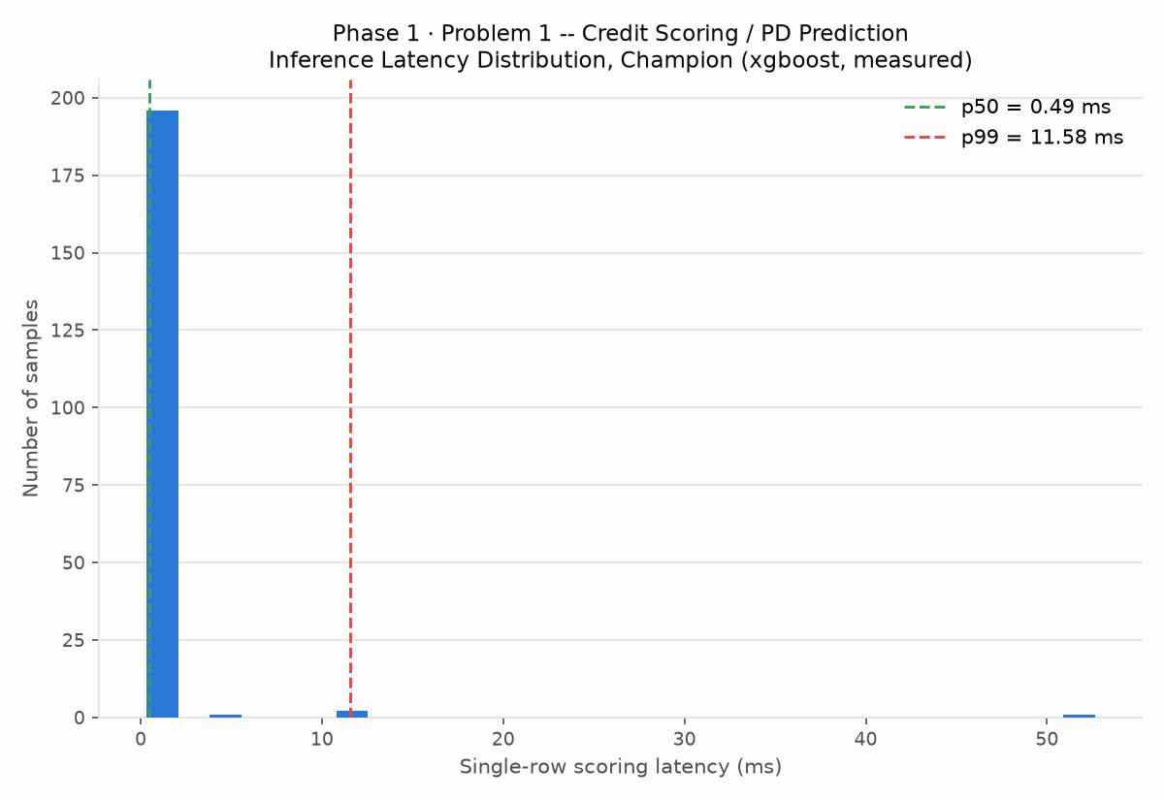
N Latency Samples | 200
Single Row P50 Ms | 0.4918
Single Row P95 Ms | 0.674
Single Row P99 Ms | 11.5809
Single Row Max Ms | 52.6358
Batch Rows Scored | 91783
Batch Seconds | 0.2656
Batch Throughput Rows Per Sec | 345611.7
Model Load Seconds | 0.0728
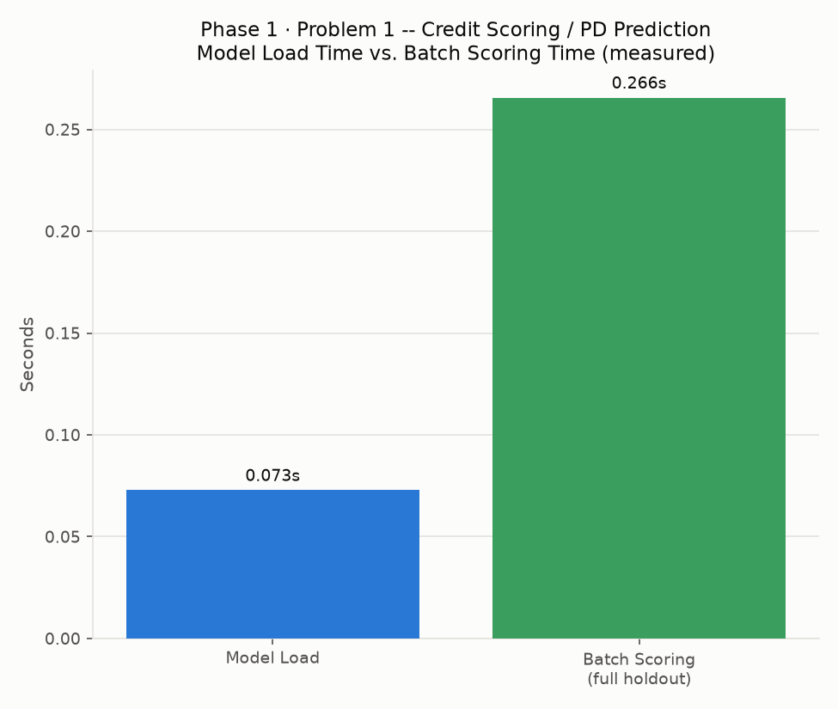

5. Ethical Considerations & Caveats
- The AMEX dataset is accepts-only (no rejected-applicant data) -- this model cannot by itself validate how a never-approved population would perform (Notebook 01).
- Fair-lending / disparate-impact testing is tracked in Notebook 07's governance checklist, not repeated here.
- This model card documents the CHAMPION model identified by Notebook 05's holdout AMEX metric ranking -- re-run Notebook 05 and this notebook together if the champion changes.

6. Deployment Readiness Checklist
Dimension | Status | Evidence
Model Registered with Integrity Hash | Pass | model_registry.json, SHA-256 253726312ba06eee...
Inference Latency Benchmarked | Pass | p99 11.58ms single-row, 345,612 rows/sec batch
Environment Snapshot Captured | Pass | requirements.txt, this run
CI/CD Pipeline Defined | Pass | ci_cd_pipeline.yml, this run
Automated Retraining Triggers Defined | Pass | retraining_trigger_policy.json, this run
Model Risk Validation (SR 11-7 / MRM) | Pass | Risk tier: Tier 2 (Medium)
Meets Stated Deployment Floor | Pass | AMEX metric 0.7935631597243085 vs floor 0.75
Scoring API Implementation (FastAPI) | Not Yet Completed | Deferred to Notebook 10
Containerization (Docker) | Not Yet Completed | Deferred to Notebook 11
Production Monitoring Configured | Not Yet Completed | Deferred to Notebook 12

7. Retraining Trigger Policy
- trigger_1_population_stability: PSI > 0.25 on any top-30 feature (Notebook 07) triggers mandatory review
Current status: 0 feature(s) currently over threshold
- trigger_2_rank_ordering: Any decile-to-decile rank-ordering inversion (Notebook 07) triggers review
Current status: 0 inversion(s) currently found
- trigger_3_performance_floor: Champion holdout AMEX metric falling below 0.75 (Notebook 01's stated floor) triggers immediate retraining
Current status: Current champion AMEX metric: 0.7935631597243085
- trigger_4_scheduled_cadence: Quarterly scheduled retraining regardless of drift signals (stated policy)
Current status: Scheduling is an operational/CI concern outside this notebook's scope -- see ci_cd_pipeline.yml

