AMEX Enterprise Credit Risk Platform
Monitoring Report -- Notebook 12
Generated: 2026-08-23 22:32

1. Scope & an Honest Limitation
This report operationalizes the two monitoring triggers Notebook 01's Risk Appetite Statement commits this platform to (Population Stability Index and default-rate swing), plus rank-ordering (AUC) tracking. The engineered feature store does not retain a per-customer calendar date at this aggregation stage, and there is no live production traffic yet -- so the windows below are a SIMULATED, illustrative partition of the real, held-out test split (91,783 customers, never trained on) into 6 sequential row-order batches. Every metric shown is a real, live computation on real data; only the 'these arrived over time' framing is illustrative.

2. Monitoring Thresholds
Psi Moderate Shift | 0.1
Psi Significant Shift | 0.25
Default Rate Swing Pp | 5.0
Min Acceptable Auc | 0.7

3. Population Stability Index -- Simulated Monitoring Windows
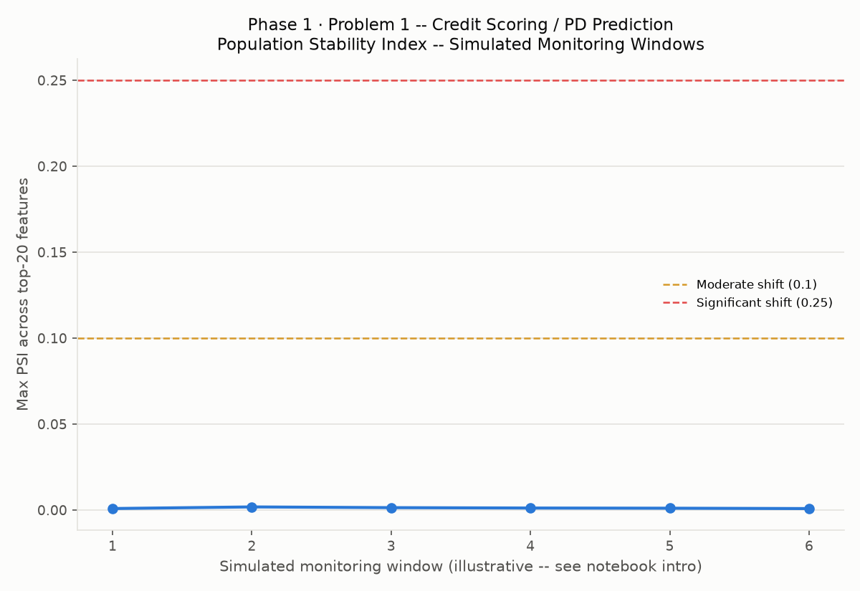

4. Default-Rate Drift vs. Training Baseline
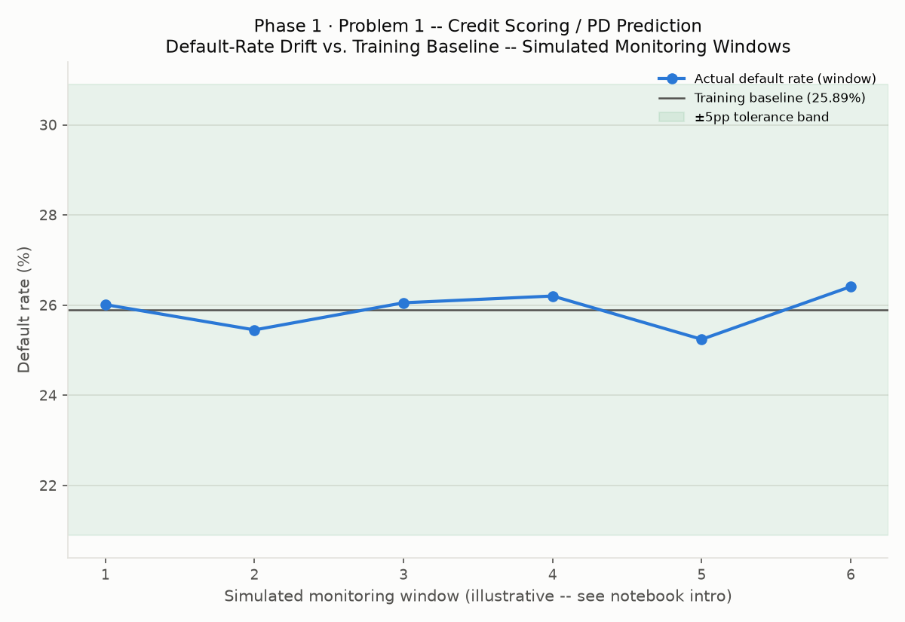

5. Rank-Ordering (AUC)
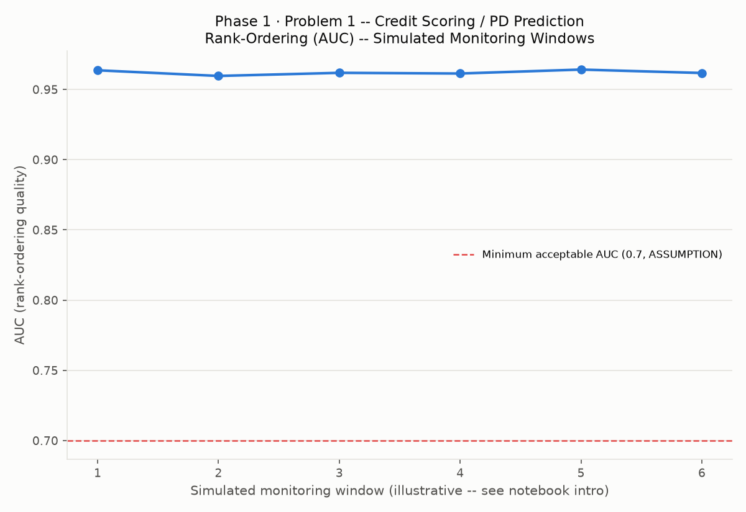

6. Alert Log
Window | Metric | Value | Status | Detail
1 | population_stability_index | 0.00089 | OK | max PSI across top-20 features; 0 feature(s) significant
2 | population_stability_index | 0.00183 | OK | max PSI across top-20 features; 0 feature(s) significant
3 | population_stability_index | 0.00141 | OK | max PSI across top-20 features; 0 feature(s) significant
4 | population_stability_index | 0.00119 | OK | max PSI across top-20 features; 0 feature(s) significant
5 | population_stability_index | 0.00108 | OK | max PSI across top-20 features; 0 feature(s) significant
6 | population_stability_index | 0.00087 | OK | max PSI across top-20 features; 0 feature(s) significant
1 | default_rate_swing_pp | 0.117 | OK | actual 26.0100% vs. training baseline 25.8933%
1 | rank_ordering_auc | 0.96365 | OK | AUC = 0.9637
2 | default_rate_swing_pp | -0.444 | OK | actual 25.4490% vs. training baseline 25.8933%
2 | rank_ordering_auc | 0.95962 | OK | AUC = 0.9596
3 | default_rate_swing_pp | 0.158 | OK | actual 26.0510% vs. training baseline 25.8933%
3 | rank_ordering_auc | 0.96184 | OK | AUC = 0.9618
4 | default_rate_swing_pp | 0.308 | OK | actual 26.2010% vs. training baseline 25.8933%
4 | rank_ordering_auc | 0.96135 | OK | AUC = 0.9614
5 | default_rate_swing_pp | -0.653 | OK | actual 25.2400% vs. training baseline 25.8933%
5 | rank_ordering_auc | 0.96416 | OK | AUC = 0.9642
6 | default_rate_swing_pp | 0.517 | OK | actual 26.4100% vs. training baseline 25.8933%
6 | rank_ordering_auc | 0.96172 | OK | AUC = 0.9617

7. Production Monitoring Job
monitoring_job.py (real, generated, syntax-validated -- see Section 13's verification below) is ready to schedule against future scored batches. Run: python monitoring_job.py --new-data-csv <path>

8. Monitoring Readiness Checklist
Dimension | Status | Evidence
PSI Trigger Implemented (Notebook 01 Risk Appetite) | Pass | psi_significant_shift=0.25, computed per window
Default-Rate Swing Trigger Implemented (Notebook 01 Risk Appetite) | Pass | default_rate_swing_pp=5.0, computed per window
Rank-Ordering (AUC) Tracked | Pass | 6/6 window(s) had both outcome classes
Alert Log Generated | Pass | 18 checks, 0 ALERT, 0 WATCH
Monitoring Baseline Persisted (for production use without full X_train) | Pass | monitoring_baseline.json
Schedulable monitoring_job.py Generated | Pass | monitoring_job.py
monitoring_job.py Executed Against a Real Live Batch | Not Verified in This Environment | No live production batch exists yet -- syntax-validated only (Section 13), see notebook intro
Alerting Escalation Path Configured | Not Yet Completed | ASSUMPTION placeholder in monitoring_config.json -- route to a real paging/ticketing system
Simulated-Window Caveat Documented | Pass | Stated in notebook intro, chart axis labels, and this report

