AMEX Enterprise Credit Risk Platform
Power BI Dashboard Report -- Notebook 13
Generated: 2026-08-23 23:07

1. Scope & an Honest Limitation
Power BI Desktop is a proprietary Windows GUI application with no Python library capable of producing a genuine, openable .pbix file -- this platform's standing rule is to never claim unsupported capability, so this notebook does not attempt to fabricate one. Instead it builds the real, import-ready data model (fact + dimension tables, CSV and Parquet), real DAX measures, a live-computed star schema diagram, and a static HTML preview of the intended report layout.

2. Data Model -- Import Instructions
- In Power BI Desktop: Home -> Get Data -> Text/CSV (or Parquet) -> select fact_customer_risk_scores.csv/.parquet.
- Repeat Get Data for dim_risk_tier.csv, dim_model_version.csv, and dim_monitoring_window.csv.
- In Model view, draw the relationships listed in Section 3 below (dim tables on the 'one' side).
- In Model view -> New Measure, paste each measure from dax_measures.dax.
- Build visuals against the measures and dimension columns -- risk tier, model version, and monitoring window are all natural slicers.

3. Star Schema Relationships (Live-Computed Cardinalities)
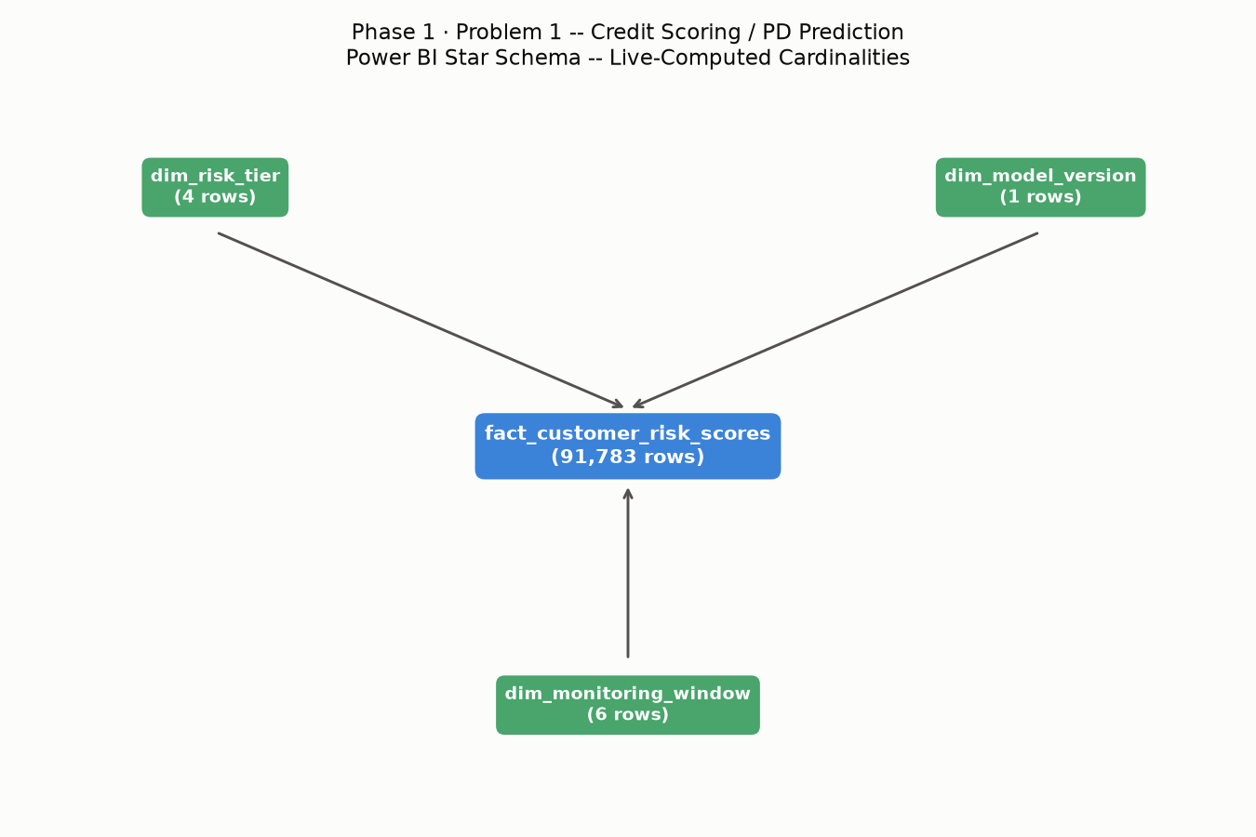
From Table | From Column | To Table | To Column | Cardinality
dim_risk_tier | risk_tier | fact_customer_risk_scores | risk_tier | 1:91,783
dim_model_version | version | fact_customer_risk_scores | model_version | 1:91,783
dim_monitoring_window | window | fact_customer_risk_scores | monitoring_window_id | 1:91,783

4. Risk Tier Distribution & Calibration (Real, Live-Computed)
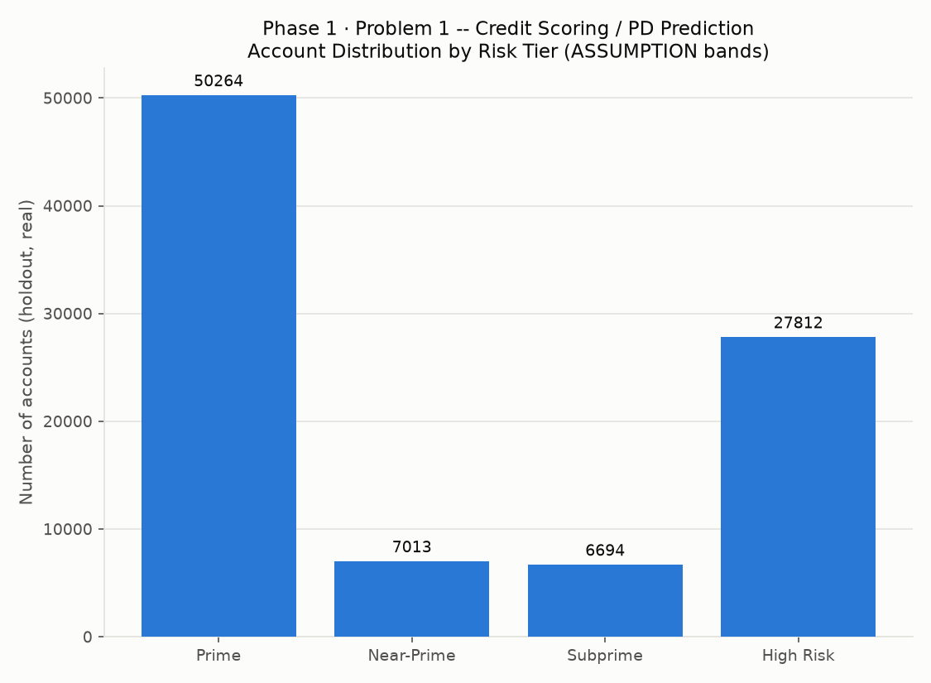
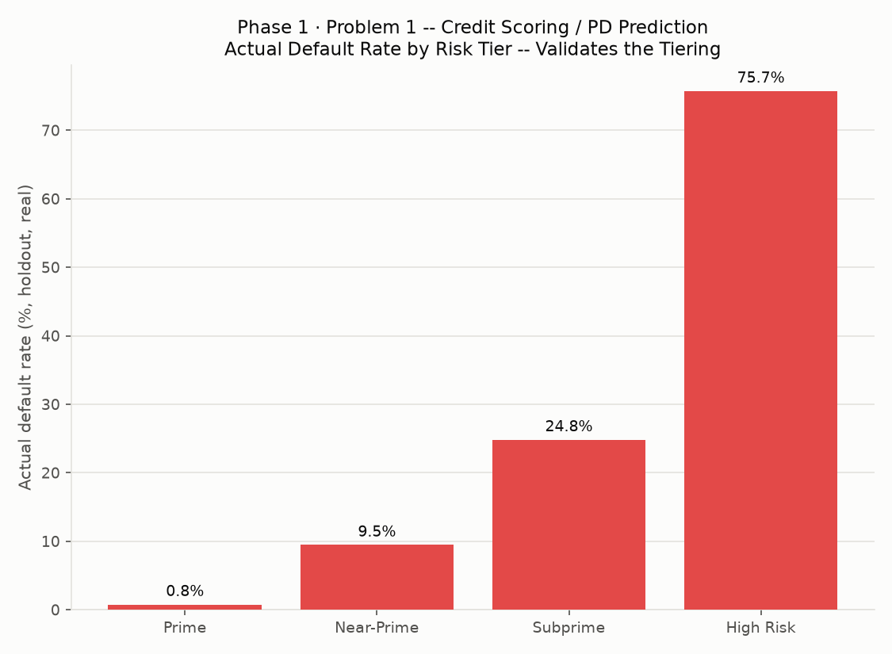
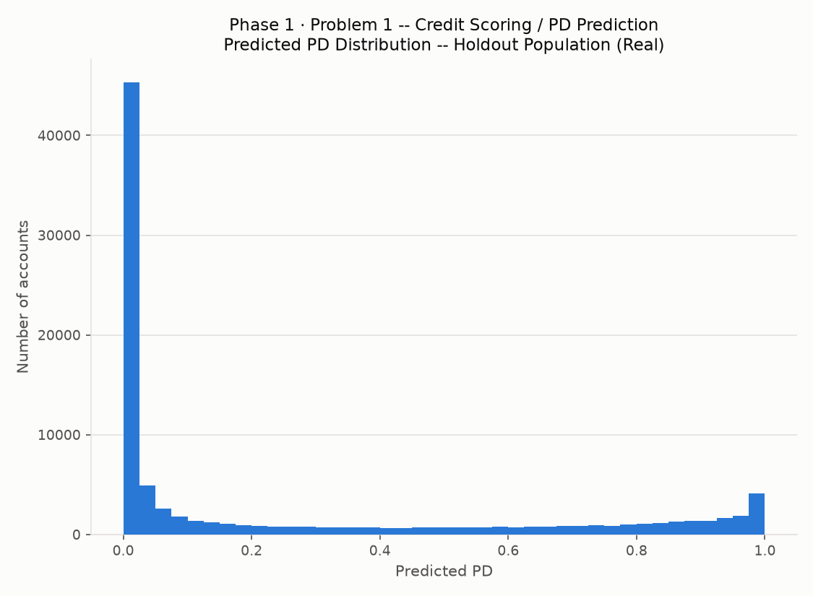

5. DAX Measures
Total Accounts = COUNTROWS(fact_customer_risk_scores)
Total Actual Defaults = SUM(fact_customer_risk_scores[actual_default])
Actual Default Rate = DIVIDE([Total Actual Defaults], [Total Accounts], 0)
Average Predicted PD = AVERAGE(fact_customer_risk_scores[predicted_pd])
High Risk Account Count = CALCULATE([Total Accounts], fact_customer_risk_scores[risk_tier] = "High Risk")
High Risk Share = DIVIDE([High Risk Account Count], [Total Accounts], 0)
Prime Share = DIVIDE(CALCULATE([Total Accounts], fact_customer_risk_scores[risk_tier] = "Prime"), [Total Accounts], 0)
Rank-Ordering Check (Avg PD by Tier) = AVERAGEX(VALUES(dim_risk_tier[risk_tier]), CALCULATE([Average Predicted PD]))
Model Calibration Gap = [Average Predicted PD] - [Actual Default Rate]

6. Power BI Readiness Checklist
Dimension | Status | Evidence
Fact Table Exported (CSV + Parquet) | Pass | fact_customer_risk_scores.csv, fact_customer_risk_scores.parquet
Dimension Tables Exported | Pass | dim_risk_tier, dim_model_version, dim_monitoring_window
Star Schema Relationships Documented | Pass | 3 relationship(s), live cardinalities
DAX Measures Written (Real, Valid Syntax) | Pass | dax_measures.dax, 9 measures
Real .pbix Built in Power BI Desktop | Not Yet Completed | Requires Power BI Desktop (Windows GUI app) -- this notebook cannot produce one, by design (see intro)
HTML Static Preview Generated | Pass | PowerBI_Dashboard_Preview.html
Risk-Tier Bands Documented as Assumption | Pass | PD_TIER_BANDS, editable
Model Version Dimension Linked to Notebook 09 | Pass | model_registry.json (1 version(s))
Monitoring Window Dimension Linked to Notebook 12 | Pass | monitoring_windows_report.csv (6 window(s), Notebook 12's own real computation)

