AMEX Enterprise Credit Risk Platform
Production Architecture Report -- Notebook 16
Generated: 2026-08-23 23:29

1. Technology Stack -- As-Built
Every row verified against a real file this platform actually wrote to disk this run.
Layer | Technology | Evidence File | Built
Data Engineering | Polars (streaming aggregation) | train_features.csv | False
Feature Engineering | Polars (trend/delta/ratio/interaction features) | train_split_engineered.csv | True
Model Training | scikit-learn / XGBoost / LightGBM / CatBoost | model_comparison.csv | True
Explainability | SHAP / LIME | notebook_06_summary.json | False
Model Risk Governance | PSI / rank-ordering / sensitivity validation | population_stability_index.csv | True
Regulatory Mapping | Basel III IRB (QRRE) / IFRS 9 staging | capital_adequacy_summary.csv | True
MLOps | Versioned model registry, GitHub Actions CI/CD | model_registry.json | True
Model Serving | FastAPI (self-tested via TestClient) | main.py | True
Containerization | Docker (python:3.11-slim, non-root) | Dockerfile | True
Production Monitoring | PSI + default-rate + AUC alerting, schedulable job | monitoring_job.py | True
Business Intelligence | Power BI star schema (CSV + Parquet) + DAX | fact_customer_risk_scores.parquet | True
Executive Reporting | Financial impact model + interactive HTML dashboard | Financial_Impact_Dashboard.html | True

2. Capacity Sizing
Scale inputs (portfolio size, daily scoring rate, peak ratio, SLA target) are stated, editable ASSUMPTIONs -- the dataset has no ground truth for production request volume. Throughput and latency, where shown, are Notebook 09's real, measured benchmark, never estimated.
Deployment Portfolio Size Accounts | 2000000
Daily Scoring Events Per Account | 0.05
Peak To Average Load Ratio | 3.0
Sla P99 Latency Ms Target | 250.0
Replica Safety Margin | 1.5
Derived Avg Qps | 1.1574
Derived Peak Qps | 3.4722
Throughput Source | MEASURED -- Notebook 09's real batch benchmark, model_registry.json
Required Replicas | 1

3. Target Production Architecture
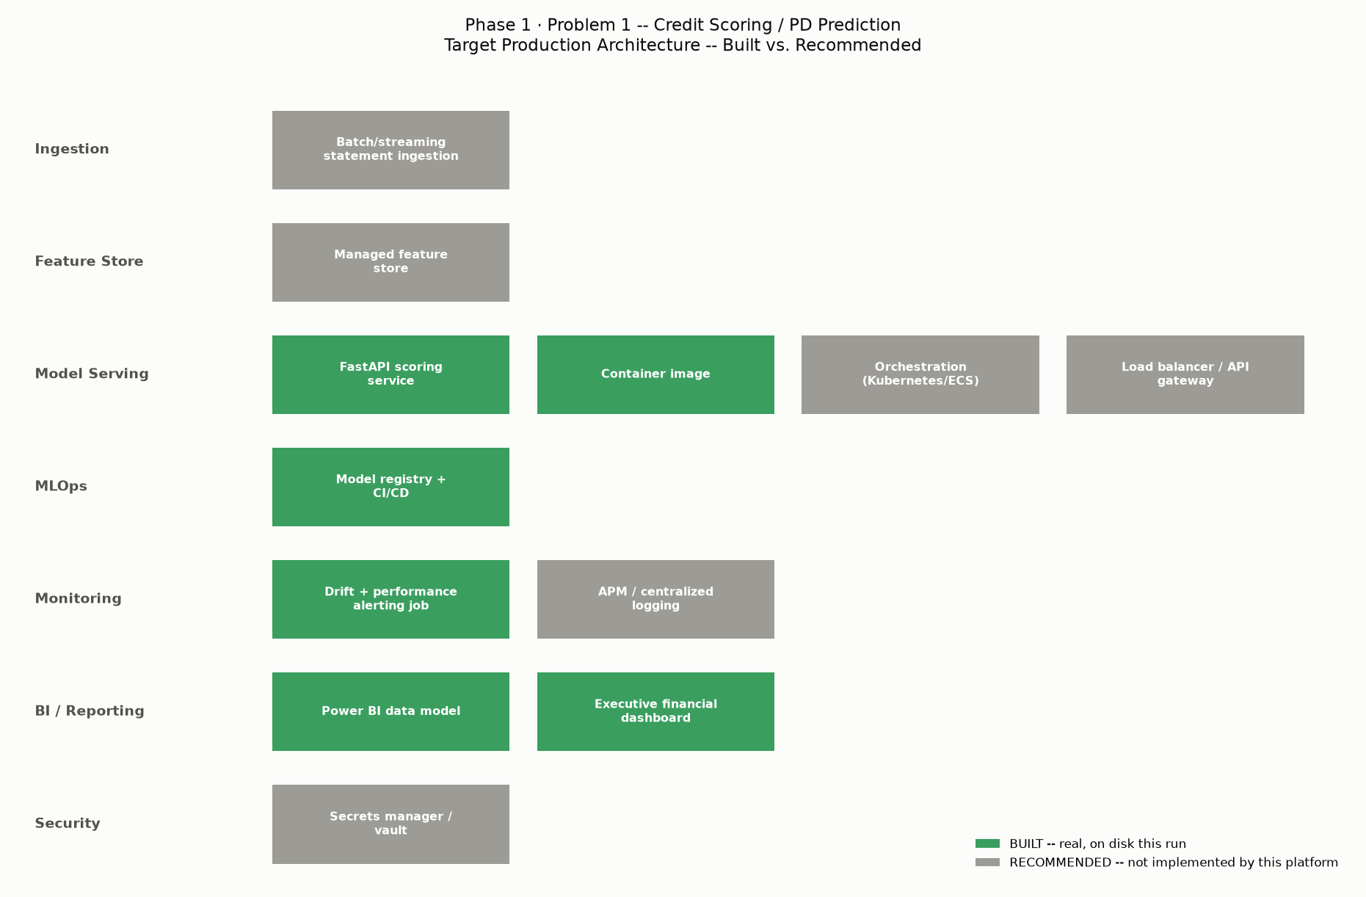
Layer | Component | Status | Note
Ingestion | Batch/streaming statement ingestion | RECOMMENDED | This platform reads static Kaggle CSVs (Notebook 02); production needs a real ingestion pipeline
Feature Store | Managed feature store | RECOMMENDED | This platform recomputes features per run (Notebook 04); production benefits from a served feature store
Model Serving | FastAPI scoring service | BUILT | Notebook 10 -- real, self-tested against the champion model
Model Serving | Container image | BUILT | Notebook 11 -- real Dockerfile, non-root, healthcheck
Model Serving | Orchestration (Kubernetes/ECS) | RECOMMENDED | This platform delivers a single-container image; orchestration is an infra-team decision (Notebook 11)
Model Serving | Load balancer / API gateway | RECOMMENDED | Needed to distribute traffic across replicas and terminate TLS
MLOps | Model registry + CI/CD | BUILT | Notebook 09 -- real versioned registry, real GitHub Actions YAML
Monitoring | Drift + performance alerting job | BUILT | Notebook 12 -- real, schedulable monitoring_job.py
Monitoring | APM / centralized logging | RECOMMENDED | This platform's monitoring is model-quality focused, not infrastructure observability
BI / Reporting | Power BI data model | BUILT | Notebook 13 -- real star schema export, real DAX
BI / Reporting | Executive financial dashboard | BUILT | Notebook 14 -- real interactive HTML dashboard
Security | Secrets manager / vault | RECOMMENDED | This platform's Dockerfile is checked for hardcoded secrets (Notebook 11) but does not integrate a vault

4. High Availability & Disaster Recovery (Stated Policy)
Availability Target | ASSUMPTION -- 99.9% monthly uptime for the scoring API (an internal SLA, not a regulatory figure).
Replica Policy | ASSUMPTION -- run at least 2 replicas at all times regardless of the Section 4 sizing calculation, for failover.
Multi Az Deployment | ASSUMPTION -- deploy replicas across at least 2 availability zones.
Model Registry Backup | ASSUMPTION -- Notebook 09's model_registry.json and every registered .joblib file should be backed up to durable, versioned storage (e.g. object storage with versioning enabled).
Rollback Procedure | ASSUMPTION -- keep the prior container image tag available; a failed health check after deploy triggers an automatic rollback to the last known-good tag.
Rto Target | ASSUMPTION -- Recovery Time Objective of 15 minutes for the scoring API.
Rpo Target | ASSUMPTION -- Recovery Point Objective of 24 hours for the model registry (matches a daily retraining/registration cadence, if adopted).

5. Security (Stated Policy)
Container Runs As Non Root | MEASURED -- Notebook 11's real Dockerfile lint: confirmed true.
No Hardcoded Secrets In Image | MEASURED -- Notebook 11's real Dockerfile lint: confirmed true.
Secrets Management | ASSUMPTION -- production should inject secrets (DB credentials, API keys) via a secrets manager/vault, never baked into the image or .env checked into source control.
Network Segmentation | ASSUMPTION -- the scoring API should sit in a private subnet behind a load balancer, not directly internet-facing.
Transport Encryption | ASSUMPTION -- TLS termination at the load balancer, minimum TLS 1.2.
Authentication | ASSUMPTION -- this platform's main.py does not implement authentication (see Notebook 10) -- production must add an API key or OAuth2 layer before external exposure.
Audit Logging | ASSUMPTION -- every /predict call should be logged with request ID, model version (Notebook 09), and predicted PD for audit trail purposes.

6. Infrastructure Cost Estimate
Replica Count Used | 1
Replica Count Source | Section 4 real sizing calculation
Monthly Compute Cost Usd | 28.8
Monthly Infra Total Usd | 198.8
Notebook 14 Stated Monthly Recurring Cost Usd | 16500
Comparison Note | Notebook 14's monthly recurring cost figure covers the FULL platform (staffing, tooling, licensing), not just infrastructure compute -- these two figures are not directly comparable, shown side-by-side for context only.
Cost Per Replica Vcpu Hour Usd | 0.04
Vcpus Per Replica | 1.0
Load Balancer Monthly Usd | 20.0
Monitoring Observability Monthly Usd | 150.0

7. Production Readiness Checklist
Dimension | Status | Evidence
Technology Stack As-Built Documented | Pass | 10/12 layers verified on disk
Capacity Sizing Computed | Pass | MEASURED -- Notebook 09's real batch benchmark, model_registry.json
SLA Latency Target Checked Against Real Measurement | Pass | measured p99 11.5809 ms vs target 250.0 ms
Target Architecture Diagram (Built vs. Recommended) | Pass | 12 components, 6 built
HA / DR Policy Documented | Pass | 7 policy items (ASSUMPTION)
Security Policy Documented | Pass | 7 policy items
Infrastructure Cost Estimated | Pass | $198.80/month (ASSUMPTION unit costs)
Orchestration (Kubernetes/ECS) Implemented | Not Yet Completed | RECOMMENDED, out of this platform's scope -- see Notebook 11
Secrets Manager Integrated | Not Yet Completed | RECOMMENDED, out of this platform's scope

