AMEX Enterprise Credit Risk Platform
Technical Documentation Report -- Notebook 15
Generated: 2026-08-23 23:27

1. Platform Architecture
The table below is the real dependency map enforced by every notebook's own Section 1 file-existence checks -- 'Has Run' reflects whether that notebook's summary artifact was actually found on disk this run, not a claim.
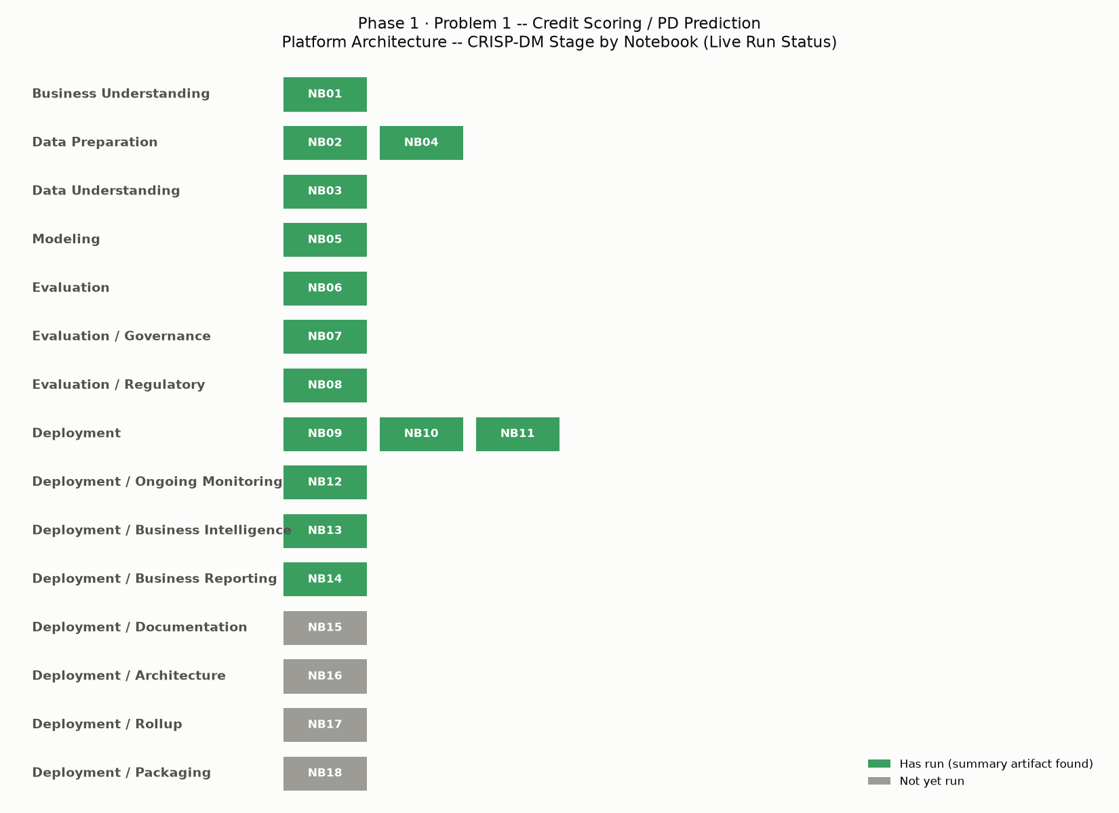
N | Notebook | Crisp Dm Stage | Depends On | Has Run
1 | Business Understanding | Business Understanding | (none) | True
2 | Data Engineering | Data Preparation | 1 | True
3 | Data Validation & EDA | Data Understanding | 1, 2 | True
4 | Feature Engineering | Data Preparation | 1, 2 | True
5 | Model Development | Modeling | 1, 4 | True
6 | Explainable AI (SHAP/LIME) | Evaluation | 1, 5 | True
7 | Model Risk Management | Evaluation / Governance | 1, 4, 5 | True
8 | Basel III / IFRS9 Mapping | Evaluation / Regulatory | 1, 5 | True
9 | MLOps | Deployment | 1, 5 | True
10 | FastAPI Deployment | Deployment | 1, 5 | True
11 | Docker | Deployment | 1, 10 | True
12 | Monitoring | Deployment / Ongoing Monitoring | 1, 4, 5 | True
13 | Power BI Dashboard | Deployment / Business Intelligence | 1, 4, 5 | True
14 | Executive Reports | Deployment / Business Reporting | 1, 5 | True
15 | Technical Documentation | Deployment / Documentation | 1 | False
16 | Production Architecture | Deployment / Architecture | 1 | False
17 | Comprehensive Reporting | Deployment / Rollup | 1 | False
18 | Repository Packaging | Deployment / Packaging | 1 | False

2. Platform Artifact Inventory (Live Filesystem Scan)
Pillar | Directory | File Count | Total Size Mb | Exists
business_documents | C:\Users\rnand\Downloads\amex-default-prediction\AMEX_Enterprise_Credit_Risk_Platform\Business_Documents | 4 | 0.103 | True
data_engineering | C:\Users\rnand\Downloads\amex-default-prediction\AMEX_Enterprise_Credit_Risk_Platform\Data_Engineering | 5 | 7948.053 | True
data_validation | C:\Users\rnand\Downloads\amex-default-prediction\AMEX_Enterprise_Credit_Risk_Platform\Data_Validation | 8 | 0.507 | True
feature_engineering | C:\Users\rnand\Downloads\amex-default-prediction\AMEX_Enterprise_Credit_Risk_Platform\Feature_Engineering | 6 | 15824.95 | True
model_development | C:\Users\rnand\Downloads\amex-default-prediction\AMEX_Enterprise_Credit_Risk_Platform\Model_Development | 16 | 227.894 | True
explainable_ai | C:\Users\rnand\Downloads\amex-default-prediction\AMEX_Enterprise_Credit_Risk_Platform\Explainable_AI_SHAP_LIME | 9 | 26.691 | True
model_risk_management | C:\Users\rnand\Downloads\amex-default-prediction\AMEX_Enterprise_Credit_Risk_Platform\Model_Risk_Management | 13 | 0.281 | True
basel_ifrs9 | C:\Users\rnand\Downloads\amex-default-prediction\AMEX_Enterprise_Credit_Risk_Platform\Basel_III_IFRS9_Mapping | 9 | 0.659 | True
mlops | C:\Users\rnand\Downloads\amex-default-prediction\AMEX_Enterprise_Credit_Risk_Platform\MLOps | 8 | 0.243 | True
fastapi_deployment | C:\Users\rnand\Downloads\amex-default-prediction\AMEX_Enterprise_Credit_Risk_Platform\FastAPI_Deployment | 9 | 0.732 | True
docker | C:\Users\rnand\Downloads\amex-default-prediction\AMEX_Enterprise_Credit_Risk_Platform\Docker | 9 | 0.147 | True
monitoring | C:\Users\rnand\Downloads\amex-default-prediction\AMEX_Enterprise_Credit_Risk_Platform\Monitoring | 10 | 0.419 | True
powerbi_dashboard | C:\Users\rnand\Downloads\amex-default-prediction\AMEX_Enterprise_Credit_Risk_Platform\PowerBI_Dashboard | 13 | 21.06 | True
executive_reports | C:\Users\rnand\Downloads\amex-default-prediction\AMEX_Enterprise_Credit_Risk_Platform\Executive_Reports | 13 | 0.911 | True
technical_documentation | C:\Users\rnand\Downloads\amex-default-prediction\AMEX_Enterprise_Credit_Risk_Platform\Technical_Documentation | 0 | 0.0 | True
production_architecture | C:\Users\rnand\Downloads\amex-default-prediction\AMEX_Enterprise_Credit_Risk_Platform\Production_Architecture | 0 | 0.0 | True

3. Data Dictionary
1804 features, built from Notebook 05's real fitted preprocessing artifacts.
Feature | Type | Categories | Imputed Median | Champion Importance Rank
P_2_last | numeric |  | 0.682651 | 1
interaction_P_2_last_x_B_18_last | numeric |  | 0.37914 | 2
interaction_P_2_last_x_B_2_last | numeric |  | 0.512893 | 3
B_1_last | numeric |  | 0.033117 | 4
D_44_last | numeric |  | 0.008034 | 5
D_42_mean | numeric |  | 0.114901 | 6
R_1_last | numeric |  | 0.005915 | 7
B_9_last | numeric |  | 0.028322 | 8
B_11_last | numeric |  | 0.021187 | 9
D_44_mean | numeric |  | 0.007132 | 10
D_42_min | numeric |  | 0.101665 | 11
D_42_max | numeric |  | 0.124424 | 12
R_1_mean | numeric |  | 0.005848 | 13
R_2_last | numeric |  | 0.005409 | 14
D_45_max | numeric |  | 0.182488 | 15
R_3_mean | numeric |  | 0.072833 | 16
B_37_last | numeric |  | 0.032782 | 17
B_4_trend_delta | numeric |  | 0.00646 | 18
D_41_trend_delta | numeric |  | 0.000427 | 19
B_2_last | numeric |  | 0.813426 | 20
... and 1784 more row(s) -- see the full CSV for the complete table.

4. API Reference
Parsed directly from Notebook 10's real, exported openapi_spec.json.
Path | Method | Summary | Query Parameters | Request Body Schema | Response Status Codes
/health | GET | Health | (none) |  | 200
/model-info | GET | Model Info | (none) |  | 200
/predict | POST | Predict | customer_id | CustomerFeatures | 200, 422

5. Model Documentation
Model Name | Version | Registered At Utc | Sha256 | File Size Mb | Holdout Auc | Holdout Amex Metric | Holdout Top4Pct Capture | Risk Tier | Latency P50 Ms | Latency P99 Ms | Batch Throughput Rows Per Sec
xgboost | 1 | 2026-08-23T16:43:28.007715+00:00 | 253726312ba06eee473b9696896dde66e238b132a3f1aabd4cd5bb9ab04c63e6 | 1.891 | 0.9620396555226549 | 0.7935631597243085 | 0.6630480518387613 | Tier 2 (Medium) | 0.4918 | 11.5809 | 345611.7

6. Glossary
Term | Definition
PD | Probability of Default -- the model's core output: the estimated likelihood a customer defaults within the prediction horizon.
LGD | Loss Given Default -- the fraction of exposure a lender expects to lose if a customer defaults, net of recoveries.
EAD | Exposure at Default -- the expected outstanding balance at the moment of default.
ECL | Expected Credit Loss -- IFRS 9's core loss-provisioning quantity, computed as PD x LGD x EAD (Stage 1) or over a lifetime horizon (Stage 2/3).
RWA | Risk-Weighted Assets -- a Basel capital-adequacy quantity; regulatory capital held is a fraction of RWA, not of raw exposure.
PSI | Population Stability Index -- a standard drift metric comparing a feature's (or score's) distribution between two populations, e.g. training vs. a newer population.
IFRS 9 | International Financial Reporting Standard 9 -- governs expected-credit-loss provisioning and staging (Stage 1/2/3) for financial instruments.
Basel III | The international regulatory capital framework (Basel Committee on Banking Supervision) setting minimum capital ratios and risk-weighting methodology for banks.
QRRE | Qualifying Revolving Retail Exposure -- the Basel exposure class credit-card-style revolving credit falls under, with its own IRB capital formula and fixed correlation parameter.
AMEX competition metric | The custom evaluation metric used by the Kaggle American Express Default Prediction competition -- a blend of Normalized Gini coefficient and the default-capture rate in the top 4% of predicted risk.
SHAP | SHapley Additive exPlanations -- a game-theoretic method for attributing a model's prediction to its input features.
LIME | Local Interpretable Model-agnostic Explanations -- explains individual predictions by fitting a simple, local surrogate model around them.
WARP | This platform's own performance convention: configuring library thread pools (e.g. Polars) to a fixed percentage of detected logical CPU cores, set once and reused across notebooks.
CRISP-DM | Cross-Industry Standard Process for Data Mining -- the six-stage process framework (Business Understanding through Deployment) this platform's notebooks are organized around.
Champion model | The best-performing model from Notebook 05's comparison, by holdout AMEX metric -- the model every downstream notebook reuses as-is.
Holdout / test split | The portion of data held out from training and never used to fit the model or its preprocessing -- the only data every validation and monitoring check in this platform trusts.
Star schema | A BI data-modeling pattern: one central fact table (the granular, measurable events) surrounded by dimension tables (the descriptive context to slice and filter by).
DAX | Data Analysis Expressions -- the formula language Power BI (and Excel Power Pivot) uses to define measures and calculated columns.

7. Setup & Run-Order Guide
- Install Python 3.11 and Conda (or venv) on a Windows machine with the raw Kaggle American Express Default Prediction CSVs already downloaded.
- Create and activate a fresh environment, then install dependencies: polars, numpy, pandas, scikit-learn, xgboost, lightgbm, catboost, shap, lime, matplotlib, psutil, joblib, python-docx, scipy, openpyxl, fastapi, uvicorn, pydantic, pyyaml (Notebook 09 exports the exact installed versions to requirements.txt once it has run).
- Open 01_business_understanding.ipynb first, set DATA_ROOT to your local Kaggle CSV folder, and run its single code cell -- this creates project_config.json and every pillar directory every later notebook depends on.
- Run the remaining notebooks in numeric order (02 through 18) -- each notebook's own intro cell states exactly which prior notebooks it depends on and which of those are optional.
- Each notebook is a single, idempotent code cell: re-running it overwrites its own outputs in place (Notebook 09's model registry is the sole deliberate exception -- see its intro).

8. Technical Documentation Readiness Checklist
Dimension | Status | Evidence
Data Dictionary Generated (Real, From Notebook 05) | Pass | 1804 features documented
Platform Artifact Inventory (Live Filesystem Scan) | Pass | 132 real files across 16 pillars
Architecture Diagram & Dependency Map | Pass | 18 notebooks mapped, 14 have run
API Reference (Real, From Notebook 10) | Pass | 3 endpoint(s) documented
Model Documentation (Real, From Notebook 09) | Pass | 1 model version(s) documented
Glossary of Terms | Pass | 18 terms defined
Setup & Run-Order Guide | Pass | 5 steps documented
README.md Generated at Project Root | Pass | README.md

