AMEX Enterprise Credit Risk Platform
Phase 1, Problem 2: Risk Tier Classification -- Deployment Report
Generated: 2026-08-24 12:42

1. Service Overview
risk_tier_service.py exposes the real champion model (xgboost) plus Notebook 19's real business-rule tier policy as a FastAPI service: GET /health, GET /policy-info, POST /risk-tier. It faithfully extends Notebook 10's main.py pattern -- same environment-variable convention, same dynamically-built Pydantic schema.

2. Live Self-Test Result
Sample customer: 000084e5023181993c2e1b665ac88dbb1ce9ef621ec5370150fc2f8bdca6202c. API-returned PD (0.006822) vs. directly-computed PD (0.006822), difference 0.00000000. API-returned tier ('Prime') vs. directly-computed tier ('Prime'). Result: PASS -- API is verified consistent with direct computation.

3. Latency Benchmark
150 real TestClient calls: {'n_samples': 150, 'p50_ms': 12.953, 'p95_ms': 14.277, 'p99_ms': 15.188, 'max_ms': 15.485}

4. Docker
Daemon probe result: Docker CLI is installed but no daemon is reachable (Docker Desktop is not running, or this environment has no Docker daemon). Skipping the real build -- see the manual build command in the Word report instead.
Manual build (if no daemon was reachable here): docker build -t amex-risk-tier-api:latest . -- run from the docker/ folder.

5. Deployment Readiness Checklist
Dimension | Status | Evidence
risk_tier_service.py Generated & Syntax-Checked | Pass | risk_tier_service.py
Live API Self-Test (PD + Tier vs. Direct Computation) | Pass | PD diff 0.00e+00, tier match True
Malformed Request Handling | Pass | extra fields ignored, no crash
Latency Benchmarked | Pass | p50=12.953ms, p99=15.188ms
Dockerfile & Compose Generated | Pass | Dockerfile, docker-compose.yml
Real Docker Build | Not Run (see probe note) | Docker CLI is installed but no daemon is reachable (Docker Desktop is not running, or this environment has no Docker daemon). Skipping the real build -- see the manual build command in the Word report instead.
Policy Read at Service Start-Up (Not Hardcoded) | Pass | risk_tier_policy.json read from disk on import

6. Charts
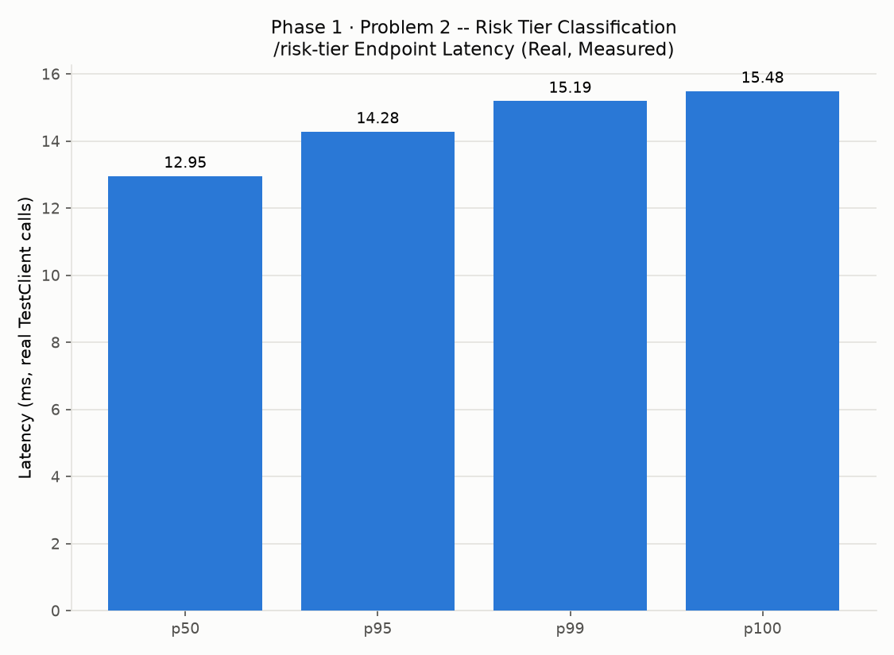
Endpoint latency, real measured

