AMEX Enterprise Credit Risk Platform
Phase 1, Problem 2: Risk Tier Classification -- Model Development Report
Generated: 2026-08-24 10:56

1. Methodology
Problem 1's real champion model (xgboost, holdout AUC 0.9620396555226549, holdout AMEX metric 0.7935631597243085) scores the real, held-out test split (91,783 customers, never trained on -- the same split Notebook 05 and Notebook 13 use). Two tier-bucketing methods, both defined in Notebook 19's policy, are computed against these real PD scores and compared.

2. Per-Tier Performance -- Both Methods (Real, Measured)
Method | Risk Tier | N Accounts | Population Pct | Actual Bad Rate Pct | Mean Predicted Pd | Calibration Gap
business_rule | Prime | 50264 | 54.76 | 0.76 | 0.0084 | 0.0008
business_rule | Near-Prime | 7013 | 7.64 | 9.454 | 0.0913 | -0.0032
business_rule | Subprime | 6694 | 7.29 | 24.813 | 0.2427 | -0.0054
business_rule | High Risk | 27812 | 30.3 | 75.723 | 0.7563 | -0.0009
quantile | Prime | 22946 | 25.0 | 0.061 | 0.0016 | 0.001
quantile | Near-Prime | 22945 | 25.0 | 0.793 | 0.0097 | 0.0018
quantile | Subprime | 22946 | 25.0 | 20.165 | 0.1987 | -0.0029
quantile | High Risk | 22946 | 25.0 | 82.555 | 0.8238 | -0.0018

3. KPI Compliance -- Honest Pass/Fail
A KPI target not met below is a real, measured outcome on this holdout population -- reported as-is, never adjusted to appear compliant.

Business-Rule Method
Monotonicity Pass: True [PASS]
Monotonicity Measured: True [PASS]
Bad Rate Ratio Top To Bottom: 99.64
Bad Rate Ratio Target: 3.0
Bad Rate Ratio Pass: True [PASS]
Min Tier Population Pct Measured: 7.29
Min Tier Population Pct Target: 5.0
Population Balance Pass: True [PASS]

Quantile Method
Monotonicity Pass: True [PASS]
Monotonicity Measured: True [PASS]
Bad Rate Ratio Top To Bottom: 1353.36
Bad Rate Ratio Target: 3.0
Bad Rate Ratio Pass: True [PASS]
Min Tier Population Pct Measured: 25.0
Min Tier Population Pct Target: 5.0
Population Balance Pass: True [PASS]

4. Population Stability (Split-Half PSI, Primary Method)
PSI = 0.0002 (target <= 0.1) -- PASS. Honest scope note: this is a random split-half stability proxy on the single available holdout population, not a genuine time-based drift measurement (Notebook 23 covers simulated temporal monitoring windows, reusing Notebook 12's real pattern).

5. Statistical Significance
Chi-square test of risk tier vs. actual default: statistic=53526.07, dof=3, p-value=0.000e+00 -- statistically significant (p < 0.001).

6. Selected Primary Method
Per Notebook 19's policy, 'business_rule' is the primary method used downstream (Notebooks 21-25). Both methods' assignments are retained in risk_tier_assignments.csv for transparency and comparison.

7. Charts
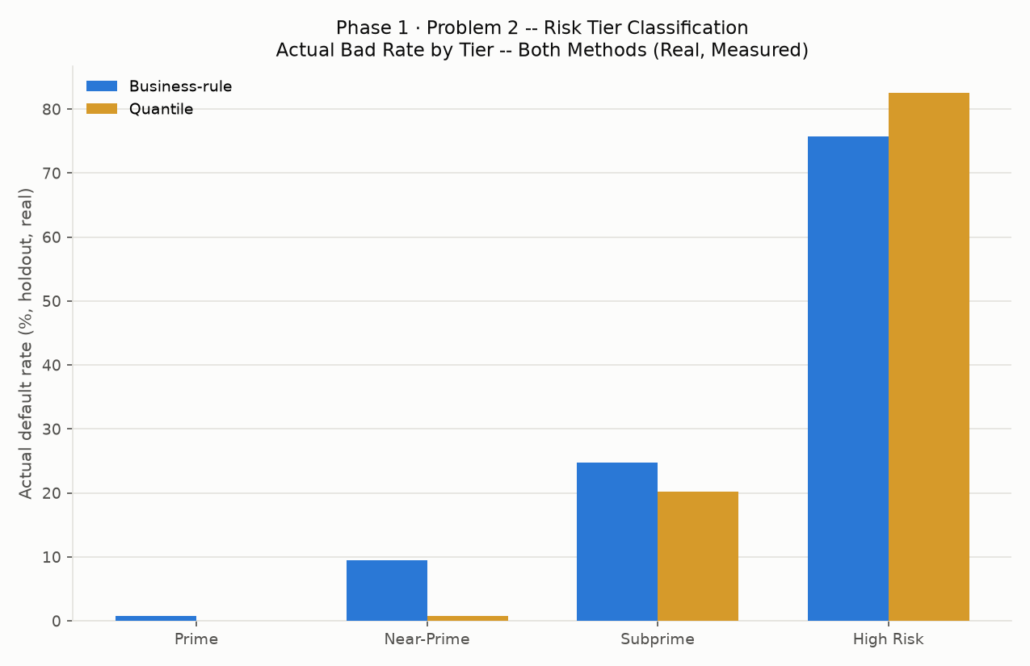
Actual bad rate by tier
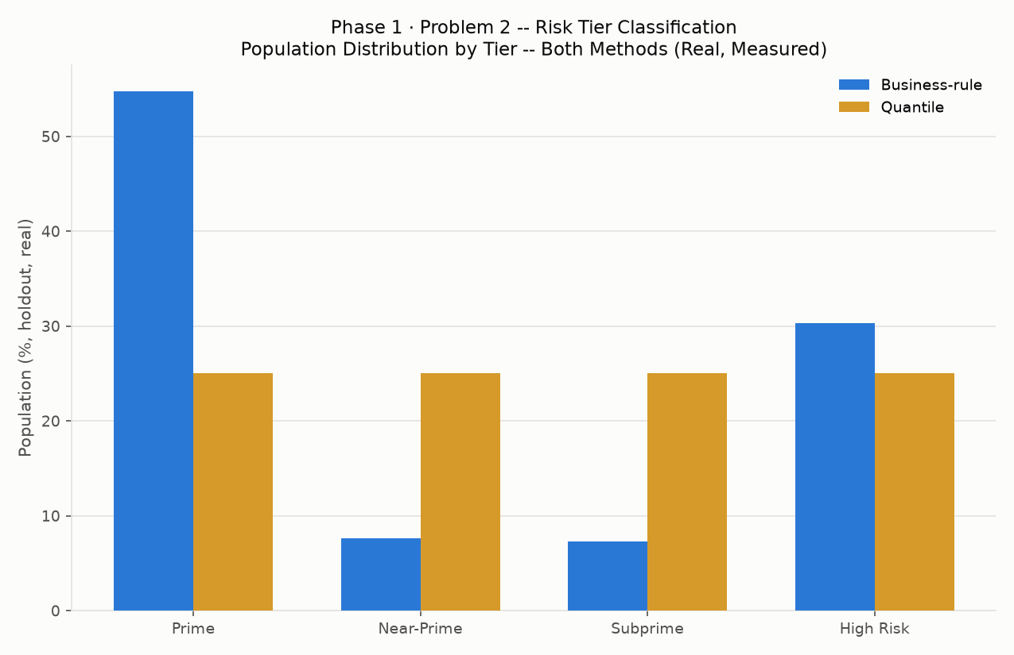
Population distribution by tier
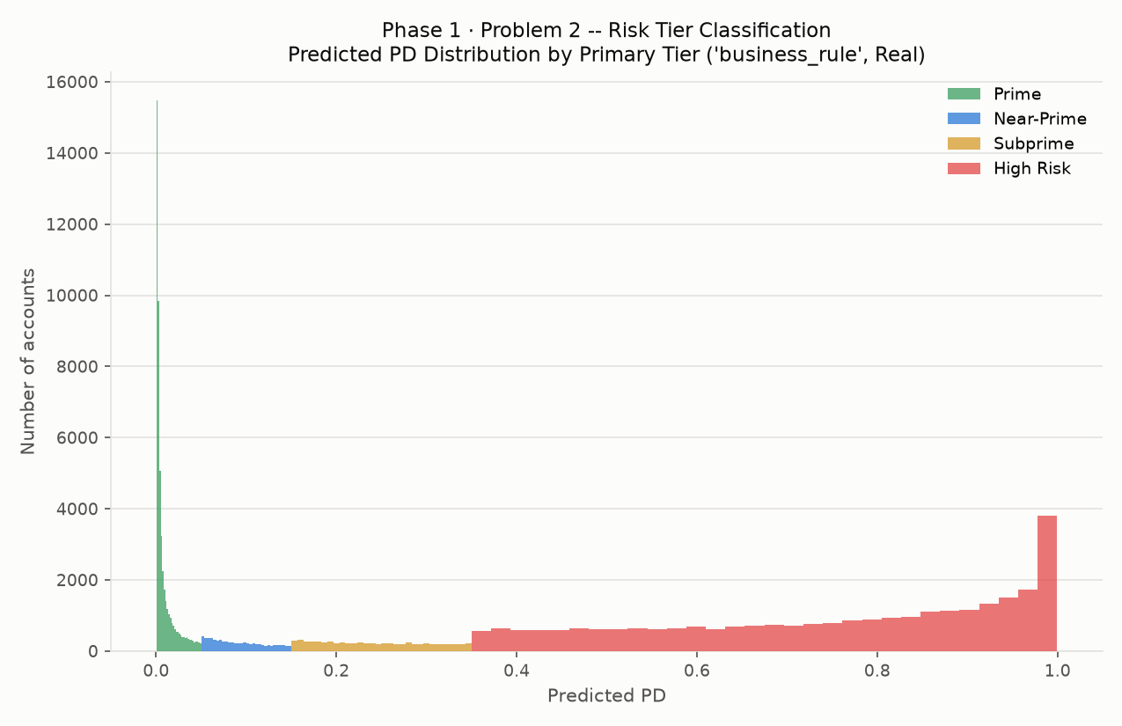
Predicted PD distribution by tier
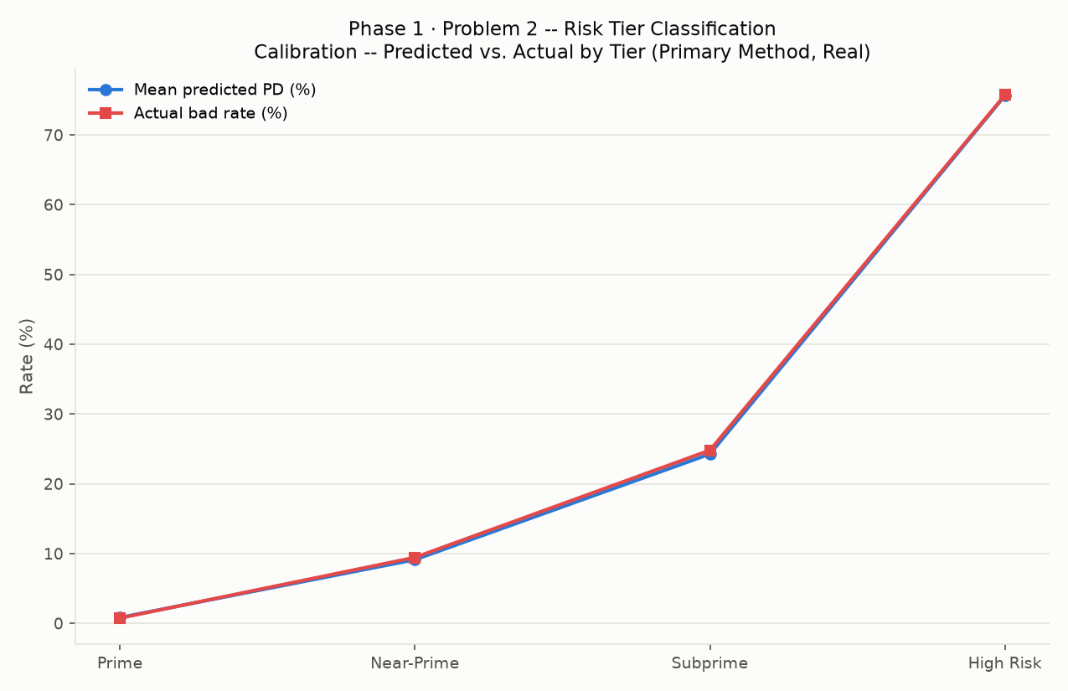
Calibration by tier

