AMEX Enterprise Credit Risk Platform
Phase 1, Problem 2: Risk Tier Classification -- Comprehensive Report
Generated: 2026-08-24 12:42

1. Notebook Completion Status
Notebook | Title | Status | Summary File
19 | Business Understanding & Policy | Complete | notebook_19_summary.json
20 | Model Development | Complete | notebook_20_summary.json
21 | Validation | Complete | notebook_21_summary.json
22 | Deployment | Complete | notebook_22_summary.json
23 | Monitoring | Not Yet Run | (missing)

2. At A Glance
Champion Model: xgboost
Champion Holdout Auc: 0.9620396555226549
Champion Holdout Amex Metric: 0.7935631597243085
N Tiers: 4
Primary Method: business_rule
Primary Method Full Kpi Pass: True
Split Half Psi: 0.0002
Chi Square P Value Nb20: 0.0
Rank Ordering Pass Nb21: True
Cramers V: 0.7636626665627394
Fair Lending Testing Status: Not Possible -- Data Limitation (see Section 9)
Api Self Test Passed: True
Api Latency P50 Ms: 12.953

3. Business & Financial Impact Narrative (Honest Scope)
This Kaggle dataset carries no revenue, cost, or investment data for any real institution -- every dollar figure below rests on an explicit, editable ASSUMPTION, separated from the real, measured tier statistics that drive it (Notebook 20's bad-rate-by-tier table).
- ASSUMPTION -- deployment portfolio size accounts: 500000
- ASSUMPTION -- avg exposure at default usd: 3500
- ASSUMPTION -- high risk tier population share: 0.1
- ASSUMPTION -- risk based repricing loss reduction share: 0.15
Real, measured bad-rate spread (highest- vs. lowest-risk tier): 74.96 percentage points. Illustrative annual loss avoidance from risk-based tiering, under the stated assumptions: $19,877,288.

4. Charts
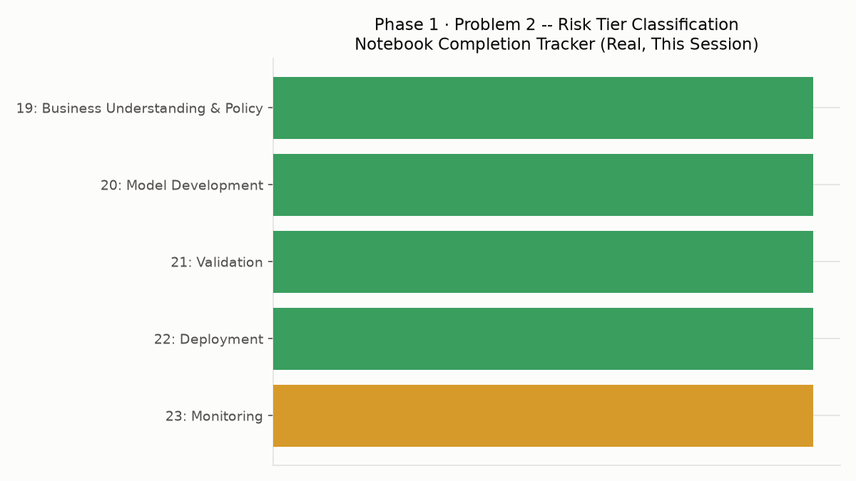
Notebook Completion Tracker Chart
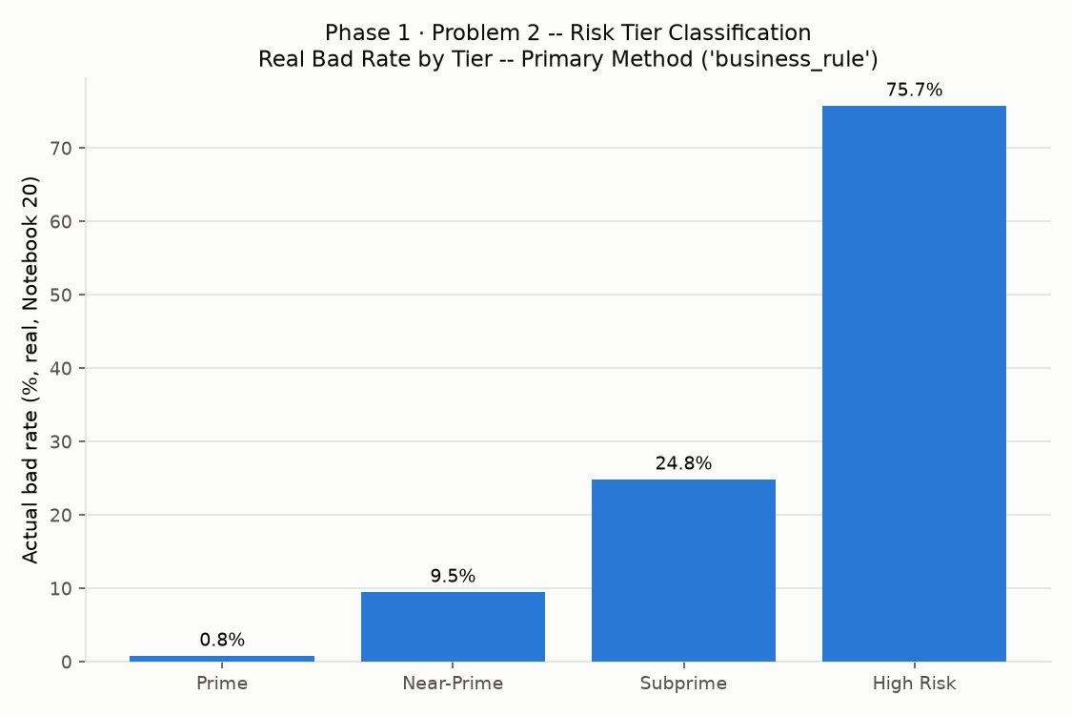
Final Bad Rate By Tier Chart

