AMEX Enterprise Credit Risk Platform
Phase 1, Problem 2: Risk Tier Classification -- Independent Validation Report
Generated: 2026-08-24 12:40

1. Scope
Independent validation, in the spirit of SR 11-7 / OCC 2011-12, of the 'business_rule' risk-tier scheme built in Notebook 20 from Problem 1's real champion model (xgboost), applied to the real holdout population (91,783 customers).

2. Statistical Validation Summary
Test | Statistic | P Value | Significant At 0 001
Chi-square (tier vs. actual default) | 53526.0713 | 0.0 | True
Cramer's V (effect size) | 0.7637 | nan | None
Spearman(tier rank, predicted PD) | 0.8984 | 0.0 | True
Spearman(tier rank, actual default) | 0.7266 | 0.0 | True
Split-half PSI (business_rule) | 0.0001 | nan | True
Split-half PSI (quantile) | 0.0003 | nan | True

3. Bootstrap Confidence Intervals
Risk Tier | N Accounts | Observed Bad Rate Pct | Ci Lower Pct | Ci Upper Pct
Prime | 50264 | 0.76 | 0.686 | 0.838
Near-Prime | 7013 | 9.454 | 8.755 | 10.11
Subprime | 6694 | 24.813 | 23.842 | 25.844
High Risk | 27812 | 75.723 | 75.248 | 76.219

4. Honest Limitation -- Fair-Lending / ECOA / Regulation B
Scope: Genuine disparate-impact / adverse-impact testing under the Equal Credit Opportunity Act (ECOA) and Regulation B requires real demographic and protected-class attributes (e.g. race, ethnicity, sex, age, national origin) linked to each account.
Dataset Gap: The Kaggle American Express Default Prediction dataset used throughout this platform carries no demographic or protected-class fields of any kind -- only anonymized behavioral and payment features.
What This Notebook Does Not Do: It does not fabricate a proxy fairness test, does not simulate synthetic demographic labels, and does not claim any prior notebook in this platform (including Notebook 07's independent model validation) has already performed genuine fair-lending testing -- it has not.
What A Real Deployment Would Require: Before this risk-tier scheme could be used for real underwriting decisions, a real institution would need: (1) lawfully collected demographic data (e.g. via BISG proxy methodology or direct self-report, per CFPB guidance), (2) a disparate-impact analysis comparing tier assignment and approval rates across protected classes, and (3) legal/compliance sign-off before production use.

5. Governance Checklist
Dimension | Status | Evidence
Tier Policy Documentation | Pass | risk_tier_policy.json (Notebook 19)
Independent Statistical Backtesting | Pass | chi-square p=0.00e+00 (this run)
Rank-Ordering Validation | Pass | Spearman rho=0.727, p=0.00e+00 (this run)
Confidence Interval Separation | Pass | 2,000-resample bootstrap, adjacent tiers non-overlapping (this run)
Population Stability (Split-Half Proxy) | Pass | business_rule PSI=0.000, quantile PSI=0.000 (this run)
Fair-Lending / Disparate-Impact Testing | Not Possible -- Data Limitation | No protected-class data in source dataset -- see Section 9
Independent Model Validation Upstream (Problem 1) | Pass | Notebook 07 (SR 11-7-aligned) completed for the underlying PD model
Ongoing Monitoring Plan | Pending | Deferred to Notebook 23 (Risk Tier Monitoring)

6. Charts
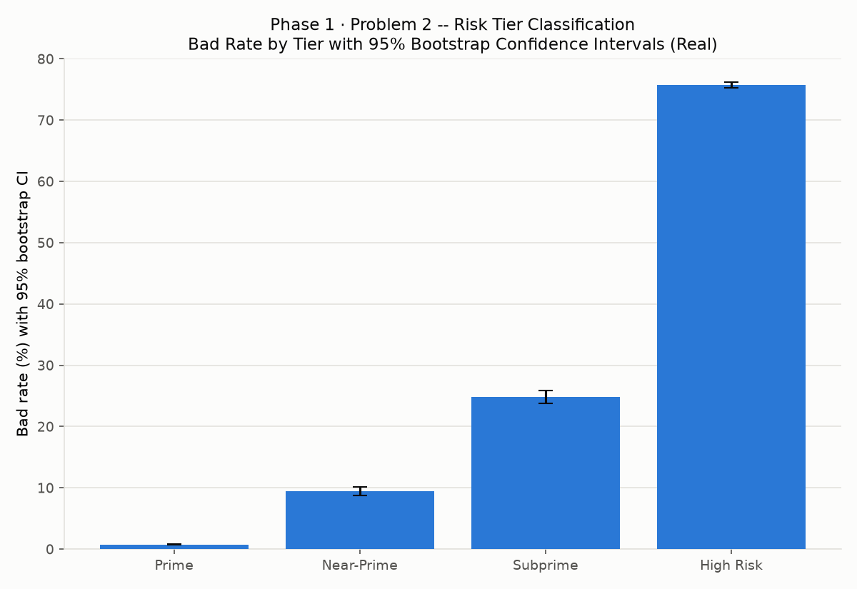
Bad rate by tier with 95% bootstrap CIs
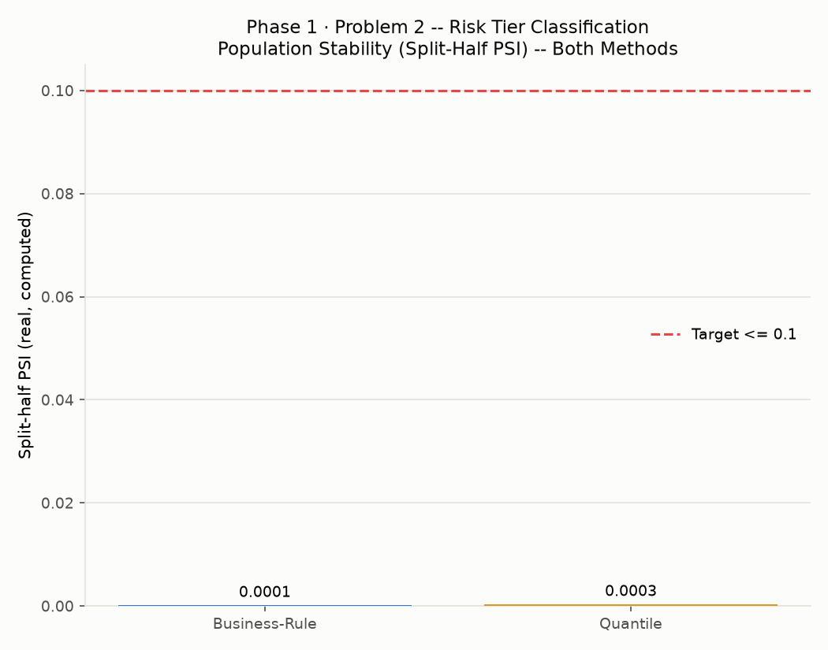
PSI comparison, both methods

