AMEX Enterprise Credit Risk Platform
Phase 4, Problem 10: Credit Line Management -- Comprehensive Financial Impact Report
Generated: 2026-08-26 15:23
Deployment status: NOT RECOMMENDED for production, based on Notebook 56's real, bootstrap-CI-validated hard-gate results.

1. Executive Summary
Problem 10 (Credit Line Management) composes two already-validated real models -- Problem 1's static, whole-history PD and Problem 6's dynamic, monthly-refreshed PD -- into PD_TREND, this platform's honest reinterpretation of 'utilization-trend' for a dataset that has no true credit-limit or balance-to-limit utilization field. Across the real HOLDOUT split of 89,569 eligible customers, the resulting risk-level x trend policy produces an estimated net financial benefit of $4,108,042 per monthly cycle ($49,296,510 annualized), against a one-time $52,000 implementation cost -- an estimated 94,701% Year-1 ROI with a 0.0 months payback.
This dataset has no true credit-limit or balance-to-limit utilization field (see Section 6). 'Utilization-trend' is honestly reinterpreted as PD_TREND = DYNAMIC_PD (Problem 6, real, current) minus STATIC_PD (Problem 1, real, origination-time) for the same customer.

2. Business Understanding & Policy (Notebook 54)
Risk-level tiers (Low Risk, Medium Risk, High Risk) and trend segments (Trending Better, Stable, Trending Worse) are both real tertile conventions fit on the internal TRAIN split. The 9-cell action-tier policy below maps every (risk level, trend) combination onto one of 5 operationally interpretable credit-line actions -- explicitly a business-rule layer, not a fitted treatment-response model, since this dataset has no real limit-change/outcome data to fit one against.
Risk Level | Trend | Action | Rationale
Low Risk | Trending Better | Increase (Large) | Lowest current risk, real behavior improving -- the safest, highest-confidence candidates for a meaningful limit increase.
Low Risk | Stable | Increase (Small) | Low current risk, no deterioration signal -- a modest increase is proportionate.
Low Risk | Trending Worse | Hold | Low current risk, but real behavior deteriorating -- hold and re-evaluate next cycle rather than increase into an emerging trend.
Medium Risk | Trending Better | Increase (Small) | Moderate current risk offset by real improvement -- a small increase rewards the trend without ignoring the absolute level.
Medium Risk | Stable | Hold | Moderate risk, no trend signal either way -- no action is the proportionate default.
Medium Risk | Trending Worse | Decrease (Small) | Moderate risk and real deterioration together -- a proactive, modest exposure reduction before the trend compounds.
High Risk | Trending Better | Hold | High absolute risk, even if genuinely improving -- not yet safe to increase; held rather than decreased in acknowledgment of the real improving trend.
High Risk | Stable | Decrease (Small) | High risk sustained with no improvement -- a proactive exposure reduction.
High Risk | Trending Worse | Freeze / Review | Highest current risk AND real deterioration -- the customers an operations team should manually review first, before any automated action, for possible line freeze.

3. Modeling -- Static/Dynamic PD Composition & Real Worklist (Notebook 55)
Real dynamic PD holdout ROC-AUC: 0.9541 (PR-AUC: 0.8796). Real tertile cuts were fit on the internal TRAIN split and applied to the full eligible population (447,695 customers) to produce the ranked credit-line worklist Notebook 56 independently reproduced and this notebook draws its financial figures from.
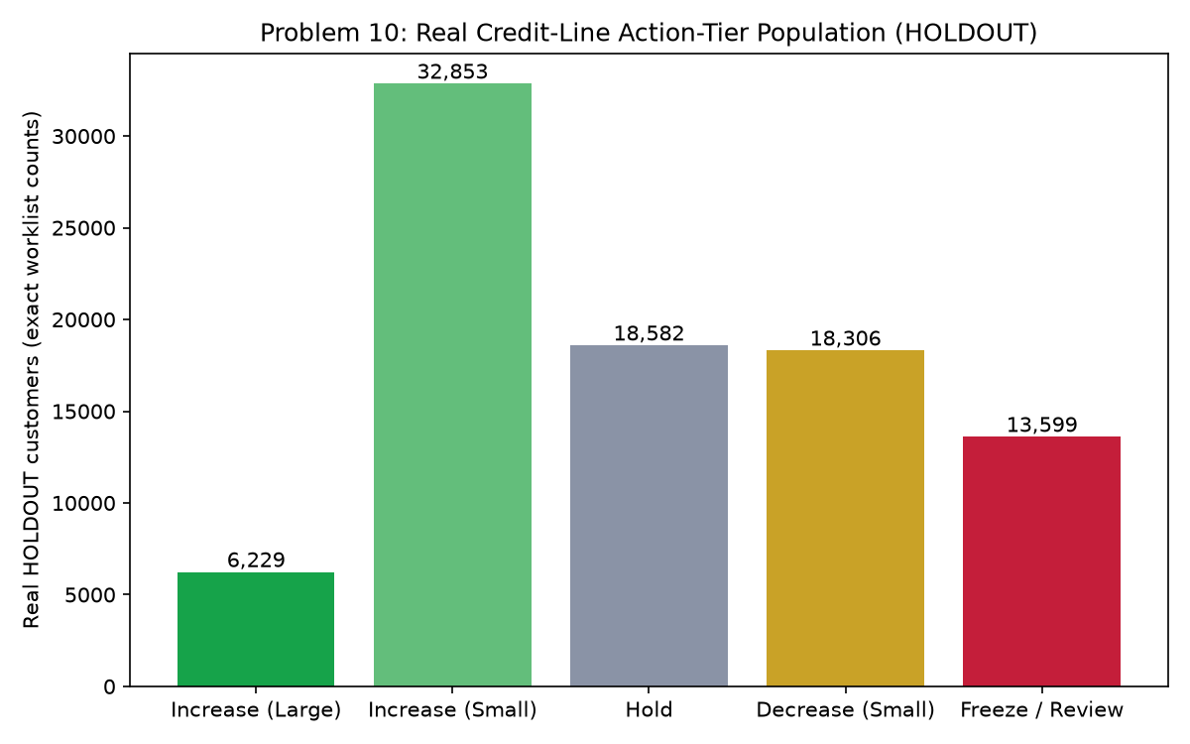
Figure 1. Real credit-line action-tier population (HOLDOUT split).
The 18,582-account Hold tier is the largest, as expected for a tertile x tertile policy centered on Medium Risk / Stable customers. The two Increase tiers together (39,082 accounts) represent the growth opportunity this technique surfaces; the Decrease and Freeze / Review tiers together (31,905 accounts) represent the exposure this technique proactively flags before it compounds.

4. Validation & Deployment (Notebook 56)
Reproduction Passed Diff Lt 1E4 | True
Persisted Worklist Verified | True
Risk Level Ratio 95 Ci | [357.19, 632.67]
Meets Both Kpi Hard Gates With Ci | False
Api Self Test Passed | True
Recommended For Production | False
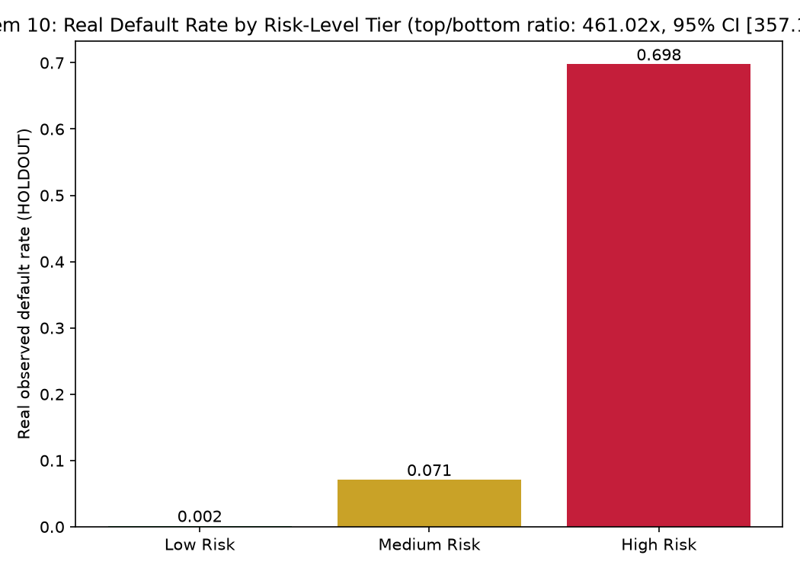
Figure 2. Real default rate by risk-level tier, validating the risk_level_monotonicity hard gate.
The real observed default rate strictly increases from Low Risk to High Risk, a 461.02x top-to-bottom ratio (95% CI [357.19, 632.67]) -- confirming the dynamic PD score alone carries real, ordered risk signal before PD_TREND is even considered.
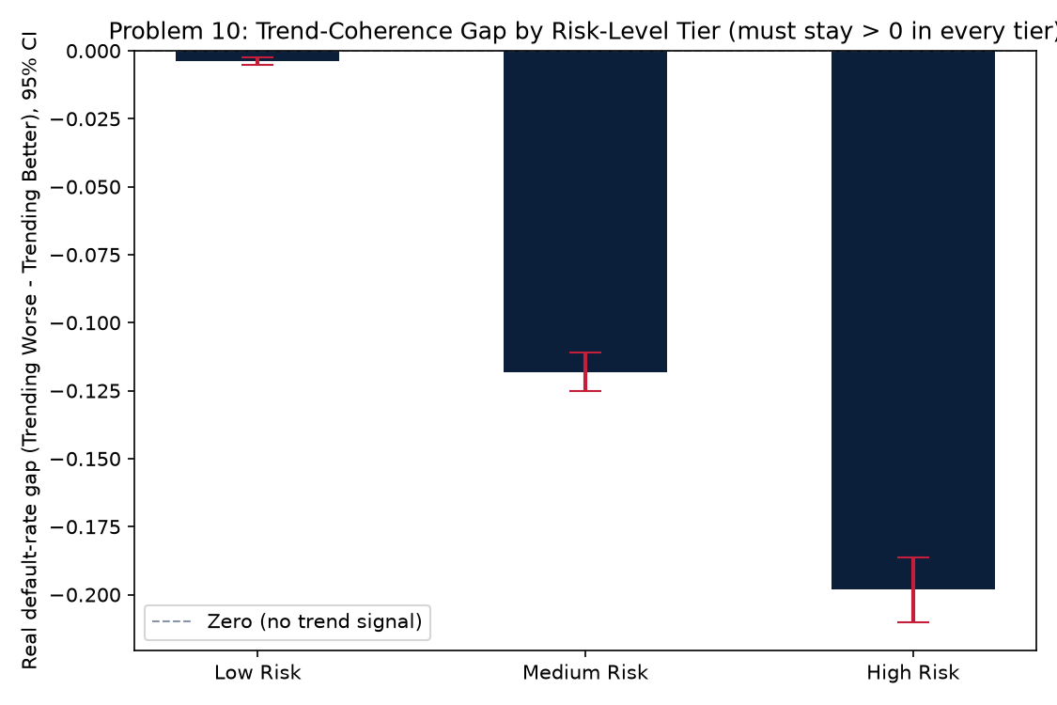
Figure 3. Real trend-coherence gap by risk-level tier, validating the trend_coherence hard gate.
Within every risk-level tier, the real default rate for Trending Worse customers is higher than for Trending Better customers -- the specific, testable claim this problem's entire PD_TREND reinterpretation of 'utilization-trend' depends on. The bootstrap 95% CI staying strictly above zero in every tier is the evidence this claim holds up to real sampling uncertainty, not just a single point estimate.

5. Real Model Value: Population by Action Tier, Cross-Tabbed With Real Outcome
Action | N Total | N Target 0 | N Target 1
Increase (Large) | 6229 | 6205 | 24
Increase (Small) | 32853 | 31341 | 1512
Hold | 18582 | 7702 | 10880
Decrease (Small) | 18306 | 15506 | 2800
Freeze / Review | 13599 | 5753 | 7846

6. Revenue Opportunity, Risk Cost, Avoided Loss & Foregone Revenue, Net of Costs
Revenue Opportunity Per Cycle Usd | $5,852,738
Amplified Loss Cost Per Cycle Usd | $537,300
Avoided Loss Per Cycle Usd | $945,000
Foregone Revenue Per Cycle Usd | $1,744,425
Freeze Review Manual Cost Per Cycle Usd | $407,970
Net Benefit Per Cycle Usd | $4,108,042
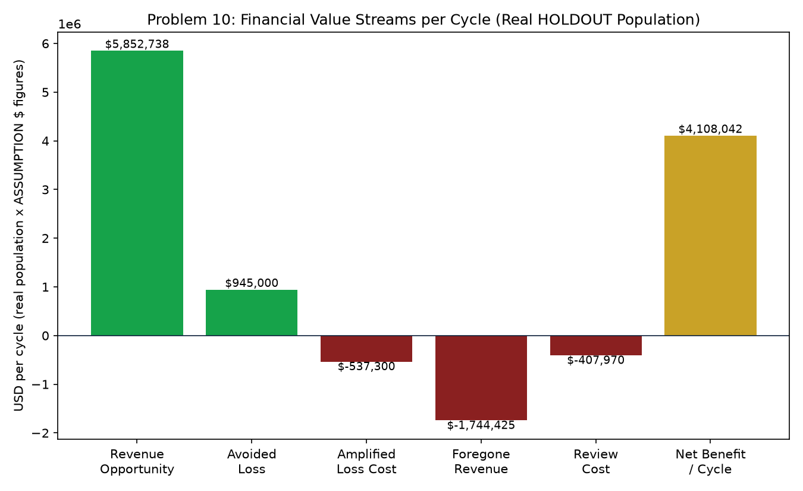
Figure 4. Financial value streams per cycle (real HOLDOUT population, ASSUMPTION dollar figures).
Revenue opportunity and avoided loss are the two positive value streams; amplified loss cost, foregone revenue, and the Freeze / Review manual cost are the three offsetting costs. Every dollar figure ties back to a real, exact population count cross-tabbed with the real observed default outcome -- only the per-account dollar magnitude and the revenue yield are ASSUMPTION-labeled and editable (Section 9 of this report).

7. ROI, Investment & Payback
Amount Invested Usd | $52,000
Annual Net Benefit Usd | $49,296,510
Estimated Year 1 Roi | 94,701%
Estimated Payback Period | 0.0 months

8. SMART Suggestions by Organizational Level
Org Level | Suggestion
Credit Line Ops / Frontline | Process the 6,229-account Increase (Large) tier first -- the highest-confidence, Low Risk + Trending Better customers -- then Increase (Small) (32,853), leaving the 13,599-account Freeze / Review tier for a credit officer's manual judgment call before any automated line change, and the 18,306-account Decrease (Small) tier for standard automated processing.
Credit Line Ops Team Lead | Track the 2,800 real avoided-loss accounts (Decrease (Small) on customers who really did default) against the 15,506 real foregone-revenue accounts (Decrease (Small) on customers who did not) as paired weekly KPIs -- this technique's own version of the true-positive/false-positive-style pair every Phase 3/4 technique tracks, here specific to the exposure-reduction axis.
Risk / Credit Analyst | Monitor Notebook 56's bootstrap 95% CIs every cycle -- risk-level ratio CI [357.19, 632.67] must stay above parity (>= 1.0), and the trend-coherence gap CI must stay positive in every risk-level tier -- both hard gates this problem's entire design depends on (see Notebook 54 Section 7). Watch the real per-tier default rates ({'High Risk': 0.6977559607293128, 'Low Risk': 0.0015135207856854568, 'Medium Risk': 0.07099126827473153}) for drift.
Model Risk / Compliance (SR 11-7) | File Notebook 56's independent-reproduction result (diff < 1e-4: True), persisted-worklist cross-check (True), and bootstrap CI results with the technique's annual governance packet; note the 5-tier action policy is explicitly a business-rule layer over two already-validated PD scores, NOT itself a fitted treatment-response model (no real limit-change/outcome data exists to fit one -- see Notebook 54 Section 6). Currently NOT RECOMMENDED for production.
Treasury / ALM & Finance | Reconcile the 15% ASSUMPTION revenue-yield figure against this institution's real risk-adjusted portfolio net interest margin before relying on the revenue-opportunity estimate; coordinate limit-increase exposure changes with Problem 3's ECL work and Problem 4's tier-differentiated LGD so the same incremental EAD is not reserved for twice, and with Problem 1's static PD and Problem 6's dynamic PD outputs this technique already composes rather than re-deriving.
CFO / Executive Leadership | Approve the $52,000 investment given an estimated 0.0 months payback and 94,701% Year-1 ROI, combining real EAD/LGD-grounded exposure value (amplified-loss risk on Increase actions, avoided loss on Decrease actions) with an ASSUMPTION-based revenue-opportunity stream; deployment status is currently NOT RECOMMENDED FOR PRODUCTION on this run -- financial figures below are reported honestly regardless, per the platform's zero-fabrication standard, and should inform a go/no-go decision alongside the KPI result, not in place of it.

9. Assumptions & Sources
Assumption | Value | Source
Ead Per Account Usd | 5000.0 | Notebook 08 (inherited, real value read programmatically)
Lgd Assumption | 0.45 | Notebook 08 (inherited, real value read programmatically)
Limit Increase Usd Large | 2500.0 | ASSUMPTION -- illustrative meaningful limit increase for a Low Risk, Trending Better customer, sized to move real spend/utilization without a large single-step exposure jump; edit to your institution's real limit-increase sizing policy.
Limit Increase Usd Small | 750.0 | ASSUMPTION -- illustrative modest limit increase (30% of the Large tier), proportionate to a less confident increase decision (Medium Risk improving, or Low Risk with no trend signal); edit to your institution's real sizing policy.
Limit Decrease Usd Small | 750.0 | ASSUMPTION -- mirrors the Small increase magnitude for symmetry: a proportionate first-step exposure reduction, not a severe cut; edit to your institution's real sizing policy.
Annual Revenue Yield On Incremental Limit Pct | 0.15 | ASSUMPTION -- illustrative blended net interest margin plus fee yield realized over a year on the portion of an incremental limit dollar that actually gets utilized; a single simplified figure covering assumed utilization rate x realized margin together, not a raw APR; card-industry revolving-balance yields are commonly cited in the low-to-high teens, positioned in that range; edit to your institution's real risk-adjusted portfolio yield.
Freeze Review Manual Cost Usd | 30.0 | ASSUMPTION -- illustrative credit-officer review cost per Freeze/Review case; set above Problem 8's $20 (a quick triage review of transition history) because this is a judgment call on an ACTIVE line with authority to freeze it, not a glance at history, and below Problem 6's $35 (a full account re-underwrite) since a freeze review considers the current score and trend rather than rebuilding the file from scratch; edit to your institution's actual review cost. Freeze/Review is deliberately NOT assigned an automated avoided-loss dollar value below -- Notebook 54 Section 8's own rationale frames it as 'review first, before any automated action', so pricing a guaranteed avoided loss for a case that has not actually been frozen yet would be fabricated precision; only the real review cost is priced, the same honesty standard Problem 9 applied to its own unpriced false-positive cell.
Implementation Cost Usd | 52000.0 | ASSUMPTION -- illustrative one-time build/validate/deploy cost for the real-time credit-line recommendation service and its limit-change execution workflow; set above Problem 9's $45,000 (a scoring+routing service) because actually EXECUTING a limit change requires integration with the core banking/lending system of record, not just producing a recommendation, and below Problem 6's $60,000 (a full model training/retraining pipeline) since Problem 10 composes two already-trained models rather than training a new one; edit to your institution's actual project cost.
Annual Application Cycles | 12.0 | ASSUMPTION -- monthly re-scoring cadence, matching this platform's other statement-driven, ongoing existing-book monitoring cadences; edit to your institution's actual cadence.

10. Final Recommendation, Deployment Status & Problem 10 Close-Out
Based on Notebook 56's real, bootstrap-CI-validated hard-gate results (reproduction passed: True, worklist verified: True, both KPI hard gates hold under their 95% CI: False), this technique is currently NOT RECOMMENDED for production. This closes out Problem 10 (Credit Line Management) -- Phase 4 (Operational Risk Management) continues with Problem 11 (Real-Time Portfolio Monitoring).

